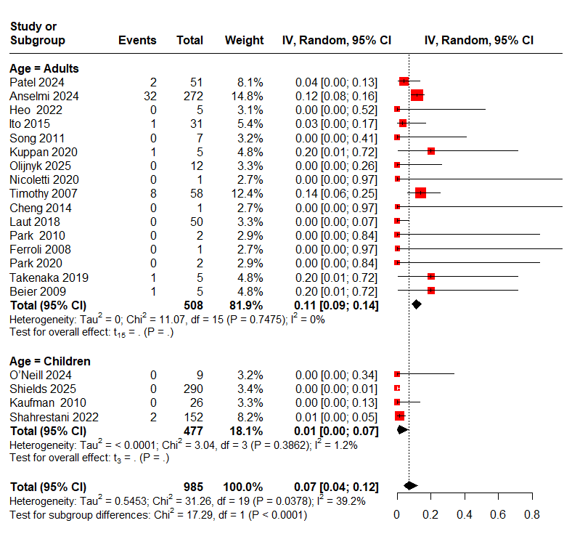 Figure S1: The overall pooled incidence of postoperative CSF leakage in spine surgery, stratified by population.

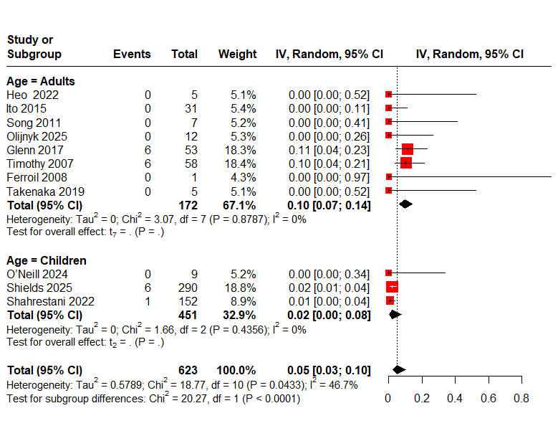Figure S2: The overall pooled incidence of postoperative infection in spine surgery, stratified by population.
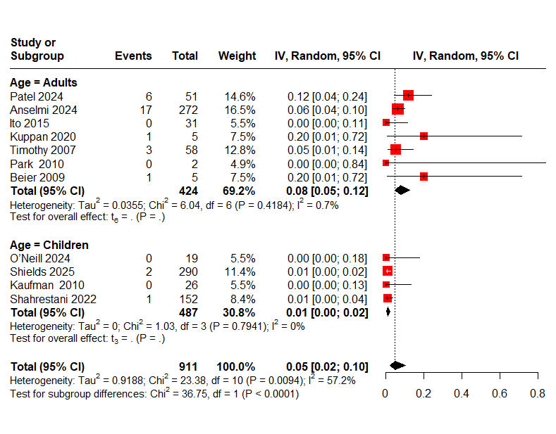
Figure S3: The overall pooled incidence of reoperation rate in spine surgery, stratified by population.

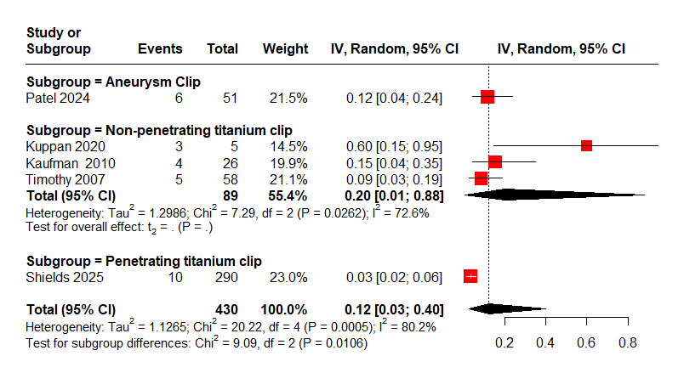
Figure S4: The overall pooled incidence of CSF leakage-related complications in spine surgery, stratified by clip type.

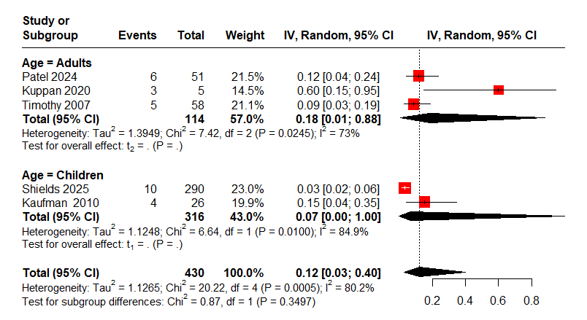
Figure S5: The overall pooled incidence of CSF leakage-related complications in spine surgery, stratified by population.

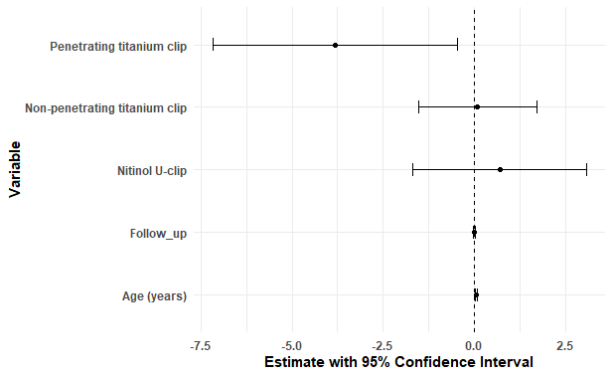

Figure S6: Meta-regression assessing the association of clip type, age, and follow-up duration with CSF leakage rates

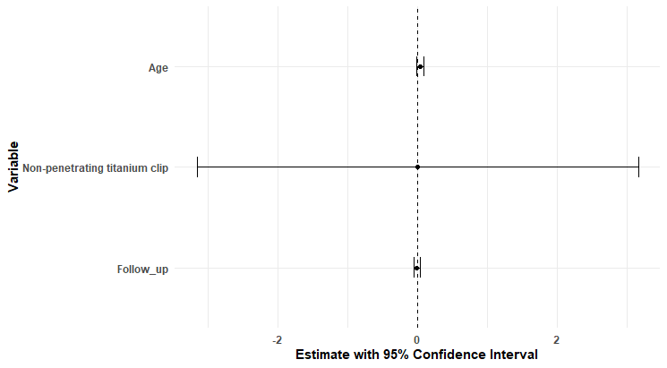

Figure S7: Meta-regression assessing the association of clip type, age, and follow-up duration with infection rates

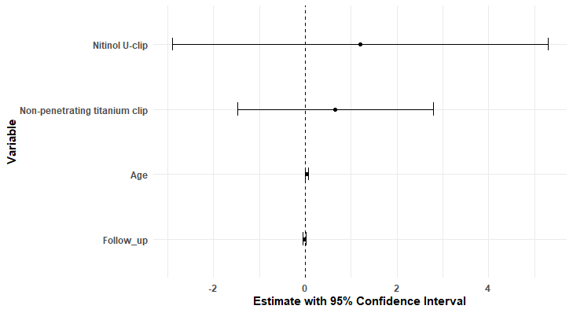
Figure S8: Meta-regression assessing the association of clip type, age, and follow-up duration with reoperation rates

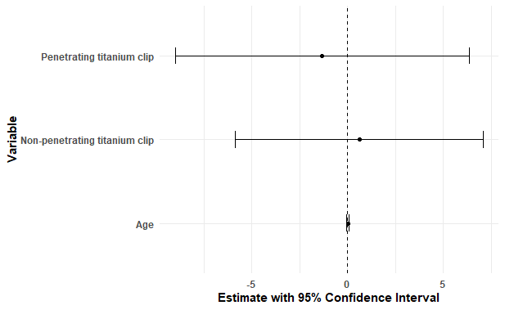
Figure S9: Meta-regression assessing the association of clip type, age, and follow-up duration with CSF leakage-related complication rates

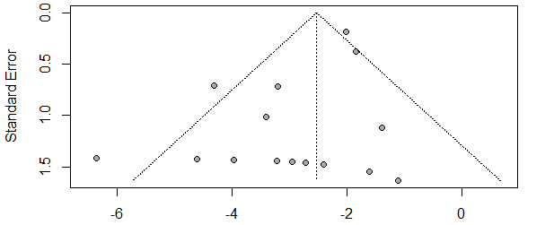
Figure S10: Funnel plot for postoperative CSF leakage in spine surgery.

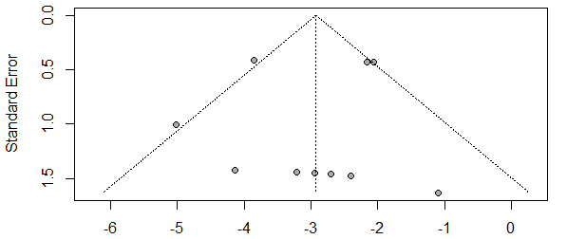 Figure S11: Funnel plot for postoperative infection in spine surgery.

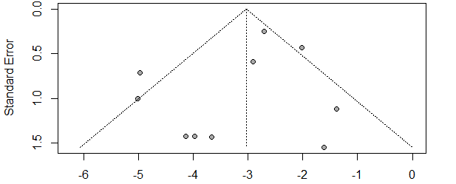
Figure S12: Funnel plot for reoperation rate in spine surgery.
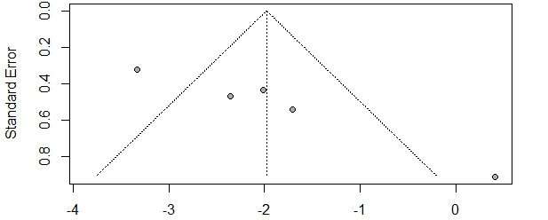 Figure S13: Funnel plot for CSF leakage-related complications in spine surgery.

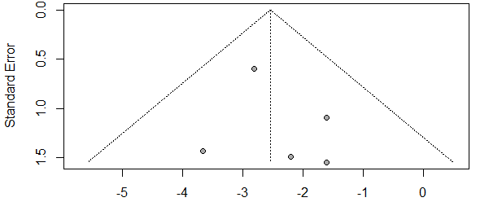
Figure S14: Funnel plot for postoperative CSF leakage in skull base surgery.
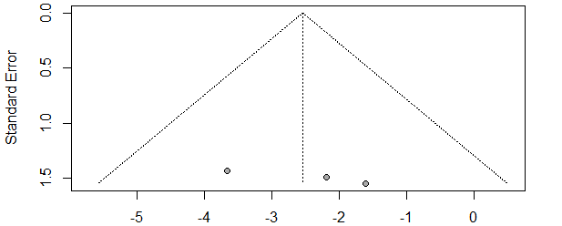 Figure S15: Funnel plot for postoperative infection in skull base surgery.

