Supplementary material 1: Antibiotic susceptibility profile

Patient presented polymicrobial spectrum of bacteria in tissue sample cultures (S. epidermidis + C. acnes), and further identification of S. epidermidis was performed using antibiotic susceptibility profiles. All profiles were identical.

Sample 1:

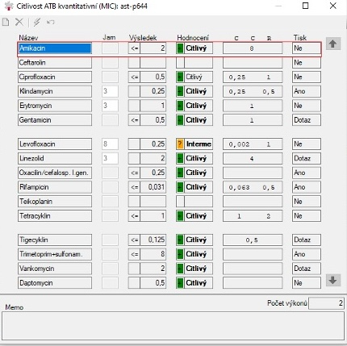

Sample 2:

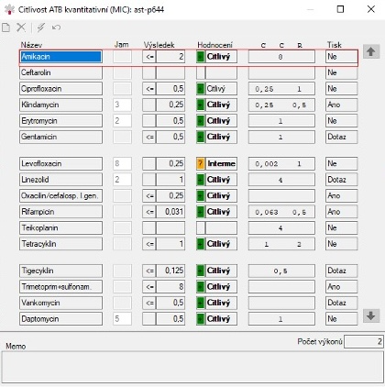

Sample 3:

