SUPPLEMENTARY MATERIAL 2 (Meta-analyses 1)
- Data

Supplementary table 1 – Cardiometabolic parameters in smokers vs. non-smokers (13 studies)

ID | Author | Year | Design | Country | Male (%) | Participants  (n) | Age | SBP | DBP | HbA1c | DM duration | HDL | BMI | TG | TC | Alb+ve Smoker | Alb-ve  Smoker | Alb+ve non-smoker | Alb-ve non-smoker
S03 | Bentata | 2016 | Prospective | Morocco | NS | 671 | 65.00 | NS | NS | 8.3 | 8.5 | NS | 27.56 | 1.53 | NS | 67 | 14 | 453 | 137
S05 | Bruno | 2003 | Prospective | Italy | 38 | 1103 | 67.50 | 154.26 | 87.50 | 8.03 | 10.30 | 1.44 | 27.55 | NS | 5.81 | 60 | 89 | 254 | 454
S06 | Cederholme | 2005 | Cross-sectional | Sweden | 59 | 15139 | 66.56 | 143.82 | 78.37 | 6.61 | 8.61 | NS | 28.82 | 1.86 | 5.17 | 366 | 2177 | 1309 | 11287
S10 | Corradi | 1993 | Cross-sectional | Italy | 100 | 90 | NS | 161.71 | 101.76 | 7.65 | NS | NS | NS | NS | NS | 29 | 15 | 17 | 29
S11 | Forsblom | 1998 | Prospective | Finland | 61 | 108 | 66.00 | 156.69 | 86.31 | 11.65 | 17.95 | 1.25 | 28.14 | NS | 5.92 | 29 | 7 | 2 | 52
S12 | Gambaro | 2001 | Prospective | Italy | 55 | 273 | 65.00 | NS | NS | 9.00 | 13.00 | NS | 27.95 | 1.88 | 6.09 | 20 | 52 | 17 | 117
S14 | Hsu | 2010 | Prospective | Taiwan | 100 | 509 | 54.70 | 128.96 | 81.38 | 8.13 | 4.90 | NS | 25.76 | 2.06 | 4.91 | 71 | 120 | 59 | 184
S16 | Kanauchi | 1998 | Cross-sectional | Japan | 46 | 155 | 65.00 | NS | NS | 7.26 | 13.50 | NS | 22.96 | NS | NS | 28 | 16 | 50 | 61
S17 | Klein | 1993 | Cross-sectional | USA | NS | 376 | NS | NS | NS | NS | NS | NS | NS | NS | NS | 21 | 32 | 16 | 184
S26 | Savage | 1995 | Cross-sectional | USA | 61 | 931 | 58.28 | 146.52 | 91.29 | 11.64 | 9.00 | NS | 30.50 | 3.26 | 5.70 | 115 | 149 | 92 | 138
S28 | Tseng | 2010 | Prospective | Taiwan | 55.3 | 519 | 58.43 | 132.34 | 82.87 | 7.98 | 9.75 | 1.24 | 24.88 | NS | 5.38 | 102 | 97 | 138 | 182
S30 | West | 1980 | Prospective | USA | NS | 973 | NS | NS | NS | NS | 6.85 | NS | NS | NS | NS | 129 | 194 | 198 | 223
S31 | Yoem | 2016 | Cross-sectional | Korea | 100 | 629 | 62.51 | 126.09 | NS | NS | 9.12 | NS | 24.30 | NS | NS | 106 | 208 | 19 | 71

- Model – Random effect meta-analysis model without moderator

Meta-analysis regression was conducted accounting for important moderator variables recorded in these studies. First, a random effect model was fitted to assess the risk of developing Albuminuria for the smoker and non-smoker groups.

Abbreviations
- Alb+ve – Albuminuria positive
- Alb-ve – Albuminuria negative
- NS – not specified
- CI – confidence interval
- LB – Lower boundary
- UB – upper boundary
- Parameters

- tau^2: Estimated amount of residual heterogeneity
- tau: square root of estimated tau^2 value
- I^2: residual heterogeneity / unaccounted variability
- H^2: unaccounted variability / sampling variability
- R^2: amount of heterogeneity accounted for
- QE: Statistic to test for Residual Heterogeneity
- QM: Statistic to test Moderators

- Model outputs
Total number of studies 13 (Supplementary table 1)
Parameters | Estimate | ci.lb | ci.ub
Tau^2 | 0.6851 | 0.3783 | 3.8372
Tau | 0.8277 | 0.6150 | 1.9589
I^2(%) | 94.7179 | 90.6594 | 98.9946
H^2 | 18.5801 | 10.7060 | 99.4634

QE = 76.59636; p-value = 1.832091e-11

 | estimate | se | z-val | p-val | ci.lb | ci.ub
intrcept | 0.7569 | 0.2462 | 3.0741 | 0.0021 | 0.2743 | 1.2395

- Test for funnel plot asymmetry
Regression Test for Funnel Plot Asymmetry
Model: weighted regression with multiplicative dispersion
predictor: standard error
test for funnel plot asymmetry: t = 2.0677, df = 11, p = 0.0630

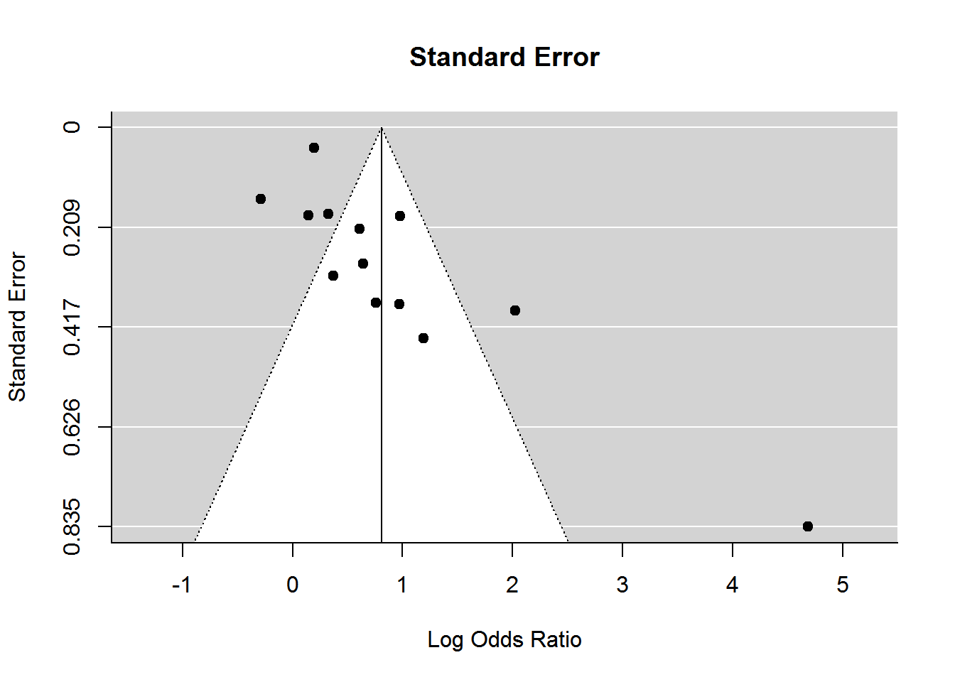

Figure 2: Funnel plot exploring publication bias

- Summary

We fitted different mixed effect meta-regression models to assess if the residual heterogeneity is influenced by different moderator variables.
The following sections include the model outcomes from the Random Effect Meta-Regression model without Moderator and Mixed Effect Meta-Regression models with different Moderators.
The results from the meta-regression output suggest that the risk of Albuminuria positive in the smoker is significantly higher; the risk if almost 2.2 times higher in the smoker group compared with the non-smoker group.
The moderator variables explored were: age, male sex, SBP, DBP, HbA1c, duration of T2DM, HDL, BMI, triglyceride and total cholesterol.
The results did not suggest that the risk of albuminuria was associated with any of the above moderator variables except the duration of type 2 diabetes when the model was adjusted for smoking status. For the variable of the duration of T2DM, each year increase in duration of T2DM increased the likelihood of albuminuria by 1.2 times (95% confidence interval: 1.09, 1.38).

We carried out meta-analyses to explore the relationship between cardiometabolic parameters. For continuous data, random effect model with inverse variance was used. The outcome measure was expressed in mean difference with 95% confidence interval. For dichotomous data, the data was analysed using random effect, and Mantel-Haenszel method and the outcome was expressed in odds ratio with 95% confidence interval. For continuous data, an inverse variance and random effects model was fitted.

Age and albuminuria

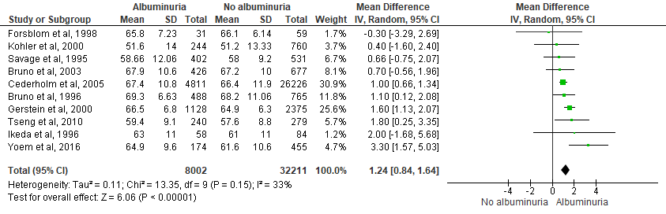

Male sex and albuminuria

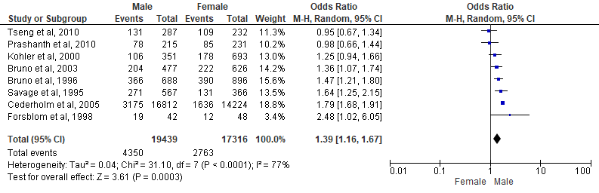

Systolic blood pressure (SBP) and albuminuria

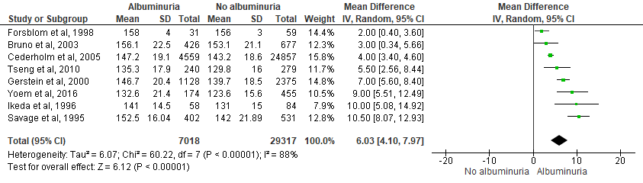

Diastolic blood pressure (DBP) and albuminuria

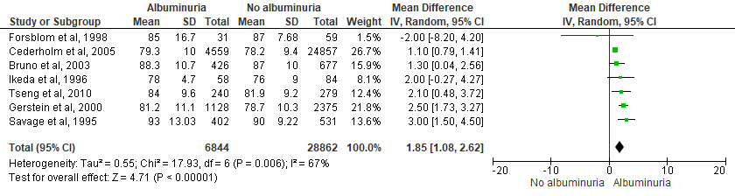

Glycosylated haemoglobin (HbA1c) and albuminuria

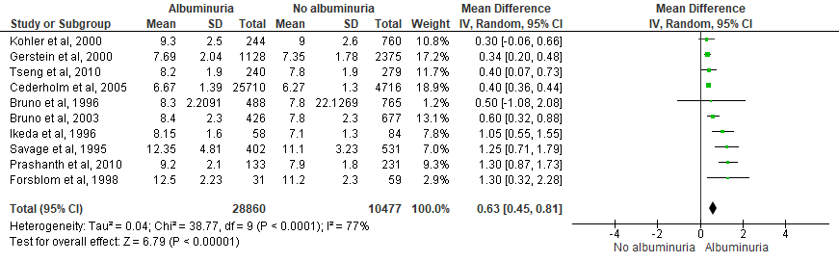

Body mass index (BMI) and albuminuria

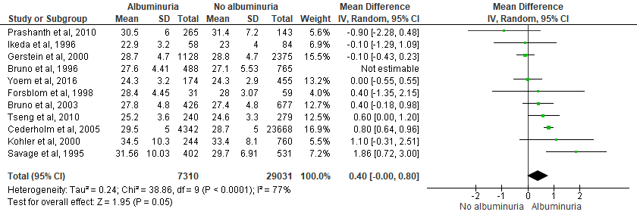

Total cholesterol (TC) and albuminuria

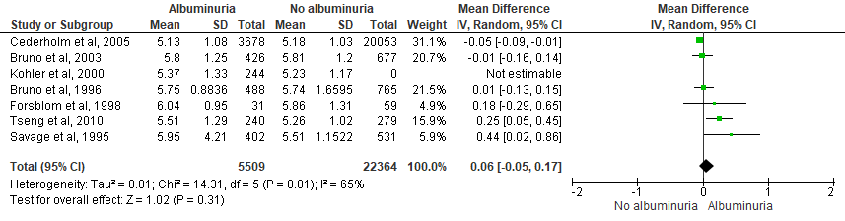

Triglyceride and albuminuria

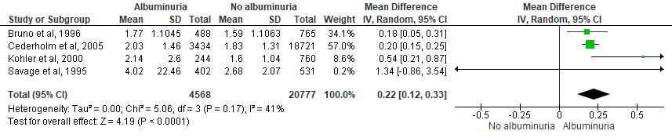

High-density lipoprotein (HDL) cholesterol and albuminuria

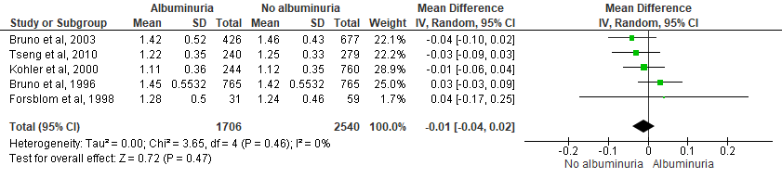

Duration of type 2 diabetes mellitus and albuminuria

