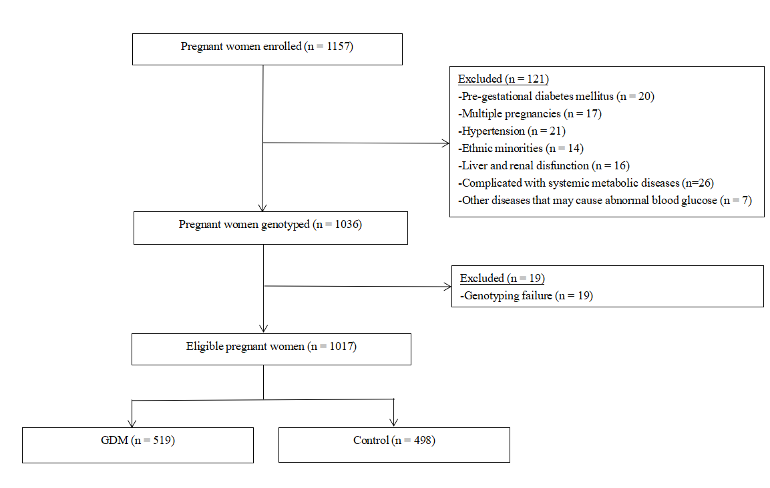
Supplementary Figure S1 The participant flowchart

Supplementary Table S1 The Hardy-Weinberg's expectation test of GCKR rs1260326, ADIPOQ rs266729, and rs1501299 in the GDM patients and controls
Single nucleotide polymorphism | Patients |  | Controls
Single nucleotide polymorphism | χ2 | p | χ2 | p
rs1260326 | 0.980 | 0.322 | 0.113 | 0.737
rs266729 | 0.054 | 0.816 | 0.804 | 0.370
rs1501299 | 0.116 | 0.733 | 0.150 | 0.699
p, p value

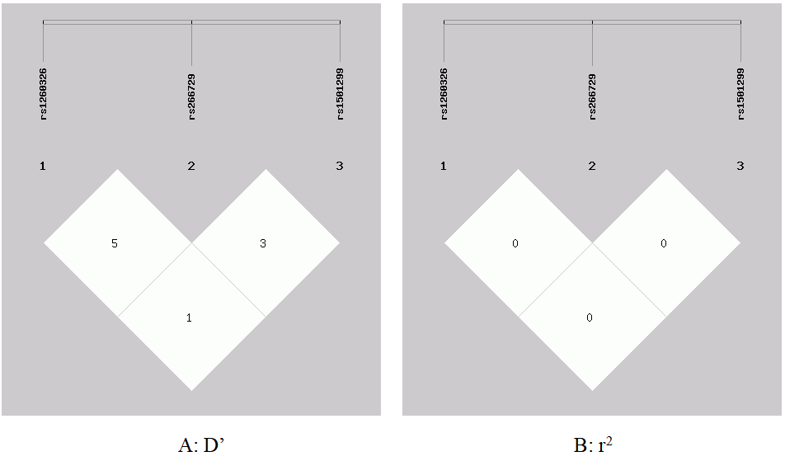
Supplementary Figure S2 Linkage disequilibrium analyses of rs1260326, rs266729, and rs1501299 SNPs in the GDM patients and controls

