Supplementary Figures

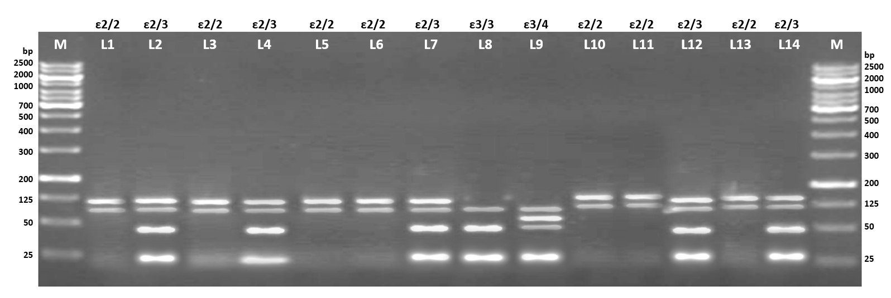
Figure 1: The picture depicts the genotype patterns observed for the 227bp APOE gene PCR product digested using Hha-I restriction enzyme, run on 3% agarose gel. The Lane 1 to Lane 14 marked as L1, L2, L3…L14 represent the series of randomly picked sample IDs confirmed for APOE polymorphisms. To verify the presence of specific genotype patterns of APOE variants: E2/2 - 104bp and 91bp; E3/3 - 91bp, 53bp and 32bp; E4/4 - 72bp, 53bp and 32bp; E2/3 - 104bp, 91bp, 53bp and 32bp; E3/4 - 91bp, 72bp, 53bp and 32bp; E2/4 - 104bp, 91bp, 72bp, 53bp and 32bp, were confirmed.

