Microvascular disease and severe COVID-19 outcomes in UKBiobank participants with diabetes
Supplementary material
Contents
Demographic details for study cohort 1
Relationship between DR & microvascular disease and codes 2
Accounting for code recency 3
Modelling relationships 3
Missing data 4
Additional Analyses 4

Demographic details for study cohort
Table 4 Descriptive statistics for UKBiobank participants with diabetes according to whether they had COVID-19 and the primary outcome
 | No +ve COVID-19 test | 1 or more +ve COVID-19 test
 | No +ve COVID-19 test | Without 1y outcome | 1y outcome
Total | 47,353 (95%) | 1,989 (4%) | 489 (1%)
Sex
Female | 20,768 (44%) | 831 (42%) | 154 (31%)
Male | 26,585 (56%) | 1,158 (58%) | 335 (69%)
Age, years (sd) | 71·4 (7·4) | 68·8 (8·2) | 73·7 (7)
BMI, kg/m² (sd) | 30·9 (5·7) | 31·7 (5·8) | 32·1 (6·1)
Ethnic group
asian | 2,790 (6%) | 224 (11%) | 36 (7%)
black | 1,535 (3%) | 102 (5%) | 23 (5%)
mixed/other | 1,127 (2%) | 68 (3%) | 8 (2%)
unknown | 414 (1%) | 18 (1%) | 11 (2%)
white | 41,487 (88%) | 1,577 (79%) | 411 (84%)
Deprivation quintile
1 (lowest) | 17,827 (38%) | 587 (30%) | 138 (28%)
2 | 9,983 (21%) | 374 (19%) | 81 (17%)
3 | 7,755 (16%) | 383 (19%) | 89 (18%)
4 | 7,572 (16%) | 415 (21%) | 110 (22%)
5 (highest) | 4,146 (9%) | 226 (11%) | 71 (15%)
unknown | 70 (0%) | 4 (0%) | NA (0%)
Smoking status
ever smoked | 24,124 (51%) | 1,010 (51%) | 305 (62%)
never smoked | 22,749 (48%) | 958 (48%) | 175 (36%)
unknown | 480 (1%) | 21 (1%) | 9 (2%)
Diabetes duration, years (sd) | 13·7 (10·6) | 13·5 (10·5) | 13·9 (11·4)
Abbreviations: 1y= primary, BMI = Body Mass Index, sd = standard deviation

Relationship between DR & microvascular disease and codes
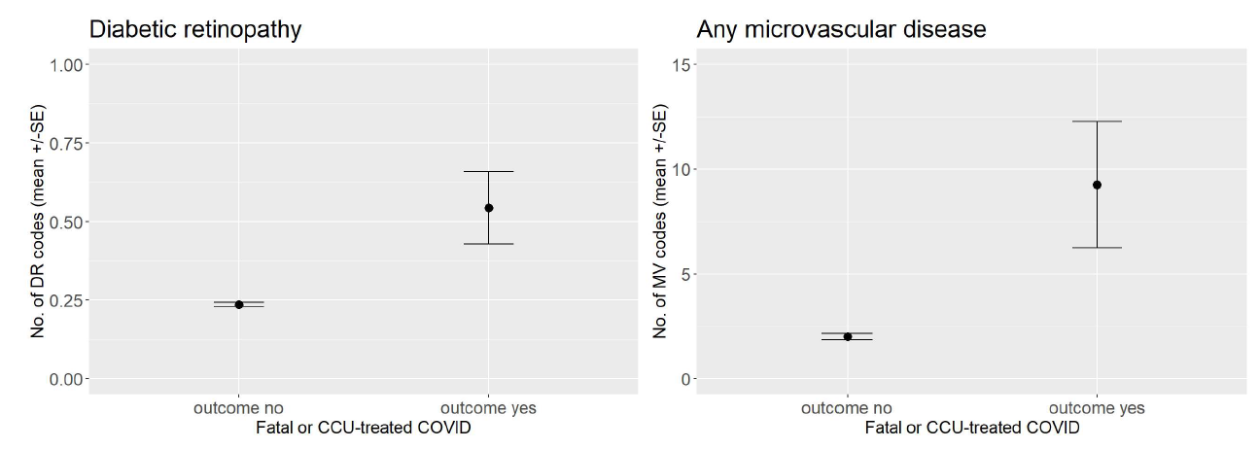
Figure 3 No of diagnostic codes for DR (left) or any microvascular disease (right) by study outcome

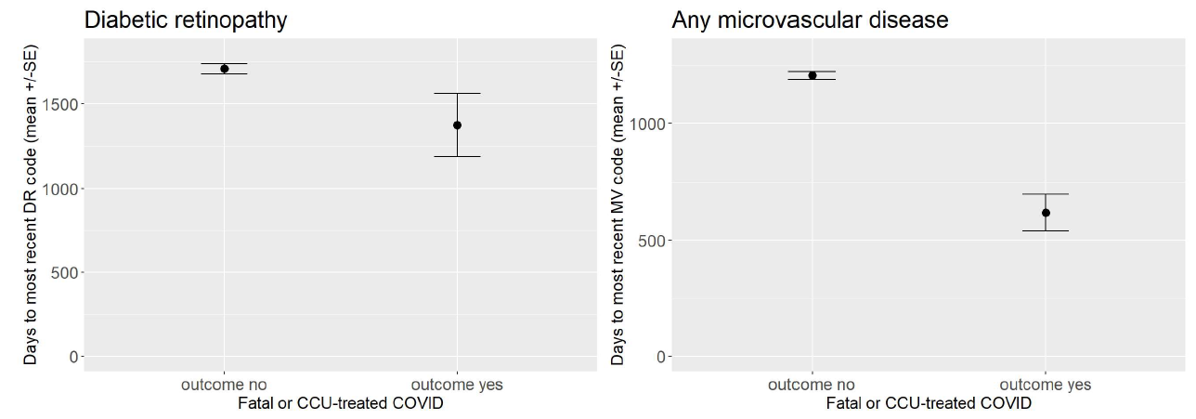
Figure 4 Days to most recent diagnostic code for DR (left) or any microvascular disease (right) by study outcome

Accounting for code recency
Transformed time to most recent code: value is given by $f\left(t\right)=\frac{1}{2}\left(1+\cos\left(π×\frac{t}{10}\right)\right)×\left(1-0·25\right)+0·25$ where t is the time since the given code in years (Figure 5).
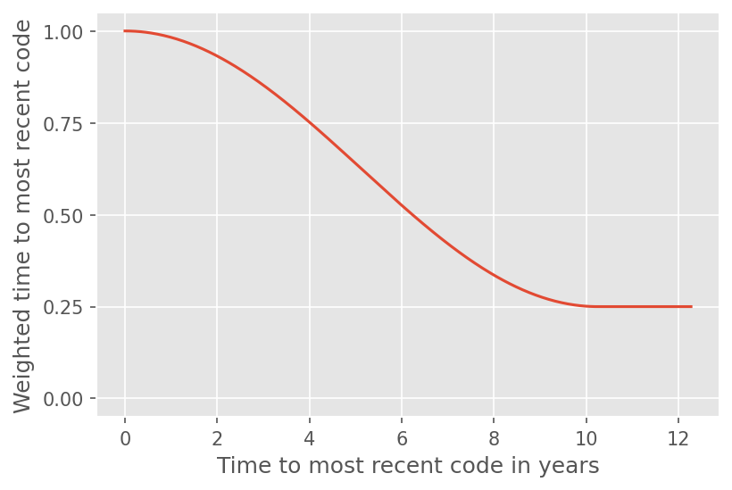
Figure 5 Weighted time to most recent code

Modelling relationships

The commonly used AIC expresses that each additional parameter should improve the log likelihood by at least 1. The relative likelihood of the two models is given by $\exp\left(\frac{AIC_{Binary}-AIC_{Weighted}}{2}\right)$. Thus, the model with weighted comorbidity coding is $\exp\left(\frac{8}{2}\right)≈54·6$ times more likely when optimising for BIC and $\exp\left(\frac{11}{2}\right)≈244·7$ more likely when optimising for AIC. Thus, the observed improvements can be considered meaningful.

Table 5 Results of stepwise selection with different comorbidity encodings using BIC as criterion
 | No of variables selected | Selected variables | Best BIC | Best AIC
Weighted time | 4 | respiratory system disease (weighted), microvascular disease (weighted), diabetic ketoacidosis (weighted), chronic liver disease (weighted) | 2258·0 | 2211·0
Binary | 4 | respiratory system disease, microvascular disease, chronic liver disease, diabetic ketoacidosis | 2266·0 | 2220·0
Count | 4 | heart disease (weighted), chronic liver disease (weighted), immunodeficiency (weighted), hypoglycaemia (weighted) | 2290·0 | 2243·0
Time to most recent | 3 | nervous system disease (weighted), heart disease (weighted), chronic liver disease (weighted) | 2309·0 | 2268·0
Abbreviations: AIC = Akaike Information Criterion, BIC = Bayesian Information Criterion

Table 6 Results of stepwise selection with different comorbidity encodings using AIC as criterion
 | No. of variables selected | Selected variables | Best BIC | Best AIC
Weighted time | 9 | respiratory system disease (weighted), microvascular disease (weighted), diabetic ketoacidosis (weighted), chronic liver disease (weighted), foot ulcer (weighted), hypoglycaemia (weighted), peripheral arterial disease (weighted), immunodeficiency (weighted), nervous system disease (weighted) | 2279·0 | 2203·0
Binary | 9 | respiratory system disease, microvascular disease, chronic liver disease, diabetic ketoacidosis, hypoglycaemia, foot ulcer, peripheral arterial disease, nervous system disease, nephropathy | 2290·0 | 2214·0
Count | 8 | heart disease (weighted), chronic liver disease (weighted), immunodeficiency (weighted), hypoglycaemia (weighted), nervous system disease (weighted), respiratory system disease (weighted), diabetic ketoacidosis (weighted), neuropathy (weighted) | 2306·0 | 2236·0
Time to most recent | 5 | nervous system disease (weighted), heart disease (weighted), chronic liver disease (weighted), nephropathy (weighted), foot ulcer (weighted) | 2316·0 | 2264·0
Abbreviations: AIC = Akaike Information Criterion, BIC = Bayesian Information Criterion

Missing data

Table 7 Missing rate and imputed values
 | missing | median | mode
sex | 0% | ·· | ··
age | 0% | ·· | ··
admSince98 | 0% | ·· | ··
diab_dur | 0% | ·· | ··
eth1stAss | 0·36% | ·· | British
ethRecode | 0·36% | ·· | white
smoke1stAss | 0·36% | ·· | Never
townsendDep | 0·15% | -1·35 | ··
townsendQ | 0·15% | ·· | 1 (lowest)
bmi1stAss | 1·07% | 27·59 | ··
bmiCat | 1·07% | ·· | overweight
bpSys | 0·52% | 136·0 | ··
bpCat | 0·52% | ·· | normal BP

Additional Analyses
Akaike Information Criterion (AIC) and Bayesian Information Criterion (BIC)
- AIC = 2p - 2 log likelihood
- BIC = p * ln(n) - 2 log likelihood
where p is the number of parameters that we fit, and n is the number of samples. So both AIC/BIC are measures of model fit adjusted for the number of parameters. BIC is typically much more conservative.

McGurnaghan et al use a "stringent" non-standard version of the AIC with a penalty of 4p, i.e. twice as high as standard AIC. ⁴ From their appendix:
The documentation they reference with [4] notes that only 2p gives "genuine AIC".

For simple baseline, we select log(adm) first, which is what we would expect. However, both respiratory and microvascular disease still make the cut.
For extended baseline, we only select respiratory and microvascular disease but no other columns – which also makes sense, as the most informative columns are already in the extended baseline.
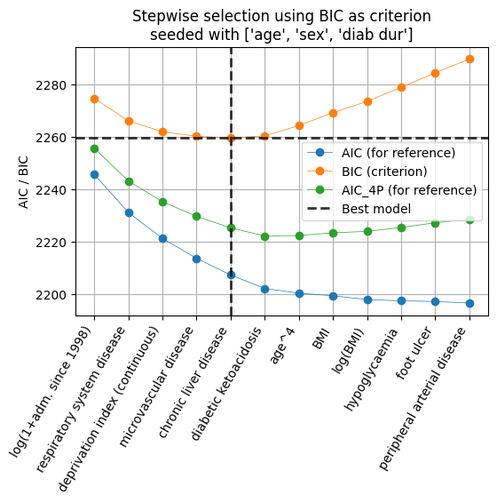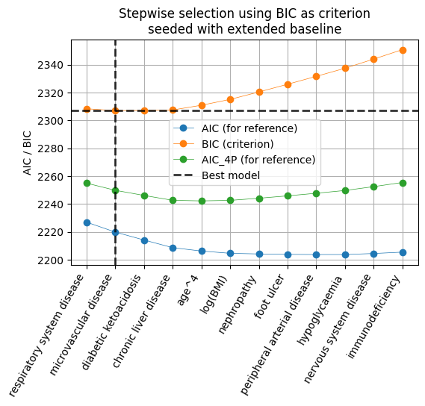
Figure 6 Stepwise selection considering all columns (rather than just comorbidities, simple (left) and extended (right) baseline

Table 8 Static comparisons – simple baseline with number of admissions (log)
 | Log-Likelihood | AIC | BIC | n (comorbidity) | BIC delta over baseline
respiratory system disease | -1110 | 2231 | 2266 | 1011 | -9
microvascular disease | -1113 | 2237 | 2272 | 619 | -3
chronic liver disease | -1112 | 2237 | 2272 | 263 | -3
chronic kidney disease | -1113 | 2239 | 2274 | 406 | -1
Nothing (just baseline) | -1118 | 2246 | 2275 | 0 | 0
diabetic ketoacidosis | -1114 | 2240 | 2275 | 42 | 0
hypoglycaemia | -1114 | 2241 | 2276 | 148 | 1
nephropathy | -1115 | 2243 | 2278 | 53 | 3
nervous system disease | -1116 | 2244 | 2279 | 486 | 4
peripheral arterial disease | -1116 | 2245 | 2280 | 131 | 5
diabetic retinopathy | -1117 | 2247 | 2281 | 225 | 6
neuropathy | -1117 | 2247 | 2282 | 153 | 7
foot ulcer | -1118 | 2248 | 2282 | 59 | 7
immunodeficiency | -1117 | 2247 | 2282 | 28 | 7
stroke | -1118 | 2248 | 2283 | 204 | 8
heart disease | -1118 | 2248 | 2283 | 1871 | 8

Table 9 Static comparisons - extended baseline without number of admissions (log)
 | Log-Likelihood | AIC | BIC | n (comorbidity) | BIC delta over baseline
respiratory system disease | -1112 | 2251 | 2326 | 1011 | -29
microvascular disease | -1117 | 2259 | 2335 | 619 | -20
chronic kidney disease | -1119 | 2264 | 2340 | 406 | -15
chronic liver disease | -1120 | 2267 | 2342 | 263 | -13
hypoglycaemia | -1122 | 2270 | 2346 | 148 | -9
nervous system disease | -1122 | 2270 | 2346 | 486 | -9
nephropathy | -1125 | 2277 | 2352 | 53 | -3
diabetic ketoacidosis | -1125 | 2276 | 2352 | 42 | -3
Nothing (just baseline) | -1131 | 2285 | 2355 | 0 | 0
peripheral arterial disease | -1127 | 2280 | 2356 | 131 | 1
heart disease | -1127 | 2281 | 2356 | 1871 | 1
neuropathy | -1128 | 2281 | 2357 | 153 | 2
diabetic retinopathy | -1129 | 2283 | 2359 | 225 | 4
stroke | -1130 | 2286 | 2361 | 204 | 6
immunodeficiency | -1130 | 2285 | 2361 | 28 | 6
foot ulcer | -1131 | 2287 | 2363 | 59 | 8

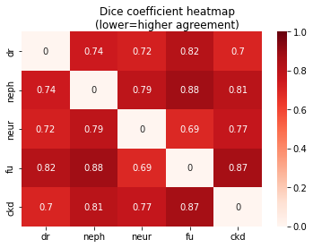
Figure 7 Dice coefficient heatmap of different comorbidities

