Supplementary materials

Supplementary Figure 1. Distribution of DCS and GS in the study population and amongst those with T2D, stratified by sex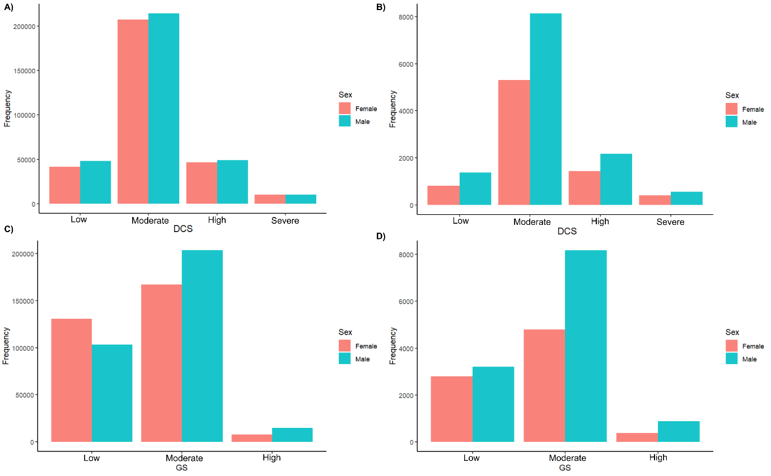
Supplementary Figure 1 legend. Panel A) DCS distribution in the study population. Panel B) DCS distribution in those with T2D. Panel C) GS distribution in the study population. Panel D) GS distribution in those with T2D. Abbreviations: DCS = Dental caries score, GS = Gingivitis score, T2D = Type 2 diabetes.

Supplementary Figure 2. The distribution of GS by DCS in the study population and amongst those with T2D, stratified by sex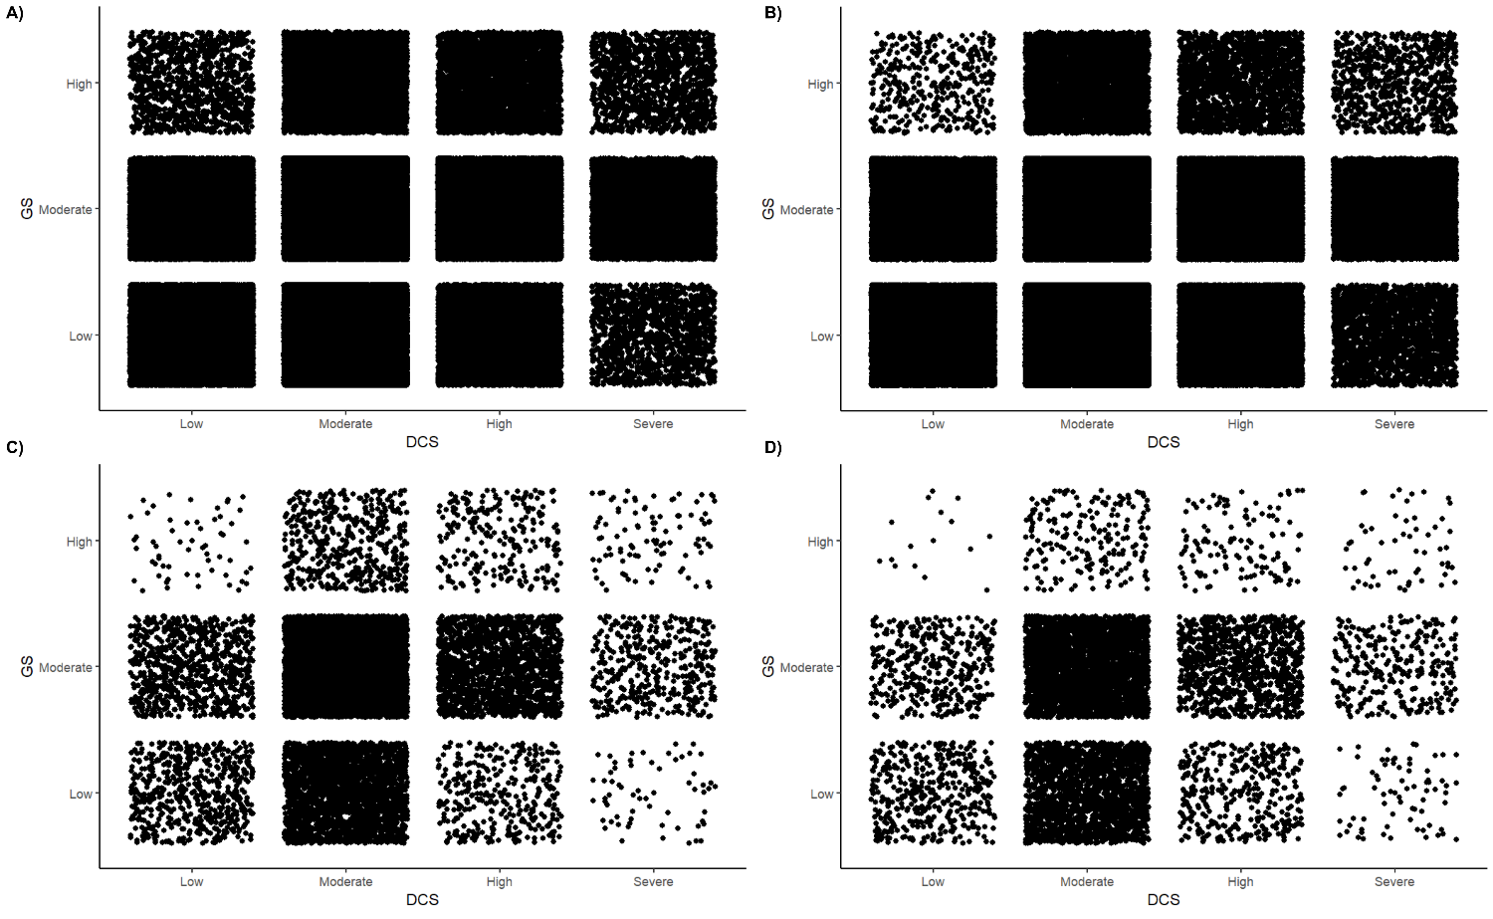
Supplementary Figure 2 legend. Panel A) Distribution of GS by DCS in the male study population. Panel B) Distribution of GS by DCS in the female study population. Panel C) Distribution of GS by DCS in males with T2D. Panel D) Distribution of GS by DCS in females with T2D. Abbreviations: DCS = Dental caries score, GS = Gingivitis score, T2D = Type 2 diabetes.

Supplementary Table 1. Unadjusted estimates for the association between T2D and childhood caries and gingivitis
 | Males |  | Females
 | HR (CI) | P | HR (CI) | P
No age restriction
DCS: Low | 1.00 (ref) | - | 1.00 (ref) | -
Moderate | 1.18 (1.12; 1.13) | < 0.001 | 1.16 (1.07; 1.24) | < 0.001
High | 1.27 (1.19; 1.36) | < 0.001 | 1.28 (1.17; 1.39) | < 0.001
Severe | 1.42 (1.29; 1.57) | < 0.001 | 1.52 (1.35; 1.72) | < 0.001
GS: Low | 1.00 (ref) | - | 1.00 (ref) | -
Moderate | 1.30 (1.18; 1.35) | < 0.001 | 1.32 (1.26; 1.39) | < 0.001
High | 1.82 (1.69; 1.97) | < 0.001 | 2.22 (1.99; 2.47) | < 0.001
Age < 40
DCS: Low | 1.00 (ref) | - | 1.00 (ref) | -
Moderate | 1.12 (1.00; 1.26) | 0.04 | 1.03 (0.93; 1.15) | 0.58
High | 1.10 (0.96; 1.27) | 0.17 | 1.04 (0.90; 1.19) | 0.62
Severe | 1.16 (0.93; 1.44) | 0.19 | 1.22 (0.99; 1.49) | 0.05
GS: Low | - | - | - | -
Moderate | 1.37 (1.25; 1.49) | < 0.001 | 1.25 (1.16; 1.35) | < 0.001
High | 2.15 (1.85; 2.51) | < 0.001 | 2.29 (1.93; 2.72) | < 0.001
Age ≥ 40
DCS: Low | 1.00 (ref) | - | 1.00 (ref) | -
Moderate | 1.20 (1.13; 1.29) | < 0.001 | 1.27 (1.14; 1.40) | < 0.001
High | 1.33 (1.23; 1.44) | < 0.001 | 1.48 (1.32; 1.66) | < 0.001
Severe | 1.51 (1.35; 1.69) | < 0.001 | 1.76 (1.51; 2.05) | < 0.001
GS: Low | 1.00 (ref) | - | 1.00 (ref) | -
Moderate | 1.28 (1.22; 1.34) | < 0.001 | 1.37 (1.29; 1.46) | < 0.001
High | 1.73 (1.59; 1.89) | < 0.001 | 2.18 (1.90; 2.50) | < 0.001
Supplementary Table 1 legend. Abbreviations: CI = 95% confidence interval, DCS = Dental caries score, GS = Gingivitis score, HR = Hazard ratios.

Supplementary Table 2. The association between T2D and childhood caries and gingivitis used as continuous variables
 | Males |  | Females
 | HR (CI) | P | HR (CI) | P
Unadjusted
dmft/DMFT | 1.01 (1.01; 1.02) | < 0.001 | 1.02 (1.01; 1.03) | < 0.001
Gingivitis index score | 1.09 (1.08; 1.09) | < 0.001 | 1.10 (1.10; 1.11) | < 0.001
Adjusted*
dmft/DMFT | 1.00 (0.99; 1.00) | 0.47 | 1.01 (1.00; 1.01) | 0.04
Gingivitis index score | 1.07 (1.06; 1.08) | < 0.001 | 1.08 (1.07; 1.09) | < 0.001
Supplementary Table 2 legend. *Highest achieved level of education between ages 25 and 30 used as strata. Abbreviations: CI = 95% confidence interval, dmft/DMFT = highest registered number decayed, missing or filled teeth in either the temporary or permanent dentition, HR = Hazard ratios.

Supplementary Table 3. Interaction analyses of the association between T2D and the highest registered DCS and GS at any point in time in SCOR.
 | Males |  | Females
 | HR (CI) | P | HR (CI) | P
No age-restriction
DCS: Low | 1.00 (ref) | - | 1.00 (ref) | -
Moderate | 1.13 (0.88; 1.02) | 0.01 | 1.09 (0.98; 1.21) | 0.11
High/Severe | 1.11 (0.90; 1.26) | 0.12 | 1.18 (1.03; 1.36) | 0.02
GS: Low | 1.00 (ref) | - | 1.00 (ref) | -
Moderate/High | 1.32 (1.18; 1.47) | < 0.001 | 1.39 (1.21; 1.59) | < 0.001
DCS×GS: | - | - | - | -
Moderate×Moderate/High | 0.99 (0.83; 1.06) | 0.25 | 0.91 (0.78; 1.05) | 0.19
High/Severe×Moderate/High | 0.97 (0.83; 1.14) | 0.93 | 0.89 (0.75; 1.06) | 0.21
Age < 40
DCS: low | 1.00 (ref) | - | 1.00 (ref) | -
Moderate | 1.16 (0.96; 1.41) | 0.14 | 1.07 (0.91; 1.25) | 0.04
High/Severe | 0.99 (0.75; 1.33) | 0.99 | 0.99 (0.79; 1.24) | 0.92
GS: low | 1.00 (ref) | - | 1.00 (ref) | -
Moderate/Severe | 1.53 (1.24; 1.89) | < 0.001 | 1.47 (1.21; 1.79) | < 0.001
DCS×GS: | - | - | - | -
Moderate×Moderate/High | 0.83 (0.65; 1.05) | 0.11 | 0.79 (0.63; 0.98) | 0.03
High/Severe×Moderate/High | 0.91 (1.66; 1.26) | 0.58 | 0.84 (0.64; 1.11) | 0.22
Age ≥ 40
DCS: low | 1.00 (ref) | - | 1.00 (ref) | -
Moderate | 1.12 (1.00; 1.24) | 0.04 | 1.12 (0.97; 1.29) | 0.12
High/Severe | 1.14 (0.98; 1.31) | 0.08 | 1.32 (1.11; 1.57) | 0.001
GS: low | 1.00 (ref) | - | 1.00 (ref) | -
Moderate/Severe | 1.25 (1.09; 1.41) | < 0.001 | 1.30 (1.08; 1.58) | 0.006
DCS×GS: | - | - | -
Moderate×Moderate/High | 0.98 (0.85; 1.12) | 0.75 | 1.02 (0.83; 1.25) | 0.87
High/Severe×Moderate/High | 1.04 (0.87; 1.23) | 0.69 | 0.95 (0.76; 1.19) | 0.68
Supplementary Table 3 legend. Using the highest achieved level of education (observed between 25-30 years) as strata. Testing at a 95% confidence level. Abbreviations: CI = confidence interval, DCS = dental caries score, GS = gingivitis score, HR = hazard ratio, P = p-value, ref = reference group.

Supplementary Table 4. Unadjusted estimates for the association of T2D with the age at the highest registered levels of oral disease, duration, and severity over time of dental caries and gingivitis
 | Males |  | Females
 | HR (CI) | P | HR (CI) | P
DC
Age at highest registered DCS
Below age 12 | 1.00 (ref) | - | 1.00 (ref) | -
Age 12 or above | 1.04 (0.87; 1.25) | 0.65 | 1.12 (0.91; 1.37) | 0.29
DCS over time
Low | 1.00 (ref) | - | 1.00 (ref) | -
Moderate | 1.44 (1.16; 1.78) | < 0.001 | 1.07 (0.77; 1.49) | 0.97
High - Severe | 1.49 (1.12; 2.05) | < 0.01 | 1.07 (0.93; 1.42) | 0.71
DC duration
Up to 2 periods in time | 1.00 (ref) | - | 1.00 (ref) | -
3 periods in time | 1.13 (0.94; 1.37) | 0.20 | 1.15 (0.93; 1.42) | 0.21
Gingivitis
Age at highest registered GS
Below age 12 | 1.00 (ref) | - | 1.00 (ref) | -
Age 12 or above | 1.27 (1.09; 1.47) | <0.01 | 1.41 (1.17; 1.69) | < 0.001
GS over time
Low | 1.00 (ref) | - | 1.00 (ref) | -
Moderate | 1.29 (1.09; 1.54) | <0.01 | 1.20 (1.01; 1.43) | 0.03
High | 1.94 (1.44; 2.60) | <0.001 | 1.71 (1.12; 2.59) | 0.01
Gingivitis duration
Up to 2 periods in time | 1.00 (ref) | - | 1.00 (ref) | -
3 periods in time | 1.29 (1.09; 1.51) | <0.01 | 1.11 (0.93; 1.31) | 0.24
Supplementary Table 4 legend. Testing at a 95% confidence level. Abbreviations: CI = confidence interval, DCS = dental caries score, GS = gingivitis score, HR = hazard ratio, P = p-value.

