Supplemental Material

Risk of Recurrent Acute Pancreatitis With GLP-1 Receptor Agonists After Prior Pancreatitis: a Systematic Review

Danielle L. Voltani,* Felipe G. Pinto,* Soemiwati Holland, MD†
*Pontifical Catholic University of Sao Paulo (PUC-SP), Sorocaba, Sao Paulo, Brazil
†Division of Endocrinology, Diabetes and Metabolism, Hackensack Meridian Health Jersey Shore University Medical Center, Neptune, New Jersey, United States of America; Hackensack Meridian School of Medicine, Clifton, New Jersey, United States of America

Content

Supplementary Tables……………….………………………………………………………...….2
Supplementary Figures………………......……………………………………………….………5
Prisma Checklist…………………………………………………………………………...………6

Supplementary Tables
Table S1 Database-specific search strategies used in the systematic review
Database | Search strategy
PubMed | (("glucagon-like peptide-1" OR "glucagon-like peptide-1 receptor agonists" OR "GLP-1 receptor agonist" OR "GLP-1 receptor agonist*" OR "GLP-1 receptor analogues" OR GLP1RA OR semaglutide OR liraglutide OR dulaglutide OR "incretin mimetic*" OR "incretin-based therap*" OR exenatide OR lixisenatide OR albiglutide OR Ozempic OR Wegovy OR Rybelsus OR Victoza OR Saxenda OR Trulicity OR Byetta OR Bydureon OR Adlyxin OR Tanzeum OR Mounjaro OR Zepbound) AND (pancreatitis OR "acute pancreatitis" OR "recurrent pancreatitis" OR "recurrent acute pancreatitis" OR RAP OR “pancreatitis relapse” OR "second episode of pancreatitis" OR "prior pancreatitis" OR "previous pancreatitis" OR "history of pancreatitis" OR "history of acute pancreatitis"))
Embase | (‘glucagon like peptide 1 receptor agonist’/exp OR ‘glucagon like peptide 1 receptor agonist’ OR ‘GLP-1 receptor agonist*’ OR GLP1RA OR semaglutide OR liraglutide OR dulaglutide OR exenatide OR lixisenatide OR albiglutide OR ‘incretin mimetic*’ OR ‘incretin based therap*’ OR Ozempic OR Wegovy OR Rybelsus OR Victoza OR Saxenda OR Trulicity OR Byetta OR Bydureon OR Adlyxin OR Tanzeum OR Mounjaro OR Zepbound) AND (‘pancreatitis’/exp OR pancreatitis OR ‘acute pancreatitis’ OR ‘recurrent pancreatitis’ OR ‘recurrent acute pancreatitis’ OR RAP OR ‘pancreatitis relapse’ OR ‘second episode of pancreatitis’ OR ‘prior pancreatitis’ OR ‘previous pancreatitis’ OR ‘history of pancreatitis’ OR ‘history of acute pancreatitis’)
Cochrane | (“glucagon-like peptide-1 receptor agonist*” OR “GLP-1 receptor agonist*” OR GLP1RA OR semaglutide OR liraglutide OR dulaglutide OR exenatide OR lixisenatide OR albiglutide OR “incretin mimetic*” OR “incretin-based therap*” OR Ozempic OR Wegovy OR Rybelsus OR Victoza OR Saxenda OR Trulicity OR Byetta OR Bydureon OR Adlyxin OR Tanzeum OR Mounjaro OR Zepbound) AND (pancreatitis OR “acute pancreatitis” OR “recurrent pancreatitis” OR “recurrent acute pancreatitis” OR RAP OR “pancreatitis relapse” OR “second episode of pancreatitis” OR “prior pancreatitis” OR “previous pancreatitis” OR “history of pancreatitis” OR “history of acute pancreatitis”)

Table S2 Definitions of pancreatitis and recurrent acute pancreatitis across included studies
Study | Acute pancreatitis | Recurrent acute pancreatitis
Lomeli 2024 | No acute pancreatitis diagnostic criteria were reported. | Any subsequent diagnosis of acute pancreatitis occurring in an individual who already has a known prior history of the condition.
Nassar 2025 | Definition was based in TriNetX database and patients who had the ICD-10-CM code K85 | The return or development of new episodes of acute pancreatitis in individuals who have previously experienced the condition or have a prior history of AP.
Steinberg 2017 | Three diagnostic criteria (typical pain, elevated serum pancreatic enzymes three times the upper limit of normal, and characteristic imaging findings) | When a patient with a prior history of pancreatitis experiences another acute event during a later observation period. A recurrent event was considered confirmed when it fulfilled the same Revised Atlanta criteria used for the initial diagnosis of acute pancreatitis, requiring at least two of the following three criteria: (1) severe acute upper abdominal pain consistent with pancreatitis; (2) serum amylase and/or lipase levels at least three times above the upper limit of normal (≥3× ULN); and/or (3) characteristic imaging findings on ultrasound, computed tomography, or magnetic resonance imaging demonstrating pancreatic inflammation.
Postlethwaite 2025 | No acute pancreatitis diagnostic criteria were reported. | New instance of acute pancreatitis (AP) occurring in a patient who has a prior history of the condition.

Table S3 Fully read studies and reasons for exclusion
Study | Reasons for exclusion | DOI or link
Dankner 2024 | Wrong outcome: recurrent acute pancreatitis was not evaluated | https://doi.org/10.1001/jamanetworkopen.2023.50408
Hsu 2025 | Wrong population: participants did not have a history of pancreatitis | https://doi.org/10.12659/msm.946935
Kushner | Wrong population: the published data do not report the treatment-arm distribution or treatment-specific outcomes among the participants with a history of prior pancreatitis. | https://doi.org/10.1002/oby.24222
Faillie 2013 | Wrong population: history of pancreatitis was reported only among participants who developed recurrent acute pancreatitis | https://doi.org/10.1007/s00592-013-0544-0
Calvarysky 2026 | Wrong population: patients with elevated lipase and those with a history of pancreatitis were not analyzed separately. | https://doi.org/10.1002/dmrr.70116

Table S4 References of studies included in the review
Study | References
Lomeli 2024 | Lomeli LD, Kodali AM, Tsushima Y, Mehta AE, Pantalone KM. The incidence of acute pancreatitis with GLP-1 receptor agonist therapy in individuals with a known history of pancreatitis. Diabetes Res Clin Pract. 2024;215:111806. doi:10.1016/j.diabres.2024.111806
Nassar 2025 | Nassar M, Abosheaishaa H, Misra A, Dandona P, Ghanim H, Chaudhuri A. Use of glucagon-like peptide-1 receptor agonists in people with history of acute pancreatitis: TriNetX analysis. Diabetes Metab. 2025;51(2):101613. doi:10.1016/j.diabet.2025.101613
Steinberg 2017 | Steinberg WM, Buse JB, Ghorbani MLM, et al. Amylase, Lipase, and Acute Pancreatitis in People With Type 2 Diabetes Treated With Liraglutide: Results From the LEADER Randomized Trial. Diabetes Care. 2017;40(7):966-972. doi:10.2337/dc16-2747
Postlethwaite 2025 | Postlethwaite R, Amin AM, Alsawas R, Almandoz JP, Sawas T. Predictors of acute pancreatitis in patients treated with GLP-1 receptor agonists for weight management. Pancreatology. 2025;25(5):609-613. doi:10.1016/j.pan.2025.06.018

Supplementary Figures
Fig. S1 Risk of bias assessment for the randomized study (RoB 2)
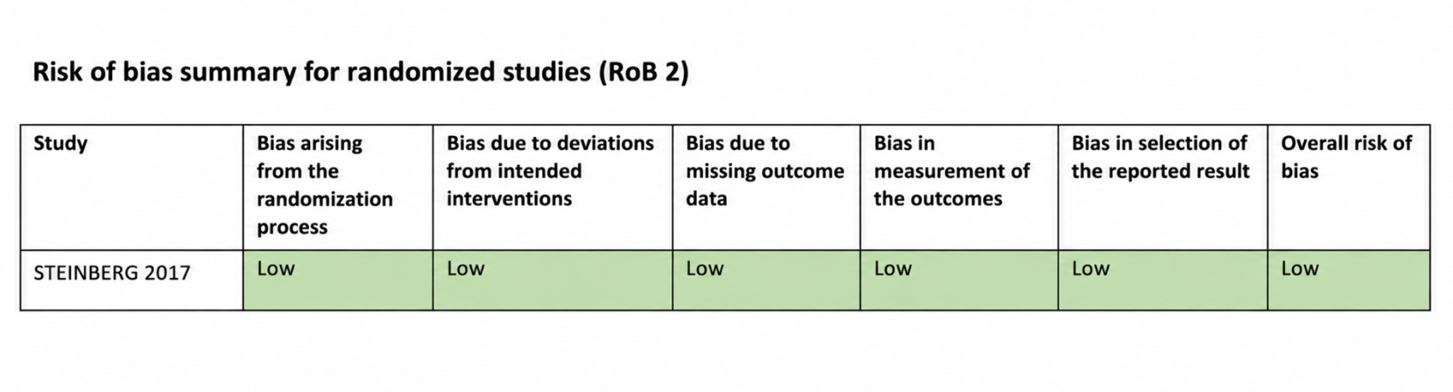

Fig. S2 Risk of bias assessment for non-randomized studies (ROBINS-I)
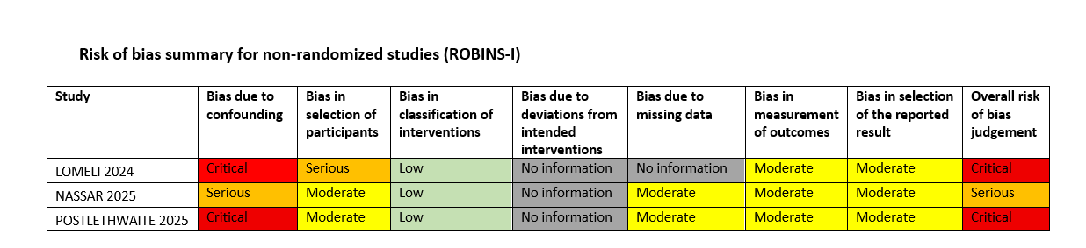

Prisma Checklist

Section and Topic | Item # | Checklist item | Reported on page:
TITLE
Title | 1 | Identify the report as a systematic review. | 1
ABSTRACT
Abstract | 2 | See the PRISMA 2020 for Abstracts checklist. | 2
INTRODUCTION
Rationale | 3 | Describe the rationale for the review in the context of existing knowledge. | 4-5
Objectives | 4 | Provide an explicit statement of the objective(s) or question(s) the review addresses. | 5
METHODS
Eligibility criteria | 5 | Specify the inclusion and exclusion criteria for the review and how studies were grouped for the syntheses. | 6
Information sources | 6 | Specify all databases, registers, websites, organisations, reference lists and other sources searched or consulted to identify studies. Specify the date when each source was last searched or consulted. | 6
Search strategy | 7 | Present the full search strategies for all databases, registers and websites, including any filters and limits used. | 6; Supplementary Table S1, p. 2
Selection process | 8 | Specify the methods used to decide whether a study met the inclusion criteria of the review, including how many reviewers screened each record and each report retrieved, whether they worked independently, and if applicable, details of automation tools used in the process. | 6
Data collection process | 9 | Specify the methods used to collect data from reports, including how many reviewers collected data from each report, whether they worked independently, any processes for obtaining or confirming data from study investigators, and if applicable, details of automation tools used in the process. | 6
Data items | 10a | List and define all outcomes for which data were sought. Specify whether all results that were compatible with each outcome domain in each study were sought (e.g. for all measures, time points, analyses), and if not, the methods used to decide which results to collect. | 6-7; Supplementary Table S2 p. 3
Data items | 10b | List and define all other variables for which data were sought (e.g. participant and intervention characteristics, funding sources). Describe any assumptions made about any missing or unclear information. | 6; Table 1, p. 23
Study risk of bias assessment | 11 | Specify the methods used to assess risk of bias in the included studies, including details of the tool(s) used, how many reviewers assessed each study and whether they worked independently, and if applicable, details of automation tools used in the process. | 7; Supplementary Figs S1-S2, p. 5
Effect measures | 12 | Specify for each outcome the effect measure(s) (e.g. risk ratio, mean difference) used in the synthesis or presentation of results. | Not applicable
Synthesis methods | 13a | Describe the processes used to decide which studies were eligible for each synthesis (e.g. tabulating the study intervention characteristics and comparing against the planned groups for each synthesis (item #5)). | 6-7
Synthesis methods | 13b | Describe any methods required to prepare the data for presentation or synthesis, such as handling of missing summary statistics, or data conversions. | Not applicable
Synthesis methods | 13c | Describe any methods used to tabulate or visually display results of individual studies and syntheses. | Not applicable
Synthesis methods | 13d | Describe any methods used to synthesize results and provide a rationale for the choice(s). If meta-analysis was performed, describe the model(s), method(s) to identify the presence and extent of statistical heterogeneity, and software package(s) used. | Not applicable
Synthesis methods | 13e | Describe any methods used to explore possible causes of heterogeneity among study results (e.g. subgroup analysis, meta-regression). | Not applicable
Synthesis methods | 13f | Describe any sensitivity analyses conducted to assess robustness of the synthesized results. | Not applicable
Reporting bias assessment | 14 | Describe any methods used to assess risk of bias due to missing results in a synthesis (arising from reporting biases). | Not applicable
Certainty assessment | 15 | Describe any methods used to assess certainty (or confidence) in the body of evidence for an outcome. | Not applicable
RESULTS
Study selection | 16a | Describe the results of the search and selection process, from the number of records identified in the search to the number of studies included in the review, ideally using a flow diagram. | 8; Fig. 1, p. 24
Study selection | 16b | Cite studies that might appear to meet the inclusion criteria, but which were excluded, and explain why they were excluded. | Supplementary Table S3, pp. 3-4
Study characteristics | 17 | Cite each included study and present its characteristics. | 8-10, Table 1, p. 23
Risk of bias in studies | 18 | Present assessments of risk of bias for each included study. | 10; Supplementary Figs. S1-S2, p. 5
Results of individual studies | 19 | For all outcomes, present, for each study: (a) summary statistics for each group (where appropriate) and (b) an effect estimate and its precision (e.g. confidence/credible interval), ideally using structured tables or plots. | 8-10
Results of syntheses | 20a | For each synthesis, briefly summarise the characteristics and risk of bias among contributing studies. | 8-10
Results of syntheses | 20b | Present results of all statistical syntheses conducted. If meta-analysis was done, present for each the summary estimate and its precision (e.g. confidence/credible interval) and measures of statistical heterogeneity. If comparing groups, describe the direction of the effect. | 8-10
Results of syntheses | 20c | Present results of all investigations of possible causes of heterogeneity among study results. | Not applicable
Results of syntheses | 20d | Present results of all sensitivity analyses conducted to assess the robustness of the synthesized results. | Not applicable
Reporting biases | 21 | Present assessments of risk of bias due to missing results (arising from reporting biases) for each synthesis assessed. | Not applicable
Certainty of evidence | 22 | Present assessments of certainty (or confidence) in the body of evidence for each outcome assessed. | Not applicable
DISCUSSION
Discussion | 23a | Provide a general interpretation of the results in the context of other evidence. | 11-14
Discussion | 23b | Discuss any limitations of the evidence included in the review. | 14-15
Discussion | 23c | Discuss any limitations of the review processes used. | 14-15
Discussion | 23d | Discuss implications of the results for practice, policy, and future research. | 14-15
OTHER INFORMATION
Registration and protocol | 24a | Provide registration information for the review, including register name and registration number, or state that the review was not registered. | 6
Registration and protocol | 24b | Indicate where the review protocol can be accessed, or state that a protocol was not prepared. | 6
Registration and protocol | 24c | Describe and explain any amendments to information provided at registration or in the protocol. | Not applicable
Support | 25 | Describe sources of financial or non-financial support for the review, and the role of the funders or sponsors in the review. | 18
Competing interests | 26 | Declare any competing interests of review authors. | 1; 18
Availability of data, code and other materials | 27 | Report which of the following are publicly available and where they can be found: template data collection forms; data extracted from included studies; data used for all analyses; analytic code; any other materials used in the review. | 17

