Supplementary Table 1. Clinical characteristics of patients with traumatic abdominal wall hernia
Variables | Patients (n = 28)
Abdominal signs on presentation
Localized or diffuse abdominal pain | 18 (64.3)
Abdominal contusion including seat-belt sign | 8 (28.6)
Abdominal wall bulging or swelling | 5 (17.9)
Evisceration of abdominal contents | 1 (3.6)
None | 5 (17.9)
CT findings
Radiological evidence of TAWH | 27 (96.4)
TAWH included in radiology report | 13/27 (48.1)
Abbreviations: CT, computed tomography; TAWH, traumatic abdominal wall hernia.

Supplementary Table 2. Lesion characteristics of traumatic abdominal wall hernia.
Variables | Patients (n = 28)
Laterality
Right | 14 (50.0)
Left | 10 (35.7)
Median | 1 (3.6)
Bilateral | 3 (10.7)
Number of locations
Single | 25 (89.3)
Multiple | 3 (10.7)
Variables | Total hernias (n = 31)
Anatomical locations
Anterior | 9 (29.0)
Rectus | 4 (12.9)
Spigelian | 5 (16.1)
Flank | 3 (9.7)
Lumbar | 12 (38.7)
Inguinal | 5 (16.1)
Intercostal | 2 (6.5)
Grade
III | 1 (3.2)
IV | 9 (29.0)
V | 20 (64.5)
VI | 1 (3.2)
Herniation contents | n = 21
Bowel | 15 (48.4)
Omentum | 5 (23.8)
Mesentery | 1 (4.8)
Defect size (cm), mean ± SD | 5.3 ± 3.6
Abbreviations: SD, standard deviation.

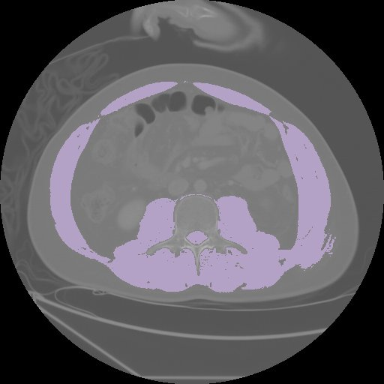
Supplementary Figure 1.
Cross-sectional computed tomographic images at the third lumbar vertebral level. Skeletal muscle area was quantified using the threshold values of -29 to 150 Hounsfield units.

