Supporting Material for
Deformation behavior and seismic characteristics of sandy facies Opalinus Clay during triaxial deformation under dry and wet conditions
Valerian Schuster^{1*}, Erik Rybacki¹, Audrey Bonnelye^{1,2} and Georg Dresen^{1, 3}
¹Helmholtz Centre Potsdam, GFZ German Research Centre for Geosciences, 14473 Potsdam, Germany
²GeoRessources Laboratory, Université de Lorraine, 54000 Nancy, France
³Institute for Earth and Environmental Science, University of Potsdam, 14476 Potsdam, Germany
*Corresponding author: Valerian Schuster (valerian.schuster@gfz-potsdam.de)
Contents of this file
Table 1 and 2
Figures S1 to S3
Table 1 Summary of mechanical and acoustic data
Sample Orientation | Sample Condition | p_{c}  (MPa) | E₁  (GPa) | E₂  (GPa) | ν₁₂ (-) | ν₂₁ (-) | ν₂₃ (-) | A_{p} (-) | Total Number of AE | Differential Stress at c_{i} (MPa) | Differential Stress at c_{d} (MPa) | σ_{max} (MPa) | ε_{max} (%)
P | dry | 50 | - | 13.9 |  | 0.13 | 0.09 | 0.22ª  0.18^{p} | 248 | 94 | 133 | 152 | 0.0315
P | wet | 50 | - | 9.3 |  | 0.18 | 0.17 | 0.06ª  0.08^{p} | 90 | 44 | 99 | 99 | 0.0314
S | dry | 50 | 8.9 | - | 0.11 | - | - | 0.28 | 261 | 78 | 178 | 148 | 0.0345
S | wet | 50 | 6.1 | - | 0.28 | - | - | 0.11 | 39 | 39 | 65 | 80 | 0.0373
p_{c} confining pressure, E Young’s modulus, ν Poisson’s ratio, A_{p} initial P-wave velocity anisotropy coefficient (c.f., Chapter 4.1 of the main text), ª azimuthal direction, ^{p} polar direction, c_{i} stress at onset of microcracking, c_{d} stress at onset of net dilation, σ_{max} peak strength, ε_{max} total axial strain at peak strength
Table 2 Summary of compositional data of different shales sorted by increasing QFP content
 | Clay (vol%) | Quartz (vol%) | Carbonate (vol%) | Feldspar (vol%) | Pyrite (vol%) | TOC (vol%) | Porosity (vol%) | QFP (vol%) | Cb (vol%) | Clay + TOC + Porosity (vol%)
Opalinus Clay Shaly Faciesª | 62.3 | 7.1 | 8.9 | 3.9 | 0.4 | 1.6 | 15.7 | 11.5 | 8.9 | 79.6
Whitby Mudstone^{b} | 50.6 | 11.6 | 9.5 | 0.5 | 3.6 | 11.2 | 13.0 | 15.7 | 9.5 | 74.8
Tournemire Shale^{c} | 61.0 | 12.8 | 12.3 | 2.4 | 1.1 | 1.9 | 8.5 | 16.4 | 12.3 | 71.4
Callovo-Oxfordian Shale^{d} | 43.5 | 15.3 | 25.4 | 2.5 | 1.4 | 1.8 | 10.0 | 19.3 | 25.4 | 55.3
Muderong Shale^{e} | 57.4 | 22.5 | 0.8 | 2.4 | 0.9 | 0.9 | 15.0 | 25.8 | 0.8 | 73.3
Norwegian Sea Shale^{f} | 51.7 | 26.8 | 0.8 | 2.3 | 0.8 | 3.6 | 14.0 | 29.9 | 0.8 | 69.3
Northwest Shelf Shale^{g} | 37.4 | 34.6 | 10.9 | 3.3 | 0.3 | 0.4 | 13.0 | 38.2 | 10.9 | 50.9
Opalinus Clay Sandy Faciesª | 33.1 | 36.4 | 8.8 | 9.3 | 0.5 | 0.7 | 11.1 | 46.2 | 8.8 | 44.9
Officer Basin Shale^{h} | 37.7 | 17.9 | 6.5 | 28.5 | 1.1 | 1.5 | 6.7 | 47.6 | 6.5 | 45.9
Sichuan Basin Longmaxi Shale^{i} | 16.4 | 60.3 | 16.3 | 0.0 | 0.0 | 4.9 | 2.0 | 60.3 | 16.3 | 23.4
QFP Quartz + Feldspar + Pyrite, Cb Carbonates, TOC Total organic carbon
ªSchuster et al.2022; ^{b}Houben et al. 2016; ^{c}Tremosa et al. 2012; ^{d}Klinkenberg et al. 2009; ^{e}Dewhurst et al. 2002; ^{f}Dewhurst et al. 2011; ^{g}Delle Piane et al. 2009, 2011; ^{h}Kuila et al. 2011, ^{i}Li et al.

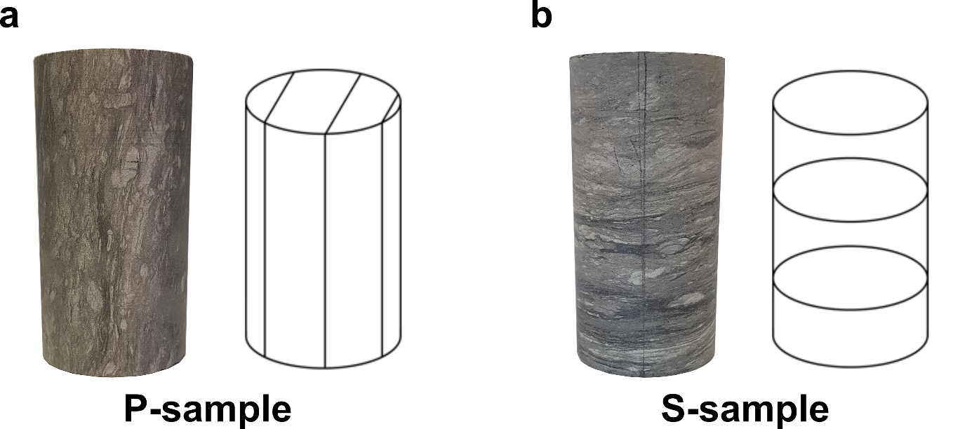Fig. S1 Photographs of undeformed samples (length 10 cm, diameter 5 cm) of the sandy facies of Opalinus Clay prepared parallel (a) and perpendicular (b) to bedding

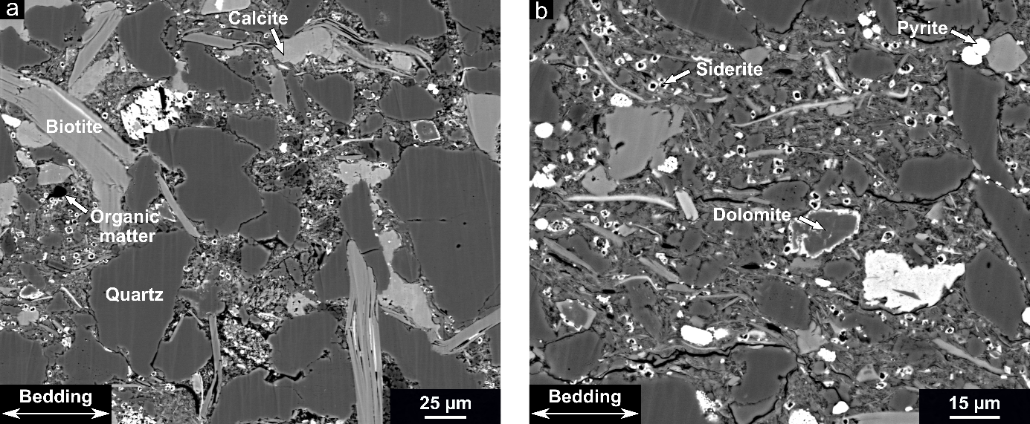
Fig. S2 Backscattered electron microscope images of undeformed Opalinus Clay of the sandy facies showing dominant mineral phases as well as the microstructural differences between grain supported sand layers (a) and matrix supported clay layers (b)

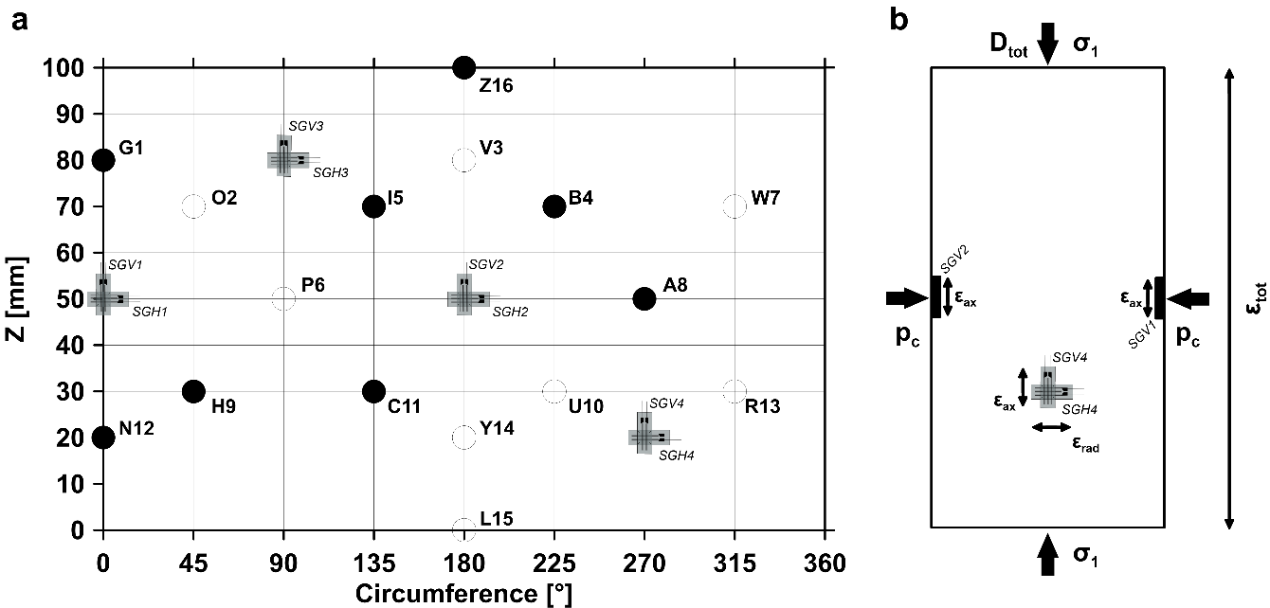
Fig. S3 Sensor map with the position of piezoelectric P-wave transducers (bold circle: transmitter; open circle: receiver) and strain gauges projected on the sample surface (a). Schematic side view of the prepared samples, showing the used nomenclature in this technical note (b)

