Electronic Supplementary Material

Microneedles-based nanoporous gold electrochemical sensor for real time catecholamine detection

Cristina Tortoliniª, Anthony E.G. Cass^{b}, Riccardo Pofi^{c}, Andrea Lenzi^{c}, Riccarda Antiochia^{a,*}
ªDepartment of Chemistry and Drug Technologies, Sapienza University of Rome, P.le Aldo Moro 5, 00185, Rome, Italy
^{b}Department of Chemistry & Institute of Biomedical Engineering, Imperial College, London, UK
ªDepartment of Experimental Medicine, Sapienza University of Rome, Rome, Italy

* Corresponding author.
E-mail address: riccarda.antiochia@uniroma1.it

(A)
(B)

Spectrum: Microneedles_ 1

Element Series unn. C norm. C Atom. C Error (1 Sigma)
[wt.%] [wt.%] [at.%] [wt.%]
--------------------------------------------------------
Gold M-series 86.98 91.24 40.08 3.45
Carbon K-series 6.23 6.53 47.05 1.16
Oxygen K-series 1.12 1.17 6.34 0.33
Nitrogen K-series 1.01 1.06 6.53 0.38
--------------------------------------------------------
Total: 95.33 100.00 100.00

Fig. S1 EDX spectra of h-nPG microneedles electrode (panel A) and chemical composition (%) of h-nPG microneedles electrode (panel B) obtained from EDX analysis.
(A)

(B)

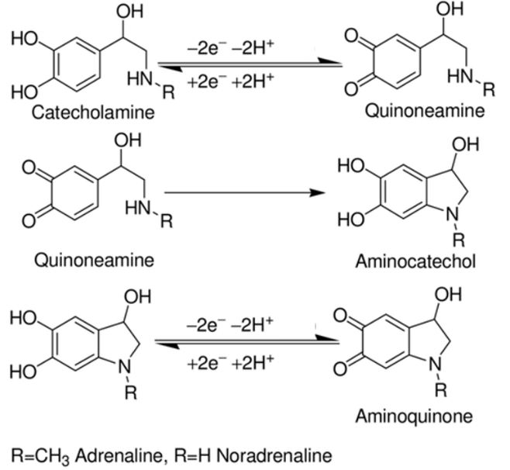

Fig. S2 CV of 0.1 mM DA with h-nPG Au classical electrode at 25 mV s⁻¹ (panel A); Possible EP and NEP oxidative pathways (panel B).

(A)

(B)

Fig. S3 CVs of 0.1 mM EP (A) and NEP (B) with microneedles h-nPG electrode at different scan rates (5-50 mV s⁻¹), in 0.1 M PBS, 0.1 M KCl (pH 7.4). In the insets, the plot of the peak current density vs. scan rate and/or square root of scan rate (5÷300 mV s⁻¹).

Fig. S4 Plots of peak potential E_{p} vs logν of h-nPG microneedles electrode in PBS buffer, containing 1.0 mM of DA (○), EP (▼) and NEP (●).

Fig. S5 Log I_{p} vs. log v plots of the three catecholamines: DA (□), EP (●) and NEP (○), respectively.

(A)

(B)

(C)
Fig. S6 Stability measurements over a period of 30 days in presence of 10 μM of DA (A), EP (B) and NEP (C) in 0.1 M PBS, 0.1 M KCl (pH 7.4), (n=10).

Table S1. Linear regression equations of J_{pa} versus ν and ν^{1/2} for DA, EP and NEP.

Catecholamine | Linear regression equation
 | ν / 5-100 mV s⁻¹ | ν / 150-300 mV s⁻¹
DA | J_{pa}/mA cm⁻² = 0.04 ν/mVs⁻¹ + 1.9, R = 0.999
EP | J_{pa}/ mA cm⁻² = 0.04 ν/mVs⁻¹ + 0.7, R = 0.992 | J_{pa}/mA cm⁻² = 1.2 ν^{1/2}/(mVs⁻¹)^{1/2} – 7.8, R = 0.999
NEP | J_{pa}/mA cm⁻² = 0.02 ν/mVs⁻¹ + 0.8, R = 0.994 | J_{pa}/mA cm⁻² = 0.6 ν^{1/2}/(mVs⁻¹)^{1/2} – 3.8, R = 0.998

