Electronic Supplementary Material

Identification of milk quality and adulteration by Surface-enhanced infrared absorption spectroscopy coupled to artificial neural networks using citrate-capped silver nanoislands

Sherif M. Eid ª*, Sherin el Shamy ^{b}, Mohamed A. Farag ^{c,d}

ª Analytical chemistry department, Faculty of Pharmacy, October 6 University, 6 October City, Giza, Egypt.
^{b} Pharmacognosy Department, Faculty of Pharmacy, Modern University for Technology & Information, Cairo, Egypt
^{c} Pharmacognosy Department, Faculty of Pharmacy, Cairo University, Cairo, 11562, Egypt
^{d} Chemistry Department, School of Sciences & Engineering, The American University in Cairo, New Cairo 11835, Egypt

*Corresponding Author, Email: Sheriefmohammed@o6u.edu.egm, sherief055@icloud.com

Preparation method of Citrate capped silver nanoparticles

A slightly modified the Lee-Meisel method [1] has been used for the preparation of Cit-AgNPs colloidal solution. In a 500-ml clean beaker, 36 mg of AgNO₃ was completely dissolved in 350 ml of double distilled water. The solution was heated and kept at kept at 65 ºC. Another solution of tri-sodium citrate (5%) was freshly prepared, then 5 ml were added to the hot solution with continuous stirring. The formation of Cit-AgNPs can be observed by the appearance of yellow colored solution.

Fig. 1S: The simplified presentation of the ANN structure used in all our algorithms for the determination of concentration of milk components.

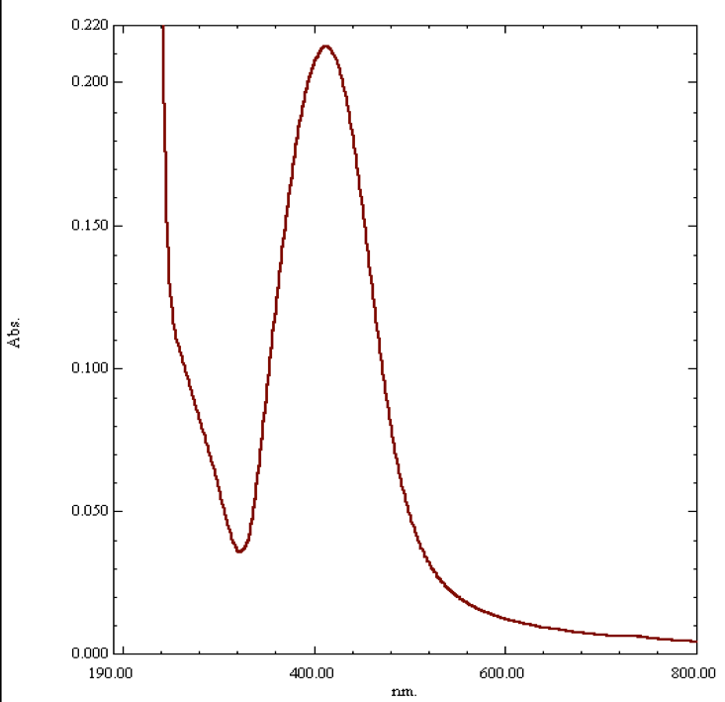
Fig. 2S: The Localized surface plasmon resonance extinction UV band of the prepared citrate capped silver nanoparticles showing a λ_{max} at 411 n m.

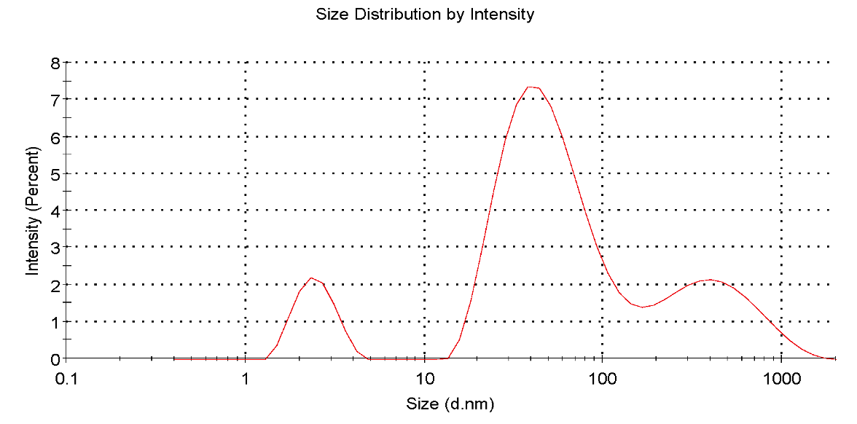
Fig. 3S: Dynamic light scattering of the prepared citrate capped silver nanoparticles size distribution by intensity.

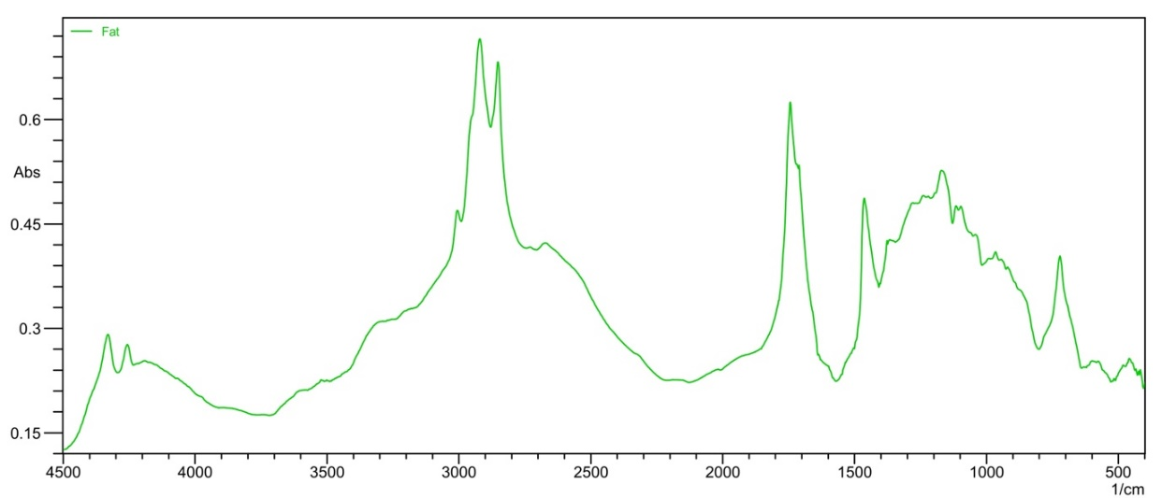
A)
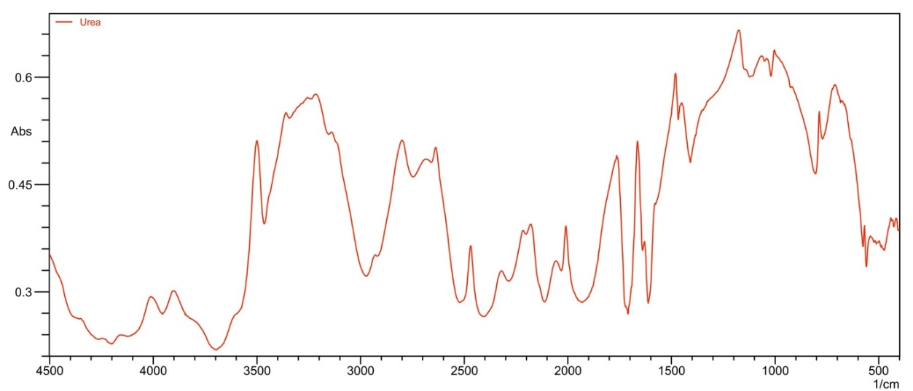
B)

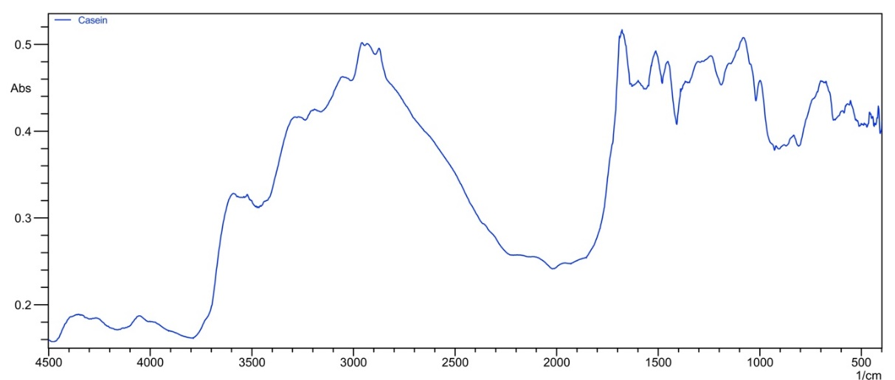
C)
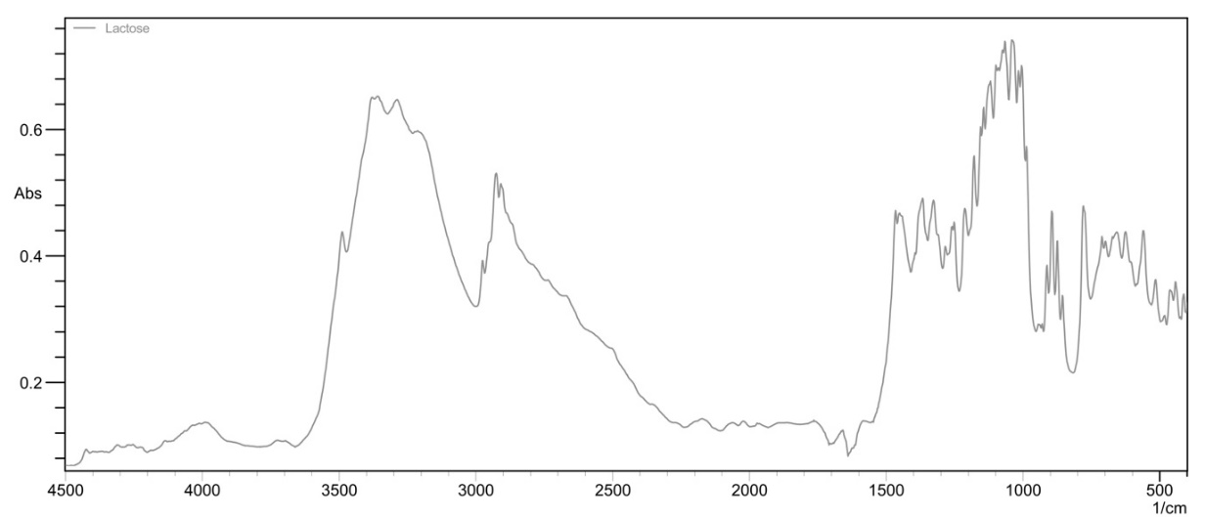
D)
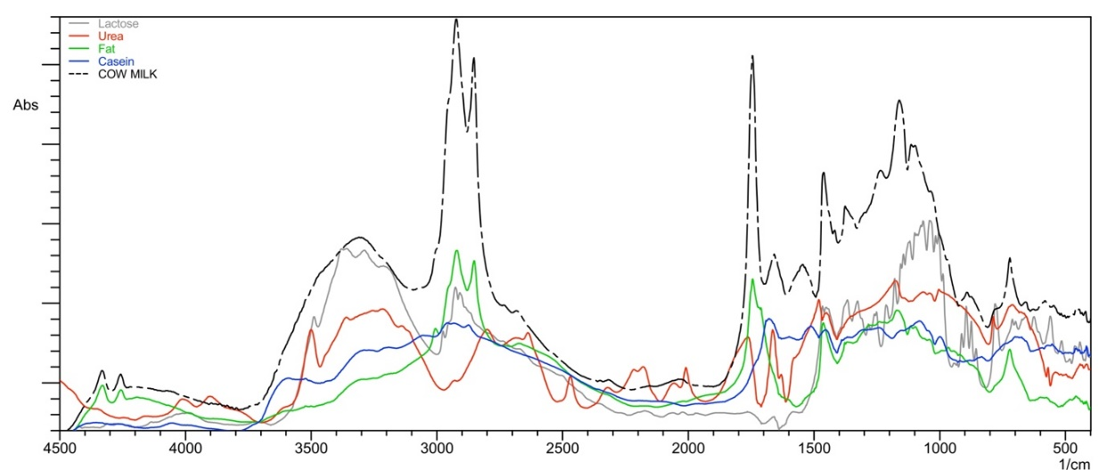
E)

Fig. 4S FTIR Extinction spectra (SEIRA) of the different milk components when placed over the nanoparticles coated glass substrate: A) fat, B) urea, C) casein, D) lactose, and E) overlay plot of the four milk components and one of the milk sample (cow milk).

Table 1S: The coded levels and concentration ranges of the selected milk components (fat, casein, lactose, and urea).
Code Levels |  |  |  | Mixture  numbers | Concentration (mg/ml)
Fat | Casein | Lactose | Urea | Mixture  numbers | Fat | Casein | Lactose | Urea
0 | 0 | 0 | 0 | 1 | 45 | 30 | 45 | 0.3
0 | −2 | -1 | -2 | 2* | 45 | 10 | 30 | 0.1
−2 | −2 | -2 | 2 | 3 | 15 | 10 | 45 | 0.5
−2 | 2 | 2 | 2 | 4* | 15 | 50 | 75 | 0.5
2 | −1 | 2 | 0 | 5 | 75 | 20 | 75 | 0.3
−1 | 2 | 0 | -1 | 6* | 30 | 50 | 45 | 0.2
2 | 0 | -1 | 2 | 7 | 75 | 30 | 30 | 0.5
0 | −1 | 2 | -1 | 8* | 45 | 20 | 75 | 0.2
−1 | −1 | -1 | 1 | 9 | 30 | 20 | 30 | 0.4
−1 | 1 | 1 | 1 | 10* | 30 | 40 | 60 | 0.4
1 | 2 | 1 | 0 | 11 | 60 | 50 | 60 | 0.3
2 | 1 | 0 | 2 | 12 | 75 | 50 | 45 | 0.5
1 | 0 | 2 | 1 | 13* | 60 | 30 | 75 | 0.4
0 | 2 | 1 | 2 | 14 | 45 | 50 | 60 | 0.5
2 | 2 | 2 | -2 | 15* | 75 | 50 | 75 | 0.1
2 | −2 | -2 | -2 | 16 | 75 | 10 | 15 | 0.1
−2 | 1 | -2 | 0 | 17* | 15 | 40 | 15 | 0.3
1 | −2 | 0 | 1 | 18 | 60 | 10 | 45 | 0.4
−2 | 0 | 1 | -2 | 19* | 15 | 30 | 60 | 0.1
0 | 1 | -2 | 1 | 20 | 45 | 40 | 15 | 0.4
1 | 1 | 1 | -1 | 21* | 60 | 40 | 60 | 0.2
1 | −1 | -1 | -1 | 22 | 60 | 20 | 30 | 0.2
−1 | −2 | -1 | 0 | 23 | 30 | 10 | 30 | 0.3
−2 | −1 | 0 | -2 | 24 | 15 | 20 | 45 | 0.1
−1 | 0 | -2 | -1 | 25 | 30 | 30 | 15 | 0.2

* The validation set concentrations.

Table 2S. Optimized parameters of ANNs in the proposed chemometric model
Parameters | Values
Architecture | 17-5-3
Training algorithm | Bayesian regularization
Transfer function | Purelin–Purelin
Number of hidden layers | 1
Number of neurons | 20
Learning coefficient | 0.001
Learning coefficient decrease | 0.001
Learning coefficient increase | 100

References

[1] D. Gkogkou, T. Shaykhutdinov, C. Kratz, T.W.H. Oates, P. Hildebrandt, I.M. Weidinger, K.H. Ly, N. Esser, K. Hinrichs, Gradient metal nanoislands as a unified surface enhanced Raman scattering and surface enhanced infrared absorption platform for analytics, The Analyst, 144 (2019) 5271-5276.

