Electronic supplementary information
Quantitative titanium imaging in fish tissues exposed to titanium dioxide nanoparticles by laser ablation-inductively coupled plasma-mass spectrometry
Cristian Suárez-Oubiña^{*1}, Annarosa Mangone², Lorena C. Giannossa², Laura Nuñez-González³, Paloma Herbello-Hermelo¹, Pilar Bermejo-Barrera¹, Antonio Moreda-Piñeiro¹

Table 1. LA-ICP-MS operating conditions.
ICP-MS parameter (units) | Value
Instrument | NexIon 2000
Nebulizer gas flow (L min⁻¹) | 0.90 - 1.00 (daily optimised)
Auxiliary gas flow rate (L min⁻¹) | 1.2
Plasma gas flow (L min⁻¹) | 15
ICP RF power (W) | 1600
Isotopes monitored | ²⁵Mg, ²⁶Mg, ²⁷Al, ³¹P, ⁴²Ca  ⁴⁶Ti, ⁴⁷Ti, ⁴⁸Ti, ⁴⁹Ti
Dwell time (ms) | 50 (²⁵Mg, ²⁶Mg, ²⁷Al, ³¹P, ⁴²Ca)  10 (⁴⁶Ti, ⁴⁷Ti, ⁴⁸Ti, ⁴⁹Ti)
LA-ICP-MS parameter (units) | Value
Laser | Nd:YAG (213 nm)
Tygon® interface tube | 3.5 m length – 1/16 inch i.d.
Ablation mode | Scan line
He flow rate (mL min⁻¹) | 900
Spot Size (µm) | 110
Fluence (J cm⁻²) | 0.40
Scan speed (µm s⁻¹) | 50
Repetition rate (Hz) | 20
Ablation depth (µm) | 0
Laser warm-up (s) | 10
Laser wash-out (s) | 15

Table S2. Total titanium and TiO₂ NPs in fish tissues from exposed sea bream (N1) and unexposed sea bream (N2).
Sample tissue | sp-ICP-MS (particles g⁻¹) | SD | ICP-MS (µg g⁻¹) | SD
Kidney N1 | 3.88×10⁶ | 1.78×10⁵ | 0.83 | 0.20
Kidney N2 | --- | --- | 0.12 | 0.04
Liver N1 | 6.67×10⁶ | 3.65×10⁵ | 0.51 | 0.05
Liver N2 | --- | --- | 0.21 | 0.17
Muscle N1 | 8.14×10⁵ | 8.90×10⁴ | 0.23 | 0.15
Muscle N2 | --- | --- | < LOD | ---

Figure S1. Representative TEM image of citrate-45nm TiO₂ NPs (JEOL JEM 1010 transmission electron microscope operating at 100 kV).

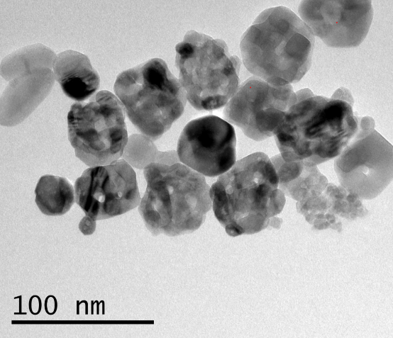

Figure S2. Thick paraffin slides (5.0 µm) of fish tissues obtained after sample pre-treatment: (A) under UV light and (B) natural light. Sample description: kidney tissue from sea bream exposed at 1.5 mg kg⁻¹ TiO₂ NPs (45 nm) for 90 days.

Figure S3. Exported images from ActiveView™ software (dark line under sample tissue) using laser energies for (A) sample fish tissue and (B) paraffin polymer under several laser fluencies.
Figure S4. Exported images from ActiveView™ software illustrating the heterogeneity of the embedded samples (A,B) and the borders between paraffin-embedded tissue / paraffin-free tissue and the glass holder (C).
Figure S5. LA-ICP-MS time vs intensity plots for a kidney tissue obtained at scanning rates of 30 µm s⁻¹ (A), 60 µm s⁻¹ (B), and 90 µm s⁻¹ (C)

Figure S6. LA-ICP-MS time vs intensity plots for a kidney tissue by recording ⁴⁸Ti (red), ⁴⁶Ti (blue), and ²⁶Mg (black). Scale referred only to ⁴⁶Ti intensities: scan implying the presence of TiO₂ NPs (A and B) and the absence of TiO₂ NPs (C) in tissues from exposed sea bream.
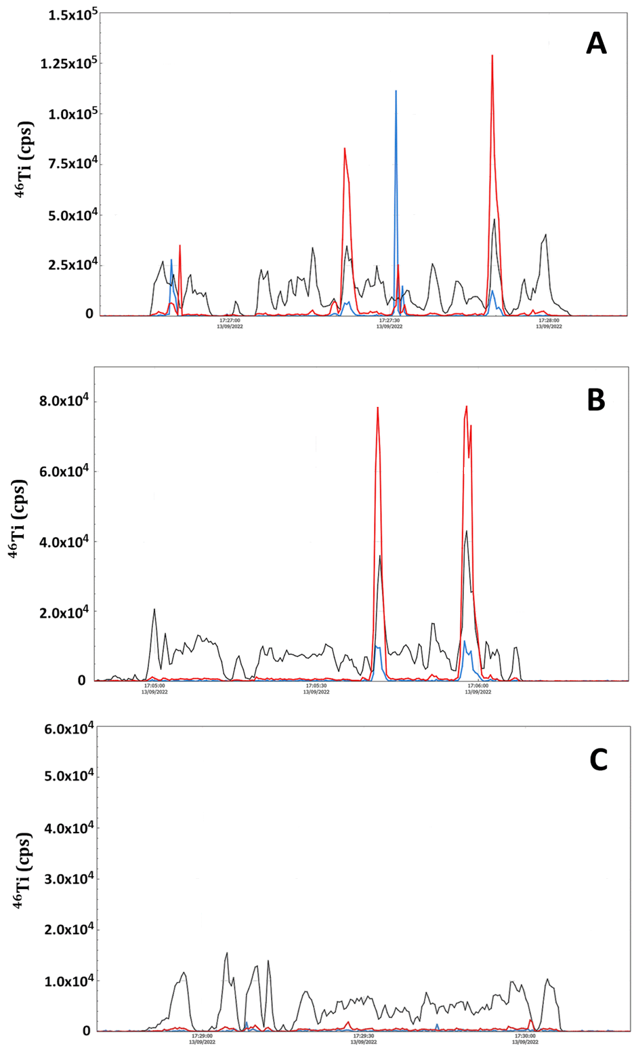
Figure S7. Images for a kidney tissue from a sea bream specimen exposed to 45 nm TiO₂ NPs (dietary exposure at 1.5 mg kg⁻¹) for 90 days tissues: sample image under UV light (A), ²⁶Mg map intensities (B), ⁴⁸Ti map concentrations (C), ⁴⁸Ti map intensities (D), ⁴⁶Ti map concentrations (E), ⁴⁶Ti map intensities (F).
Figure S8. Images for a kidney tissue from an un-exposed sea bream specimen (sampling at 75 days): sample image under UV light (A), ²⁶Mg map intensities (B), ⁴⁸Ti map concentrations (C), ⁴⁸Ti map intensities (D), ⁴⁶Ti map concentrations (E), ⁴⁶Ti map intensities (F).
Figure S9. Images for a liver tissue from a sea bream specimen exposed to 45 nm TiO₂ NPs (dietary exposure at 1.5 mg kg⁻¹) for 75 days tissues: sample image under UV light (A), ²⁶Mg map intensities (B), ⁴⁸Ti map concentrations (C), ⁴⁸Ti map intensities (D), ⁴⁶Ti map concentrations (E), ⁴⁶Ti map intensities (F).

Figure S10. Images for a liver tissue from an un-exposed sea bream specimen (sampling at 45 days): sample image under UV light (A), ²⁶Mg map intensities (B), ⁴⁸Ti map concentrations (C), ⁴⁸Ti map intensities (D), ⁴⁶Ti map concentrations (E), ⁴⁶Ti map intensities (F).

Figure S11. Images for a muscle tissue from a sea bream specimen exposed to 45 nm TiO₂ NPs (dietary exposure at 1.5 mg kg⁻¹) for 75 days tissues: sample image under UV light (A), ²⁶Mg map intensities (B), ⁴⁸Ti map concentrations (C), ⁴⁸Ti map intensities (D), ⁴⁶Ti map concentrations (E), ⁴⁶Ti map intensities (F).

Figure S12. Images for a liver tissue from an un-exposed sea bream specimen (sampling at 45 days): sample image under UV light (A), ²⁶Mg map intensities (B), ⁴⁸Ti map concentrations (C), ⁴⁸Ti map intensities (D), ⁴⁶Ti map concentrations (E), ⁴⁶Ti map intensities (F).

