Supplementary Materials

Toward the development of a specific non-enzymatic amperometric sensor for determining uric acid in fermentation samples

E.V. Butyrskaya¹, E.V. Zolotukhina², P. Herbeck-Engel³, M. Koch^{3,4}, Y.E. Silina^{5*}

¹Voronezh State University, Department of Analytical chemistry, Voronezh, Russia
²Federal Research Center of Problems of Chemical Physics and Medicinal Chemistry,
Russian Academy of Sciences, Moscow region, Russia
³INM – Leibniz Institute for New Materials, Saarbrücken, Germany
⁴HTW saar – University of Applied Sciences, Saarbrücken, Germany
⁵Saarland University, Department of Biochemistry, Saarbrücken, Germany

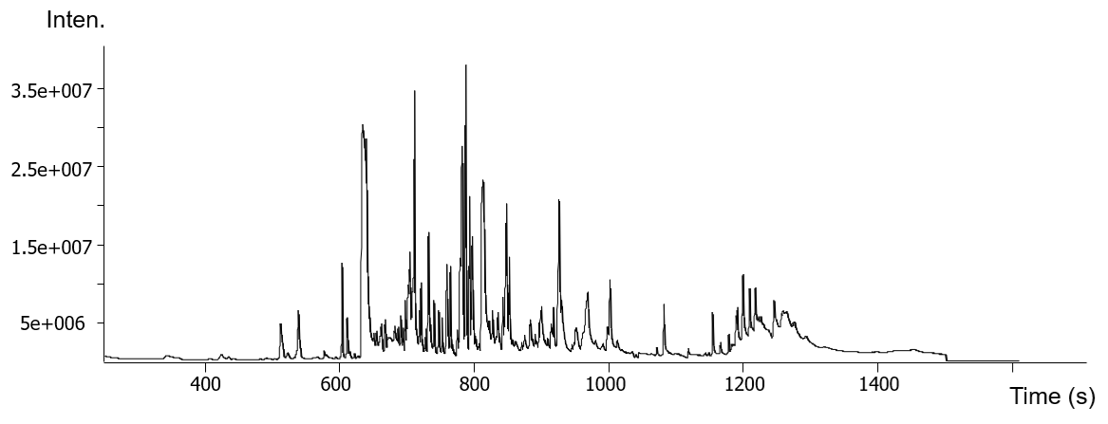
Fig. S1 – GC-MS chromatogram obtained for the yeast supernatant (cultivation time 96 h as a case study) after derivatization with TMSTFA.

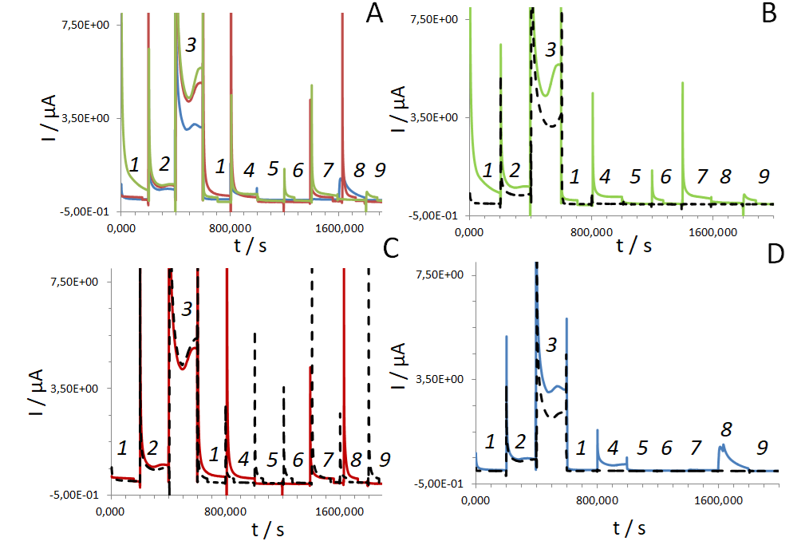
Fig. S2 – AM plots recorded at 0.22 V from Cu-NPs-modified SPEs in: 1 – buffer; 2 – 100 µM UA, 3 – 1 mM UA, 4 – 100 µM AA, 5 – 10 mM glycerol; 6 – 10 mM EtOH, 7 – 10 mM ethylamine; 8 – 10 mM ethanolamine, 9 – 10 mM urea. Note: the pH of all tested solutions was 9±0.2. (A) – intact electrodes modified with Cu-NPs electrodeposited on: GO (green), r-GO (red), carbon (blue). (B) – Cu-NPs deposited on GO before (green) and after heating at 70 °C for 20 min (dashed black line); (C) – Cu-NPs deposited on r-GO before (red) and after heating at 70 °C for 20 min (dashed black line); (D) – Cu-NPs deposited on carbon before (blue) and after heating at 70 °C for 20 min (dashed black line).

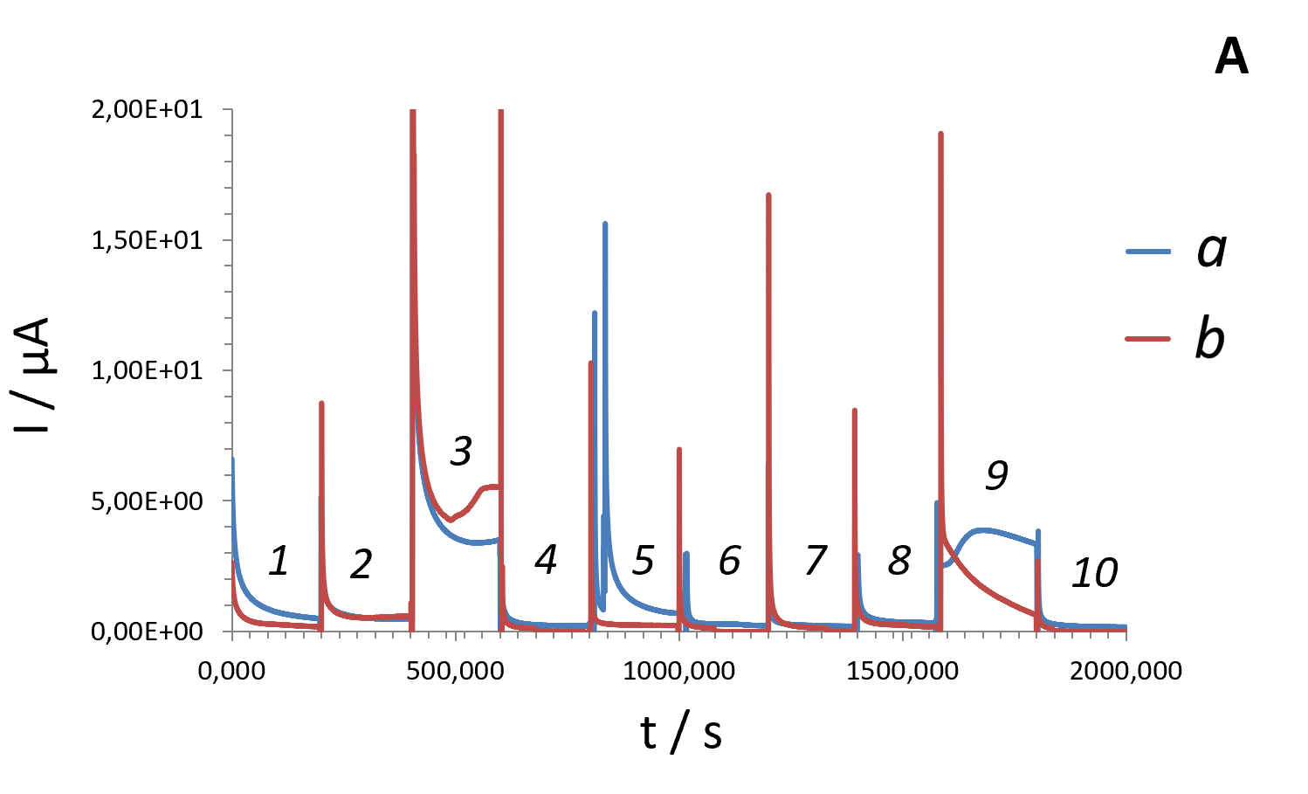
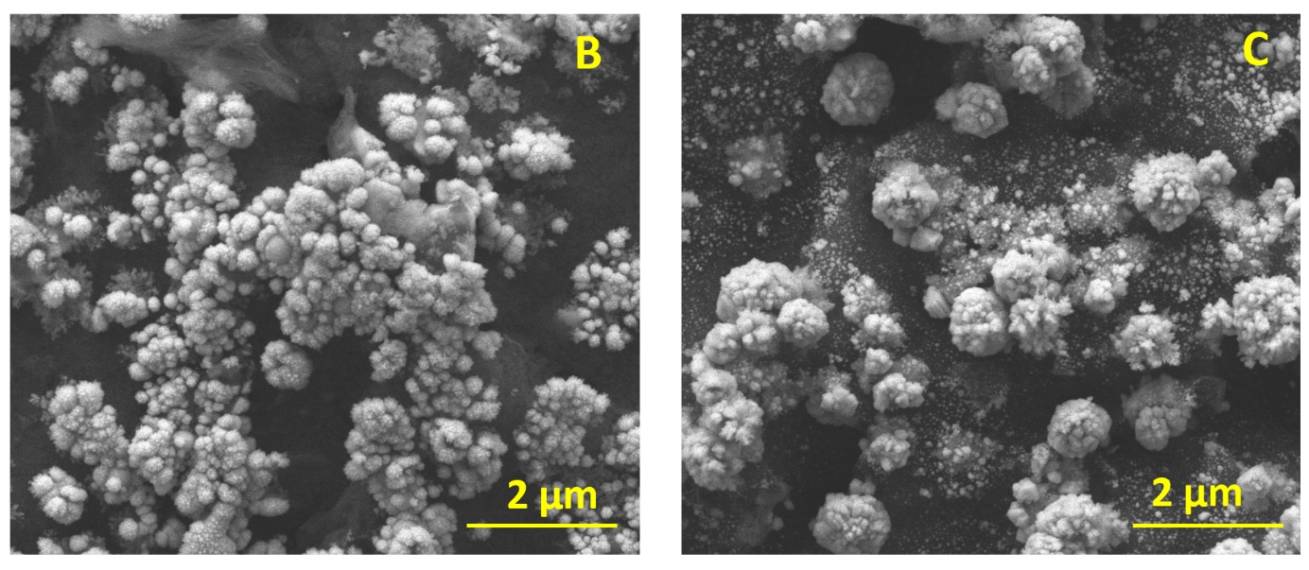

Fig. S3 – (A) AM plots recorded at 0.22 V from larger (100 mM electrolyte) Cu-NPs-modified GO/SPEs in: 1 – buffer; 2 – 100 µM UA, 3 – 1 mM UA, 4 – 100 µM AA (ascorbic acid), 5 – 10 mM glycerol; 6 – 10 mM EtOH, 7 – 10 mM ethylamine; 8 – 10 mM ethanolamine, 9 – 10 mM urea recorded from the intact electrode (a) and the same electrode heated at 70 °C (b). Note: the pH 9 of all tested solutions was 9±0.2. (B,C) – SEM images recorded from the intact Cu-NPs-modified GO/SPE (B) and from the identical electrode heated at 70 °C and explored during two months (C).

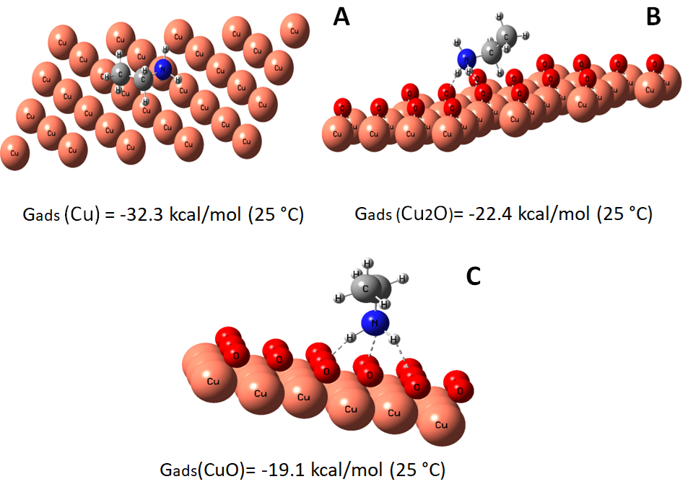

Fig. S4 – The Gibbs adsorption energies (G_{ads}) and the most favorable location of ethylamine on Cu (A), Cu₂O (B) and CuO (C) surfaces. Note: by dashed line the hydrogen bond is shown.

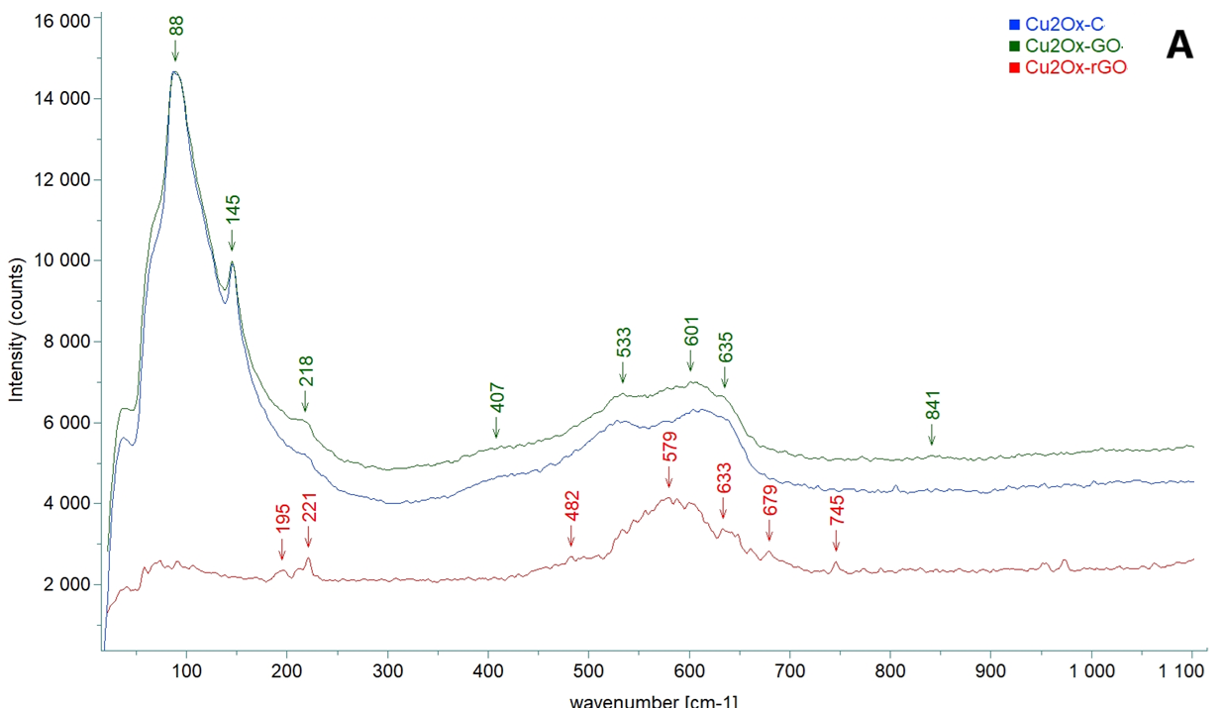
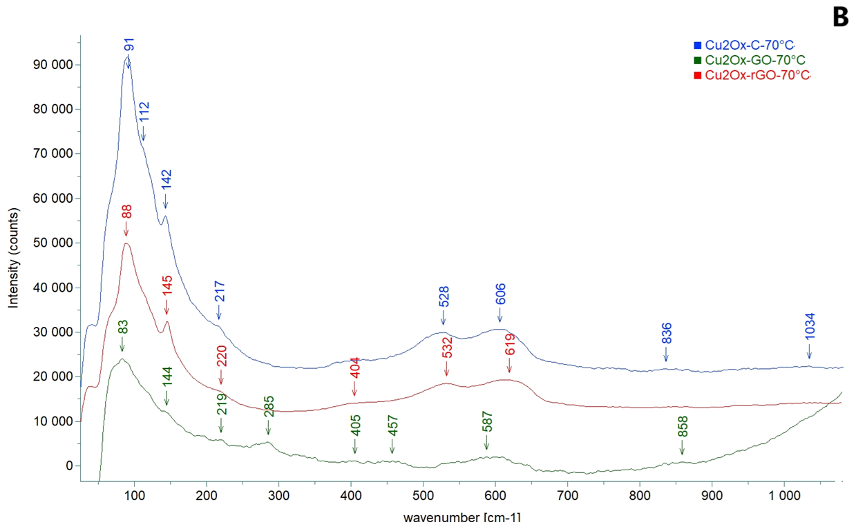

Fig. S5 – RAMAN spectra recorded from electrodes modified with electrodeposited Cu-NPs (100 mM electrolyte was used as a case study) as prepared (A) and after heating at 70 °C for 20 min (B). Note: c – carbon used as the electrode support material; GO – graphene oxide; r-GO – reduced graphene oxide.

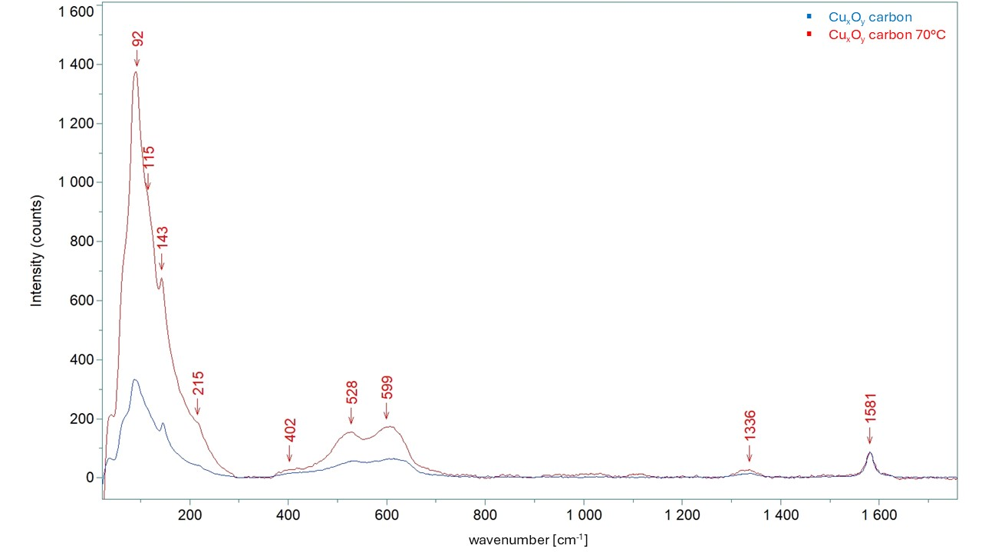

Fig. S6 – RAMAN spectra recorded from electrodes modified with electrodeposited Cu-NPs (100 mM electrolyte was used as a case study) as prepared and after treatment at 70 °C.

Table S1 – Qualitative table of selected amines present in supernatants of yeast cells (shown for cells cultivated for 96 h)
Name | Height | RT(s) | Weight | Unique mass | Quant mass | Quant. S/N* | Peak area
1,1,1-trimethyl-silanamine, N,N'-methanetetraylbis | 196502 | 378.8 | 186 | 171 | 171 | 416.3 | 9693405
Tris(trimethylsilyl)amine | 18650679 | 510.2 | 233 | 218 | 218 | 105240 | 549211547
N-Ethyl-4-propyl-4-octanamine | 205802 | 647.6 | 199 | 156 | 156 | 596.4 | 4523817
1,1,1-trimethyl-N-(1-methyl-2-phenylethyl)-N-(trimethylsilyl)-silanamine | 17272759 | 697.6 | 279 | 188 | 188 | 74522 | 250133093
2-(p-Chlorophenyl)-ethylamine | 4548 | 750.8 | 155 | 236 | 236 | 29.56 | 106278
4-ethyl-4H-1,2,4-  Triazol-3-amine | 2978741 | 856.6 | 112 | 112 | 112 | 5784.4 | 48870187
Benzeneethanamine | 18917 | 960.6 | 241 | 446 | 446 | 289.35 | 1338489
Trimethylsilyloxy-methylamine | 7191 | 991.3 | 343 | 345 | 345 | 65.675 | 191586
Adamantanemethylamine | 13916 | 1123.3 | 179 | 190 | 190 | 34.615 | 326441
*S/N – signal to noise ratio
Table S2 – The amount (µM) of uric acid (UA) found in tested fermentation samples (supernatants) by conventional fluorescence-based Amplex™ Red Uric Acid/Uricase assay

Tested  supernatant | Cultivation time of cells, h | Optical density (OD) of cell suspension | Concentration of (UA), µM ±SD | Calibration formula | R²
E. coli | 2 | 2.1 | 28.21±0.01 | y = 1571·x + 7213 | 0.998
E. coli | 2 | 1.7 | 10.83±0.03 | y = 1571·x + 7213 | 0.998
E. coli | 7 | 3.8 | 3.29±0.05 | y = 1571·x + 7213 | 0.998
E. coli | 7 | 4.3 | 3.43±0.05 | y = 1571·x + 7213 | 0.998
E. coli | 12 | 6.3 | 0.62±0.09 | y = 1571·x + 7213 | 0.998
Yeast cells | 70 | 5.7 | 1.36±0.03 | y = 1571·x + 7213 | 0.998
Yeast cells | 96 | 6.1 | 0.79±0.02 | y = 1571·x + 7213 | 0.998
Table S3 – Wavenumbers for Cu₂O, Cu₃O₄ and CuO reported in the literature and recorded from the samples in this study (shown for GO/SPE as a case study)

Literature | [1] |  | [2] |  | [3] |  | [4]
Oxide type | Cu₂O | CuO | Cu₂O | CuO | Cu₂O | CuO | Cu₂O | Cu₄O₃ | CuO
Wave numbers [cm⁻¹] | 93
Wave numbers [cm⁻¹] | 110
Wave numbers [cm⁻¹] | 148 |  |  |  | 150 |  | 195
Wave numbers [cm⁻¹] | 215 |  | 218 |  | 220 |  | 218 | 218
Wave numbers [cm⁻¹] |  | 296 |  | 298 |  | 297 |  | 285 | 285
Wave numbers [cm⁻¹] |  | 345 |  | 347 |  | 347
Wave numbers [cm⁻¹] | 520 |  | 523 |  | 520 |  | 520 | 520
Wave numbers [cm⁻¹] |  |  |  | 591 |  | 605
Wave numbers [cm⁻¹] | 630 | 630 | 623 |  | 630 |  | 620 | 620
Wave numbers [cm⁻¹] |  |  |  |  |  |  |  | 860
Wave numbers [cm⁻¹] |  |  |  |  |  |  |  | 1135

Literature | [5] |  |  | [6] |  |  | [7]
Oxide type | Cu₂O | Cu₄O₃ | CuO | Cu₂O | Cu₄O₃ | CuO | Cu₂O | Cu₄O₃ | CuO
Wave numbers [cm⁻¹] | 93 |  |  |  |  |  | 90
Wave numbers [cm⁻¹] | 109 |  |  |  |  |  | 110
Wave numbers [cm⁻¹] | 145 |  |  | 150 |  |  | 150 | 175
Wave numbers [cm⁻¹] | 220 |  |  | 220 |  |  | 220
Wave numbers [cm⁻¹] |  | 318 | 296 |  | 320 | 300 |  | 280 | 290
Wave numbers [cm⁻¹] |  |  | 346 |  |  | 350 |  | 320 | 340
Wave numbers [cm⁻¹] | 520 | 510 |  | 530 | 540 |  | 540 | 530
Wave numbers [cm⁻¹] |  | 540
Wave numbers [cm⁻¹] | 610 | 650 | 631 |  |  |  |  | 610
Wave numbers [cm⁻¹] | 800 |  |  | 650 | 650 | 640 | 650 |  | 620

Literature | [8] |  |  | [9] |  |  | [10] |  | [11]
Oxide type | Cu₂O | Cu₄O₃ | CuO | Cu₂O | Cu₄O₃ | CuO | Cu₄O₃ | CuO | Cu₂O  Cu₄O₃  CuO _{y}
Wavenumbers [cm⁻¹] | 90
Wavenumbers [cm⁻¹] | 110 |  |  | 110 |  |  |  |  | 148
Wavenumbers [cm⁻¹] | 148 |  |  | 140
Wavenumbers [cm⁻¹] | 218 |  |  | 218 |  |  |  |  | 216
Wavenumbers [cm⁻¹] | 308 | 312 | 298 |  | 312 | 287 | 312 | 290 | 296 / 318
Wavenumbers [cm⁻¹] |  |  | 330 |  |  | 340 |  | 321 | 345
Wavenumbers [cm⁻¹] | 515 | 533 |  | 520 | 515
Wavenumbers [cm⁻¹] |  |  |  |  | 534 |  | 515
Wavenumbers [cm⁻¹] | 612 |  | 602 |  | 627 | 620 | 534 |  | 541
Wavenumbers [cm⁻¹] |  |  |  | 635
Wavenumbers [cm⁻¹] |  |  |  |  |  |  | 627 | 612 | 651

Oxide type | This work at RT¹ |  |  | This work at 70 °C
Oxide type | Cu₂O on C² | Cu₂O on GO³ | Cu₂O  Cu₄O₃  rGO⁴ | Cu₂O  Cu₄O₃ on C at 70 °C | Cu₂O  Cu₄O₃  GO | Cu₂O  Cu₄O₃  CuO on  rGO | Cu₂O  Cu₄O₃  on rGO
wavenumbers [cm⁻¹] | 87 | 87 |  | 91 | 90 | 86 | 91
wavenumbers [cm⁻¹] | 145 | 145 |  | 143 | 143 | 142 | 143
wavenumbers [cm⁻¹] |  |  | 195
wavenumbers [cm⁻¹] | 218 | 218 | 221 | 216 | 216 |  | 216
wavenumbers [cm⁻¹] |  |  |  |  |  | 278
wavenumbers [cm⁻¹] |  |  |  |  |  | 322
wavenumbers [cm⁻¹] | 417 | 417 | 483 | 403 | 403 | 450 | 403
wavenumbers [cm⁻¹] | 528 | 528 |  | 528 | 530 |  | 528
wavenumbers [cm⁻¹] |  |  | 579 |  |  | 600
wavenumbers [cm⁻¹] | 612 | 612 |  | 606 | 610 |  | 606
 | 638 | 638 | 633
 |  |  |  | 836 | 844 | 840 | 836
¹RT – at room temperature (as prepared Cu-NPs);
² – SPE/carbon;
³ – SPE/GO
⁴ – SPE/r-GO.
References:
1. Levitskii VS, Shapovalov VI, Komlev AE, et al (2015) Raman spectroscopy of copper oxide films deposited by reactive magnetron sputtering. Technical Physics Letters 41:1094–1096. https://doi.org/10.1134/S106378501511022X
2. Henderson E (2010) Lawrence Berkeley National Laboratory (Lbnl). The Military-Industrial Complex and American Society 185–186
3. Zoolfakar AS, Rani RA, Morfa AJ, et al (2014) Nanostructured copper oxide semiconductors: a perspective on materials, synthesis methods and applications. Journal of Materials Chemistry C 2:5247–5270. https://doi.org/10.1039/C4TC00345D
4. Schennach R, Gupper A (2003) Copper Oxidation Studied by In Situ Raman Spectroscopy. MRS Online Proceedings Library 766:32. https://doi.org/10.1557/PROC-766-E3.2
5. Farhad SFU, Webster RF, Cherns D (2018) Electron microscopy and diffraction studies of pulsed laser deposited cuprous oxide thin films grown at low substrate temperatures. Materialia 3:230–238. https://doi.org/https://doi.org/10.1016/j.mtla.2018.08.032
6. Debbichi L, Marco de Lucas MC, Pierson JF, Krüger P (2012) Vibrational Properties of CuO and Cu4O3 from First-Principles Calculations, and Raman and Infrared Spectroscopy. The Journal of Physical Chemistry C 116:10232–10237. https://doi.org/10.1021/jp303096m
7. Meyer BK, Polity A, Reppin D, et al (2012) Binary copper oxide semiconductors: From materials towards devices. physica status solidi (b) 249:1487–1509. https://doi.org/https://doi.org/10.1002/pssb.201248128
8. Purusottam-Reddy B, Sivajee-Ganesh K, Jayanth-Babu K, et al (2015) Microstructure and supercapacitive properties of rf-sputtered copper oxide thin films: influence of O2/Ar ratio. Ionics 21:2319–2328. https://doi.org/10.1007/s11581-015-1403-5
9. Murali DS, Subrahmanyam A (2016) Synthesis of low resistive p type Cu4O3 thin films by DC reactive magnetron sputtering and conversion of Cu4O3 into CuO by laser irradiation. Journal of Physics D: Applied Physics 49:375102. https://doi.org/10.1088/0022-3727/49/37/375102
10. Murali DS, Aryasomayajula S (2018) Thermal conversion of Cu4O3 into CuO and Cu2O and the electrical properties of magnetron sputtered Cu4O3 thin films. Applied Physics A 124:279. https://doi.org/10.1007/s00339-018-1666-6
11. Cocke DL, Schennach R, Hossain MA, et al (2005) The low-temperature thermal oxidation of copper, Cu3O2, and its influence on past and future studies. Vacuum 79:71–83. https://doi.org/https://doi.org/10.1016/j.vacuum.2005.01.010
Table S4 – Reproducibility of the baseline of electrodes modified with electrodeposited Cu-NPs and heated at 70 °C (evaluated in buffer solution in MAM at pH 9±0.2, read-out at 0.22 V)

Cu₂O_{x}-NPs/GO  (heated) | Reproducibility of the baseline
Cu₂O_{x}-NPs/GO  (heated) | I, µA | Mean ±SD | RSD, %
Run to run | 7.7 ˣ10⁻¹  7.1 ˣ10⁻¹  6.9 ˣ10⁻¹ | 7.23 ˣ10⁻¹±0.41 | 5.75
Batch to batch | 7.2 ˣ10⁻¹  5.5 ˣ10⁻¹  6.2 ˣ10⁻¹ | 6.30 ˣ10⁻¹±0.85 | 13.56

