SUPPORTING INFORMATION (SI)

Multifunctional Cerium Nanolabels in Electrochemical Immunosensing with Improved Robustness and Performance. Determination of TIM-1 in Colorectal Cancer Scenarios as a Case Study

Andrea Cabrero-Martín^{1‡}, Sara Santiago^{1‡}, Verónica Serafín¹, María Pedrero¹, Ana Montero-Calle², José M. Pingarrón¹, Rodrigo Barderas^{2,3}*, Susana Campuzano^{1,3}*

‡These authors contributed equally to this work and shared first authorship
¹Departamento de Química Analítica, Facultad de CC. Químicas, Universidad Complutense de Madrid, Pza. de las Ciencias 2, Madrid 28040, Spain.
²Chronic Disease Programme, UFIEC, Institute of Health Carlos III, Majadahonda, Madrid 28220, Spain.
³CIBER of Frailty and Healthy Aging (CIBERFES), Instituto de Salud Carlos III, Madrid, 28046 Spain
E-mail: susanacr@quim.ucm.es; E-mail: r.barderasm@isciii.es

Contents | Page/s
Fig. S1 | S2
Fig. S2 | S2
Table S1 | S2
Fig. S3  Fig. S4 | S3  S4
Table S2 | S6
Fig. S5 | S6
Fig. S6 | S7
Fig. S7 | S7
Fig. S8 | S8
Table S3 | S8
References | S8

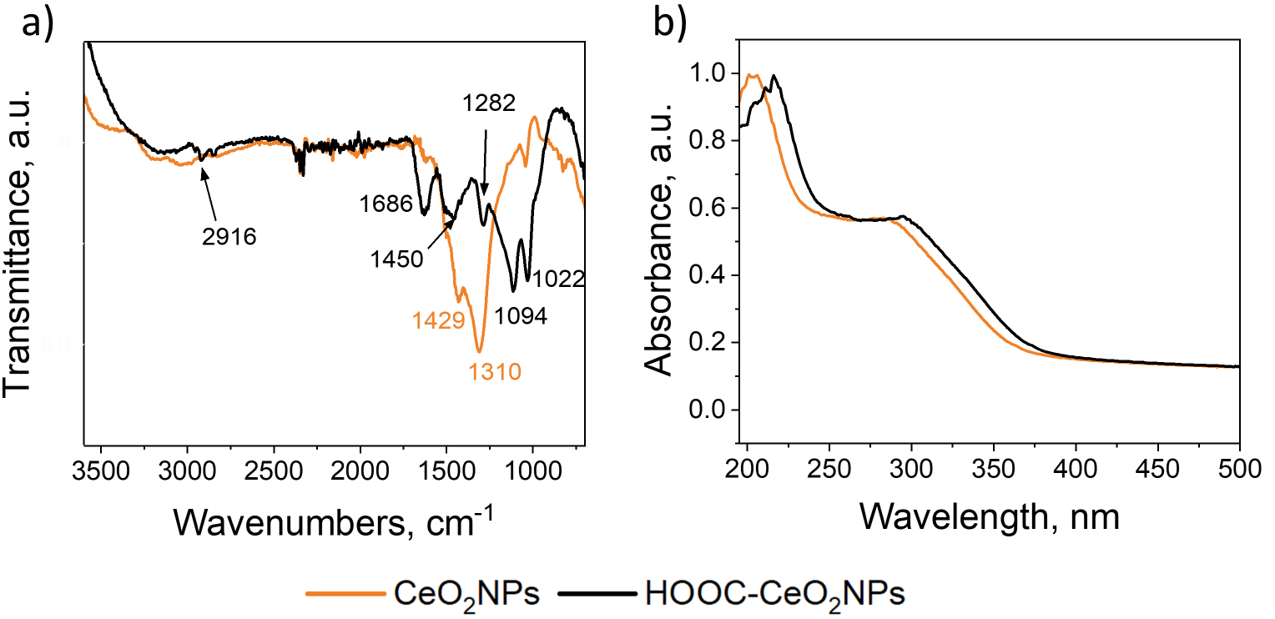
Fig. S1 a) FTIR and b) UV-Vis spectra of CeO₂ NPs (orange line) and HOOC-CeO₂ NPs (black line).
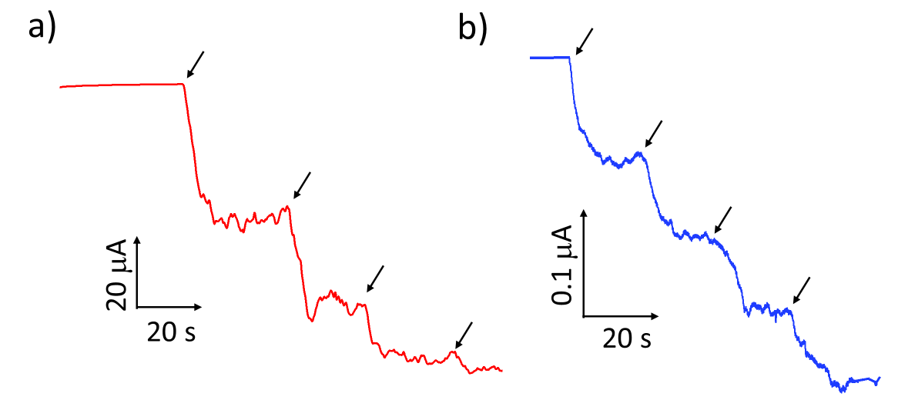
Fig. S2 Comparison of amperometric responses obtained with HRP/SPCE and dAb/HOOC-CeO₂NPs/SPCE for 50 μL additions of 0.3 M H₂O₂ to an electrochemical cell containing 10 mL of 50 mM PB at pH 6.0 supplemented with 50 μL of 100 mM HQ solution.

Table S1 Apparent rate constants calculated for the tested enzyme/nanozymes.
Enzyme/Nanozyme | K_{app}, min⁻¹ | R²
HRP | 5.43 ± 0.03 | 0.998
CeO₂NPs | 1.68 ± 0.01 | 0.999
HOOC-CeO₂NPs | 1.40 ± 0.09 | 0.998
dAb/HOOC-CeO₂NPs | 1.54 ± 0.01 | 0.999
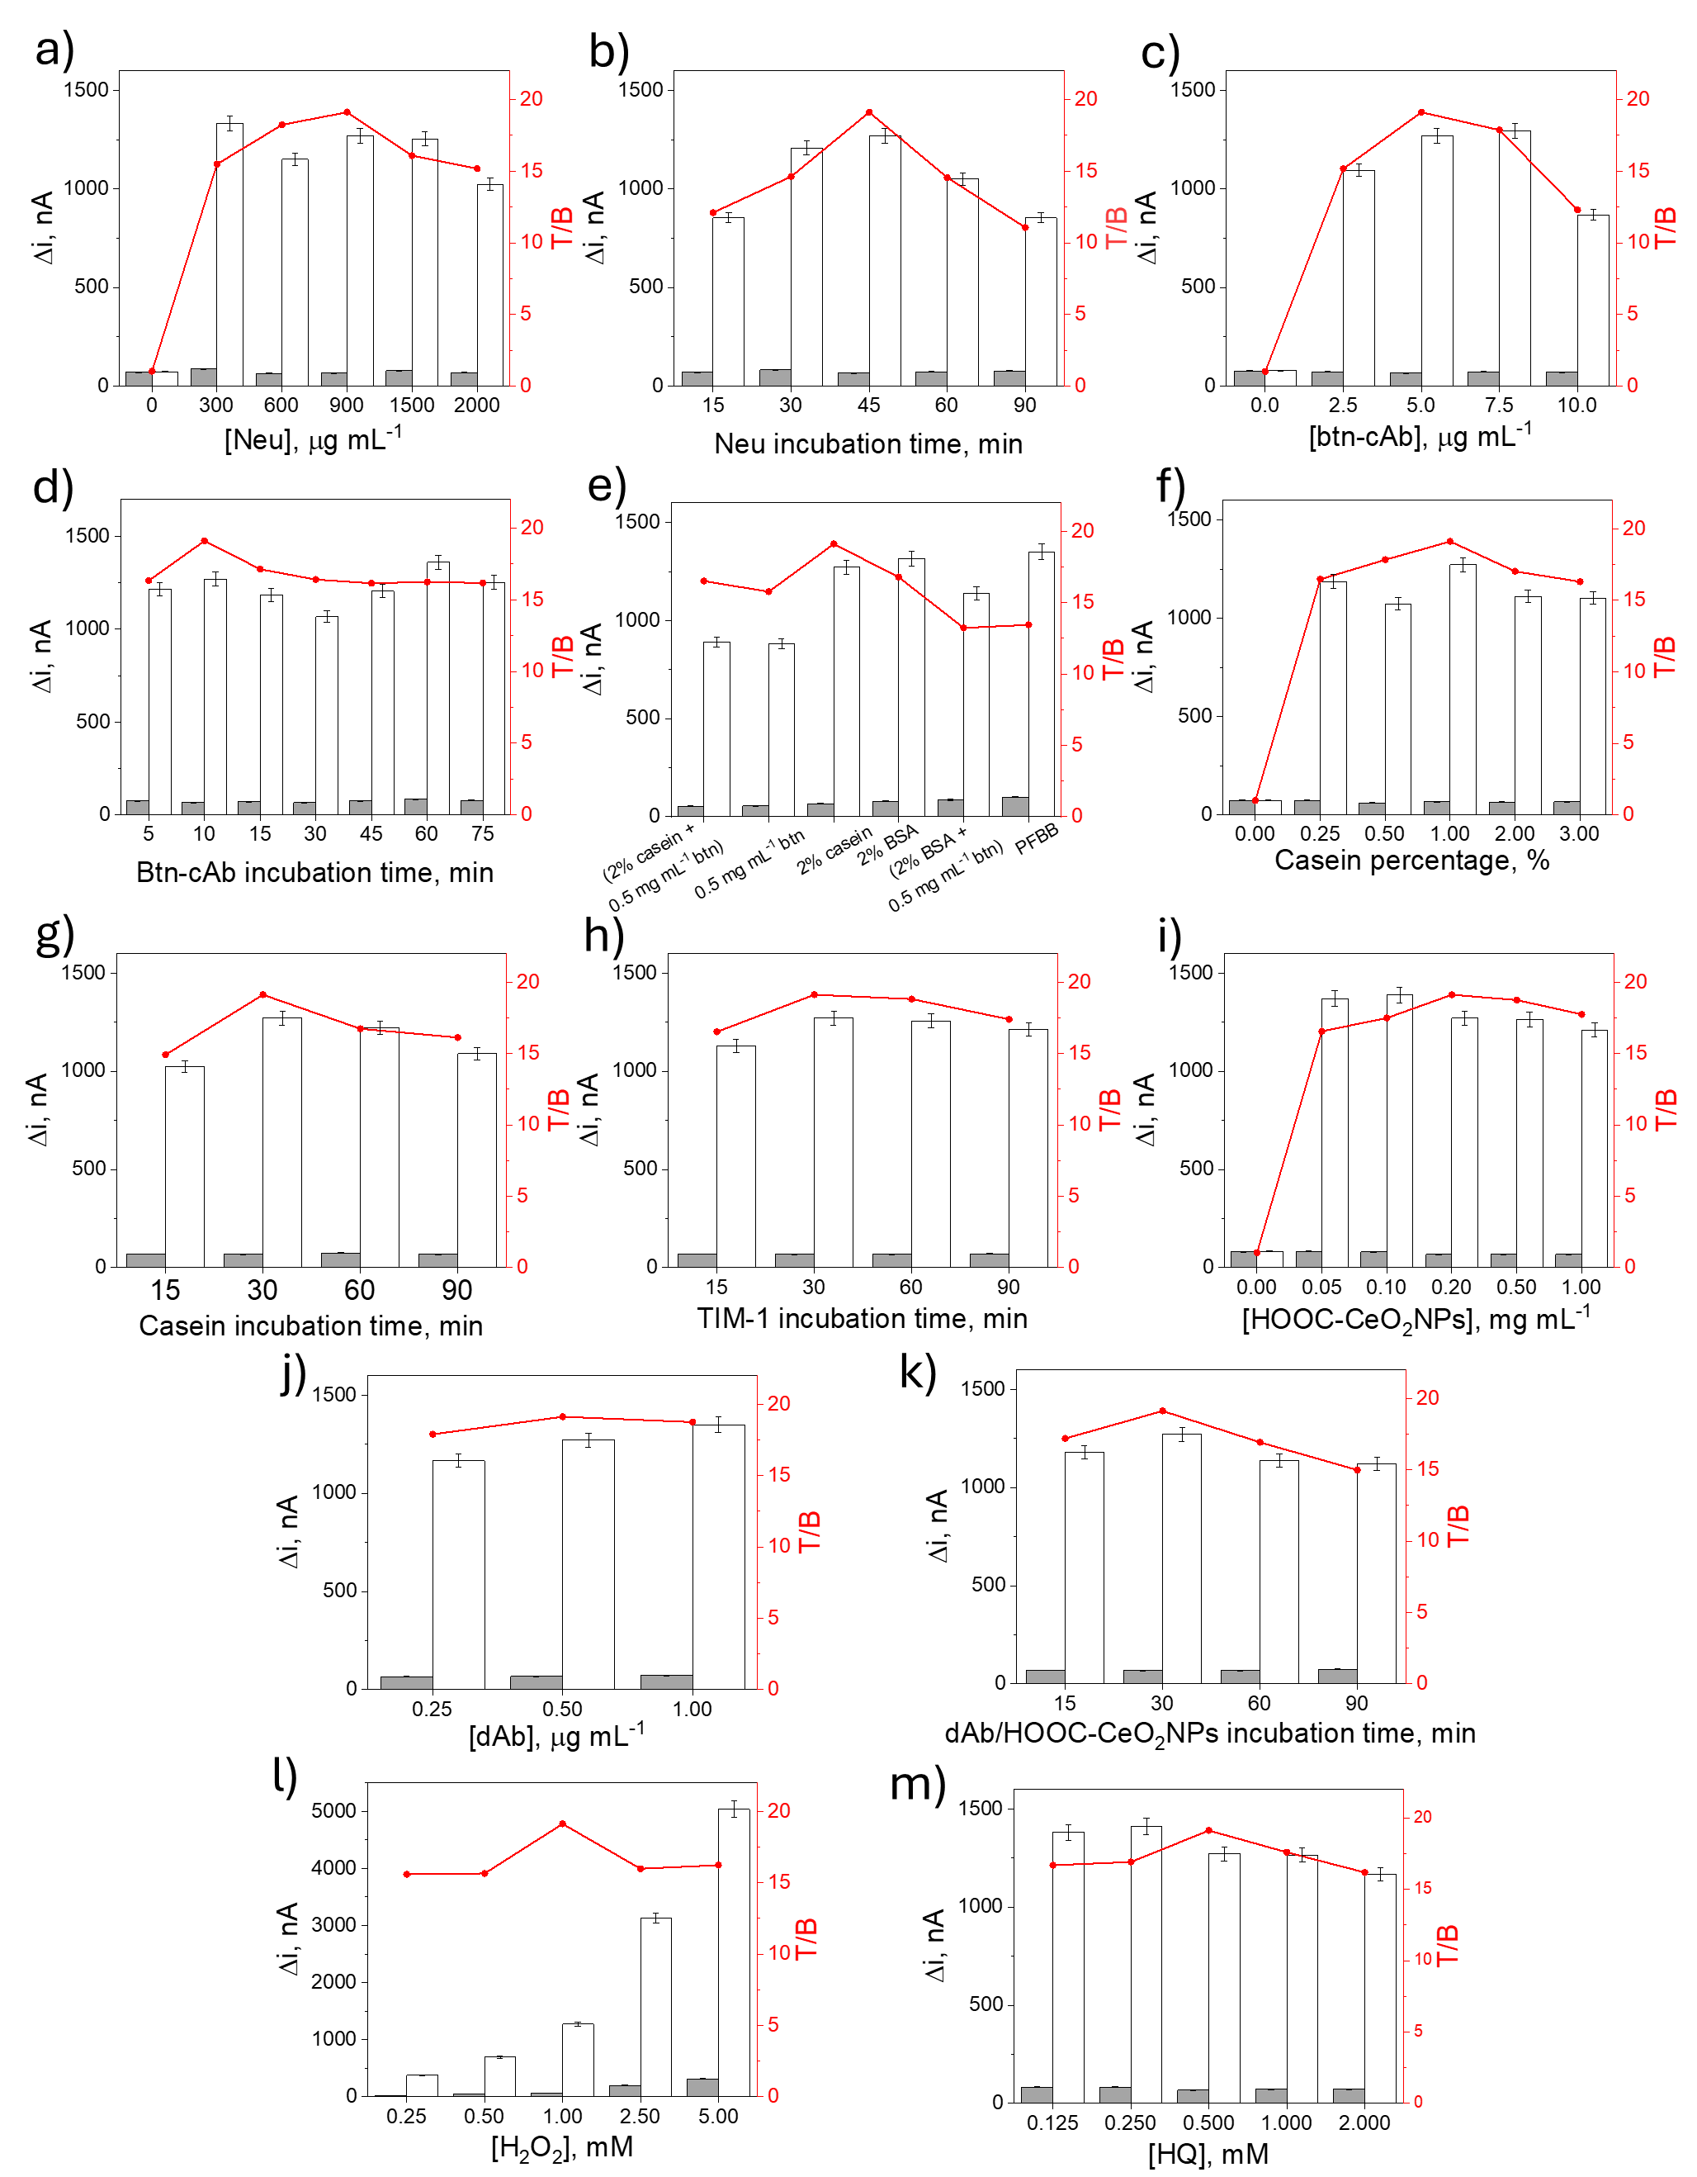
Fig. S3 Amperometric responses measured in the presence (blue bars, T signals) and absence (grey bars, B signals) of 500 pg mL⁻¹ TIM-1 standard, along with the corresponding T/B ratio values (in red), as a function of: a) Neu concentration; b) Neu incubation time; c) btn-cAb concentration; d) btn-cAb incubation time; e) blocking solution; f) casein percentage; g) casein incubation time; h) TIM-1 incubation time; i) HOOC-CeO₂NPs loading; j) dAb loading; k) dAb/HOOC-CeO₂NPs incubation time; l) H₂O₂ concentration; m) HQ concentration.
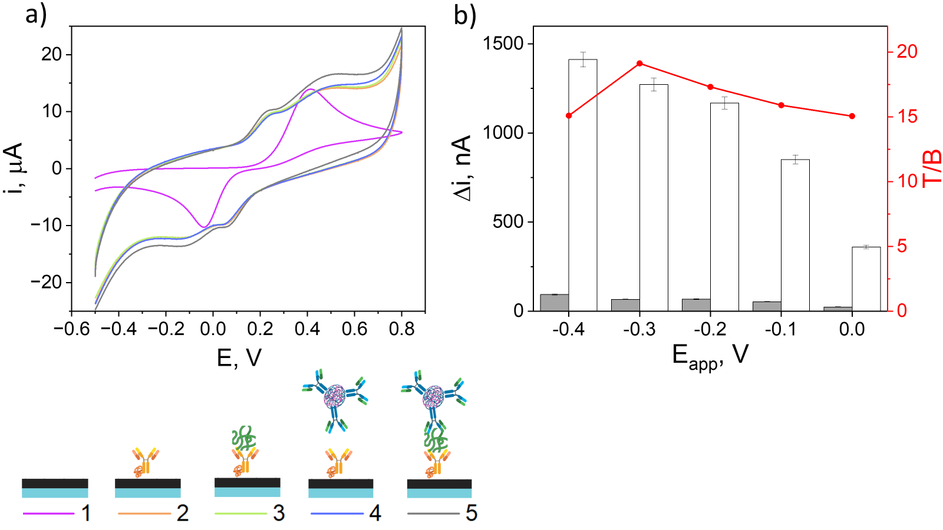
Fig. S4 a) Cyclic voltammograms (scan rate, 50 mV s⁻¹) obtained for 0.5 mM HQ in the presence of 1.0 mM H₂O₂ at the bare SPCE (purple), btn-cAb/SPCE (orange), TIM-1/btn-cAb/SPCE (green), dAb/HOOC-CeO₂NPs/btn-cAb/SPCE (blue) and dAb/HOOC-CeO₂NPs/TIM-1/btn-cAb/SPCE (grey). b) Amperometric responses measured in the presence (white bars, T signals) and absence (grey bars, B signals) of 500 pg mL⁻¹ TIM-1 standard, along with the corresponding T/B ratio values (in red), as a function of the applied detection potential.

Table S2 Optimization of experimental variables involved in the preparation and operation of the developed immunoplatform.
Variable | Tested Range | Selected Value
[Neu], μg mL⁻¹ | 0 – 2000.0 | 900.0
Neu incubation time, min | 15 – 90 | 45
[Btn-cAb], μg mL⁻¹ | 0.0 – 10.0 | 5.0
Btn-cAb incubation time, min | 5 – 75 | 10
Blocking mixture* | A – F | B
[Casein], % (wt.) | 0.2 – 3.0 | 1.0
Casein incubation time, min | 15 – 90 | 30
TIM-1 incubation time, min | 15 – 90 | 30
[HOOC-CeO₂NPs], mg mL⁻¹ | 0.0 – 1.0 | 0.2
[dAb], µg mL⁻¹ | 0.25 – 5.0 | 0.5
dAb/HOOC-CeO₂NPs incubation time, min | 15 – 90 | 30
[H₂O₂], mM | 0.25 – 5.0 | 1.0
[HQ], mM | 0.125 – 2.0 | 0.5
E_{app}, V** | (− 0.4) – (0.0) | − 0.2
* (A) 0.5 mg mL⁻¹ btn, (B) 2 % casein, (C) 2 % casein + 0.5 mg mL⁻¹ btn, (D) 2 % BSA, (E) 2 % BSA + 0.5 mg mL⁻¹ btn, (F) PFBB. ** vs. Ag pseudo-reference electrode.

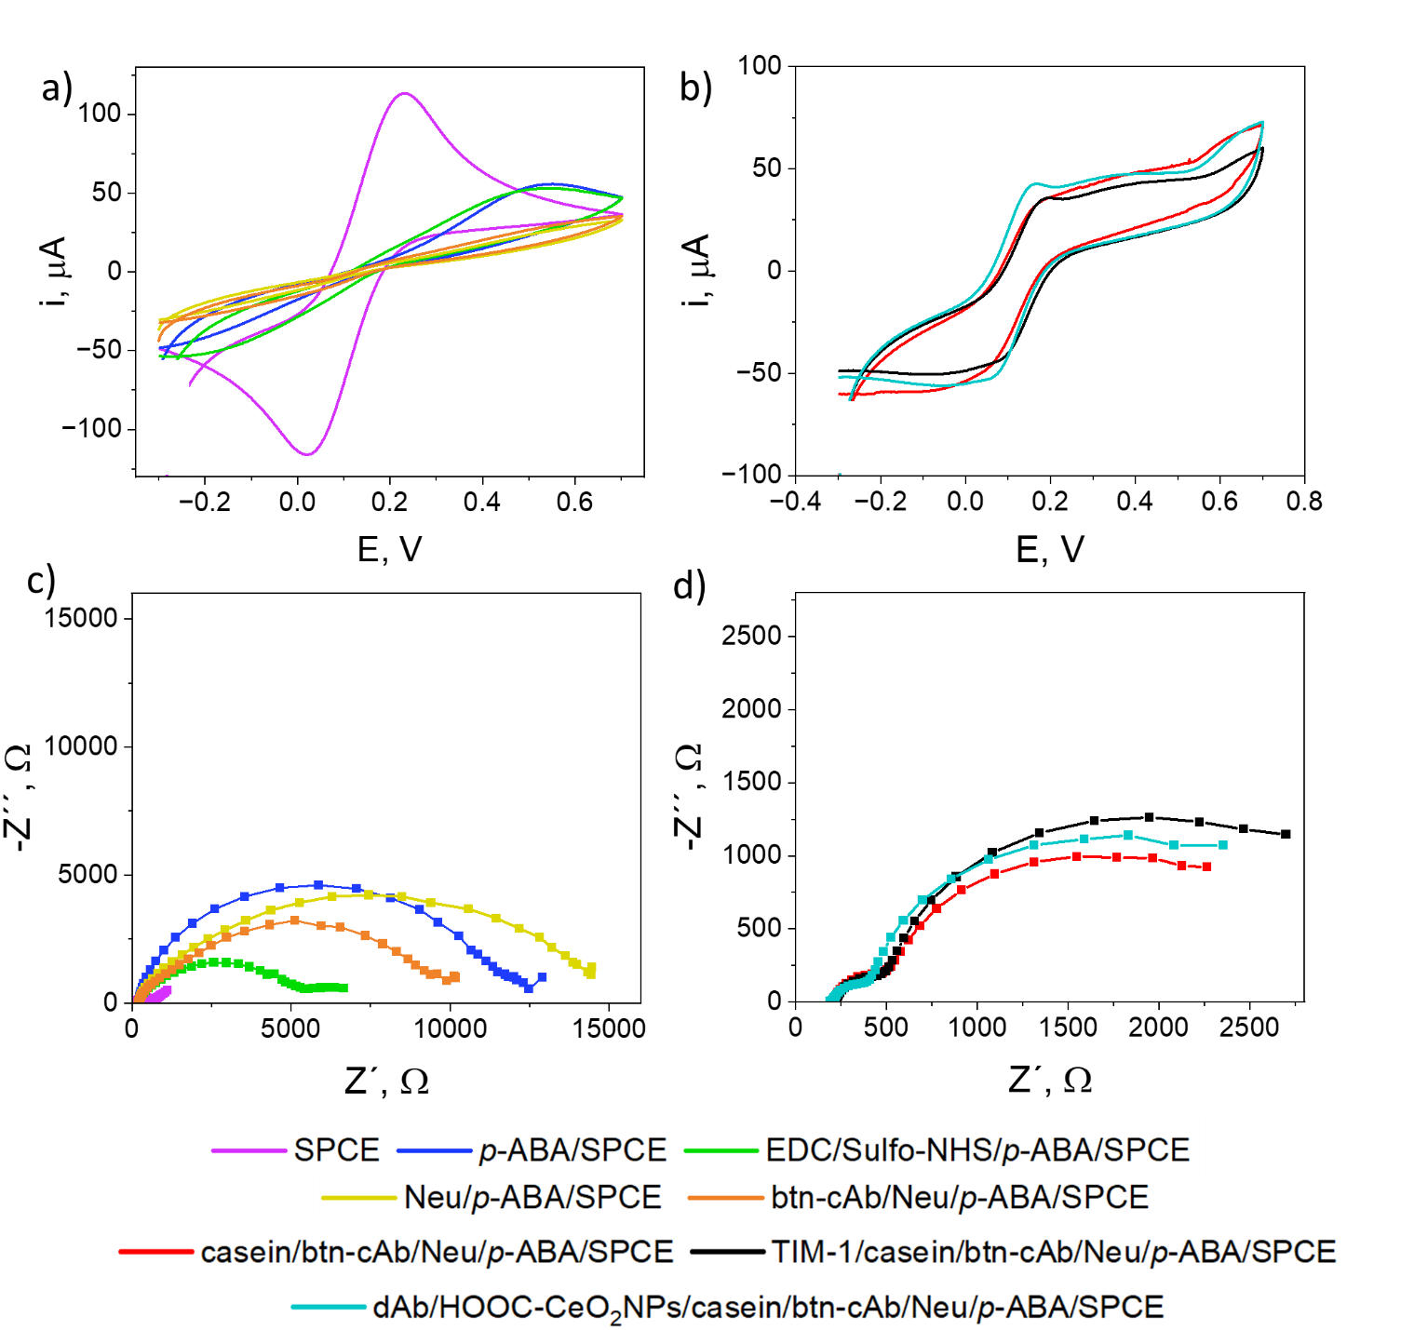
Fig. S5 a, b) Nyquist plots for the [Fe(CN)₆]^{3‒/4‒} redox pair recorded after each step involved in the immunoplatform preparation (n° of frequencies = 50; frequency sweep: 10⁵ – 0.04 Hz; amplitude (rms) = 0.01 V, fitted to the equivalent circuits R1(Q1[R2W1]) a) or R1(R2Q1)(Q2[R3W1]) b). c, d) Cyclic voltammograms of the [Fe(CN)₆]^{3‒/4‒} redox pair (potential scan sweep: − 0.3 V/+ 0.7 V; scan rate: 50 mV s⁻¹). SPCE (purple); p-ABA/SPCE (dark blue); EDC/sulfo-NHS/p-ABA/SPCE, (green); Neu/p-ABA/SPCE (yellow); btn-cAb/Neu/p-ABA/SPCE (orange); casein/btn-cAb/Neu/p-ABA/SPCE (red); TIM-1/casein/btn-cAb/Neu/p-ABA/SPCE (black); and dAb/HOOC-CeO₂NPs/TIM-1/casein/btn-cAb/Neu/p-ABA/SPCE (light blue).

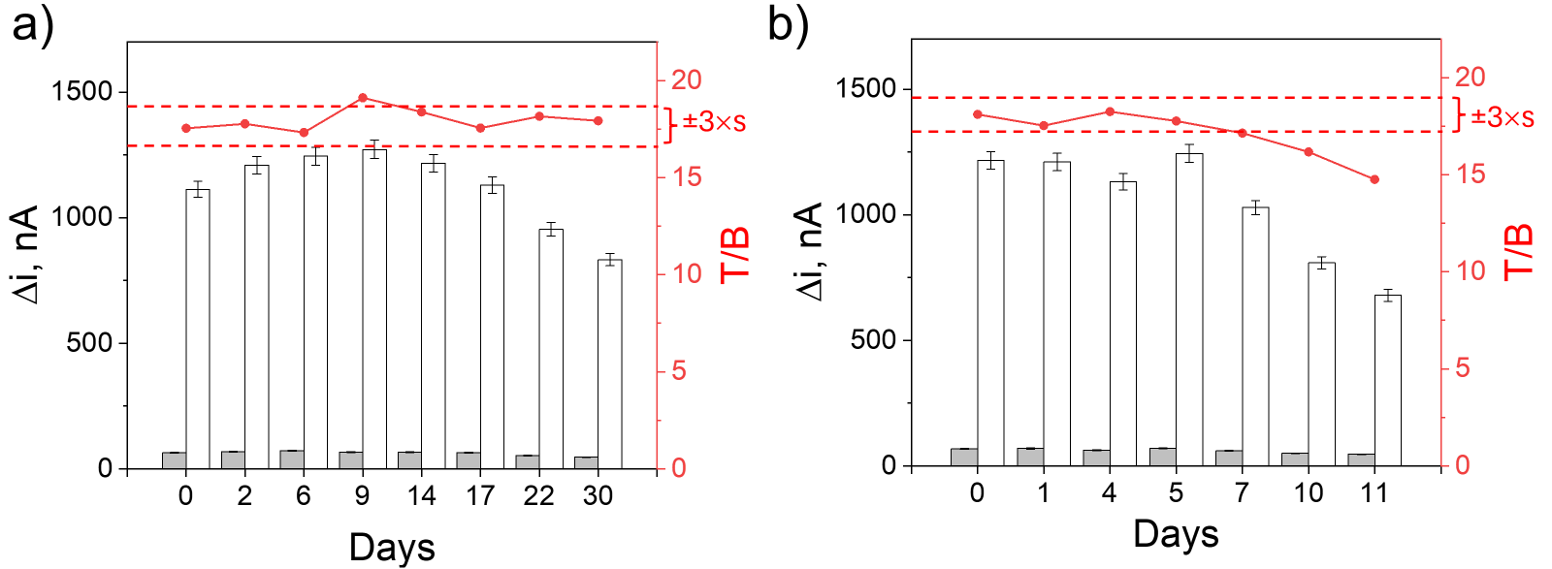
Fig. S6 Storage stability of a) the immunoplatform (casein/btn-cAb/Neu/p-ABA-SPCEs, at 4 °C in a humid chamber) and b) the dAb/HOOC-CeO₂NPs (stored in PBST at 4 °C under constant stirring). Amperometric responses were obtained in the absence (grey bars) and in the presence (white bars) of 500 pg mL⁻¹ TIM-1, along with the corresponding T/B ratio values (red dots and lines). Control limits were defined as ± 3 times the standard deviation of three measurements performed on the day of preparation (day 0).
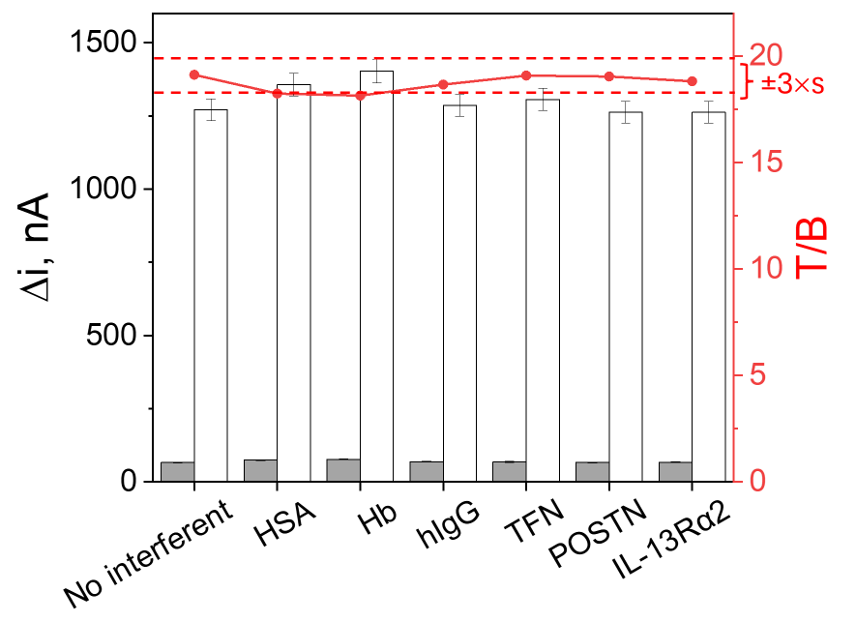
Fig. S7 Amperometric responses obtained with the immunoplatforms for 0 (gray bars) and 500 pg mL⁻¹ (white bars) TIM-1 prepared in the absence (“No interferent”) and in the presence of 1 mg mL⁻¹ hIgG, 50 mg mL⁻¹ HSA, 2.5 mg mL⁻¹ Hb, 5 ng mL⁻¹ TNF, 5 ng mL⁻¹ POSTN, and 50 ng mL⁻¹ IL-13Rα2.

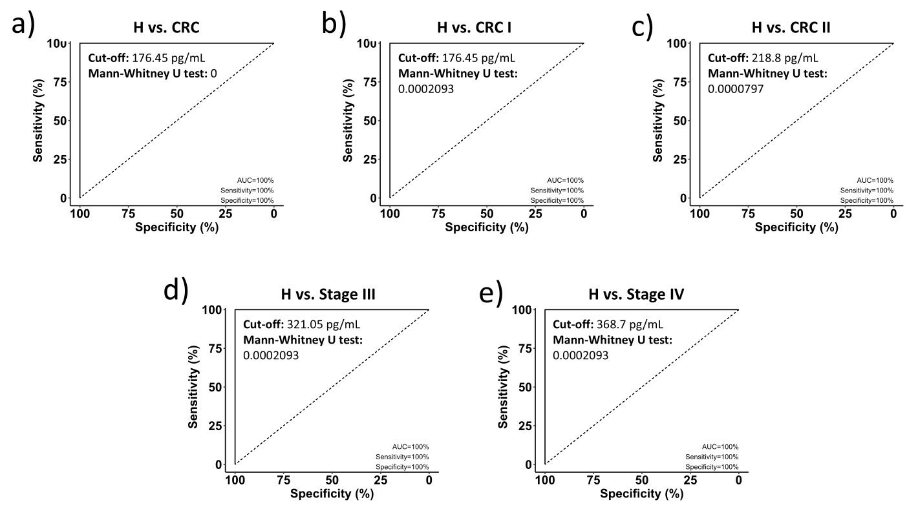
Fig. S8 Analysis of the quantitative results obtained with the developed immunoplatform for the determination of TIM-1by means of ROC curves.

Table S3 TIM-1 recoveries in plasma samples from healthy (H) and colorectal (CRC) patients at different stages.
Sample | % Recovery
H | 98.2
stage I CRC | 99.2
stage II CRC | 104.0
stage III CRC | 100.6
stage IV CRC | 100.3

References
S1. Wang Y, Martin TA, Jiang WG (2013) HAVcR-1 expression in human colorectal cancer and its effects on colorectal cancer cells in vitro. Anticancer Res 33(1):207–214. PMID: 2326S57147
S2. Telford EJA, Jiang WG, Martin TA (2017) HAVcR-1 involvement in cancer progression. Histopathology 32:121–128. https://doi.org/10.14670/HH-11-817
S3. Zheng X, Xu K, Chen L, Zhou Y, Jiang J (2019) Prognostic value of TIM-1 expression in human non-small-cell lung cancer. J Transl Med 17:178. https://doi.org/10.1186/s12967-019-1931-2
S4. Kong X, Fu M, Niu X, Jiang H (2020) Comprehensive analysis of the expression, relationship to immune infiltration and prognosis of TIM-1 in cancer. Front Oncol 10:1086. https://doi.org/10.3389/fonc.2020.01086
S5. Chen L, Qing J, Xiao Y, Huang X, Chi Y, Chen Z (2022) TIM-1 promotes proliferation and metastasis, and inhibits apoptosis, in cervical cancer through the PI3K/AKT/P53 pathway. BMC Cancer 22:370. https://doi.org/10.1186/s12885-022-09386-7
S6. Wichukchinda N, Nakajima T, Saipradit N, Nakayama EE, Ohtani H, Rojanawiwat A, Pathipvanich P, Ariyoshi K, Sawanpanyalert P, Shioda T, Kimura A (2010) TIM1 haplotype may control the disease progression to AIDS in a HIV-1-infected female cohort in Thailand. AIDS 24:1625–1631. https://doi.org/10.1097/QAD.0b013e32833a8e6d
S7. Mosbruger TL, Duggal P, Goedert JJ, Kirk GD, Hoots WK, Tobler LH, Busch M, Peters MG, Rosen HR, Thomas DL, Thio C (2010) Large-scale candidate gene analysis of spontaneous clearance of hepatitis C virus. J Infect Dis 201:1371–1380. https://doi.org/10.1086/651606
S8. Kim HY, Eyheramonho MB, Pichavant M, Cambaceres CG, Matangkasombut P, Cervio G, Kuperman S, Moreiro R, Konduru K, Manangeeswaran M, Freeman GJ (2011) A polymorphism in TIM1 is associated with susceptibility to severe hepatitis A virus infection in humans. The Journal of Clinical Investigation 121:1111–1118. https://doi.org/10.1172/JCI44182
S9. Hu S, Xie Y, Zhou N, Jin L, Tan Y, Liu D, Gong Y, Liu L, Liu J, Liu W, Chen Y (2011) Expression of T-cell immunoglobulin-and mucin-domain-containing molecules-1 and-3 (Tim-1 and Tim-3) in Helicobacter pylori infection. Helicobacter 16:373–381. https://doi.org/10.1111/j.1523-5378.2011.00855.x
S10. Duanghathaipornsuk S, Alateeq FAO, Kim SS, Kim DS, Alba-Rubio AC (2020) The effects of size and content of cerium oxide nanoparticles on a composite sensor for hydroxyl radicals detection. Sens Actuators B 321:128467. https://doi.org/10.1016/J.SNB.2020.128467
S11. Serafín V, Valverde A, Martínez-García G, Martínez-Periñán E, Comba F, Garranzo-Asensio M, Barderas R, Yáñez-Sedeño P, Campuzano S, Pingarrón JM (2019) Graphene quantum dots-functionalized multi-walled carbon nanotubes as nanocarriers in electrochemical immunosensing. Determination of IL-13 receptor α2 in colorectal cells and tumor tissues with different metastatic potential. Sens Actuators B Chem 284:711–722. https://doi.org/10.1016/J.SNB.2019.01.012
S12. Sánchez-Tirado E, González-Cortés A, Yáñez-Sedeño P, Pingarrón JM (2018) Magnetic multiwalled carbon nanotubes as nanocarrier tags for sensitive determination of fetuin in saliva. Biosens Bioelectron, 113:88–94. https://doi.org/10.1016/J.BIOS.2018.04.056
S13. Martínez-García G, Agüí L, Yáñez-Sedeño P, Pingarrón JM (2016) Multiplexed electrochemical immunosensing of obesity-related hormones at grafted graphene-modified electrodes. Electrochim Acta 202:209–215. https://doi.org/10.1016/J.ELECTACTA.2016.03.140
S14. Arévalo B, Blázquez-García M, Valverde A, Serafín V, Montero-Calle A, Solís-Fernández G, Barderas R, Campuzano S, Yáñez-Sedeño P, Pingarrón JM (2022) Binary MoS₂ nanostructures as nanocarriers for amplification in multiplexed electrochemical immunosensing: Simultaneous determination of B cell activation factor and proliferation-induced signal immunity-related cytokines. Microchim Acta 189:143. https://doi.org/10.1007/s00604-022-05250-4.
S15. Sigma-Aldrich. Enzymatic assay of peroxidase (EC 1.11.1.7) 2,2’-Azino-bis(3-Ethylbenzthiazoline-6-Sulfonic Acid) as a substrate. https://www.sigmaaldrich.com/ES/es/technical-documents/protocol/protein-biology/enzyme-activity-assays/enzymatic-assay-of-peroxidase-abts-as-substrate. Accesed 4 August 2024
S16. Liu YH, Zuo JC, Ren XF, Yong L (2014) Synthesis and character of cerium oxide (CeO₂) nanoparticles by the precipitation method. Metalurgia 53:463–465. https://hrcak.srce.hr/file/180642
S17. Latha P, Prakash K, Karuthapandian S (2018) Effective photodegradation of CR & MO dyes by morphologically controlled cerium oxide nanocubes under visible light illumination. Optik 154:242–250. https://doi.org/10.1016/J.IJLEO.2017.10.054
S18. Tao Y, Wang H, Xia Y, Zhang G, Wu H, Tao G (2010) Preparation of shape-controlled CeO₂ nanocrystals via microwave-assisted method. Mater Chem Phys 124:541–546. https://doi.org/10.1016/J.MATCHEMPHYS.2010.07.007
S19. Kaushik A, Solanki PR, Ansari AA, Ahmad S, Malhotra BD (2009) A nanostructured cerium oxide film-based immunosensor for mycotoxin detection. Nanotechnology 20:055105. https://doi.org/10.1088/0957-4484/20/5/055105
S20. Campuzano S. (2004) Desarrollo de biosensores amperométricos enzimáticos basados en monocapas autoensambladas. Tesis doctoral, Universidad Complutense de Madrid. https://dialnet.unirioja.es/servlet/tesis?codigo=195611&info=resumen&idioma=SPA
S21. Serafín V (2015) Biosensores electroquímicos basados en nanomateriales y en materiales magnéticos para la determinación de analitos de interés bioquímico. Tesis doctoral, Universidad Complutense de Madrid. https://hdl.handle.net/20.500.14352/26206
S22. Cao-Milán R, He LD, Shorkey S, Tonga GY, Wang LS, Zhang X, Uddin I, Das R, Sulak M, Rotello VM (2017) Modulating the catalytic activity of enzyme-like nanoparticles through their surface functionalization. Mol Syst Des Eng 2:624–628. https://doi.org/10.1039/C7ME00055C
S23. Morales-Urrea D, López-Córdoba A, Contreras EM (2023) Inactivation kinetics of horseradish peroxidase (HRP) by hydrogen peroxide. Sci Rep 13:13363. https://doi.org/10.1038/s41598-023-39687-1
S24. Thermo Fisher Scientific. Avidin and streptavidin conjugates. https://www.thermofisher.com/es/es/home/references/molecular-probes-the-handbook/antibodies-avidins-lectins-and-related-products/avidin-streptavidin-neutravidin-and-captavidin-biotin-binding-proteins-and-affinity-matrices.html. Accessed 20 November 2024
S25. Valverde A, Serafín V, Montero-Calle A, González-Cortés A, Barderas R, Yáñez-Sedeño P, Campuzano S, Pingarrón JM (2020) Carbon/inorganic hybrid nanoarchitectures as carriers for signaling elements in electrochemical immunosensors: First biosensor for the determination of the inflammatory and metastatic processes biomarker RANK-ligand. ChemElectroChem 7:810. https://doi.org/10.1002/celc.201902025

.

