Appendix B: Patient Example – CPPopt Curves for MAP Based Sx_a and Mx_a
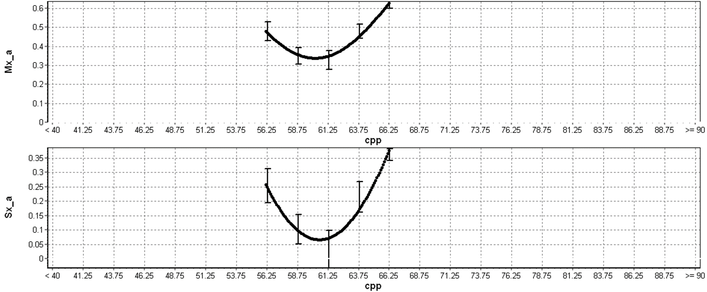
a.u. = arbitrary units, cm = centimeters, CPP = cerebral perfusion pressure, FVm = mean flow velocity, FVs = systolic flow velocity, MAP = mean arterial pressure, Mx_a = MAP based mean flow index (correlation between FVm and MAP), Sx_a = MAP based systolic flow index (correlation between FVs and MAP).

