Supplementary figure 1: Length of surgery.
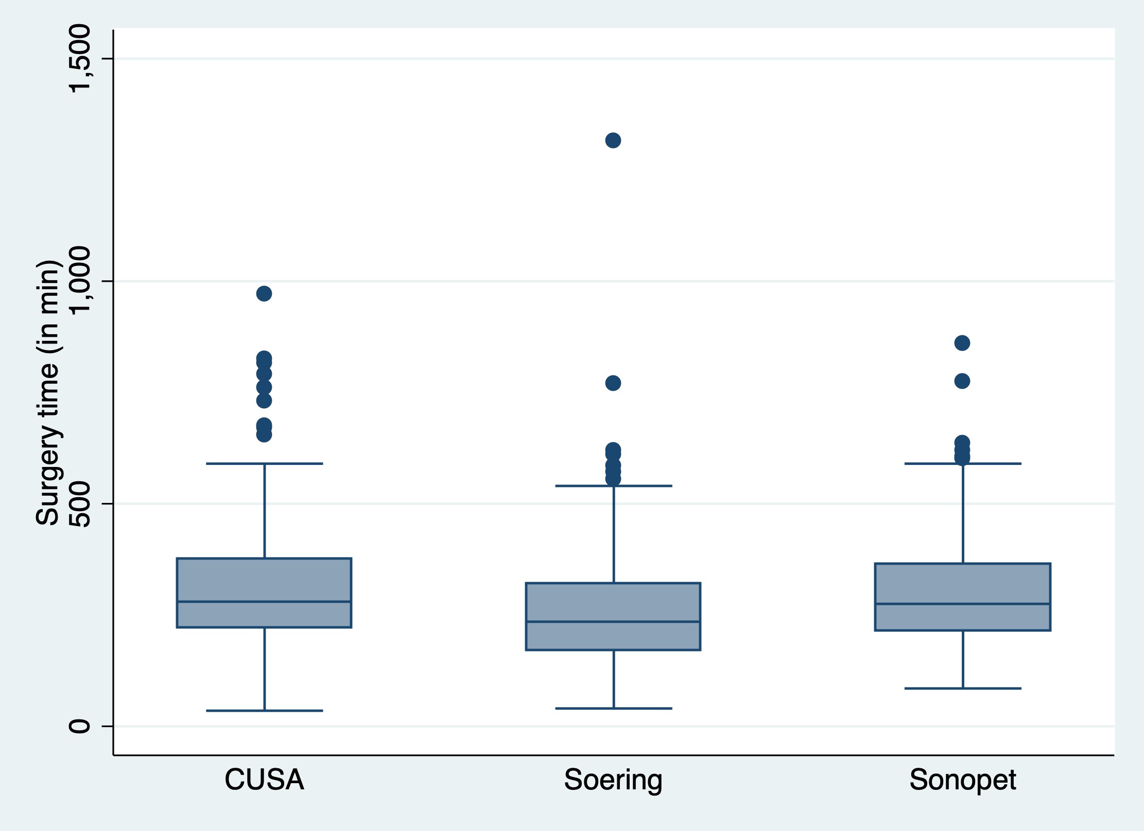
The figures display the median with 25th – 75th percentile (box), the upper and lower adjacent values (whiskers) and outliers (dots).

Ultrasonic aspiration in neurosurgery: comparative analysis of complications and outcome for three commonly used models
Stephanie Henzi^{1,2}, MMed; Niklaus Krayenbühl^{1,2}, MD; Oliver Bozinov^{1,2}, MD; Luca Regli, MD; Martin N. Stienen^{1,2}, MD/FEBNS
¹ Department of Neurosurgery, University Hospital Zurich, Zurich, Switzerland
² Clinical Neuroscience Center, University of Zurich, Zurich, Switzerland

Corresponding author:

Martin N. Stienen, MD
Fellow of the European Board of Neurological Surgeons (FEBNS)
University Hospital Zurich
Clinical Neuroscience Center
University of Zurich
Frauenklinikstrasse 10
8091 Zurich, Switzerland
Tel: +41-(0)44-255-1111

Email: mnstienen@gmail.com

