Supplementary figure 1. Flow chart for inclusion in the study.
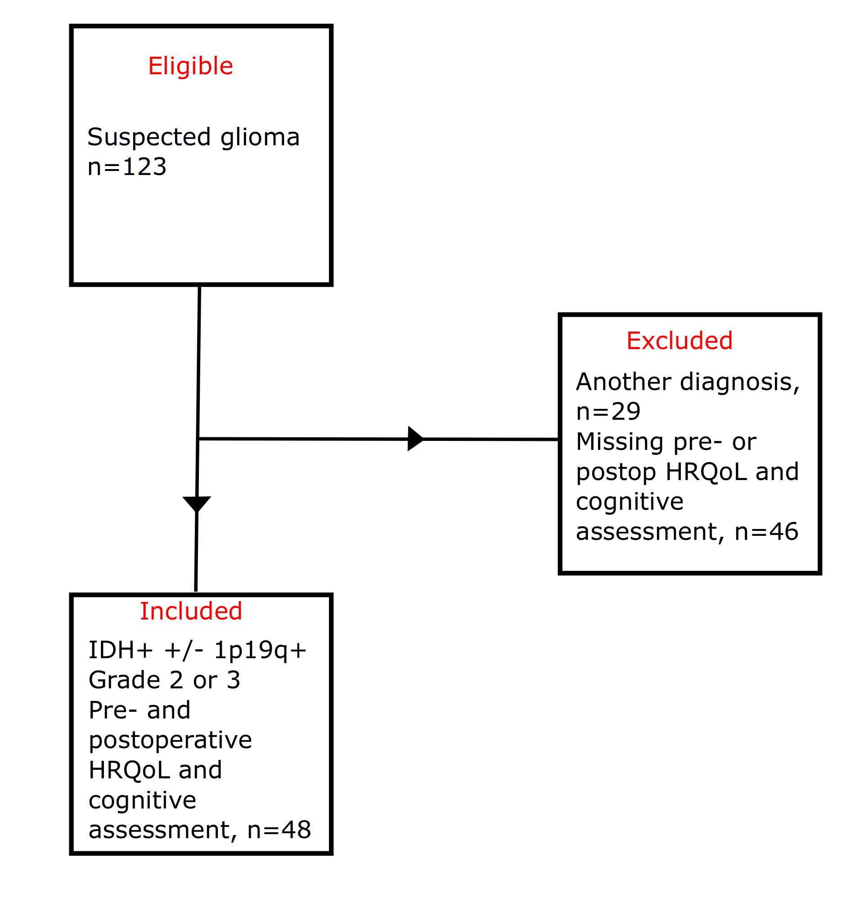
For the patients with “another diagnosis”, this included astrocytoma grade 4/glioblastoma (n=20), ganglioglioma (n=3), dysembryoplastic neuroepithelial tumor (n=1), neurocytoma (n=1), and unclear/other diagnosis than brain tumor (n=4)).

