Supplementary:
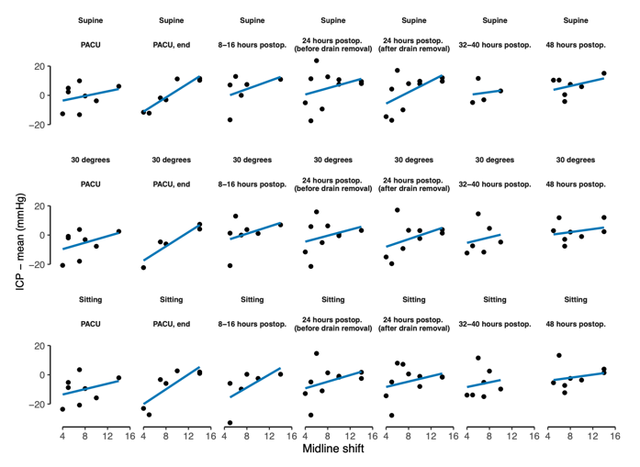
a)
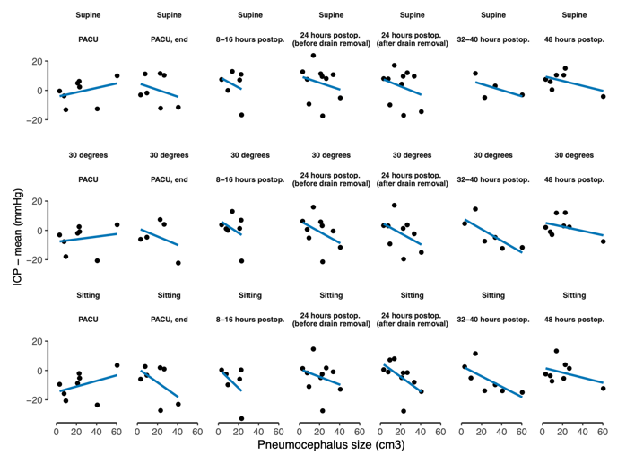
b)
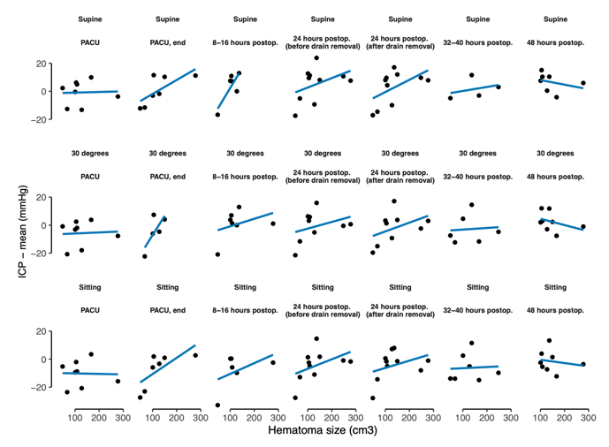
c)
Supplementary Fig. 1 a–c: Scatter plots depicting the relationships between mean intracranial pressure (ICP) and radiographic variables: (a) midline shift, (b) pneumocephalus volume, and (c) preoperative hematoma size—stratified by each position (supine, 30° elevation, and sitting). Each panel highlights how these variables correlate with ICP under different positional conditions throughout the study period.

