Impact of cyst size on recurrence

Comparison by histology
Supplementary Table 1. Comparison of maximum dimension in all three investigated axes according to histopathology
Histopathology/AP | Mean ± SD | Median (IQR) | Mean Rank | p*
Colloid | 21.52 ± 7.1 | 22.5 (16.5-25) | 37.75 | <0.001
Dermoid | 29 ± 13.73 | 32 (19.5-38.5) | 58.12 | <0.001
Epidermoid | 32.52 ± 11.48 | 29.5 (24.5-39.5) | 64.12 | <0.001
Neurenteric | 36.13 ± 18.51 | 42 (28.7-46.5) | 65.67 | <0.001
Rathke Cleft | 15.48 ± 4.34 | 15 (13.8-18) | 18.86 | <0.001
Histopathology/LL | Mean ± SD | Median (IQR) | Mean Rank | p**
Colloid | 22.4 ± 6.6 | 24.5 (17.45-28) | - | <0.001
Dermoid | 34.75 ± 11.52 | 35.5 (27-42.5) | - | <0.001
Epidermoid | 29.93 ± 10.44 | 28.1 (23-37.5) | - | <0.001
Neurenteric | 36.46 ± 17.35 | 38 (28.2-45.5) | - | <0.001
Rathke Cleft | 16.01 ± 2.93 | 16 (14-18) | - | <0.001
Histopathology/CC | Mean ± SD | Median (IQR) | Mean Rank | p**
Colloid | 22.24 ± 7.49 | 22 (16-29) | - | <0.001
Dermoid | 28.5 ± 11.09 | 28.5 (21-36) | - | <0.001
Epidermoid | 34.45 ± 12.05 | 33.5 (24.4-42.5) | - | <0.001
Neurenteric | 51.36 ± 18.98 | 50 (41.5-60.5) | - | <0.001
Rathke Cleft | 15.5 ± 4.05 | 16.1 (12-19) | - | <0.001
*Kruskal-Wallis H Test, **Welch ANOVA Test

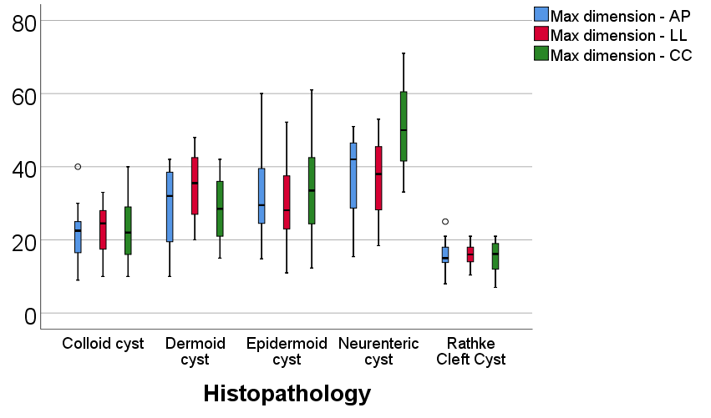
Figure 1. Comparison of maximum dimension in all three investigated axes according to histopathology

Comparison by recurrence
Supplementary Table 2. Comparison of maximum dimensions on investigated axes according to the existence of recurrence
Dimension axis/Recurrence (Median (IQR)) | Absent | Present | p*
Antero-Posterior | 24 (16-30) | 29.5 (21-39.75) | 0.087
Latero-lateral | 24 (17.1-31) | 27 (19.25-37) | 0.248
Cranio-caudal | 24 (17.1-36.1) | 30.5 (20-42.75) | 0.154
*Mann-Whitney U Test
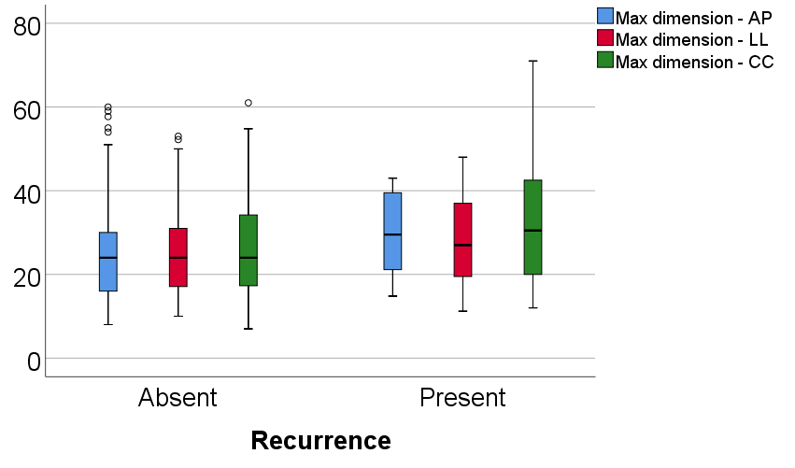
Figure 2. Comparison of maximum dimensions on investigated axes according to the existence of recurrence

Multivariable regression
Supplementary Table 3. Multivariable binomial logistic regression models used in the prediction of recurrence using localization on coronal/axial axis and maximum antero-posterior dimension
Parameter/Model* | OR (95% C.I.) | p
Complex – Coronal | 6.906 (2.149-22.190) | 0.001
Max dimension - AP | 0.996 (0.950-1.044) | 0.862
Parameter/Model** | OR (95% C.I.) | p
Median&Paramedian – Axial | 5.702 (1.646-19.759) | 0.006
Max dimension – AP | 0.997 (0.951-1.045) | 0.891
*Multivariable binomial logistic regression model, χ² (2) = 13.053, p=0.001, Nagelkerke R2 = 0.197, Hosmer and Lemeshow Test, p=0.617, Sensitivity = 100%; Specificity = 0%, Overall accuracy =79.4%
**Multivariable binomial logistic regression model, χ² (2) = 8.986, p=0.011, Nagelkerke R2 = 0.139, Hosmer and Lemeshow Test, p=0.371, Sensitivity = 100%; Specificity = 0%, Overall accuracy =79.4%

Relative prognostic contribution of histology vs. cisternal localization

Supplementary Table 4. Distribution of the patients according to histopathology and type of cysts according to coronal/axial axis localization
Histopathology/  Coronal axis | Other | Complex |  | p*
Histopathology/  Coronal axis | % | %
Colloid | 36.1% | 0% | <0.001
Dermoid | 2.8% | 7.9%
Epidermoid | 34.7% | 84.2%
Neurenteric | 1.4% | 7.9%
Rathke Cleft | 25% | 0%
Histopathology/  Axial axis | Other | Median&Paramedian |  | p*
Histopathology/  Axial axis | % | %
Colloid | 28.9% | 0% | <0.001
Dermoid | 3.3% | 10%
Epidermoid | 43.3% | 90%
Neurenteric | 4.4% | 0%
Rathke Cleft | 20% | 0%
*Fisher’s Exact Test

Supplementary Table 5. Univariable and multivariable binomial logistic regression models used in the prediction of recurrence based on coronal/axial localization and histopathology
Parameter | Univariable |  | Multivariable*
Parameter | OR (95% C.I.) | p | OR (95% C.I.) | p
Complex location (Coronal) | 6.753 (2.457-18.565) | <0.001 | 8.094 (2.394-27.37) | 0.001
Epidermoid cysts | 2.009 (0.773-5.224) | 0.152 | 0.707 (0.207-2.417) | 0.581
Parameter | Univariable |  | Multivariable**
Parameter | OR (95% C.I.) | p | OR (95% C.I.) | p
Median&paramedian location (Axial) | 5.923 (2.062-17.016) | 0.001 | 5.621 (1.756-17.989) | 0.004
Epidermoid cysts | 2.009 (0.773-5.224) | 0.152 | 1.122 (0.375-3.353) | 0.837
*Multivariable enter approach model, χ² (2) = 15.461, p<0.001, Nagelkerke R² = 0.204, Hosmer and Lemeshow Test, p =0.426, Sensitivity = 100%, Specificity = 0%, Overall accuracy = 79.1%
**Multivariable enter approach model, χ² (2) = 10.790, p=0.005, Nagelkerke R² = 0.146, Hosmer and Lemeshow Test, p =0.526, Sensitivity = 88.5%, Specificity = 34.8%, Overall accuracy = 77.3%

Supplementary Table 6. Distribution of the patients according to the existence of recurrence and histopathology type
Recurrence/  Type | Absent | Present | p*
Recurrence/  Type | % | %
Colloid | 27.6% | 8.7% | 0.062
Dermoid | 3.4% | 8.7% | 0.062
Epidermoid | 48.3% | 65.2% | 0.062
Neurenteric | 2.3% | 8.7% | 0.062
Rathke Cleft | 18.4% | 8.7% | 0.062
Recurrence/  Epidermoid type | Absent | Present | p*
Recurrence/  Epidermoid type | % | %
Other type | 51.7% | 34.8% | 0.167
Epidermoid | 48.3% | 65.2% | 0.167
*Fisher’s Exact Test

Supplementary Table 7. Univariable and multivariable binomial logistic regression models used in the prediction of recurrence based on coronal/axial localization and histopathology
Parameter | Multivariable*
Parameter | OR (95% C.I.) | p
Complex location (Coronal) | 5.925 (1.509-23.267) | 0.011
Histopathology (Reference = Rathke Cleft) | - | -
Colloid | 0.667 (0.085-5.228) | 0.700
Dermoid | 1.663 (0.121-22.906) | 0.704
Epidermoid | 0.871 (0.128-5.923) | 0.888
Neurenteric | 2.021 (0.124-32.815) | 0.621
Parameter | Multivariable**
Parameter | OR (95% C.I.) | p
Median&paramedian location (Axial) | 4.961 (1.497-16.434) | 0.009
Histopathology (Reference = Rathke Cleft) | - | -
Colloid | 0.667 (0.085-5.228) | 0.700
Dermoid | 2.676 (0.223-32.127) | 0.438
Epidermoid | 1.526 (0.281-8.282) | 0.624
Neurenteric | 8.000 (0.690-92.703) | 0.096
*Multivariable enter approach model, χ² (2) = 16.227, p<0.001, Nagelkerke R² = 0.214, Hosmer and Lemeshow Test, p =0.903, Sensitivity = 97.7%, Specificity = 17.4%, Overall accuracy = 80.9%
**Multivariable enter approach model, χ² (2) = 15.313, p=0.009, Nagelkerke R² = 0.203, Hosmer and Lemeshow Test, p =0.806, Sensitivity = 97.7%, Specificity = 17.4%, Overall accuracy = 80.9%

Overall, it can be safely assumed that the localization of cysts based on coronal/axial axes remain a significant and independent predictor over recurrence, even when adjusting for histopathology.

