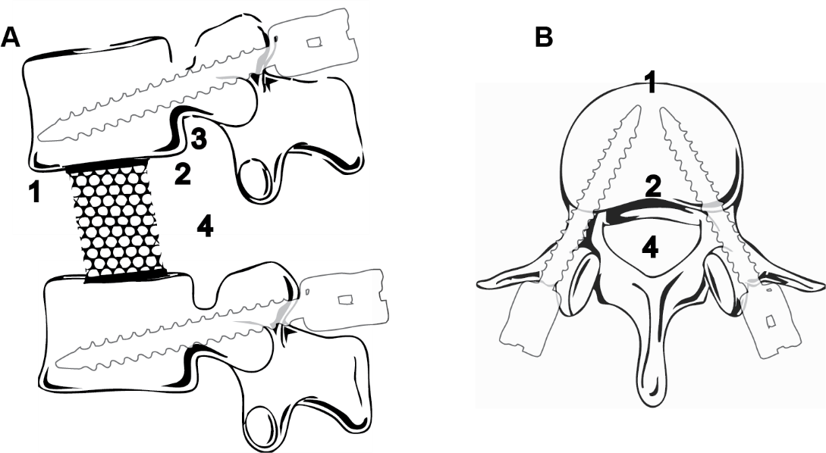

Supplementary Figure 1: Shematic drawing of the anatomical landmarks scored in sagittal (A) and axial (B) view. 1. Anterior vertebral column. 2. Posterior vertebral column. 3. Neuroforamen. 4 Spinal canal.
Adapted from: Servier Medical Art (license: https://creativecommons.org/licenses/by/4.0/)

