Supplementary Figure 1. Flowchart of inclusion and exclusion of patients.
269 patients with spontaneous cerebellar hemorrhage treated at the NIC unit

75 patients excluded:
63 Due to secondary etiology
11 Due to missing data
1 <18 years

194 patients included

There were 269 patients with sCH (diagnostic codes I16.3 and I16.4) treated at the NIC unit, Uppsala University Hospital, between 1 January 2008 and 31 August 2024, who were eligible for inclusion in this study. For the 269 patients, 75 were excluded; 63 patients had secondary etiology (e.g., hemorrhage due to trauma, intracranial tumors, vascular malformations, or neurosurgical procedures), 11 patients had missing clinical and radiological data, and 1 patient was younger than 18 years of age. The final cohort included 194 sCH patients.
NIC = Neurointensive care. sCH = Spontaneous cerebellar hemorrhage.

Supplementary Figure 2. GODS in relation to surgical approach
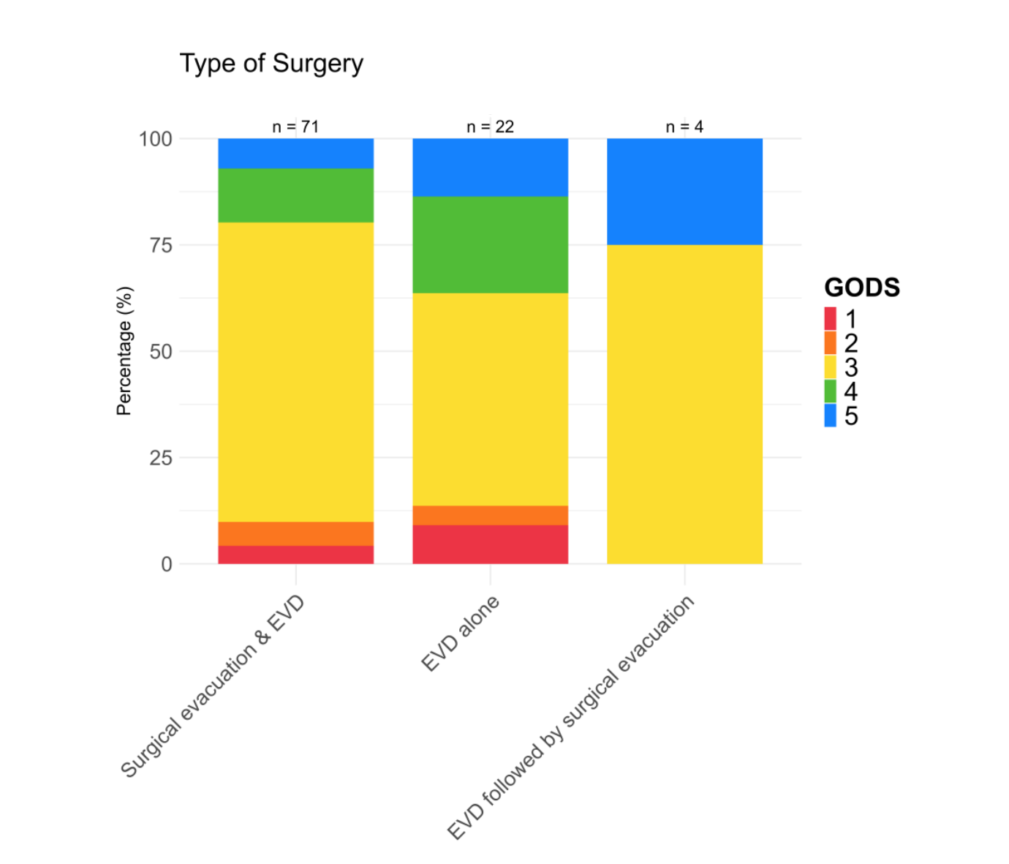
The figure illustrates the outcome distribution for each surgical approach.
EVD = External ventricular drainage. GODS = Glasgow Outcome Scale at Discharge.

Supplementary Figure 3. Long-term mortality in relation to age in the surgical and conservatively managed sub-cohorts – Kaplan-Meier analyses 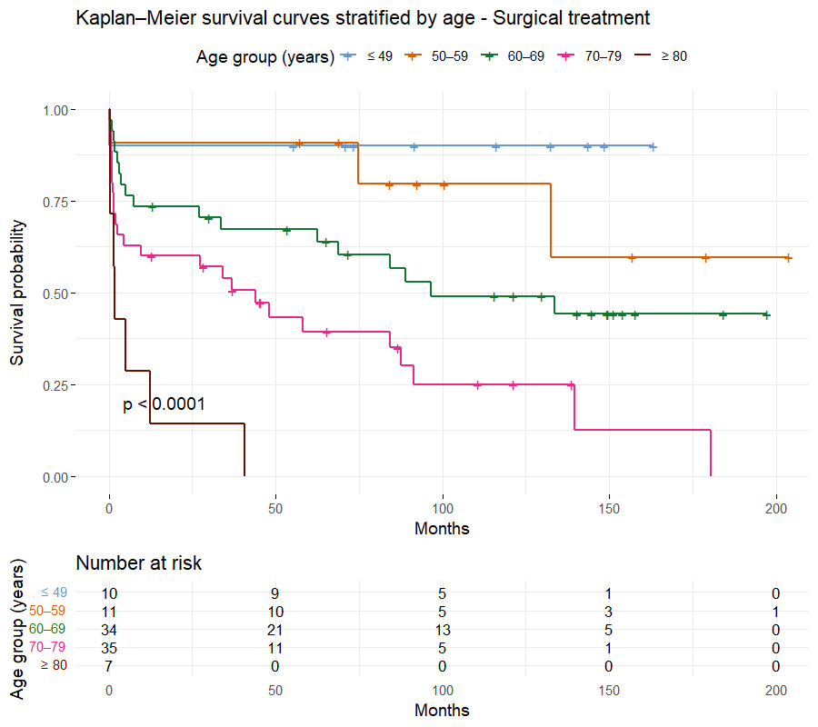

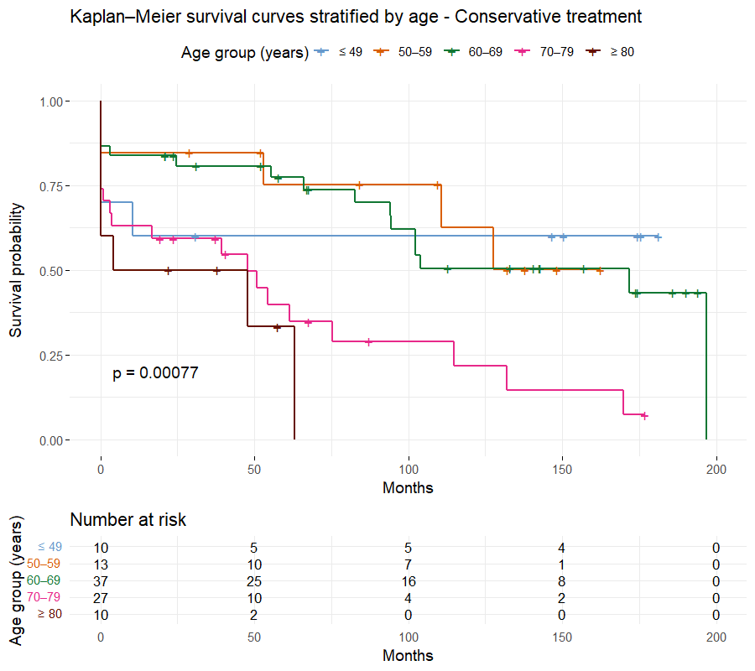
p < 0.05 indicates statistical significance.

