Supplement A: Visual aid for self-evaluation
Compared to 100 people of your age, you are better than…

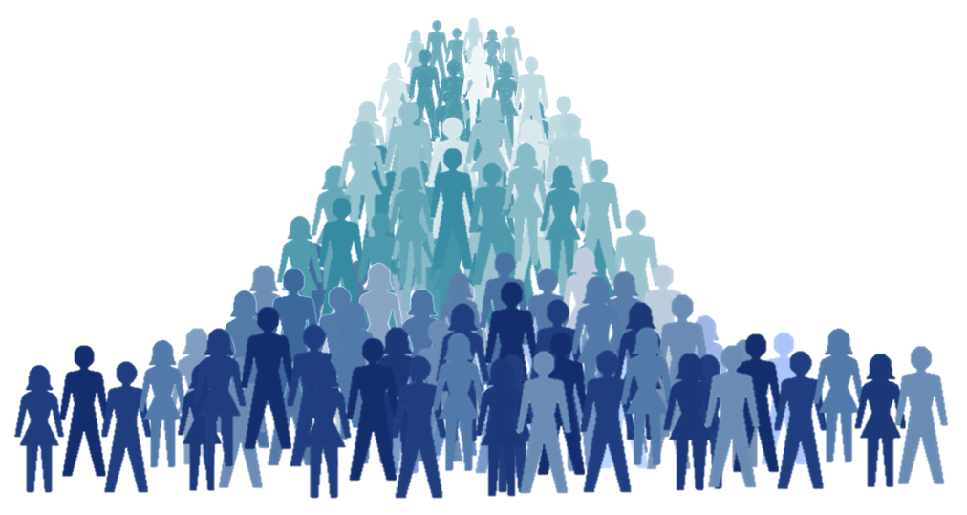
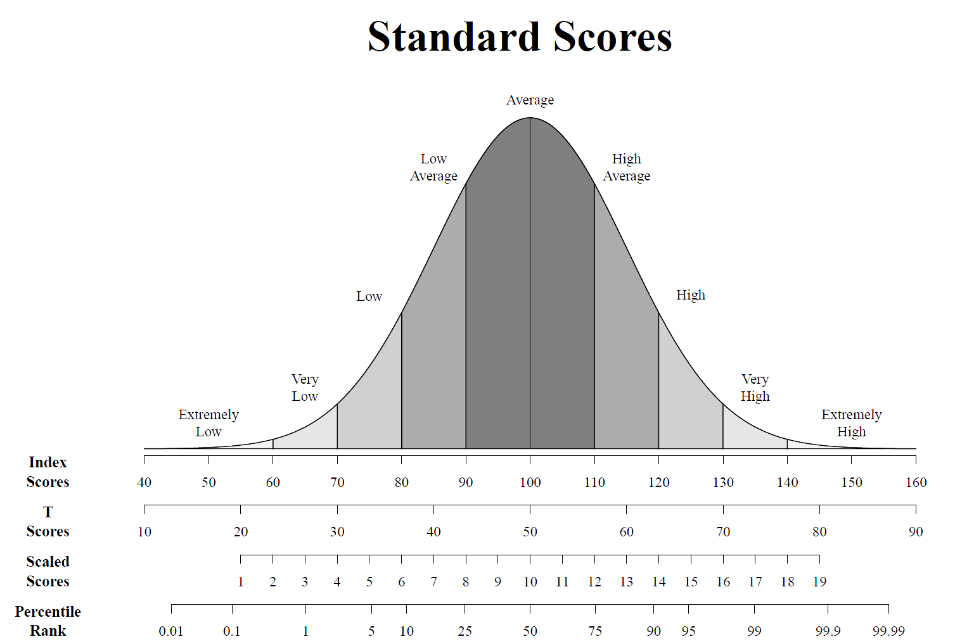
The Average The Worst Best

