Supplement B: Visual aid for self-evaluation with examples
Compared to 100 people of your age, you are better than…

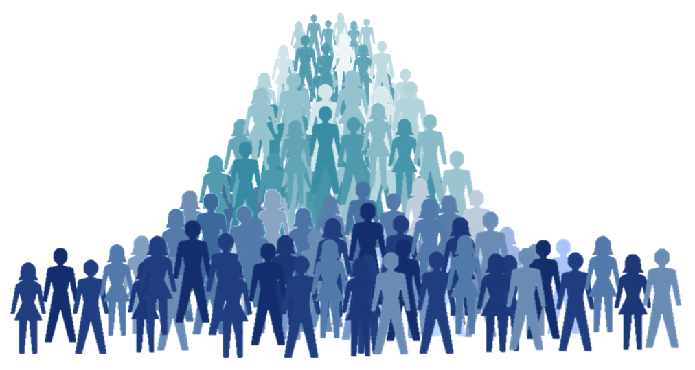


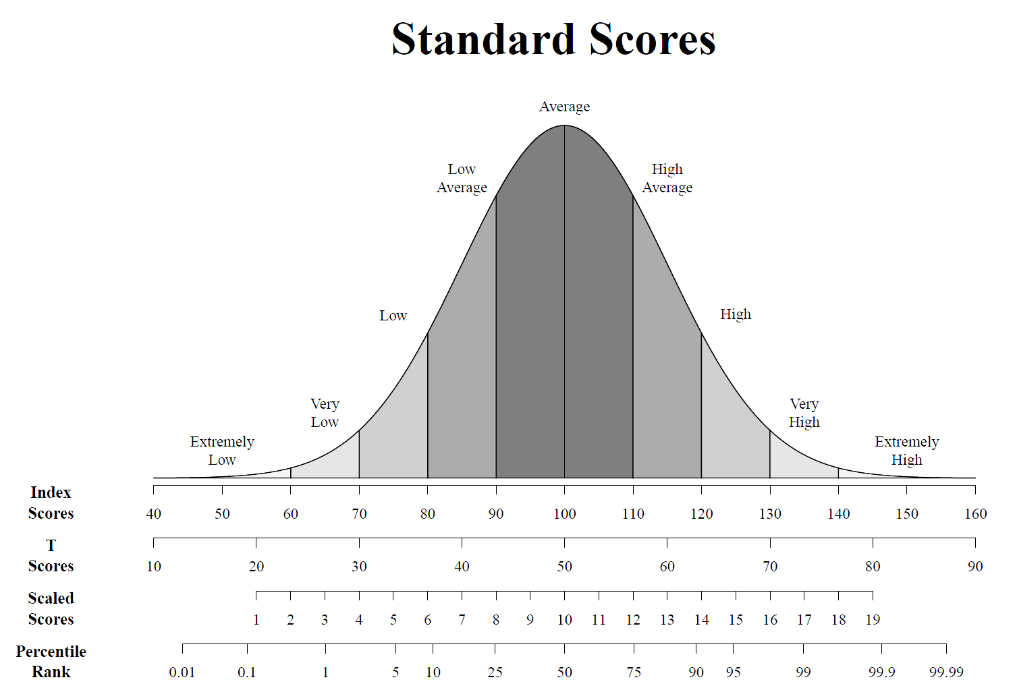
Person 2
Rank 14
Person 1
Rank 81
The Average The Worst Best

