Supplementary Materials

Table 1. HRF counting in PD, MSA and healthy controls

 | PD |  | MSA |  | HC |  | ANCOVA
 | mean | SD | mean | SD | mean | SD | p-value
HRF INL | 2.1 | 0.3 | 6.1 | 0.5 | 2.5 | 0.1 | <0.001
HRF GCIP | 5.1 | 4.5 | 1.3 | 0.9 | 1.1 | 0.6 | <0.001
HRF IRL | 7.2 | 9.1 | 7.5 | 0.1 | 3.6 | 0.9 | <0.001

Table 2. Skin biopsies results including IHC scores.
 |  | PD |  | MSA
Skin IHC score | 0 | 4 |  | 4
 | 0.25 | 5 |  | 3
 | 0.50 | 3 |  | 4
 | 0.75 | 1 |  | 1
 | 1 | 1 |  | 0
 | Score (mean; SD) | 0.32 | 0.30 | 0.27 | 0.27

Table 3. Anatomical localization of α-syn in skin biopsies of PD and MSA patients.
 | PD | MSA
Anatomical localization of α-syn | PD | MSA
Vascular innervation | 9 | 4
Glandular innervation | 4 | 4
Free nerve endings | 1 | 1
Hypodermal/dermal nerve bundles | 4 | 5

eFig 1. OCT mean thickness in PD and MSA population
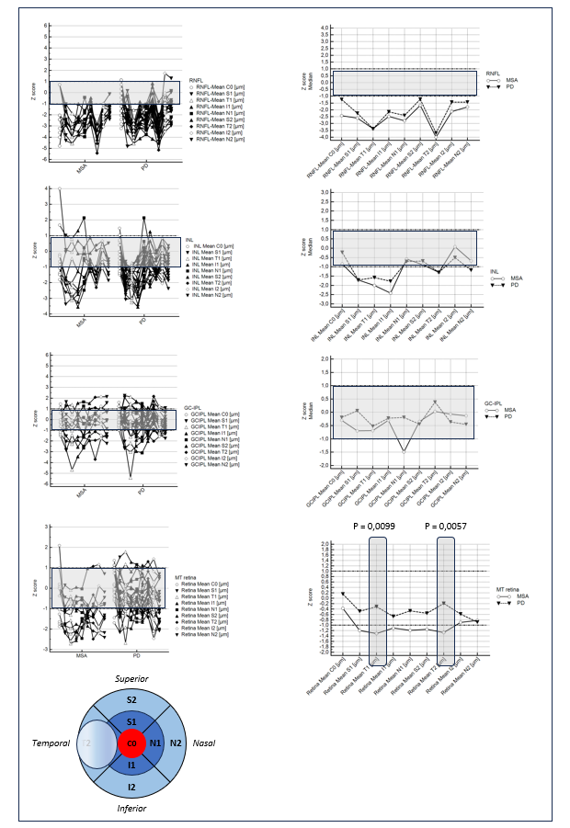
b
a
Legend. Z-scores from OCT central, inner, and outer temporal, nasal, inferior, and superior measures were compared between PD and MSA using Mann Whitney U test. A Bonferroni adjusted threshold p< 0.0055 was considered. a) A dot&line diagram was used to compare the single patient OCT profile in PD and MSA subgroups. B) median z scores values comparing MSA and PD profile. Normal range was outlined in the gray region included in -1 / +1 Z-score range.
eFig 2. Correlations between disease specific OCT-markers and clinical features
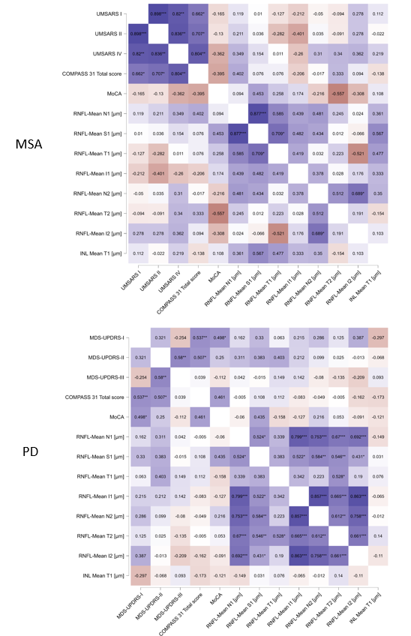
Legend. Partial Spearman's rho heatmap conditioned on variable age at visit; * p <0.05, ** p <0.01, *** p <0.001

