Title: EEG Neurosubtyping of infants predicts language trajectories
Authors: Gabriel Blanco-Gomez, Nicky Wright, Christian O'Reilly, Sara Jane Webb, Mayada Elsabbagh & The BASIS Team
Contact author information:
Gabriel Blanco Gomez, M.Sc.
McGill University
ORC-ID: 0009-0001-8490-4060
3775 Rue University, Room C18
Duff Medical Building
Montréal, Québec, H3A 2B4
gabriel.blancogomez@mail.mcgill.ca

Supplementary information
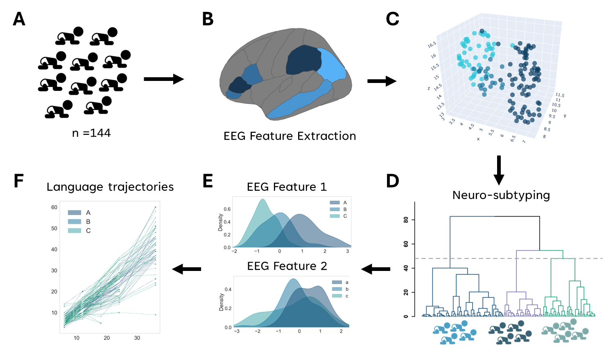

General overview of methodology
Fig. S1. Data was collected from a cohort of 6-7 month-old infants (n=144), comprising 96 with elevated likelihood of autism spectrum disorder and 48 with typical development. B) EEG measures were extracted from key brain regions, primarily those associated with language processes. C) EEG features were pre-processed and analyzed to be used for stratification methods. D) Both hierarchical clustering and latent profile analysis was used to derived three distinct EEG subtypes. Above is a dendrogram showing the three subgroups identified. E) Results from the latent profile analysis and hierarchical clustering were analyzed for each group. Analyzes showed connectivity in the left hemisphere, lateralization of gamma power and connectivity in the auditory network to be important for deriving groups. F) Longitudinal language development trajectories (Mullen Scales of Early Learning scores) from 6 to 36 months across the three identified EEG subtypes.
EEG Pre-processing:
Recordings were standardized and preprocessed with the EEG-IP-Lossless pipeline (Desjardins et al., 2021), which included the identification and removal of noisy channels and epochs. Non-neural components, such as ocular artifacts, were identified through independent component analysis and removed; all automated classifications were confirmed through expert review (Desjardins et al., 2021). Preliminary analyses revealed no significant differences in spectral EEG power between each of the three video conditions (p> 0.05). Thus, data from all videos were combined, segmented into non-overlapping 1-second epochs, and used for source reconstruction and to calculate the EEG metrics. The mean number of epochs did not differ between groups (p > 0.05). We excluded six participants because they had fewer than 20 epochs, an insufficient number for adequate analysis (O’Reilly et al., 2023). In addition, we excluded all participants whose EEG spectral power values were ±3 standard deviations away from the mean for individual EEG frequencies. This threshold is consistent with established practice for artifact rejection and corresponds to rejecting values more extreme than 99.7% of the samples when data follow the Gaussian distribution (Miskovic et al., 2009). Following exclusions, the final sample consisted of 144 participants.

Source reconstruction
One of the drawbacks of using EEG as an imaging tool is a lack of information on the provenance of the captured signals. Electrodes measure electrical potential on the scalp, not providing activity localized within neuroanatomically defined regions. Different techniques can be used to localize the sources of EEG and counteract this issue (Michel & Brunet, 2019; O’Reilly et al., 2021). Source estimation was carried out using age-appropriate head templates (O’Reilly et al., 2021). These templates were built from MRI averages and boundary element method (BEM) segmentation of head tissue. Sources were estimated using the MNE Python package (Gramfort et al., 2013) and the eLORETA inverse operator (Pascual-Marqui et al., 1994), with λ²=10⁻⁴. In total, 66 regions were obtained from the original templates based on the Desikan-Killiany parcellation (Desikan et al., 2006) matched to infant brain structural MRIs through Infants FreeSurfer (Zöllei et al., 2020). Sources were averaged for each brain region within the network. Although considerable advances in the field have allowed researchers to determine sources of brain oscillations, these methods are not perfect, and sources often encompass large brain regions. For instance, the auditory network was primarily composed of the STG. This anatomical region encompasses a large area, and various subdivisions are thought to be functionally different (e.g., posterior regions are more responsive to syntax). Therefore, interpretations from source estimation analyses should be carefully examined alongside their limitations
Functional connectivity
Functional connectivity was calculated using the corrected imaginary part of phase-locking value (CIPLV). Moreover, given that sample size has been shown to impact measures of functional connectivity (O’Reilly et al., 2023; Vinck et al., 2011), we ensured that all subjects had the same number of epochs by applying bootstrapping methods (O’Reilly et al., 2023). We repetitively selected a sample of 20 random epochs for each subject and then took the average CIPLV estimates after 1000 iterations. In terms of frequency, we selected only values in the gamma frequency band (30-50Hz) based on previous studies (Takesaki et al., 2016) and to ensure compatibility with lateralization and frontal power values.

EEG Lateralization index

Lateralization was obtained from the absolute spectral power (SP) values. SP was computed from the standardized EEG-IP recordings. We calculated power using the multi-taper method by employing the time_frequency.psd_array_multitaper function on MNE-Python (Gramfort et al., 2013). The power spectrum was averaged across epochs for each recording and a lateralization index (LI) was calculated using the formula LI=(left-hemisphere – right-hemisphere)/(left-hemisphere + right-hemisphere) (Thut, 2006). Only values within the gamma range (30-50 Hz) were used in this calculation.

EEG Measures
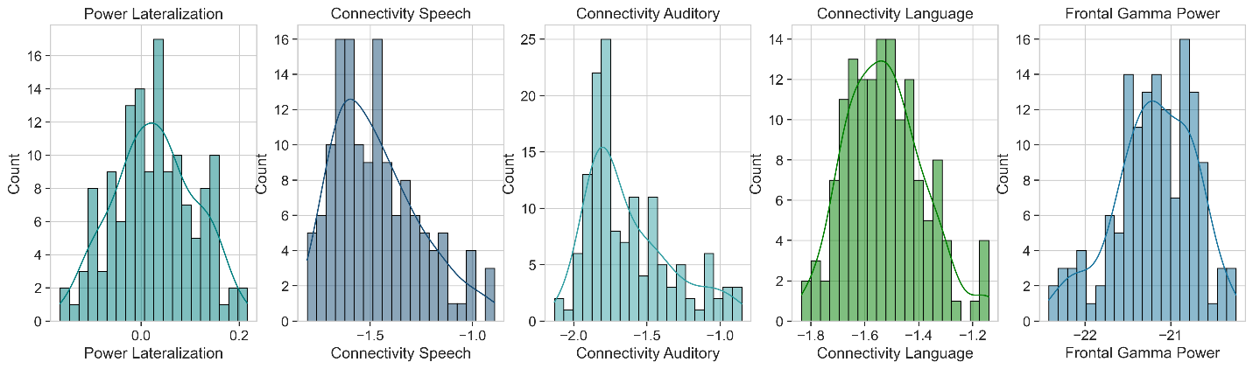
Fig. S2 Frequency distributions of five neural markers derived from infant EEG data. Histograms with density curves illustrate the distribution of Power Lateralization, Speech Connectivity, Auditory Connectivity, Language Connectivity, and Frontal Gamma Power across the sample. Shapiro-Wilk tests were performed to assess normality of distributions. These neural markers represent key electrophysiological features associated with early auditory and language processing.

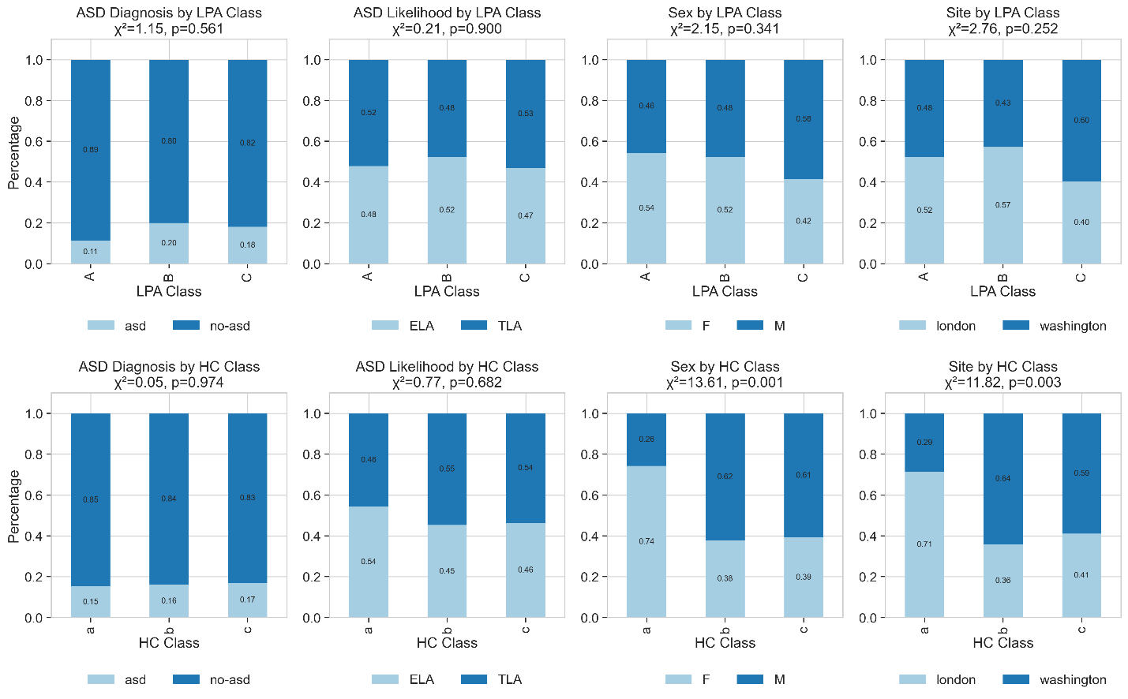
Fig. S3 Demographic distributions across different clustering approaches. The figure compares demographic variables (ASD Diagnosis, ASD Likelihood, Sex, and Site) between two clustering methods: Latent Profile Analysis (LPA, top row) and hierarchical clustering (HC, bottom row). Each subplot shows the percentage distribution of demographic categories within each neural subgroup (Classes A, B, C for LPA; Classes a, b, c for HC). Chi-square statistics with p-values indicate whether demographic distributions differ significantly between neural subgroups. ELA: Elevated likelihood for ASD. TLA: Typical likelihood for ASD.
Descriptive Power
In order to assess which EEG measures were the biggest drivers of differences between classes, we computed an F-statistic for each feature. The F-statistic is a ratio of between-group variance over within-group variance. Higher F-statistics indicate greater discriminative power, suggesting that this feature better distinguishes groups. For the LPA method, our analyses showed that Speech Connectivity had the highest discriminative capacity (F = 127.60), followed by Auditory Connectivity (F = 91.56) and Language Connectivity (F = 50.10). Similarly, Language Connectivity (F = 58.66) and Speech Connectivity (F = 59.78) had the highest differentiation power for the HC Classes. Power Lateralization and Frontal Gamma Power had generally low differentiation power for all groups (F values <10). These findings suggest that connectivity measures were consistently more important when differentiating classes.

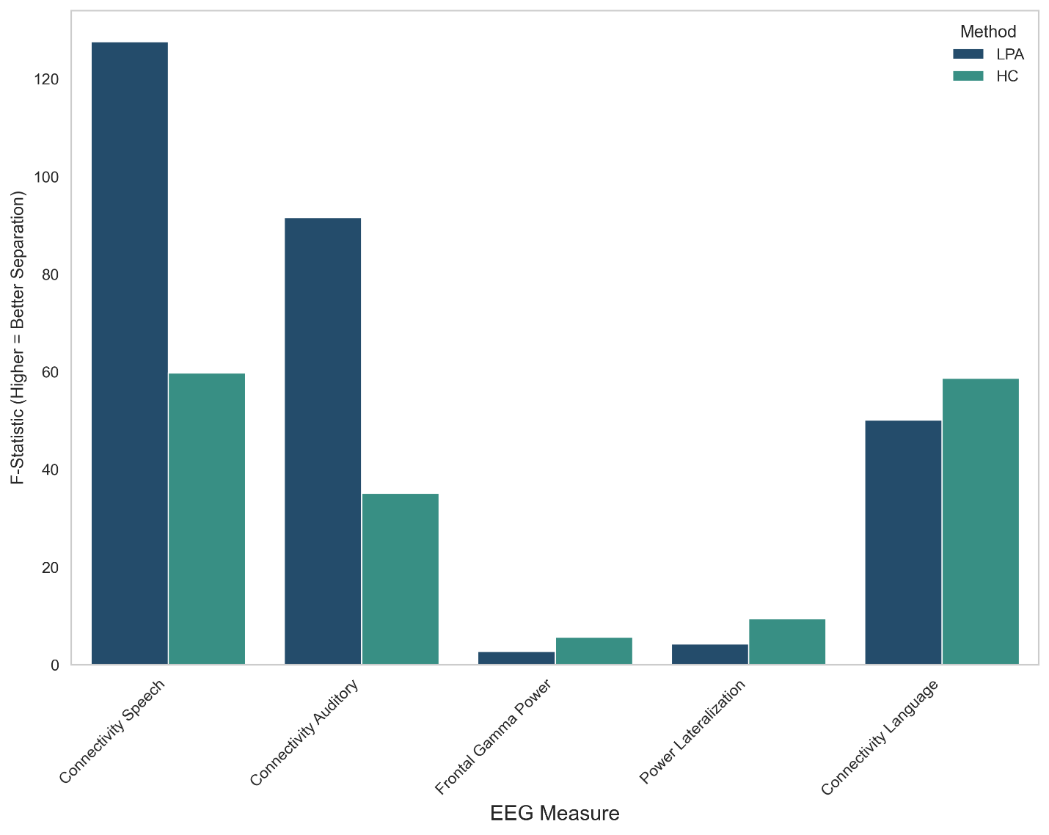
Fig. S4 Discriminative power of EEG features in distinguishing neural subgroups. The bar graph presents F-statistics for each EEG measure (Power Lateralization, Connectivity Speech, Connectivity Auditory, Connectivity Language, and Frontal Gamma Power), comparing two clustering approaches: Latent Profile Analysis (LPA, blue) and Hierarchical Clustering (HC, teal). Higher F-statistics indicate greater between-group variance relative to within-group variance, representing stronger differentiation power of that feature in separating neural subgroups.
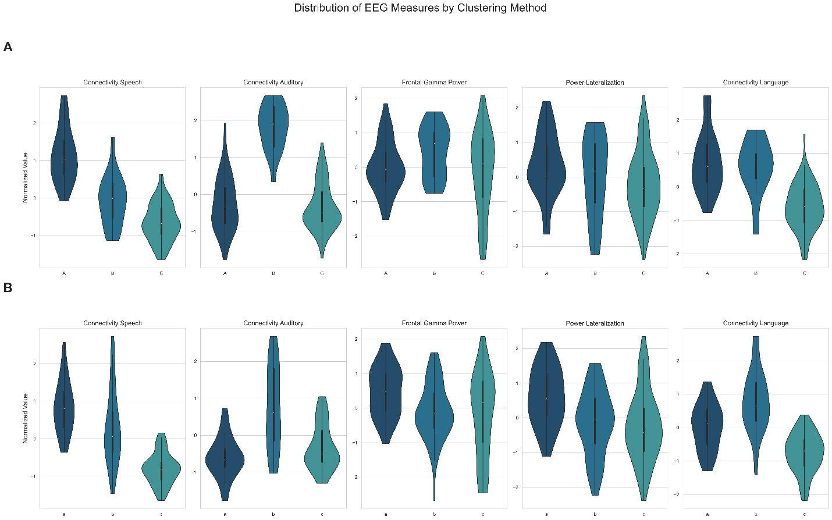
Fig. S5 Distribution of EEG measures across neural subgroups identified by two clustering approaches. Panel A shows the distribution of five EEG measures (Power Lateralization, Connectivity Speech, Connectivity Auditory, Connectivity Language, and Frontal Gamma Power) across subgroups identified using Latent Profile Analysis (LPA Classes A, B, and C). Panel B displays the same measures distributed across hierarchical clustering subgroups (HC Classes a, b, and c). Violin plots with embedded box plots visualize both the distribution shape and central tendency/spread statistics for each neural marker within each subgroup.
Table 1
Demographic differences
Demographic characteristics of infant neural subgroups identified through Latent Profile Analysis and Hierarchical Clustering
Variable | Statistics | Chi-square | p-value | Cramer's V | Class a | Class b | Class c
LPA
ASD Diagnosis
asd | n (%) | 0.05 | 0.974 | 0.02 | 5 (15.2%) | 8 (16.0%) | 9 (17.0%)
no-asd | n (%) |  |  |  | 28 (84.8%) | 42 (84.0%) | 44 (83.0%)
ASD Likelihood
ELA | n (%) | 0.77 | 0.682 | 0.073 | 19 (54.3%) | 24 (45.3%) | 26 (46.4%)
TLA | n (%) |  |  |  | 16 (45.7%) | 29 (54.7%) | 30 (53.6%)
Sex
F | n (%) | 13.61 | 0.001 | 0.307 | 26 (74.3%) | 20 (37.7%) | 22 (39.3%)
M | n (%) |  |  |  | 9 (25.7%) | 33 (62.3%) | 34 (60.7%)
Site
London | n (%) | 11.82 | 0.003 | 0.287 | 25 (71.4%) | 19 (35.8%) | 23 (41.1%)
Seattle | n (%) |  |  |  | 10 (28.6%) | 34 (64.2%) | 33 (58.9%)
HC
ASD Likelihood
asd | n (%) | 1.15 | 0.561 | 0.092 | 5 (11.4%) | 4 (20.0%) | 13 (18.1%)
no-asd | n (%) |  |  |  | 39 (88.6%) | 16 (80.0%) | 59 (81.9%)
ASD Likelihood
ELA | n (%) | 0.21 | 0.9 | 0.038 | 22 (47.8%) | 11 (52.4%) | 36 (46.8%)
TLA | n (%) |  |  |  | 24 (52.2%) | 10 (47.6%) | 41 (53.2%)
Sex
F | n (%) | 2.15 | 0.341 | 0.122 | 25 (54.3%) | 11 (52.4%) | 32 (41.6%)
M | n (%) |  |  |  | 21 (45.7%) | 10 (47.6%) | 45 (58.4%)
Site
London | n (%) | 2.76 | 0.252 | 0.138 | 24 (52.2%) | 12 (57.1%) | 31 (40.3%)
Seattle | n (%) |  |  |  | 22 (47.8%) | 9 (42.9%) | 46 (59.7%)

Table 2
Lateralization values for each group
Class | Group | Mean Power Lateralization | Standard Deviation | t-statistic | p-value | Significant Lateralization
LPA Class | A | 0.055 | 0.075 | 4.835 | 0 | Yes
LPA Class | C | 0.01 | 0.078 | 1.153 | 0.253 | No
LPA Class | B | 0.028 | 0.095 | 1.361 | 0.189 | No
HC Class | b | 0.015 | 0.078 | 1.317 | 0.194 | No
HC Class | c | 0.007 | 0.083 | 0.64 | 0.525 | No
HC Class | a | 0.075 | 0.067 | 6.62 | 0 | Yes

Table 3
Missingness for each variable
variable | n_missing | % missing
MSEL 6 months | 0 | 0.00%
MSEL 12 months | 15 | 10.42%
MSEL 18 months | 84 | 58.33%
MSEL 24 months | 44 | 30.56%
MSEL 36 months | 78 | 54.17%
Diagnosis | 8 | 5.56%
Sex | 0 | 0.00%
Site | 0 | 0.00%
Power Lateralization | 5 | 3.47%
Connectivity Speech | 4 | 2.78%
Connectivity Auditory Network | 4 | 2.78%
Connectivity Language | 2 | 1.39%
Frontal Gamma Power | 2 | 1.39%

Table 4
Correlation matrix between EEG variables
 | Connectivity Auditory Network | Connectivity Language | Connectivity Speech | Frontal Gamma Power | Power Lateralization
Connectivity Auditory Network | 1 | 0.23 | 0.02 | 0.09 | 0.02
Connectivity Language | 0.23 | 1 | 0.5 | 0.05 | 0.04
Connectivity Speech | 0.02 | 0.5 | 1 | 0.07 | 0.16
Frontal Gamma Power | 0.09 | 0.05 | 0.07 | 1 | 0.17
Power Lateralization | 0.02 | 0.04 | 0.16 | 0.17 | 1

Table 5
Model Comparison: Hierarchical Clustering vs Individual EEG Features for Expressive language
Model/Feature | AIC | BIC | Marginal R² | Conditional R² | Main Effect p-value^{1,2} | Interaction with Age p-value
Frontal Gamma | 2,603.555 | 2,645.580 | 0.884 | 0.952 | 0.482 | 0.008**
Connectivity Auditory Network | 2,553.660 | 2,595.481 | 0.884 | 0.951 | 0.182 | 0.253
Connectivity Language | 2,601.596 | 2,643.621 | 0.878 | 0.951 | 0.753 | 0.525
Connectivity Speech | 2,546.702 | 2,588.564 | 0.883 | 0.951 | 0.569 | 0.451
Power Lateralization | 2,562.407 | 2,604.228 | 0.878 | 0.951 | 0.786 | 0.876
HC | 2,621.568 | 2,672.119 | 0.888 | 0.952 | 0.657 | 0.001***
LPA | 2,630.758 | 2,672.884 | 0.877 | 0.951 | 0.904 | 0.665
Note: p < 0.05, ** p < 0.01, *** p < 0.001
Table 6
Model Comparison: Hierarchical Clustering vs Individual EEG Features for Receptive Language

Model/Feature | AIC | BIC | Marginal R² | Conditional R² | Main Effect p-value^{1,2} | Interaction with Age p-value
Frontal Gamma | 2,500.294 | 2,542.319 | 0.890 | 0.964 | 0.486 | 0.805
Connectivity Auditory Network | 2,414.865 | 2,456.686 | 0.896 | 0.967 | 0.849 | 0.283
Connectivity Language | 2,497.406 | 2,539.431 | 0.890 | 0.963 | 0.721 | 0.277
Connectivity Speech | 2,440.054 | 2,481.916 | 0.897 | 0.964 | 0.663 | 0.015*
Power Lateralization | 2,451.203 | 2,493.024 | 0.892 | 0.964 | 0.202 | 0.635
HC | 2,521.862 | 2,572.413 | 0.894 | 0.964 | 0.701 | 0.098
LPA | 2,540.13 | 2,590.69 | 0.893 | 0.964 | 0.726 | 0.033*
Note: p < 0.05, ** p < 0.01, *** p < 0.001

