Supplemental Material for Evaluation of Precipitation-Reanalysis Products for Regional Hydrological Modelling in the Yellow River Basin
Cong Jiang,ª Eric J. R. Parteli,^{b} Qian Xia^{c, d} and Yaping Shaoª
aInstitute for Geophysics and Meteorology, University of Cologne, Pohligstr. 3, D 50969, Cologne, Germany
bFaculty of Physics, University of Duisburg-Essen, Lotharstr. 1, D 47057, Duisburg, Germany
cSchool of Water Resources and Hydropower Engineering, Wuhan University, Bayi Road. 299, 430072, Wuhan, China
^{d}Hubei Water Resources and Hydropower Science and Technology Promotion Center, Hubei Water Resources Research Institute, 430070, Wuhan, China

Required near surface meteorological variables for offline AHMS-IRR
Table S1. List of near surface meteorological variables required to run AHMS-IRR in an offline mode.
Number | Name | Meteorological variables | Unit
1 | Wind | Near-surface wind speed | m s⁻¹
2 | Tair | Near-surface air temperature | K
3 | PSurf | Surface air pressure | N m⁻²
4 | Qair | Near-surface specific humidity | kg kg⁻¹
5 | LWdown | Surface downward longwave radiation | W m⁻²
6 | SWdown | Surface downward shortwave radiation | W m⁻²
7 | Rainf | Rainfall flux | kg m⁻² s⁻¹
8 | Snowf | Snowfall flux | kg m⁻² s⁻¹

Infiltration capacity and infiltration-excess runoff
The infiltration capacity or maximum infiltration rate determines how surface water is distributed between infiltration and runoff. It is predominantly governed by soil properties and is represented by Eq. S1 in this study. Subsequently, infiltration-excess runoff is computed using the Eq. S2.
$$\begin{aligned}I_{max}=βK_{sat}\left(0\right)\#\left(S.1\right)\end{aligned}$$

$$\begin{aligned}R_{ins}=\max\left(0,Q_{wat}-I_{max}\right)\#\left(S.2\right)\end{aligned}$$
where $I_{max}$ is the infiltration capacity or maximum infiltration rate, ($K_{sat}(0)$is the saturated hydraulic conductivity at surface soil, $β$ is an empirical parameter ($0≤β≤1$), which can be determined by calibration of the annual average runoff in the sub-basins of the Yellow River Basin, $R_{ins}$ is the infiltration-excess runoff, and $Q_{wat}$ is the water input on the soil surface.

Irrgation scheme in AHMS-IRR
The present work adopts the irrigation scheme AHMS-IRR developed by Jiang et al. (2022) for arid and semi-arid river basins, which is briefly described below.
The soil moisture deficit method calculates the irrigation water requirements, i.e., when, where and how much water is required to irrigate (Ozdogan et al., 2010; Xu et al., 2019). The equations for the integrated soil moisture availability (SMA) in root zones and irrigation water requirements ($IWR$) are,

$$\begin{aligned}SMA=\frac{SM-{SM}_{wlt}}{{SM}_{ref}-{SM}_{wlt}}\#\left(S.3\right)\end{aligned}$$

$$\begin{aligned}IWR=\left({SM}_{ref}-SM\right)∙F_{veg}∙F_{crop}∙(1.0+F_{iloss})\#\left(S.4\right)\end{aligned}$$
where $SM$ represents the integrated soil moisture [m]; ${SM}_{ref}$ and ${SM}_{wlt}$are the integrated field capacity and wilting point in the root zone [m], respectively; $F_{veg}$ is the vegetation fraction, taken from the MODIS‐based climatological dataset from 2001 to 2012 (Broxton et al., 2014); $F_{crop}$ represents the associated 500-m MODIS-based irrigation fraction (Ozdogan & Gutman, 2008), and $F_{iloss}$ is the fraction of flood irrigation loss, and is set as 0.1 in this study.
The actual total irrigation water flow $Q_{irr}$ is related to both surface water and groundwater irrigation. However, this actual irrigation flow is limited by the availability of surface water in rivers and lakes. The following formulae applies,

$$\begin{aligned}Q_{irr}=Q_{irr,sf}+Q_{irr,gw}\#\left(S.5\right)\end{aligned}$$
$$\begin{aligned}Q_{irr,sf}=\min\left(I_{max}*A_{g}**F_{irr,sw},W_{sf,avail}\right)\#\left(S.6\right)\end{aligned}$$
$$\begin{aligned}Q_{irr,gw}=I_{max}*A_{g}*F_{irr,gw}\#\left(S.7\right)\end{aligned}$$
$$\begin{aligned}IWRR(t)=max\left(IWRR(t-1)-\frac{Q_{irr}*∆t}{A_{g}},0\right)\#\left(S.8\right)\end{aligned}$$
where $Q_{irr,sf}$ and $Q_{irr,gw}$ represent the actual irrigation water flow from surface water and groundwater [m³ s⁻¹], respectively; $F_{irr,sw}$ and $F_{irr,gw}$ are the corresponding area fractions of surface water (river) and groundwater irrigation according to the “Global Map of Irrigation Areas” (Siebert et al., 2005); I_{max} is the infiltration capacity [m s⁻¹], and A_{g} denotes the grid area [m²]. Moreover, $W_{sf,avail}$ denotes the available surface water in the river or lake according to the channel routing model [m³ s]. We assume that groundwater is sufficient to meet irrigation demand. IWRR (t) and IWRR (t-1) denote the remaining irrigation water demand [m] at times t and t-1, respectively, while $∆t$ is the time step.

Performance evaluation metrics
Table S2. Evaluation metrics, range, and perfect agreement value
Evaluation metrics | Range | The value indicates perfect agreement
Nash–Sutcliffe model efficiency coefficient  (NSE) | (-∞, 1] | 1
Root mean square error  (RMSE) | [0, +∞) | 0
Pearson correlation coefficient  (PCC) | [-1, 1] | 1
Mean absolute error  (MAE) | [0, +∞) | 0
Mean absolute percentage error  (MAPE) | [0, +∞) | 0
Relative error in percent  (BIAS) | [-∞, +∞) | 0
Kling-Gupta efficiency  (KGE) | (-∞, 1] | 1

Rainfall-runoff model calibration
In our study, the soil saturation hydraulic conductivity is derived from the default soil parameter table (SOILPARM.TBL) of the Noah-MP land surface model (Chen & Dudhia, 2001; Niu et al., 2011). They are further calibrated in four sub-basins, namely, Headwater-Tangnaihai (HW-TNH), Tangnaihai-Lanzhou (TNH-LZ), Lanzhou-Toudaouai (LZ-TDG) and Toudaoguai-Huanyuankou (TDG-HYK), as shown in Table S3.
Table S3. Calibrated soil parameters against observed runoff in the sub-basins.
Para | The soil saturated hydraulic conductivity (×K_{sat}) in sub-basins
Para | 1 | 2 | 3 | 4
1 | 0.039 | 0.060 | 0.400 | 0.300
2 | 0.020 | 0.035 | 0.250 | 0.140
3 | 0.008 | 0.020 | 0.100 | 0.080
4 | 0.010 | 0.025 | 0.250 | 0.130
5 | 0.025 | 0.035 | 0.200 | 0.150
6 | 1.000 | 1.000 | 0.300 | 0.090
7 | 0.065 | 0.100 | 0.400 | 0.280
As seen in Table S4, during the calibration period, in the upper reaches of the Yellow River Basin, which is rarely affected by human activity, the BIAS of the gauge-corrected reanalysis products is calibrated to less than 10% (except for NCEP/NCAR at LZ station BIAS=25%). In the middle reaches of the basin, where irrigation has large influence on the water balance (Jiang et al., 2022), the BIAS of the gauge-corrected reanalysis products is calibrated to less than 15% (except for CMFD at TDG station BIAS=23%). The slightly larger errors in the sub-basin areal runoff for the NCEP/NCAR at LZ station and CMFD at TDG station may be due to the lack of further calibration of other parameters (e.g. hydraulic conductivity of the riverbed). However, this error is within acceptable limits, while further increasing the number of considered parameters would make the parameter calibration process substantially more difficult.

Table S4. Simulated and observed mean annual area runoff from 1979 to 1987 in the Yellow River Basin including four subbasins, Sub-basins 1 (HW-TNH), Sub-basins 2 (TNH-LZ), Sub-basins 3 (LZ-TDG) and Sub-basins 4 (TDG-HYK).
Para | Areal Runoff (mm)
Para | Sub-basins 1 |  |  | Sub-basins 2 |  |  | Sub-basins 3 |  |  | Sub-basins 4
Para | Observed  runoff | Simulated  runoff minus Irrigation | BIAS | Observed  runoff | Simulated  runoff minus irrigation | BIAS | Observed  runoff | Simulated  runoff minus rrrigation | BIAS | Observed  runoff | Simulated  runoff minus irrigation | BIAS
1  calibration | 210.96 | 203.32 | 3.62 | 100.92 | 107.39 - 1.62=105.77 | 4.80 | -53.34 | 9.57-54.82  =-45.25 | 15.17 | 48.57 | 51.08-3.17  = 47.91 | 1.36
1  validation | 171.11 | 188.00 | 9.54 | 101.94 | 111.06-1.31=109.75 | 7.66 | -53.92 | 10.26-47.58  =-37.31 | 30.80 | 46.09 | 40.62-3.53  =37.09 | 19.53
2  calibration | 210.96 | 209.21 | 0.83 | 100.92 | 99.12-1.48  =97.64 | 3.25 | -53.34 | 6.48-47.46  =-40.98 | 23.17 | 48.57 | 47.85-2.68  =45.17 | 7.00
2  validation | 171.11 | 195.59 | 14.30 | 101.94 | 98.02-1.03  =96.99 | 4.86 | -53.92 | 8.83-44.73  =-35.90 | 33.43 | 46.09 | 41.44-2.78  =38.66 | 16.12
3 calibration | 210.96 | 201.66 | 4.40 | 100.92 | 107.69-2.66  =105.03 | 4.07 | -53.34 | 22.94-74.63  =-51.69 | 3.09 | 48.57 | 55.47-4.52  =50.95 | 4.90
3  validation | 171.11 | 190.05 | 11.07 | 101.94 | 114.70-2.13  =112.57 | 10.43 | -53.92 | 24.31-77.22  =-52.91 | 1.87 | 46.09 | 44.74-6.55  =38.19 | 17.14
4  calibration | 210.96 | 200.60 | 4.91 | 100.92 | 98.80-2.17  =96.63 | 4.25 | -53.34 | 12.49-  59.30  =-46.81 | 12.24 | 48.57 | 53.21-4.21 =49.00 | 0.89
4  validation | 171.11 | 192.49 | 12.49 | 101.94 | 107.87-1.85  =106.02 | 4.00 | -53.92 | 10.87-66.34  =-55.47 | 2.87 | 46.09 | 42.56-6.20  =36.36 | 21.11
5  calibration | 210.96 | 205.92 | 2.39 | 100.92 | 104.04-1.53  =102.51 | 1.58 | -53.34 | 14.44-60.10  =-45.66 | 14.40 | 48.57 | 48.41-3.10  =45.31 | 6.71
5  validation | 171.11 | 190.89 | 11.56 | 101.94 | 109.96-1.29  =108.67 | 6.60 | -53.92 | 16.75-53.17  =-36.42 | 32.46 | 46.09 | 41.96-3.71  =38.25 | 17.01
6  calibration | 210.96 | 233.88 | 10.86 | 100.92 | 126.99-2.07  =126.43 | 25.28 | -53.34 | 9.53-58.98  =-49.46 | 7.26 | 48.57 | 54.03-4.18  =49.85 | 0.58
6  validation | 171.11 | 268.56 | 56.95 | 101.94 | 146.21-2.46=143.75 | 41.01 | -53.92 | 11.87-46.91  =-35.04 | 35.01 | 46.09 | 59.00-2.45  =56.55 | 22.69
7  calibration | 210.96 | 202.30 | 4.10 | 100.92 | 102.32-1.03  =101.29 | 0.37 | -53.34 | 9.48-42.77  =-33.29 | 37.59 | 48.57 | 48.04-1.71  =46.33 | 4.61
7  validation | 171.11 | 218.34 | 27.6 | 101.94 | 123.93-0.88  =123.05 | 20.71 | -53.92 | 11.67-37.55  =-25.88 | 52.00 | 46.09 | 51.53-1.86  =49.47 | 7.33

Performance evaluation using offline Atmospheric and Hydrological Modelling System (AHMS)
Table S5. Comparison of monthly streamflow simulated with gauge-calibrated parameters using seven different precipitation products and observed streamflow.
Precipitation products | Tangnaihe |  | Lanzhou |  | Toudaoguai |  | Huayuankou |  | Mean
Precipitation products | NSE | KGE | NSE | KGE | NSE | KGE | NSE | KGE | NSE | KGE
Calibration period
OBS | 0.77 | 0.86 | 0.46 | 0.61 | 0.03 | 0.54 | 0.47 | 0.73 | 0.43 | 0.69
CMFD | 0.49 | 0.57 | 0.21 | 0.55 | -0.16 | 0.27 | -0.42 | 0.08 | 0.03 | 0.37
GLDAS 2.0 | -0.49 | -0.20 | -1.02 | -0.14 | -1.07 | -0.51 | -1.20 | -0.61 | -0.95 | -0.37
WFDE5/CRU | -0.32 | 0.03 | -0.76 | 0.15 | -0.79 | -0.19 | -0.95 | -0.36 | -0.71 | -0.09
WFDE5/(CRU+GPCC) | 0.54 | 0.59 | 0.32 | 0.60 | -0.18 | 0.27 | -0.52 | -0.02 | 0.04 | 0.36
NCEP/NCAR | -2.13 | -0.15 | -6.44 | -0.20 | -7.46 | -0.65 | -0.53 | 0.32 | -4.14 | -0.17
ERA5 | 0.53 | 0.52 | 0.12 | 0.62 | -0.59 | 0.37 | 0.40 | 0.63 | 0.12 | 0.54
Validation period
OBS | 0.82 | 0.82 | 0.51 | 0.59 | -0.18 | 0.58 | 0.43 | 0.70 | 0.40 | 0.67
CMFD | 0.72 | 0.73 | 0.40 | 0.62 | 0.03 | 0.42 | -0.43 | 0.14 | 0.18 | 0.48
GLDAS 2.0 | -0.29 | 0.07 | -0.89 | 0.17 | -1.09 | -0.33 | -1.31 | -0.47 | -0.90 | -0.14
WFDE5/CRU | -0.08 | 0.26 | -0.56 | 0.36 | -0.94 | -0.17 | -1.18 | -0.30 | -0.69 | 0.04
WFDE5/(CRU+GPCC) | 0.75 | 0.72 | 0.54 | 0.69 | -0.06 | 0.32 | -0.50 | 0.05 | 0.18 | 0.45
NCEP/NCAR | -6.50 | -0.64 | -15.51 | -0.62 | -19.23 | -1.33 | -3.53 | -0.12 | -11.19 | -0.68
ERA5 | 0.01 | 0.17 | -0.94 | 0.35 | -3.67 | -0.27 | -0.44 | 0.32 | -1.26 | 0.14

Table S6. Same as Table S5, but with recalibrated parameters for each of the six precipitation products (Scenario 2).
Precipitation products | Tangnaihe |  | Lanzhou |  | Toudaoguai |  | Huayuankou |  | Mean
Precipitation products | NSE | KGE | NSE | KGE | NSE | KGE | NSE | KGE | NSE | KGE
Calibration period
OBS | 0.77 | 0.86 | 0.46 | 0.61 | 0.03 | 0.54 | 0.47 | 0.73 | 0.43 | 0.69
CMFD | 0.78 | 0.82 | 0.54 | 0.71 | 0.19 | 0.65 | 0.51 | 0.74 | 0.51 | 0.73
GLDAS 2.0 | 0.82 | 0.83 | 0.57 | 0.76 | 0.08 | 0.60 | 0.49 | 0.74 | 0.49 | 0.73
WFDE5/CRU | 0.83 | 0.82 | 0.63 | 0.76 | 0.19 | 0.64 | 0.49 | 0.72 | 0.54 | 0.74
WFDE5/(CRU+GPCC) | 0.77 | 0.76 | 0.60 | 0.76 | 0.23 | 0.65 | 0.52 | 0.70 | 0.53 | 0.72
NCEP/NCAR | 0.68 | 0.65 | 0.70 | 0.85 | 0.33 | 0.66 | 0.50 | 0.65 | 0.55 | 0.70
ERA5 | 0.57 | 0.56 | 0.49 | 0.66 | 0.08 | 0.47 | 0.51 | 0.59 | 0.41 | 0.57
Validation period
OBS | 0.82 | 0.82 | 0.51 | 0.59 | -0.18 | 0.58 | 0.43 | 0.70 | 0.40 | 0.67
CMFD | 0.77 | 0.77 | 0.57 | 0.64 | 0.07 | 0.64 | 0.60 | 0.81 | 0.50 | 0.72
GLDAS 2.0 | 0.77 | 0.78 | 0.38 | 0.64 | -0.14 | 0.58 | 0.61 | 0.80 | 0.41 | 0.70
WFDE5/CRU | 0.72 | 0.77 | 0.32 | 0.60 | 0.17 | 0.67 | 0.59 | 0.77 | 0.45 | 0.70
WFDE5/(CRU+GPCC) | 0.81 | 0.78 | 0.62 | 0.74 | 0.11 | 0.63 | 0.61 | 0.81 | 0.54 | 0.74
NCEP/NCAR | 0.13 | 0.36 | -0.51 | 0.53 | -2.08 | 0.10 | 0.42 | 0.40 | -0.51 | 0.35
ERA5 | 0.62 | 0.46 | 0.52 | 0.67 | -0.33 | 0.30 | 0.47 | 0.58 | 0.32 | 0.50

Table S7. Root-Mean-Square Error (RMSE) and Nash-Sutcliffe Efficiency (NSE) computed between the measured and simulated evapotranspiration produced by the numerical experiments for the period January 1980 to December 1987.
Scenario | Setup | Precipitation products | Basin
 | 1 | Precipitation products | RMSE | MAE | NSE | r²
Ⅰ | 1 | OBS | 6.56 | 4.79 | 0.90 | 0.979
Ⅰ | 2 | CMFD | 6.77 | 5.00 | 0.89 | 0.983
Ⅰ | 3 | GLDAS 2.0 | 6.68 | 4.90 | 0.90 | 0.978
Ⅰ | 4 | WFDE5/CRU | 6.78 | 5.02 | 0.89 | 0.981
Ⅰ | 5 | WFDE5/(CRU+GPCC) | 7.42 | 5.44 | 0.87 | 0.982
Ⅰ | 6 | NCEP/NCAR | 9.24 | 7.69 | 0.80 | 0.985
Ⅰ | 7 | ERA5 | 11.90 | 9.57 | 0.67 | 0.982
Ⅱ | 8 | CMFD | 5.90 | 4.39 | 0.92 | 0.982
Ⅱ | 9 | GLDAS 2.0 | 5.11 | 4.02 | 0.94 | 0.975
Ⅱ | 10 | WFDE5/CRU | 5.13 | 3.90 | 0.94 | 0.979
Ⅱ | 11 | WFDE5/(CRU+GPCC) | 6.41 | 4.67 | 0.91 | 0.980
Ⅱ | 12 | NCEP/NCAR | 9.32 | 7.76 | 0.80 | 0.985
Ⅱ | 13 | ERA5 | 12.52 | 10.05 | 0.64 | 0.983

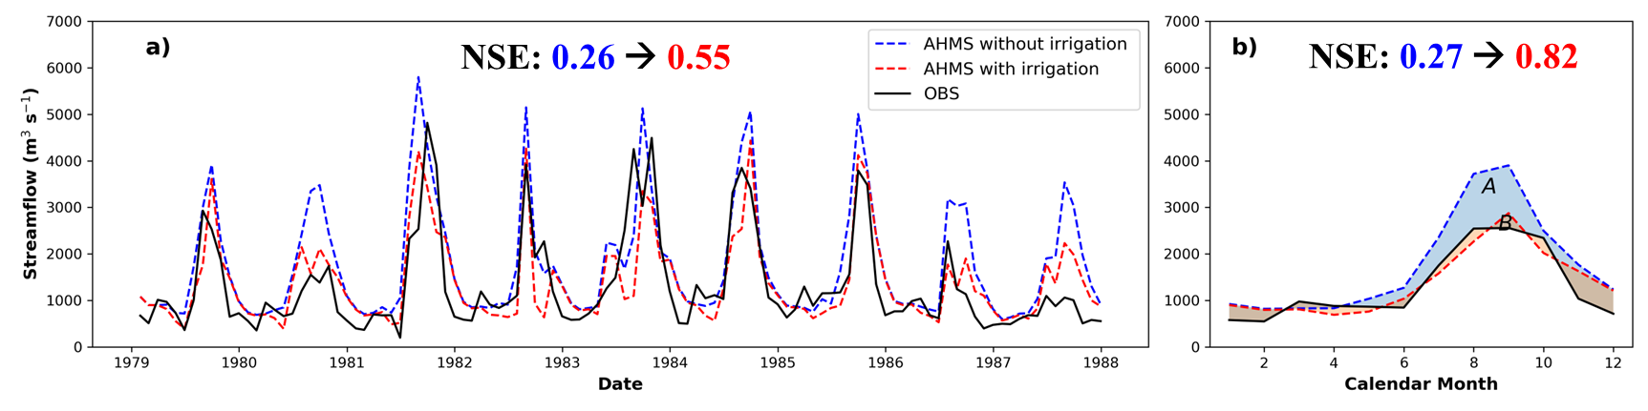
Fig. S1. Comparison of simulated streamflow using CMFD as precipitation forcing data, with and without irrigation, and observed streamflow at the outlet of the middle reaches of the Yellow River Basin (Huayuankou station) for the period 1979-1987: (a) Monthly and (b) Annual cycles (Jiang et al., 2022).

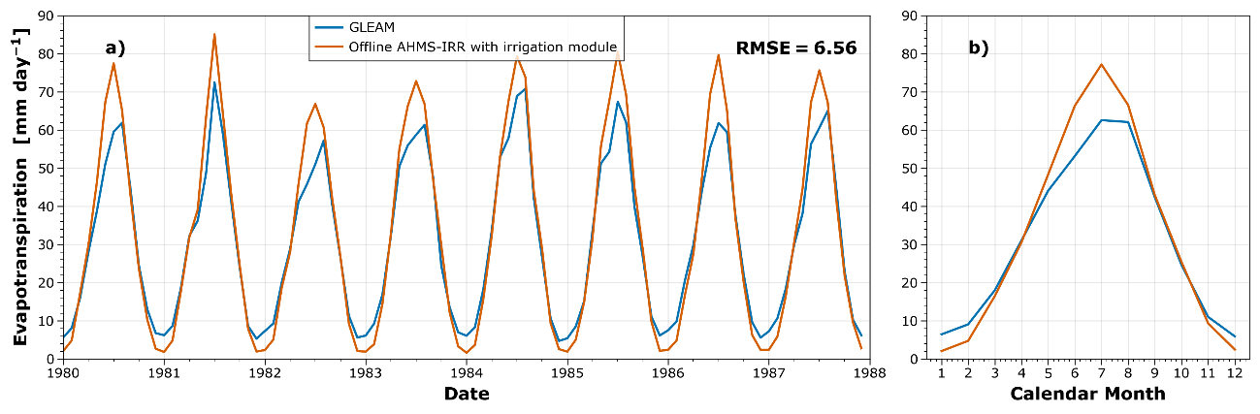
Fig. S2. Comparison of simulated evapotranspiration by GLEAM and AHMS-IRR using gridded rain gauge as precipitation forcing data in the Yellow River Basin for the period 1980-1987: (a) Monthly (b) Annual cycles.
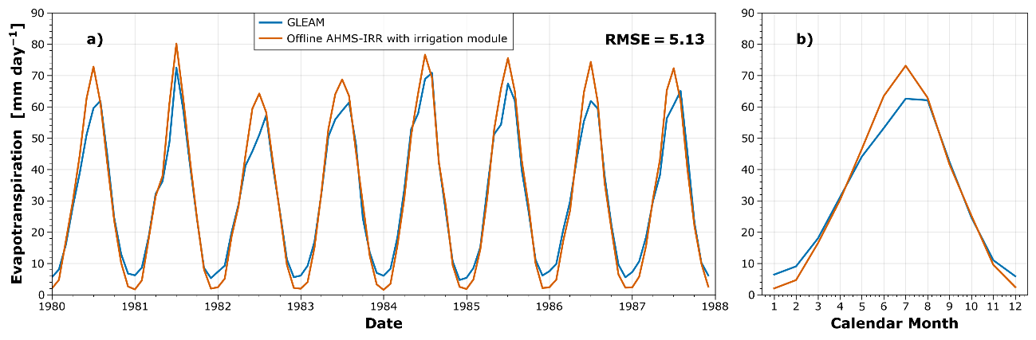
Fig. S3. Same as Fig. S2 but simulated evapotranspiration by AHMS-IRR using WFDE5/CRU as precipitation forcing data.
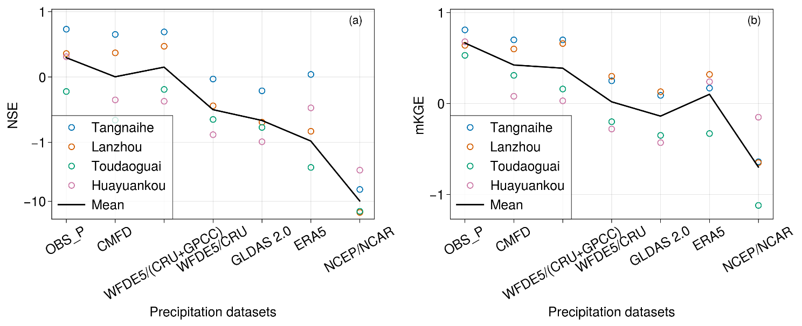
Fig. S4. Same as Fig. 12 (Scenario 1) but based on daily streamflow.

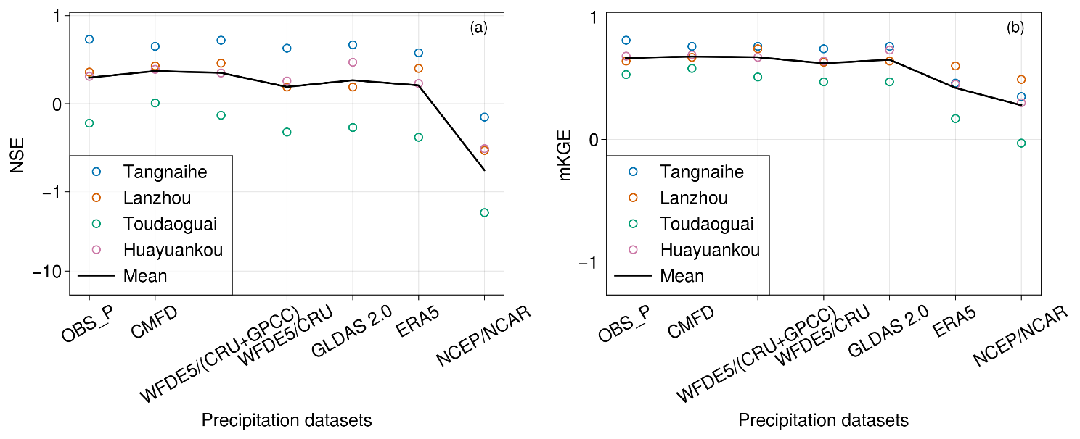
Fig. S5. Same as Fig. 14 (Scenario 2) but based on daily streamflow.

Table S8. Same as Table S5 (Scenario 1) but based on daily streamflow.
Precipitation products | Tangnaihe |  | Lanzhou |  | Toudaoguai |  | Huayuankou |  | Mean
Precipitation products | NSE | KGE | NSE | KGE | NSE | KGE | NSE | KGE | NSE | KGE
Validation period
OBS | 0.73 | 0.81 | 0.36 | 0.64 | -0.22 | 0.53 | 0.31 | 0.68 | 0.30 | 0.67
CMFD | 0.65 | 0.7 | 0.37 | 0.6 | -0.66 | 0.31 | -0.35 | 0.08 | 0.00 | 0.42
WFDE5/(CRU+GPCC) | 0.69 | 0.7 | 0.47 | 0.66 | -0.19 | 0.16 | -0.37 | 0.03 | 0.15 | 0.39
WFDE5/CRU | -0.03 | 0.25 | -0.44 | 0.3 | -0.65 | -0.2 | -0.88 | -0.28 | -0.50 | 0.02
GLDAS 2.0 | -0.21 | 0.09 | -0.69 | 0.13 | -0.77 | -0.35 | -0.99 | -0.43 | -0.67 | -0.14
ERA5 | 0.04 | 0.17 | -0.83 | 0.32 | -2.66 | -0.33 | -0.47 | 0.24 | -0.98 | 0.10
NCEP/NCAR | -6.31 | -0.64 | -15.45 | -0.65 | -14.85 | -1.36 | -2.95 | -0.15 | -9.89 | -0.70

Table S9. Same as Table S6 (Scenario 2) but based on daily streamflow.
Precipitation products | Tangnaihe |  | Lanzhou |  | Toudaoguai |  | Huayuankou |  | Mean
Precipitation products | NSE | KGE | NSE | KGE | NSE | KGE | NSE | KGE | NSE | KGE
Validation period
OBS | 0.73 | 0.81 | 0.36 | 0.64 | -0.22 | 0.53 | 0.31 | 0.68 | 0.30 | 0.67
CMFD | 0.65 | 0.76 | 0.43 | 0.67 | 0.01 | 0.58 | 0.39 | 0.69 | 0.37 | 0.68
WFDE5/(CRU+GPCC) | 0.72 | 0.76 | 0.46 | 0.74 | -0.13 | 0.51 | 0.35 | 0.67 | 0.35 | 0.67
WFDE5/CRU | 0.63 | 0.74 | 0.19 | 0.63 | -0.32 | 0.47 | 0.26 | 0.64 | 0.19 | 0.62
GLDAS 2.0 | 0.67 | 0.76 | 0.19 | 0.64 | -0.27 | 0.47 | 0.47 | 0.73 | 0.27 | 0.65
ERA5 | 0.58 | 0.46 | 0.4 | 0.6 | -0.38 | 0.17 | 0.23 | 0.45 | 0.21 | 0.42
NCEP/NCAR | -0.15 | 0.35 | -0.53 | 0.49 | -1.83 | -0.03 | -0.51 | 0.3 | -0.76 | 0.28

REFERENCES
Broxton, P. D., Zeng, X., Scheftic, W., & Troch, P. A. (2014). A MODIS-based global 1-km maximum green vegetation fraction dataset. Journal of Applied Meteorology and Climatology, 53(8), 1996–2004. https://doi.org/10.1175/JAMC-D-13-0356.1
Chen, F., & Dudhia, J. (2001). Coupling and advanced land surface-hydrology model with the Penn State-NCAR MM5 modeling system. Part I: Model implementation and sensitivity. Monthly Weather Review, 129(4), 569–585. https://doi.org/10.1175/1520-0493(2001)129<0569:CAALSH>2.0.CO;2
Jiang, C., Parteli, E. J. R., Xia, Q., Yin, X., & Shao, Y. (2022). A regional hydrological model for arid and semi-arid river basins with consideration of irrigation. Environmental Modelling and Software, 157, 105531. https://doi.org/10.1016/j.envsoft.2022.105531
Niu, G. Y., Yang, Z. L., Mitchell, K. E., Chen, F., Ek, M. B., Barlage, M., Kumar, A., Manning, K., Niyogi, D., Rosero, E., Tewari, M., & Xia, Y. (2011). The community Noah land surface model with multiparameterization options (Noah-MP): 1. Model description and evaluation with local-scale measurements. Journal of Geophysical Research Atmospheres, 116(12). https://doi.org/10.1029/2010JD015139
Ozdogan, M., & Gutman, G. (2008). A new methodology to map irrigated areas using multi-temporal MODIS and ancillary data: An application example in the continental US. Remote Sensing of Environment, 112(9), 3520–3537. https://doi.org/10.1016/j.rse.2008.04.010
Ozdogan, M., Rodell, M., Beaudoing, H. K., & Toll, D. L. (2010). Simulating the effects of irrigation over the united states in a land surface model based on satellite-derived agricultural data. Journal of Hydrometeorology, 11(1), 171–184. https://doi.org/10.1175/2009JHM1116.1
Siebert, S., Döll, P., Hoogeveen, J., Faures, J. M., Frenken, K., & Feick, S. (2005). Development and validation of the global map of irrigation areas. Hydrology and Earth System Sciences, 9(5), 535–547. https://doi.org/10.5194/hess-9-535-2005
Xu, X., Chen, F., Barlage, M., Gochis, D., Miao, S., & Shen, S. (2019). Lessons Learned From Modeling Irrigation From Field to Regional Scales. Journal of Advances in Modeling Earth Systems, 11(8), 2428–2448. https://doi.org/10.1029/2018MS001595

