Supplementary
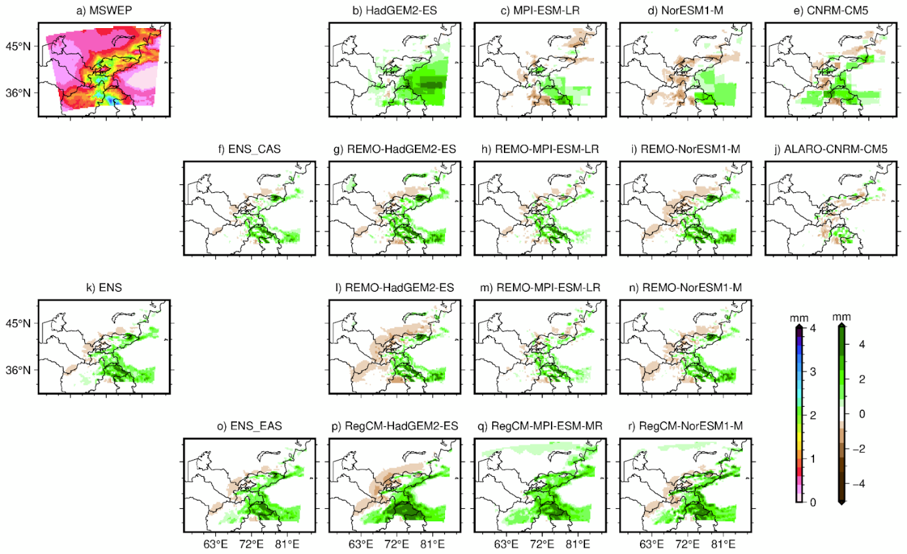
Fig. S1: Climatology of mean daily precipitation (mm/day) for MSWEP (a), and absolute biases of the ensembles (f, k, o), the corresponding driving GCMs (b-e) column wise, and the single RCM simulations in comparison to MSWEP from CORDEX-CAS (g-j) and CORDEX-EAS (l-n and p-r) for the period of 1981-2005.
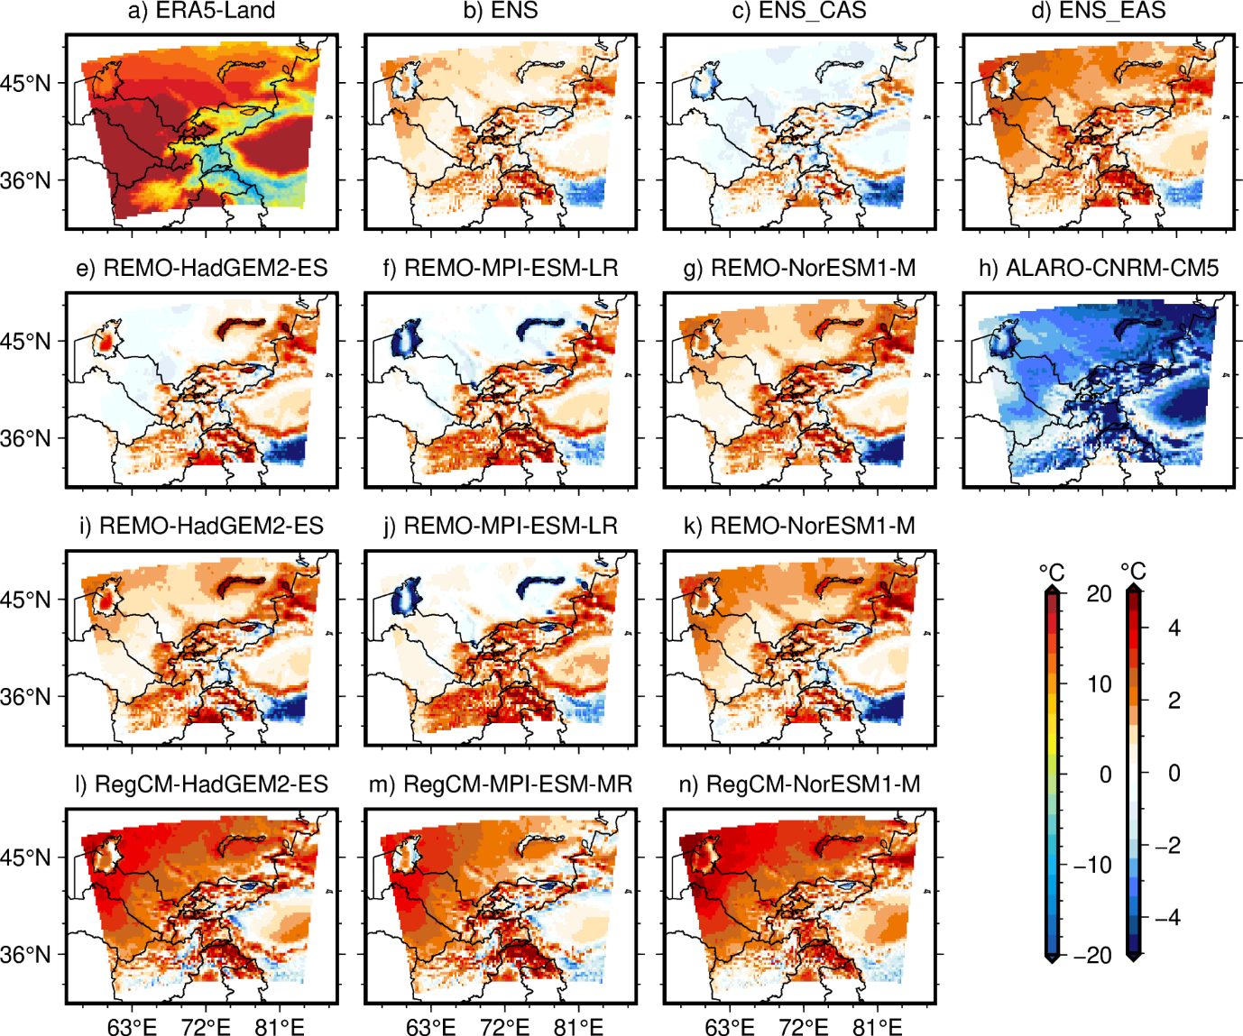Fig. S2: Climatology of mean daily 2m maximum temperature (°C) for ERA5-Land (a), and biases of the ensembles (b-d) and single simulations in comparison to ERA5-Land from CORDEX-CAS (e-h), and CORDEX-EAS (i-n) for the period of 1981-2005.

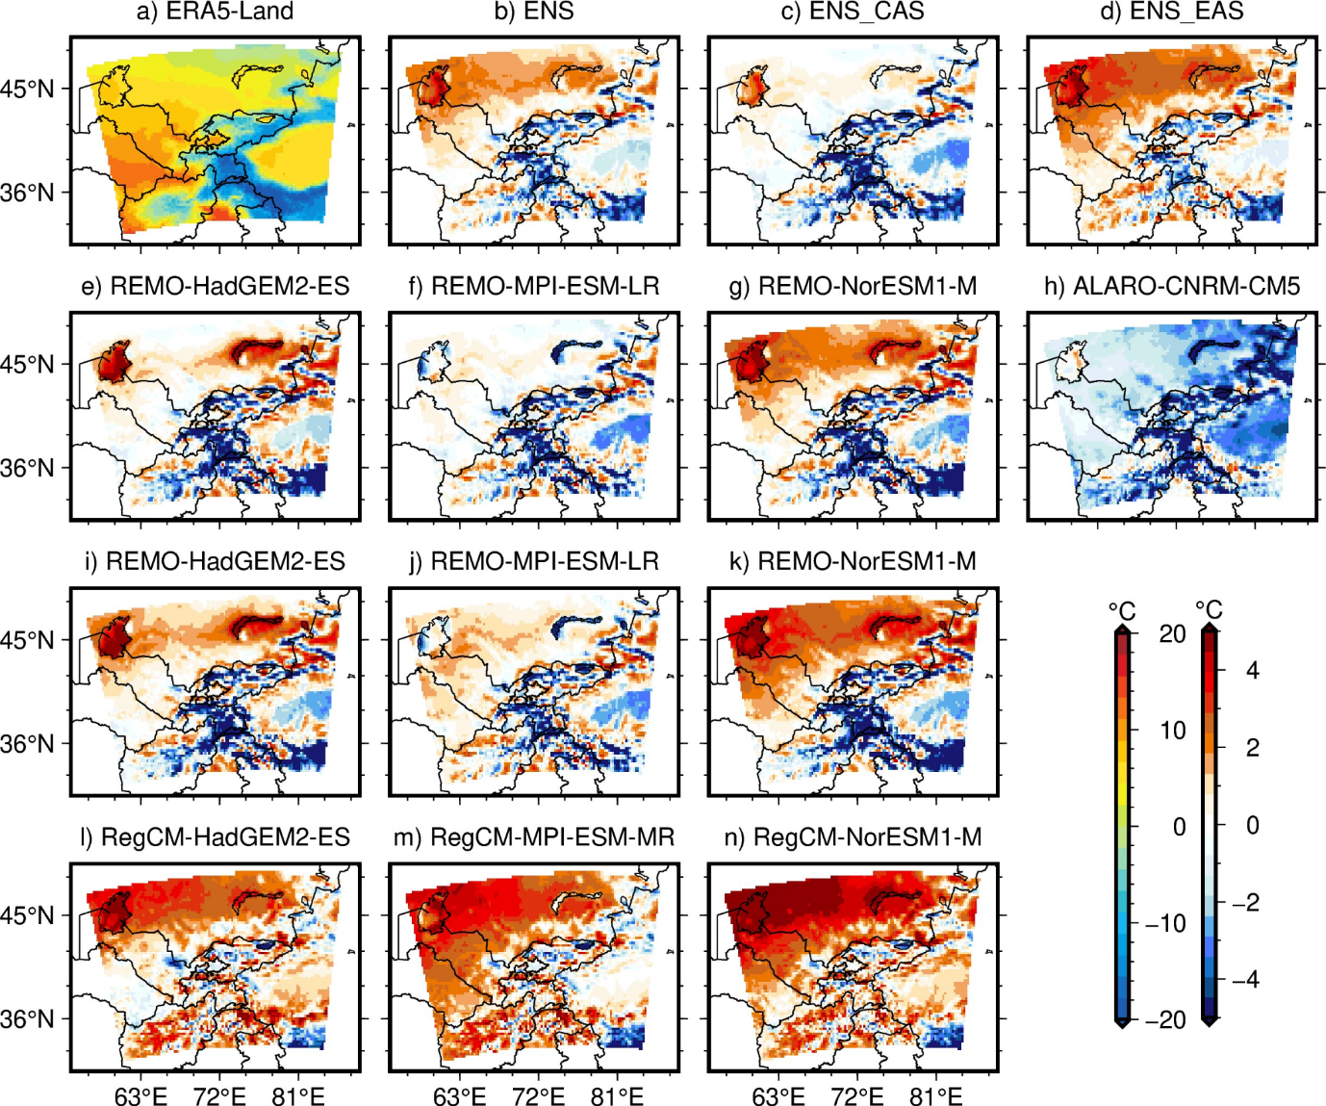Fig. S3: Climatology of mean daily 2m minimum temperature (°C) for ERA5-Land (a), and biases of the ensembles (b-d) and single simulations in comparison to ERA5-Land from CORDEX-CAS (e-h), and CORDEX-EAS (i-n) for the period of 1981-2005.

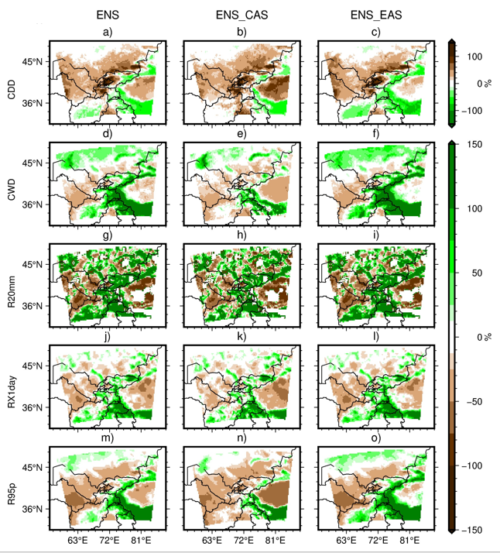 Fig. S4: Biases in precipitation-based indices for all three ensembles in comparison to MSWEP for the period of 1981-2005.

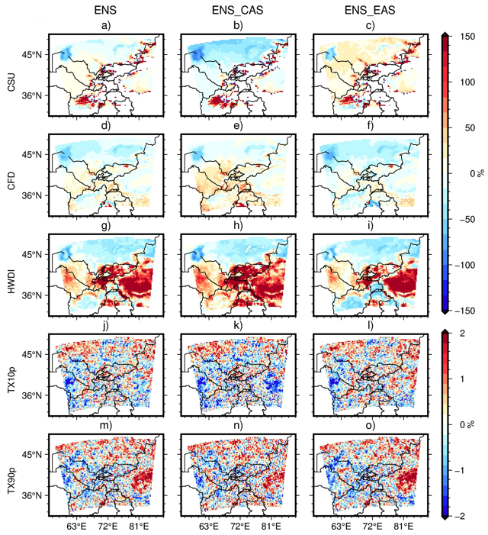 Fig. S5: Biases in temperature-based indices for ensembles, in comparison to ERA5-Land for the period of 1981-2005.

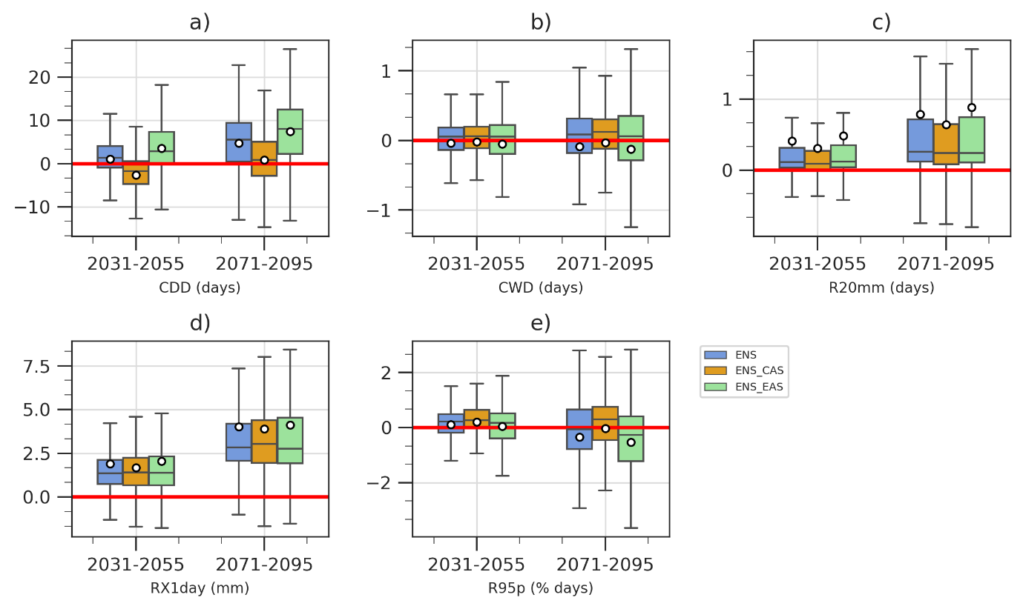Fig. S6: Box and whisker plot for the projected change in precipitation indices for the near- (2031-2055) and far-future (2071-2095) and all three ensembles.

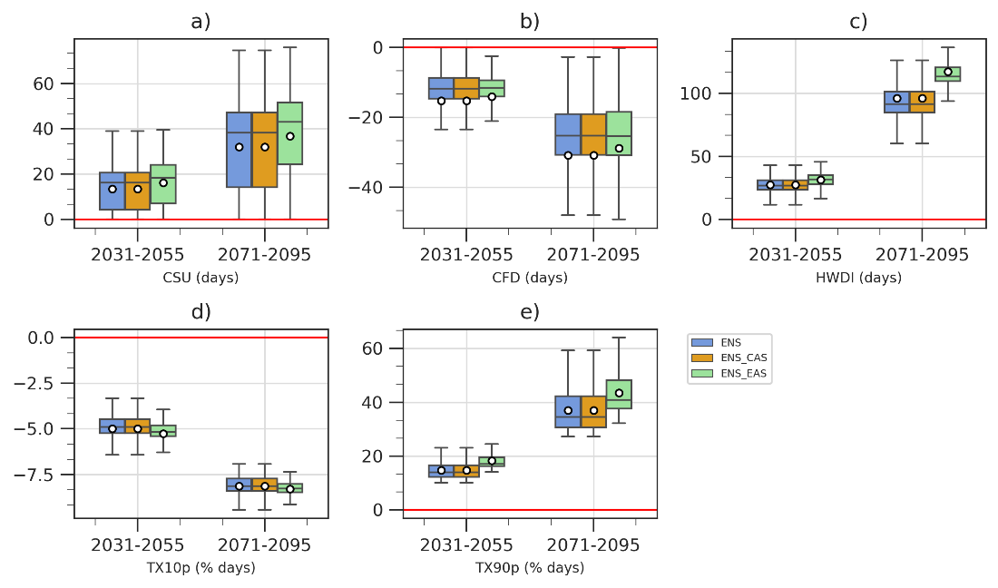
Fig. S7: Box and whisker plot for the projected change in temperature indices for near- (2031-2055) and far-future (2071-2095) and all three ensembles.

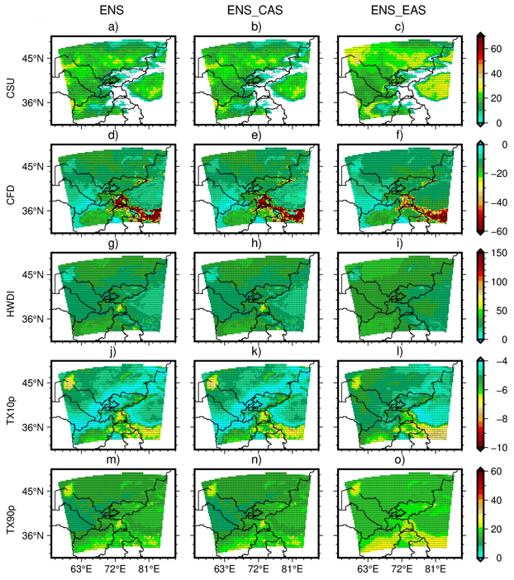Fig. S8: Projected changes in temperature indices [absolute values] from ENS, ENS_CAS, and ENS_EAS for the near-future (2031-2055) compared to the reference period (1981-2005). Stippling denotes grid points where more than 70% of the simulations agree on the sign of change.

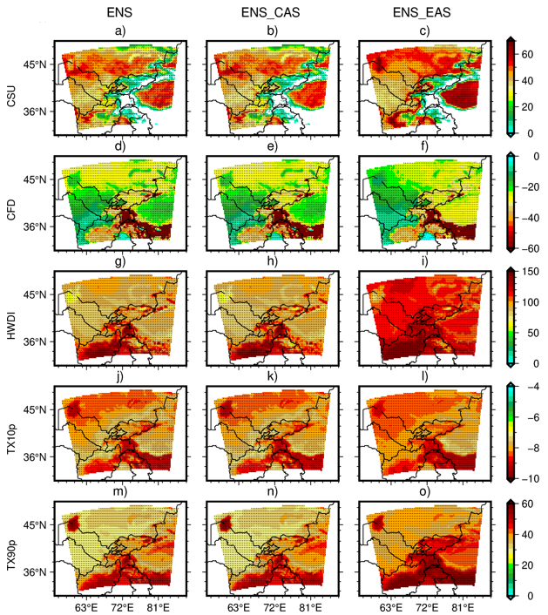Fig. S9: Same as Fig. S8, but for the far-future (2071-2095).

