Supplemental Information

Station | Station ID | Latitude  (°N) | Longitude  (°W) | Non-Missing Data (%)
Ashland, KY | USC00150254 | 38.4537 | 82.6130 | 95
Barbourville, KY | USC00150381 | 36.8825 | 83.8819 | 94
Bowling Green, KY | USW00093808 | 36.9647 | 86.4238 | 94
Bowling Green, KY | USC00150904 | 36.9987 | 86.4276 | 98
Cave Run Lake, KY | USC00152791 | 38.1227 | 83.5327 | 97
Covington, KY | USW00093814 | 39.0444 | 84.6724 | 100
Cynthiana, KY | USC00151998 | 38.3769 | 84.3030 | 90
Georgetown Water, KY | USC00153194 | 38.2094 | 84.5621 | 92
Greensburg, KY | USC00153430 | 37.2571 | 85.5012 | 93
Henderson, KY | USC00153762 | 37.7558 | 87.6455 | 96
Hopkinsville, KY | USC00153994 | 36.8489 | 87.5208 | 93
Lexington, KY | USW00093820 | 38.0339 | 84.6114 | 97
Louisville, KY | USW00013810 | 38.2302 | 85.6629 | 100
Louisville, KY | USC00154955 | 38.2778 | 85.7917 | 98
Mammoth Cave, KY | USC00155097 | 37.1318 | 86.1481 | 94
Madisonville, KY | USC00155067 | 37.3475 | 87.5238 | 97
Danville, KY | USC00152040 | 37.6513 | 84.7627 | 96
Murray, KY | USC00155694 | 36.6121 | 88.3012 | 96
Maysville, KY | USC00155243 | 38.6869 | 83.7872 | 94
Paintsville, KY | USC00156136 | 37.8176 | 82.7882 | 96
Scottsville, KY | USC00157215 | 36.7462 | 86.2259 | 99
Shepherdsville, KY | USC00157334 | 38.0544 | 85.6241 | 96
Taylorsville, KY | USC00157948 | 38.0144 | 85.3713 | 92
Paducah, KY | USW00003816 | 37.0564 | 88.7743 | 99
Saint Francis, AR | USC00036380 | 36.4546 | 90.1459 | 97
Brookeville, IN | USC00121030 | 39.4239 | 85.0145 | 90
Evansville, IN | USW00093817 | 38.0502 | 87.5147 | 99
Wise, VA | USC00449215 | 36.9725 | 82.5579 | 90
Pennington Gap, VA | USC00446626 | 36.7586 | 83.0105 | 93
Hogsett, WV | USC00464200 | 38.6842 | 82.1838 | 94
Beckley, WV | USC00460580 | 37.7648 | 81.1941 | 98
Portsmouth, OH | USC00336781 | 38.7569 | 82.8872 | 94
Martin, TN | USC00405681 | 36.3444 | 88.8636 | 93
Clarksville, TN | USC00401790 | 36.5471 | 87.3353 | 94
Newcomb, TN | USC00406493 | 36.5516 | 84.1728 | 94
Rogersville, TN | USC00407884 | 36.4161 | 82.9838 | 90
Carbondale, IL | USC00111265 | 37.7308 | 89.1658 | 97
Supplemental Table 1. Precipitation Station Metadata

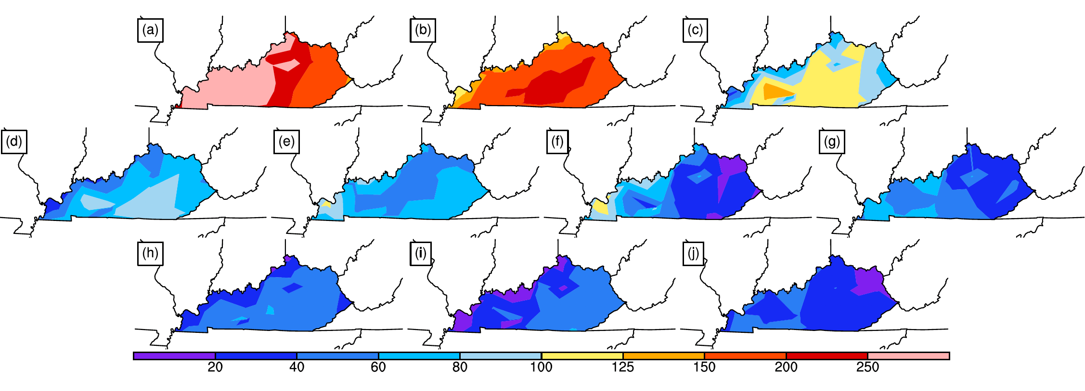Supplemental Figure 1. Average annual precipitation, in mm, for the ten heavy and extreme precipitation-inducing weather patterns, 1949-2022: (a) Type 1, (b) Type 2, (c) Type 3, (d) Type 4, (e) Type 5, (f) Type 6, (g) Type 7, (h) Type 8, (i) Type 9, and (j) Type 10.

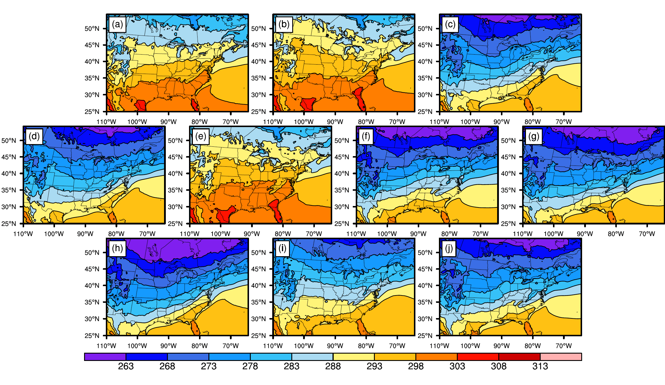
Supplemental Figure 2. Composited surface air temperatures (K) for the ten heavy and extreme precipitation-inducing weather patterns, 1949-2022: (a) Type 1, (b) Type 2, (c) Type 3, (d) Type 4, (e) Type 5, (f) Type 6, (g) Type 7, (h) Type 8, (i) Type 9, and (j) Type 10.

