Supplementary Information:
Performance of a 179-year high-resolution climate simulation of southern Alaska
Sandra K. Königseder,ª Timothy T. Barrows,^{b} Jenny A. Fisher,^{a,c} Jason P. Evans,^{d} Youngil Kim,^{d} Chesley McColl,^{e}
ª Environmental Futures, University of Wollongong, Wollongong, New South Wales, Australia
^{b} Chronos Radiocarbon Laboratory, University of New South Wales, Sydney, New South Wales, Australia
^{c} College of Science and Engineering, James Cook University, Townsville, Australia
^{d} Climate Change Research Centre and ARC Centre of Excellence for Climate Extremes,
University of New South Wales, Sydney, Australia
^{e} NOAA Physical Sciences Laboratory, Boulder, Colorado
Corresponding author: Sandra Königseder, sandrak@uow.edu.au, koenigseder.sandra@googlemail.com

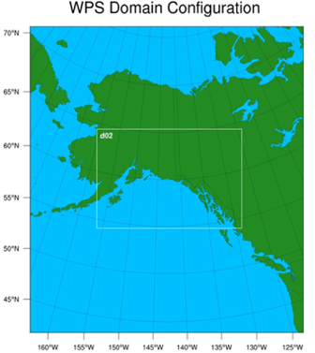
Fig. S1 WRF Domain set up, including 20-km parent domain with 4-km nest (white box d02)

Table S1 Details of the five physics configuration tested for the 20CRv3 downscaling.
 | Test 0 | Test 1 | Test 2 | Test 3 | Test 4
Microphysics | Morrison 2-moment¹ | Thompson² | Thompson² | Thompson² | WRF Single-moment 3-class and 5-class Schemes³
Cumulus  (only for parent domain) | Grell 3D^{4,5} | Kain-Fritsch Cumulus Potential (KF-CuP)⁶ | new-Tiedtke⁷ | Grell 3D^{4,5} | Kain-Fritsch Scheme⁸
Shortwave and longwave | RRTMG⁹ | RRTMG⁹ | RRTMG⁹ | RRTMG⁹ | RRTMG⁹  (longwave), Goddard Shortwave Scheme^{10,11}
Planetary boundary layer | Mellor–Yamada–Janjic´ (MYJ)^{12,13} | Mellor–Yamada–Janjic´ (MYJ)^{12,13} | Mellor–Yamada–Janjic´ (MYJ)^{12,13} | Yonsei University (YSU)¹⁴ | Mellor–Yamada–Janjic´ (MYJ)^{12,13}
Surface layer | Eta Similarity^{12,15,16,17} | Eta Similarity^{12,15,16,17} | Eta Similarity^{12,15,16,17} | MM5 Similarity^{18,19,20,21,22} | Eta Similarity^{12,15,16,17}
Land-surface model | NOAH-MP^{23,24,25} | NOAH-MP^{23,24,25} | NOAH-MP^{23,24,25} | NOAH-MP^{23,24,25} | Unified Noah Land Surface Model²⁶
Rationale/  Reference: | Bieniek et al., 2016/18 and Lader et al., 2017 | Evans et al., 2012 and Ji et al., 2013 | Evans et al., 2012 and Ji et al., 2013 | Monaghan et al., 2018 | WRF Users Guide

¹Morrison et al. (2009a), ²Thompson et al. (2008),³Hong et al. (2004), ⁴Grell (1993), ⁵Grell and Dévényi (2002), ⁶ Berg et al. (2013), ⁷Zhang and Wang (2017), ⁸Kain and Kain (2004), ⁹Iacono et al. (2008), ¹⁰Chou (1994); ¹¹Matsui et al. (2020), ¹²Janjić (1994), ¹³Mesinger (1993), ¹⁴Hong et al. (2006), ¹⁵Monin and Obukhov (1954), ¹⁶Janjić (1996), ¹⁷Janjić (2001), ¹⁸Paulson (1970), ¹⁹Dyer and Hicks (1970), ²⁰Webb (1970), ²¹Beljaars (1995), ²²Zhang and Anthes (1982a), ²³Niu et al. (2011), ²⁴Yang et al. (2011), ²⁵He et al. (2023), ²⁶Tewari et al. (2004)

Table S2 GSOD stations used for point-location analysis. Stations in bold were included for the temperature analysis but not the precipitation analysis due to data gaps.
Station ID | Station name | Latitude | Longitude | GSOD elevation (m) | 20CRv3-WRF elevation (m)
70231026510 | McGrath Airport, AK US | 62.9574 | -155.6103 | 101.5 | 101.732254
70251026528 | Talkeetna Airport, AK US | 62.32 | -150.095 | 106.7 | 107.771
70259026523 | Kenai Airport, AK US | 60.5797 | -151.2391 | 27.7 | 26.28645
70261026411 | Fairbanks International Airport, AK US | 64.8039 | -147.8761 | 131.7 | 133.68274
70271026425 | Gulkana Airport, AK US | 62.1591 | -145.4588 | 476.1 | 466.28278
70273026451 | Anchorage Ted Stevens International Airport, AK US | 61.169 | -150.0278 | 36.6 | 16.885082
70296026410 | Cordova Airport, AK US | 60.4888 | -145.4511 | 9.4 | 4.311111
70326025503 | King Salmon Airport, AK US | 58.6829 | -156.6563 | 20.4 | 21.694
70340025506 | Iliamna Airport, AK US | 59.7494 | -154.9089 | 43.6 | 45.431087
70341025507 | Homer Airport, AK US | 59.642 | -151.4908 | 19.5 | 116.07453
70350025501 | Kodiac Airport, AK US | 57.7511 | -152.4855 | 24.4 | 49.6763
70361025339 | Yakutat Airport, AK US | 59.512 | -139.6712 | 10.1 | 22.095695
70371025333 | Sitka Airport, AK US | 57.0481 | -135.3647 | 4.3 | 69.48629
70381025309 | Juneau Airport, AK US | 58.3566 | -134.564 | 4.9 | 37.499992
71949099999 | Faro AUT YT, CA | 62.2333333 | -133.35 | 717 | 777.78577
71949399999 | Faro, CA | 62.2075 | -133.37583 | 716.58 | 745.56537
71965099999 | Mayo, CA | 63.616389 | -135.86833 | 503.83 | 556.2125
71967599999 | Beaver Creek Airport, CA | 62.4166667 | -140.86667 | 649 | 643.33545

Table S3 Statistical comparison of 20CRv3-WRF and ERA5 annual average 2-meter temperature (in degree Celsius) at GSOD station locations used for point-location analysis. Analysis was conducted for 1986-2015.
Station ID | Station name | 20CRv3-WRF temp | ERA5 temp | Difference | NME | r² | r | 20CRv3-WRF STD | ERA5 STD | Difference STD
70231026510 | McGrath Airport, AK US | -3.27 | -1.47 | -1.80 | 1.87 | 0.90 | 0.95 | 1.33 | 1.29 | 0.04
70251026528 | Talkeetna Airport, AK US | 1.18 | -0.06 | 1.24 | 1.42 | 0.88 | 0.94 | 0.87 | 1.09 | -0.22
70259026523 | Kenai Airport, AK US | 0.26 | 3.66 | -3.40 | 4.49 | 0.86 | 0.93 | 0.81 | 0.93 | -0.12
70261026411 | Fairbanks International Airport, AK US | -2.55 | -1.46 | -1.09 | 1.29 | 0.86 | 0.93 | 1.25 | 1.08 | 0.17
70271026425 | Gulkana Airport, AK US | -1.77 | -1.46 | -0.30 | 0.43 | 0.88 | 0.94 | 0.98 | 1.04 | -0.06
70273026451 | Anchorage Ted Stevens International Airport, AK US | 0.59 | 2.46 | -1.87 | 2.45 | 0.86 | 0.93 | 0.74 | 0.95 | -0.21
70296026410 | Cordova Airport, AK US | 3.31 | 3.09 | 0.22 | 0.46 | 0.90 | 0.95 | 0.62 | 0.87 | -0.25
70326025503 | King Salmon Airport,AK US | 0.28 | 2.32 | -2.05 | 1.87 | 0.94 | 0.97 | 1.41 | 1.42 | -0.01
70340025506 | Iliamna Airport, AK US | 0.92 | 2.15 | -1.23 | 1.23 | 0.89 | 0.94 | 1.12 | 1.27 | -0.14
70341025507 | Homer Airport, AK US | 2.49 | 2.44 | 0.05 | 0.42 | 0.87 | 0.93 | 0.79 | 1.06 | -0.27
70350025501 | Kodiac Airport, AK US | 2.87 | 4.40 | -1.52 | 2.07 | 0.91 | 0.96 | 0.74 | 0.97 | -0.23
70361025339 | Yakutat Airport, AK US | 3.31 | 6.78 | -3.47 | 6.62 | 0.77 | 0.88 | 0.57 | 0.63 | -0.06
70371025333 | Sitka Airport, AK US | 4.49 | 5.34 | -0.86 | 1.38 | 0.64 | 0.80 | 0.56 | 0.79 | -0.23
70381025309 | Juneau Airport, AK US | 5.02 | 3.12 | 1.90 | 2.90 | 0.73 | 0.85 | 0.67 | 0.88 | -0.21
71949099999 | Faro AUT YT, CA | -0.66 | -3.22 | 2.56 | 3.70 | 0.75 | 0.87 | 0.83 | 0.94 | -0.12
71949399999 | Faro, CA | -0.86 | -3.14 | 2.28 | 3.30 | 0.77 | 0.88 | 0.81 | 0.94 | -0.13
71965099999 | Mayo,CA | -0.29 | -3.42 | 3.14 | 4.77 | 0.77 | 0.88 | 0.89 | 0.94 | -0.05
71967599999 | Beaker Creek Airport, CA | -2.55 | -3.38 | 0.83 | 1.17 | 0.82 | 0.90 | 1.03 | 0.89 | 0.14

Table S4 Statistical comparison of 20CRv3-WRF and ERA5 annual accumulated precipitation (in mm) at GSOD station locations used for point-location analysis. Analysis was conducted for 1986-2015.
Station ID | Station name | 20CRv3-WRF ppt | ERA5 ppt | Difference | NME | r² | r | 20CRv3-WRF STD | ERA5 STD | Difference STD
70231026510 | McGrath Airport, AK US | 1115.98 | 573.66 | 542.31 | 8.04 | 0.55 | 0.74 | 174.89 | 88.94 | 85.95
70251026528 | Talkeetna Airport, AK US | 1540.43 | 894.91 | 645.52 | 6.40 | 0.25 | 0.50 | 322.00 | 126.02 | 195.98
70261026411 | Fairbanks International Airport, AK US | 835.67 | 391.75 | 443.92 | 7.14 | 0.32 | 0.57 | 156.99 | 79.02 | 77.97
70273026451 | Anchorage Ted Stevens International Airport, AK US | 1009.40 | 856.19 | 153.21 | 2.44 | 0.05 | 0.23 | 147.52 | 99.282 | 48.24
70326025503 | Kind Salmon Airport, AK US | 1553.49 | 827.15 | 726.34 | 8.70 | 0.53 | 0.72 | 259.54 | 103.35 | 156.19
70341025507 | Homer Airport, AK US | 1294.79 | 1219.50 | 75.29 | 1.69 | 0.07 | 0.26 | 162.22 | 135.11 | 27.11
70350025501 | Kodiac Airport, AK US | 3264.42 | 1561.18 | 1703.23 | 13.35 | 0.52 | 0.72 | 394.92 | 157.64 | 237.27
70361025339 | Yakutat Airport, AK US | 5271.73 | 2962.72 | 2309.02 | 8.23 | 0.68 | 0.82 | 606.79 | 352.96 | 253.83
70371025333 | SitkaAirport, AK US | 3553.43 | 2596.25 | 957.18 | 4.17 | 0.29 | 0.54 | 516.77 | 283.43 | 233.34
70381025309 | Juneau Airport, AK US | 3657.36 | 2722.75 | 934.61 | 3.87 | 0.64 | 0.80 | 421.13 | 311.46 | 109.67

a)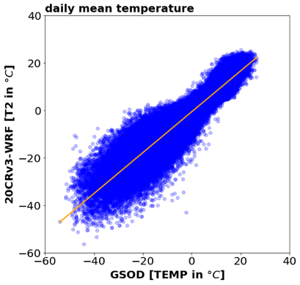 b)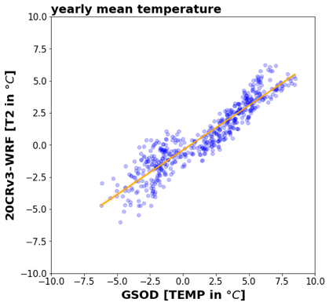 c)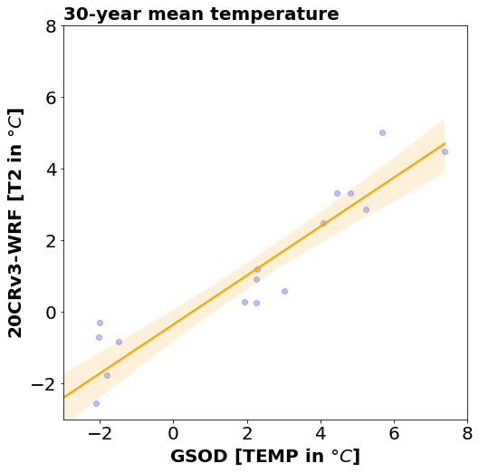
Fig. S2 Correlation of modelled (WRF) and observed (GSOD) average temperature on different time scales. (a) daily mean temperature, (b) yearly mean temperature, (c) 30-year mean temperature, orange lines representing linear regression

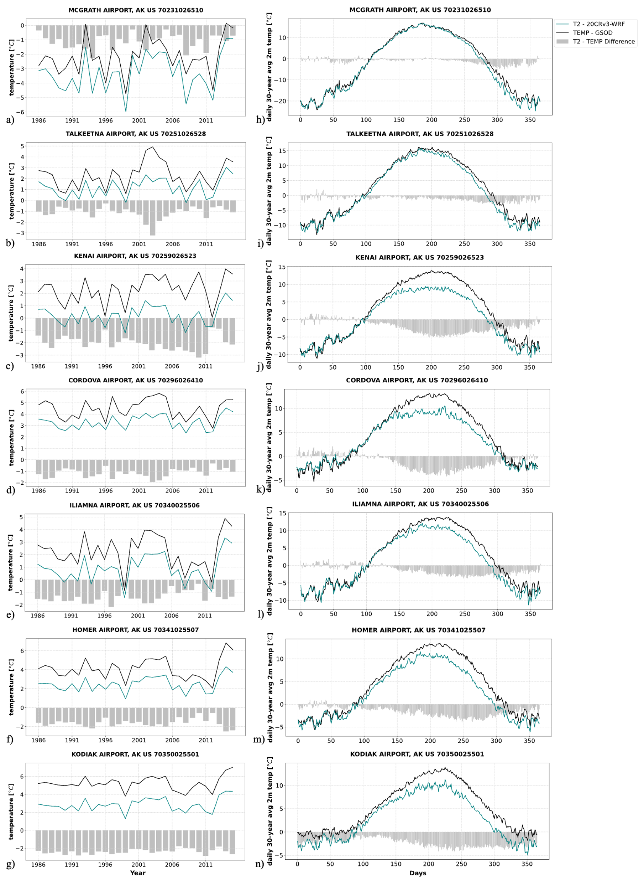
Fig. S3 Left (a-g) - Annual mean temperature for the 20CRv3-WRF downscaling (teal lines) and GSOD observations (black lines), and the difference (model – observations, grey bars). Right (h-n) - daily 30-year (1986-2015) mean temperature for 20CRv3 downscaling modelled data (teal) and GSOD observations (black), and the difference (model – observations, grey bars). For the stations: (a,h) McGrath Airport, AK US; (b,i) Talkeetna Airport, AK US; (c,j) Kenai Airport, AK US; (d,k) Cordova Airport, AK US; (e,l) Iliamna Airport, AK US; (f,m) Homer Airport, AK US; (g,n) Kodiak Airport, AK US; AK, US for Alaska, United States of America, and CA for Canada

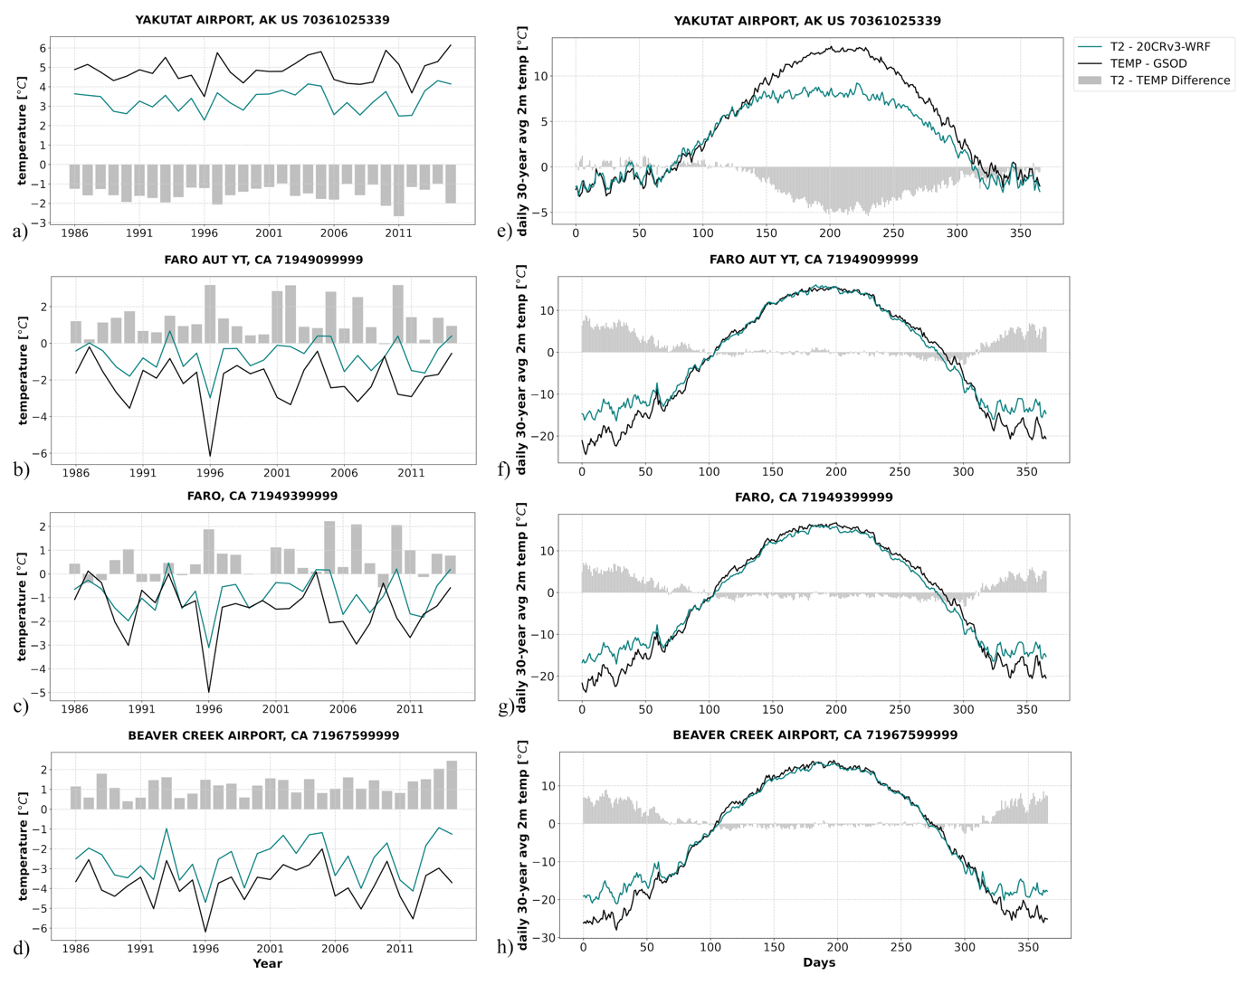
Fig. S4 Left (a-d)- Annual mean temperature for the 20CRv3-WRF downscaling (teal lines) and GSOD observations (black lines), and the difference (model – observations, grey bars). Right (e-h) - daily 30-year (1986-2015) mean temperature for 20CRv3 downscaling modelled data (teal) and GSOD observations (black), and the difference (model – observations, grey bars). For the stations: (a,e) Yakutat Airport, AK US; (b,f) Juneau Airport, AK US; (c,g) Faro AUT YT, CA; (d,h) Faro, CA; Beaver Creek Airport, CA. AK US for Alaska, United States of America, and CA for Canada

a)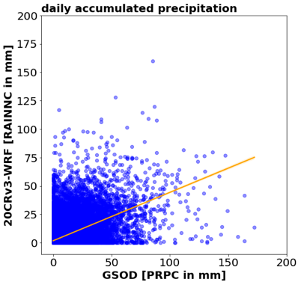 b)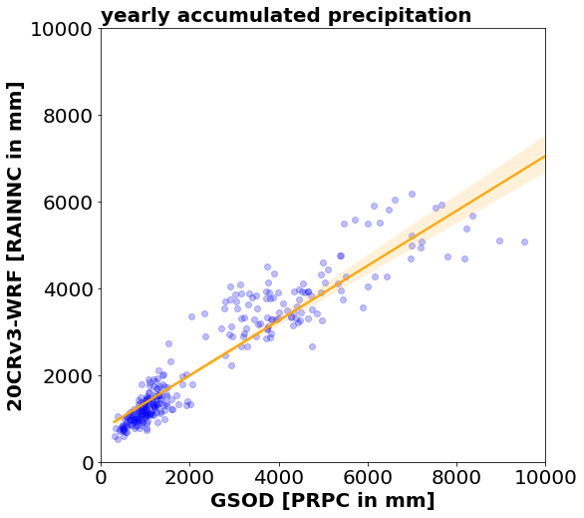 c)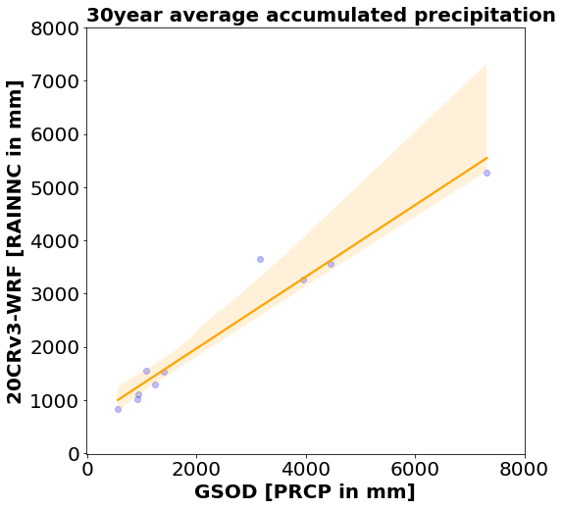
Fig. S5 Same as Figure S2 but for accumulated precipitation. (a) daily accumulated precipitation, (b) yearly accumulated precipitation, c) 30-year average accumulated precipitation, orange lines representing linear regression

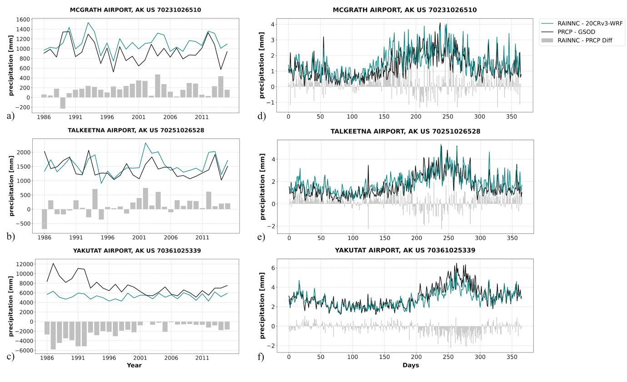
Fig. S6 Left (a-c) - Yearly accumulated precipitation for the 20CRv3-WRF downscaling (teal) and GSOD observations, with the difference (model – observation) for each year presented in the grey bars. Right (d-f) - daily 30-year (1986-2015) average precipitation for 20CRv3 downscaling modelled data (teal) and GSOD observations (black), and the difference (model – observations, grey bars). For the stations: (a,d) McGrath Airport, AK US; (b,e) Talkeetna Airport, AK US; (c,f) Yakutat Airport, AK. AK US for Alaska, United States of America

a)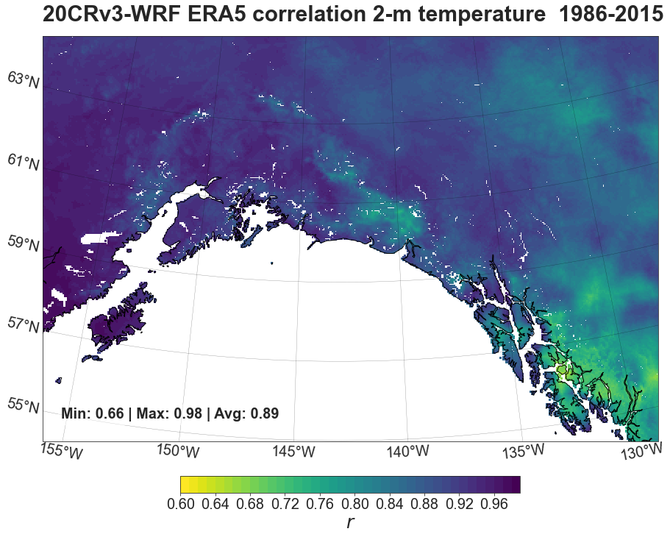
b)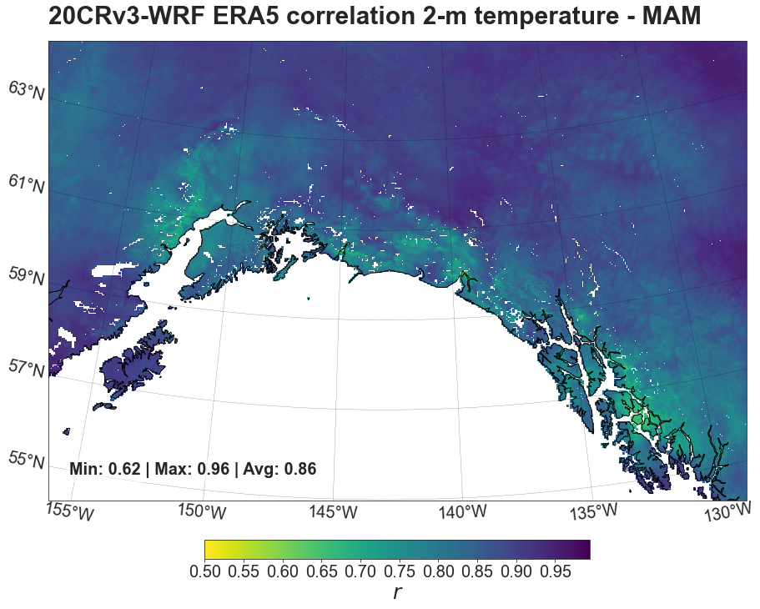 c)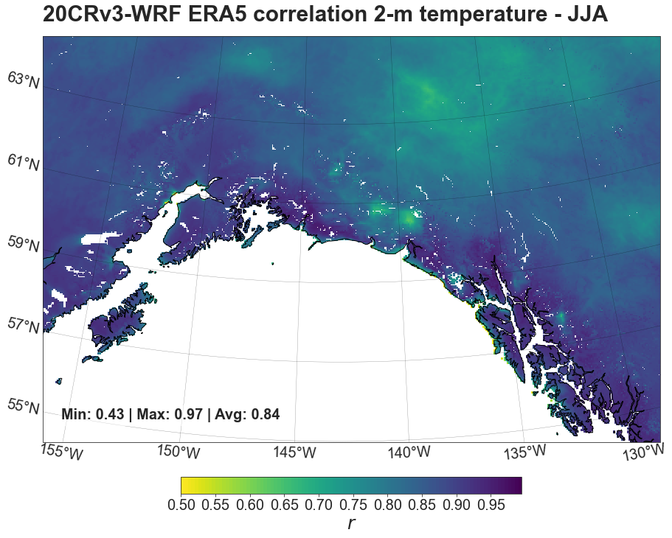
d)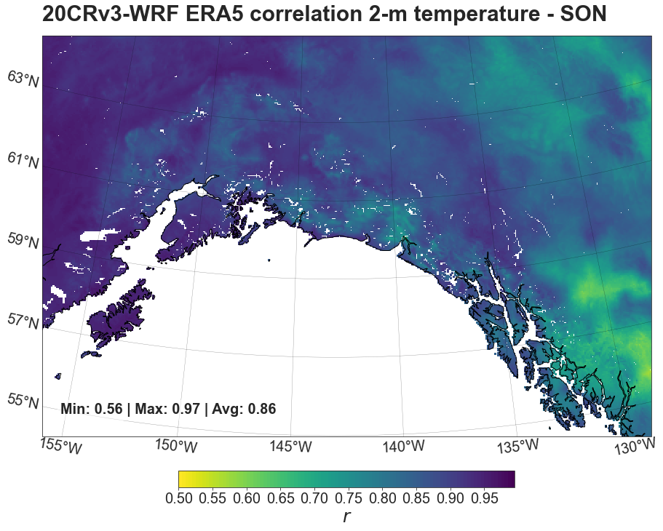 e)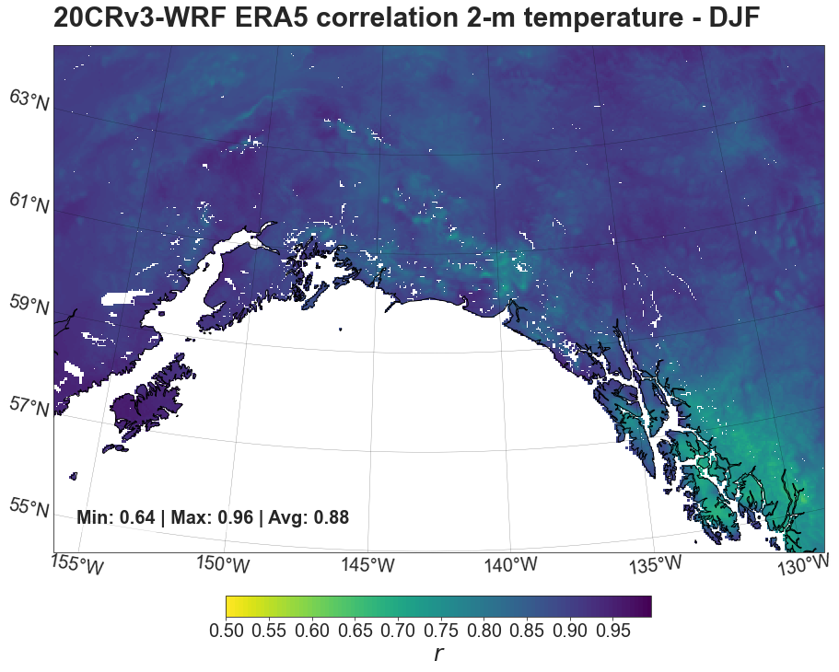
Fig. S7 (a) Annual and (b-e) seasonal maps of 30-year (1986-2015) temporal Pearson correlation (r) of the land area of annual 2-m temperature between 20CRv3-WRF and ERA5 ((b) spring (MAM), (c) summer (JJA), (d) autumn (SON) and (b) winter (DJF)). For each plot, minimum, maximum and mean values of r are provided inset
a)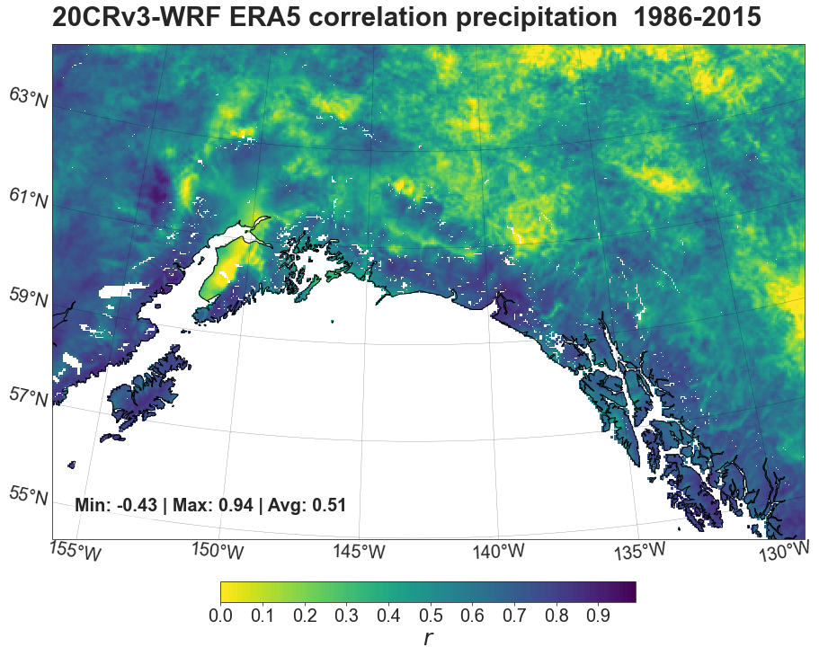
b)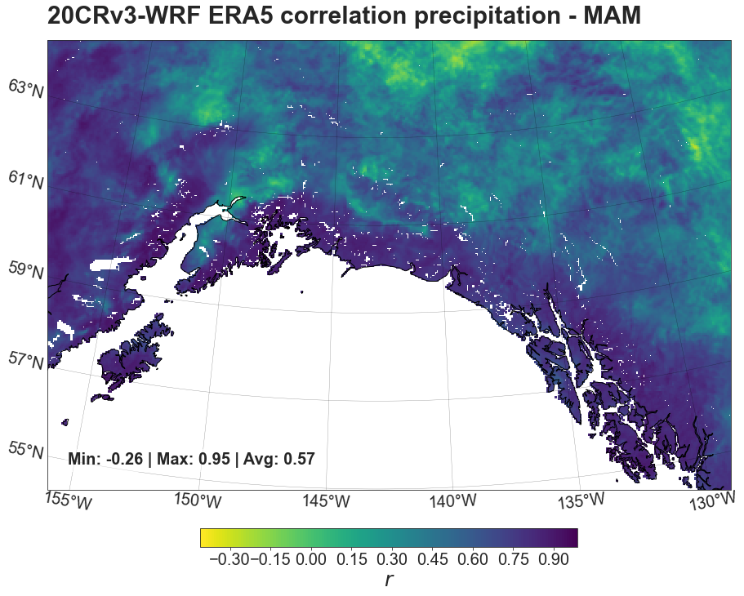 c)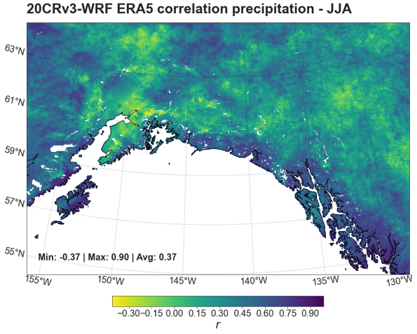
d)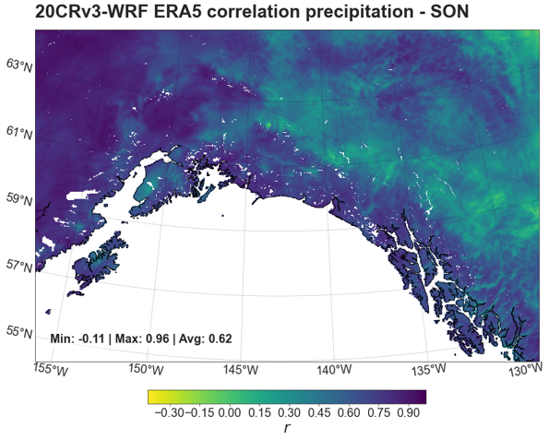 e)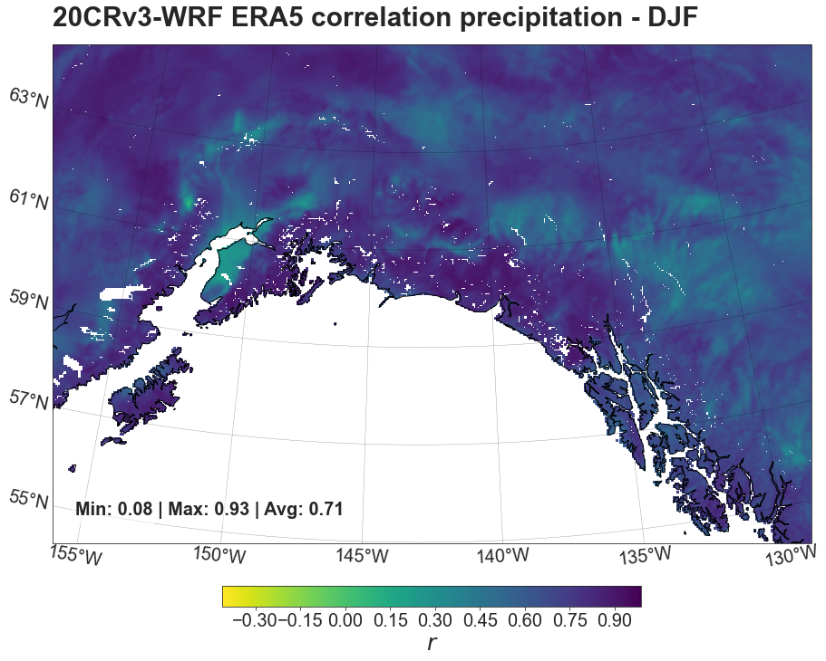
Fig. S8 (a) Annual and (b-e) seasonal maps of 30-year (1986-2015) temporal Pearson correlation (r) of the land area of annual accumulated precipitation between 20CRv3-WRF and ERA5 ((b) spring (MAM), (c) summer (JJA), (d) autumn (SON) and (b) winter (DJF)). For each plot, minimum, maximum and mean values of r are provided inset

