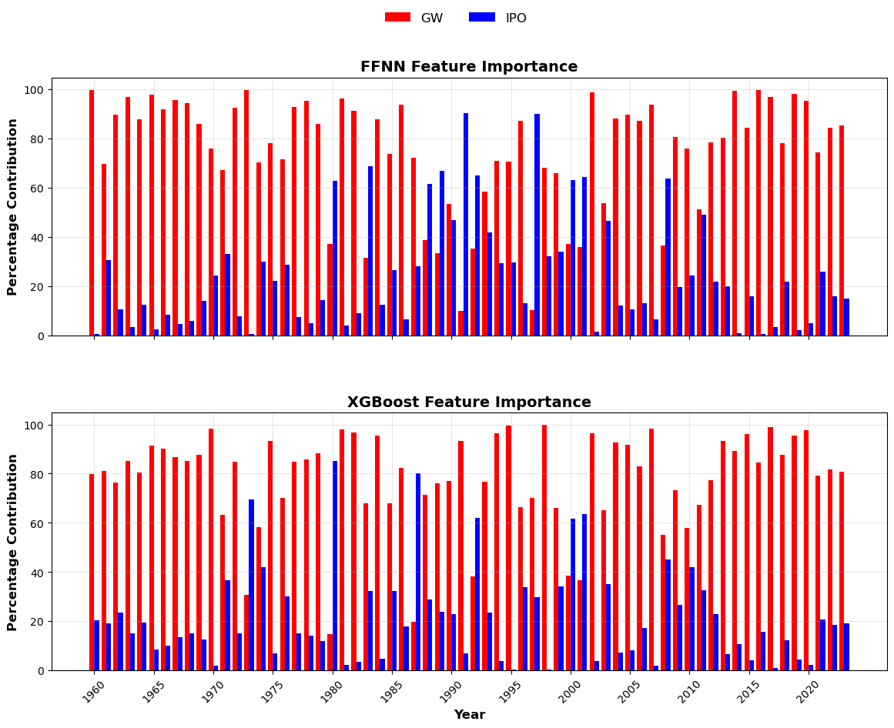
Figure S1: Local feature importance from SHAP showing the percentage contribution of GW and IPO for each year in the analysis period (1960-2023) from FFNN and XGBoost applied to 10-year moving average of precipitation averaged across the 55 stations

