Supplementary Material: Assessing future changes in Baltic Sea extreme wave heights using a machine learning approach

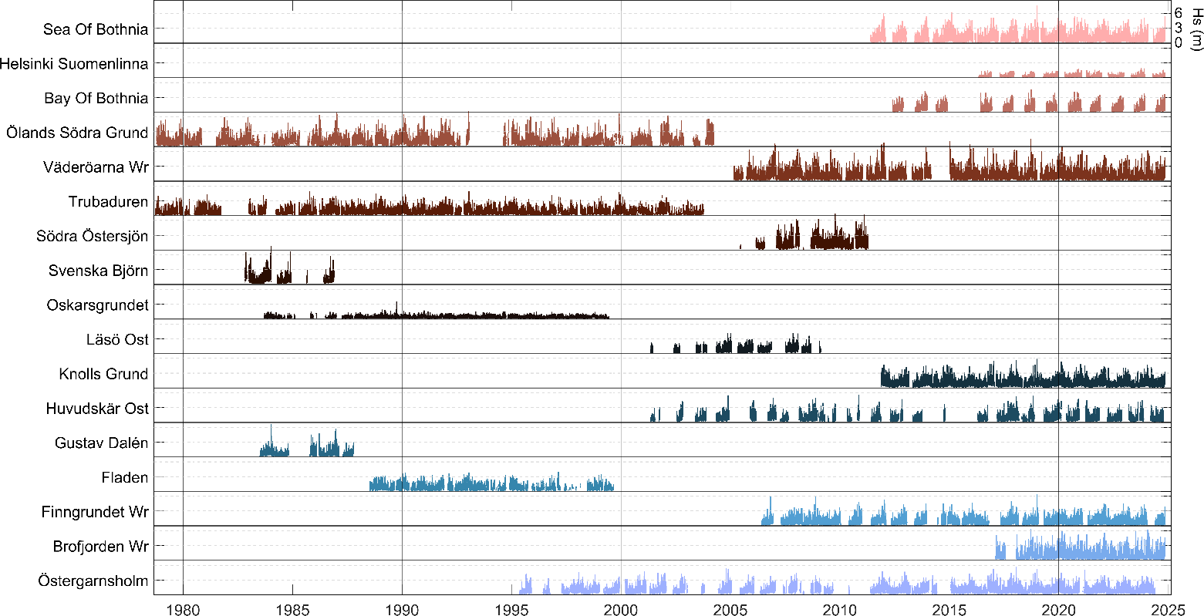
Figure A1: Time series of observed significant wave height (Hs) from 17 buoy stations across the Baltic Sea for the period 1978–2025. Each station’s Hs record is plotted with a vertical offset of 7 meters to enhance visual separation. Colours distinguish individual stations. Horizontal dashed lines every 3 meters on each offset represent a wave height reference scale, with labelled values shown on the right axis at the station: Sea of Bothnia.
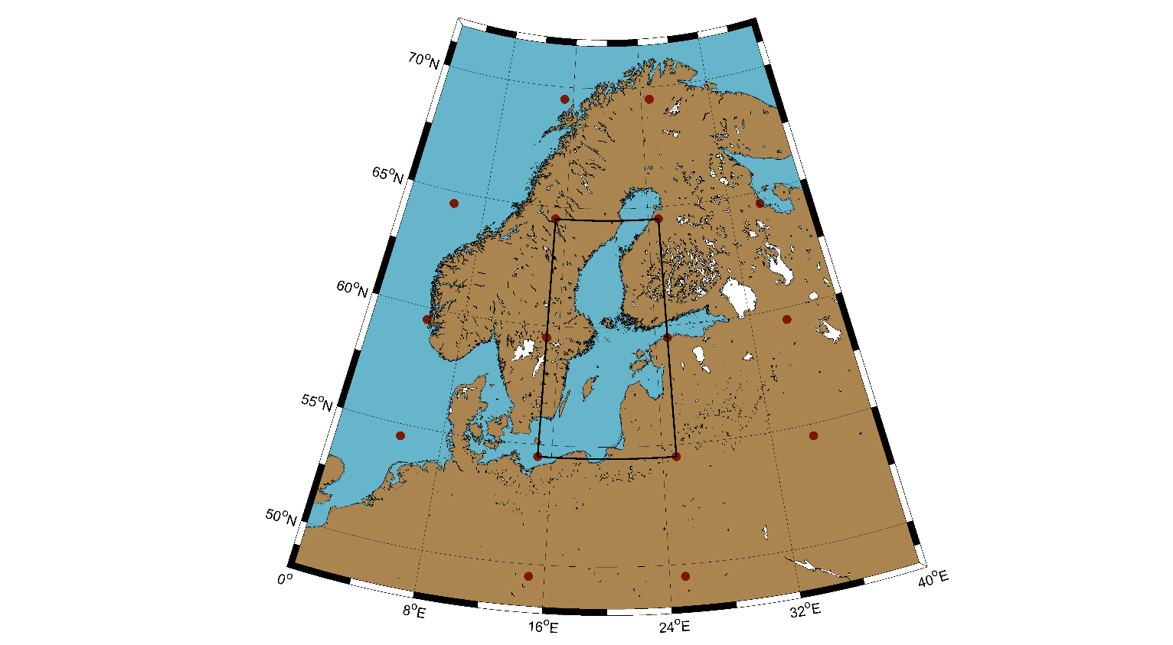
Figure A2: Map of the Baltic Sea region used for the Lamb Weather Type (LWT) classification. The red dots indicate the 16 grid points from which sea level pressure fields were extracted to construct the LWT classification scheme. The black rectangular box outlines the spatial domain focused on for this analysis.

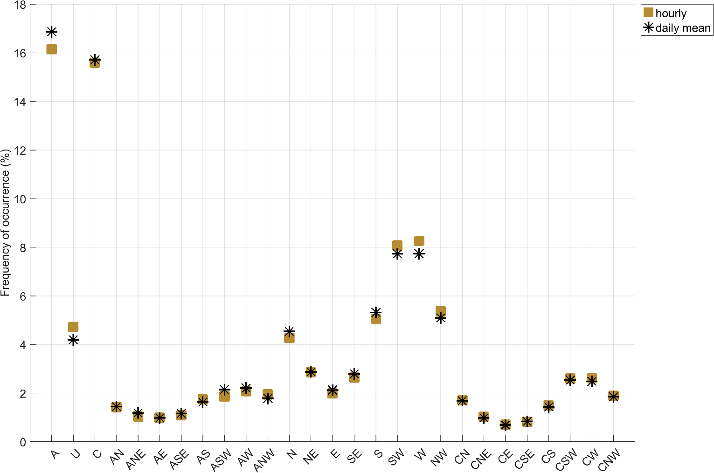
Figure A3: Occurrence frequency of Lamb Weather Types (LWTs) derived from ERA5 reanalysis using daily mean (dark asterisks) and hourly (brown squares) sea level pressure fields. The x-axis shows the 27 LWT categories, while the y-axis represents their frequency of occurrence in percentage, calculated over the reference period (1980-2009).

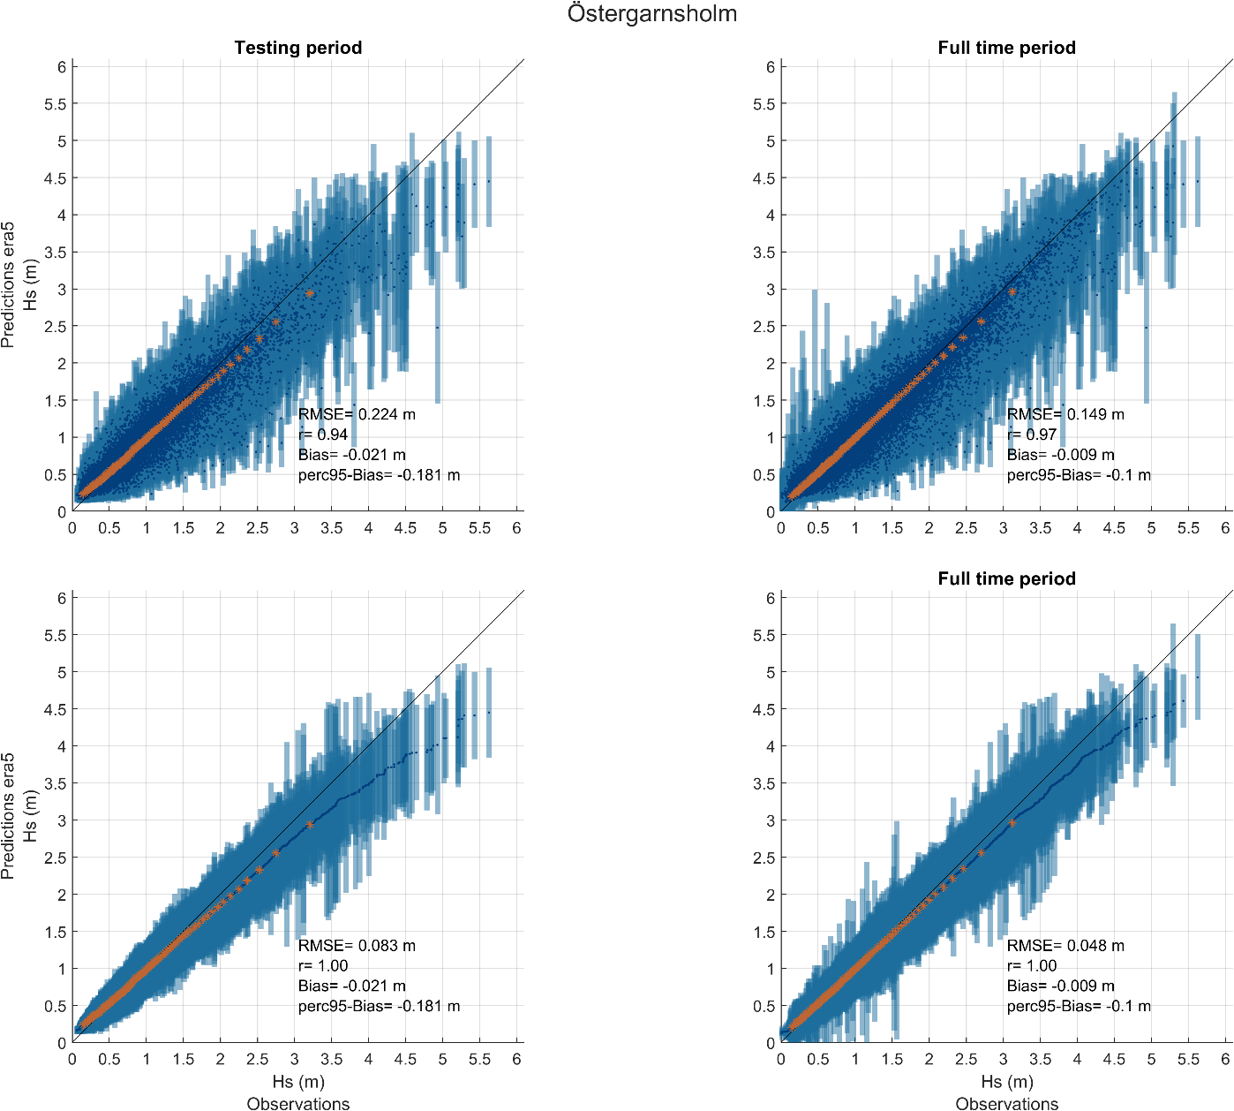
Figure A4: Correlation (upper panel) and sorted scatter plots (lower panel) of the RF model predictions based on ERA5 inputs at the station “Östergarnsholm” over the testing period (left panel) and the full-time period (right panel). The orange stars represent the 1st to 99th percentiles while the dots and error bars are the mean and uncertainty values from the RF model.

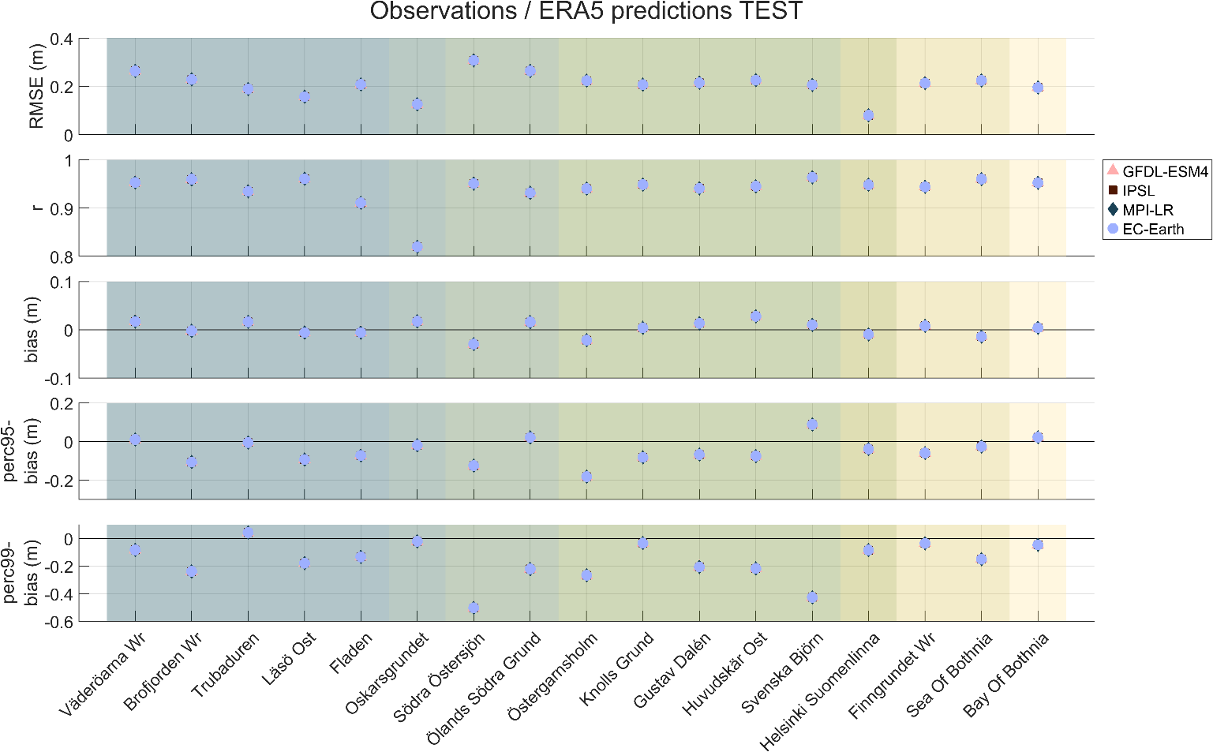
Figure A5: GOF metrics over the 3-hourly maxima time series of each RF model for the ERA5 RF models at each station. GOF metrics are calculated from the correlation plots over the testing period. Background colours indicate the regional classification of each station, as shown in Figure 1.

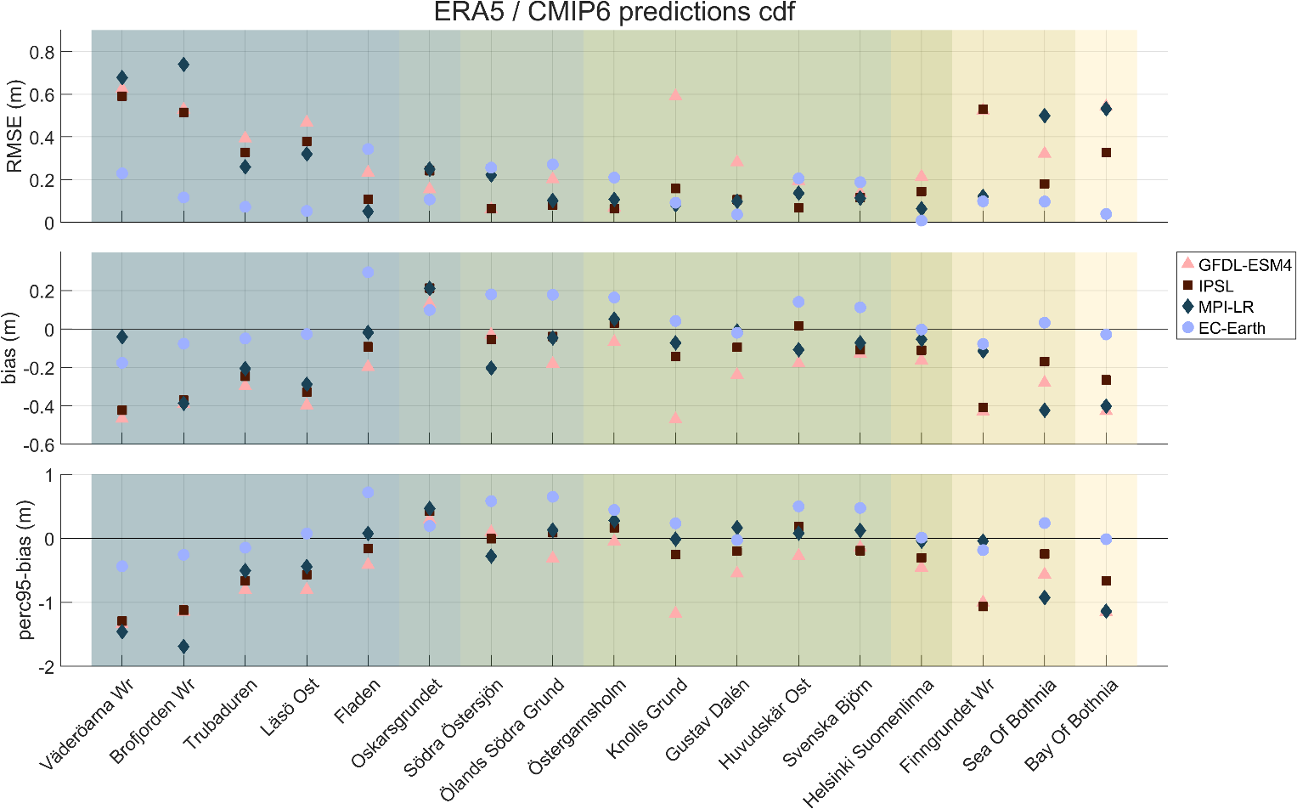
Figure A6: GOF metrics over the 3-hourly maxima time series of each RF model for the four climate models at each station. GOF metrics are calculated from the sorted scatter plots over the reference period (1980-2009) between ERA5 and CMIP6 mean predictions values. Background colours indicate the regional classification of each station, as shown in Figure 1.
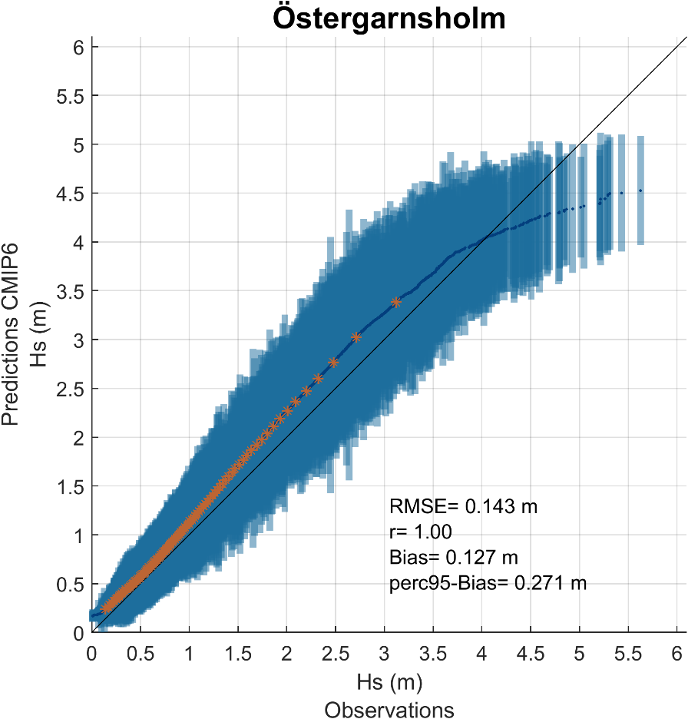
Figure A7: Sorted scatter plots of the RF model predictions based on CMIP6 inputs at the station “Östergarnsholm” validation period (co-occurring period between observations and predictions). The orange stars represent the 1st to 99th percentiles while the dots and error bars are the mean and uncertainty values from the RF model.

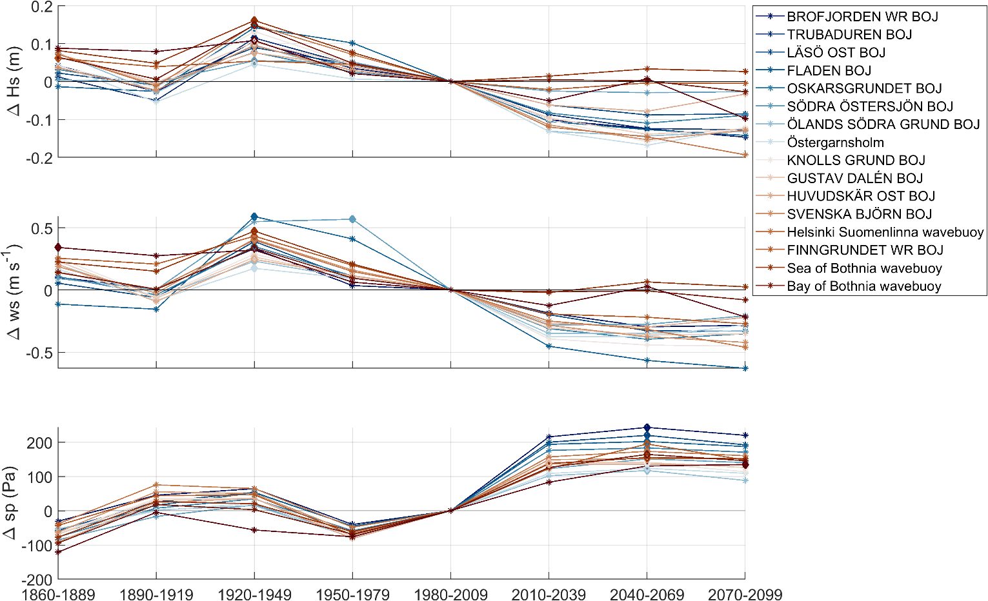
Figure A8: Temporal evolution of the 95th percentile of significant wave height (ΔHs), wind speed (Δws), and surface pressure (Δsp) across all stations in the Baltic Sea, based on EC-Earth simulations, under SSP2-4.5. Each panel shows 30-year block differences relative to the reference period (1980-2009). Diamonds symbols show the maximum change value for each station and each variable.
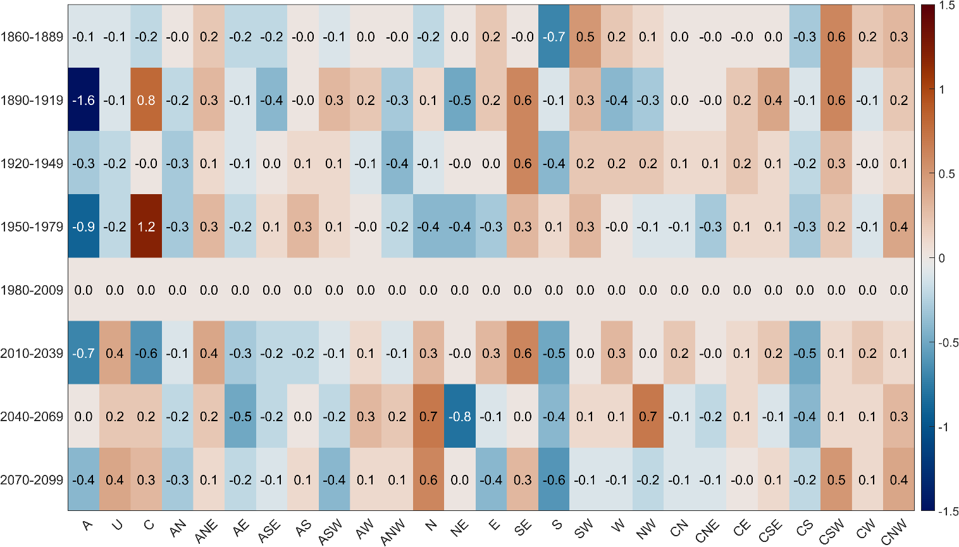
Figure A9: Temporal evolution of the frequency of Lamb Weather Types (ΔLWT) defined over the Baltic Sea (see section 2.2.1), based on the EC-Earth climate model, under SSP2-4.5. The y-axis shows 30-year block differences relative to the reference period (1980-2009). The x-axis displays the values for each LWT class. Colours indicate the percentage change in LWT frequency relative to the reference period, with blue tones indicating a decreased occurrence for the specific time period and red tones indicating an increased frequency of occurrence.

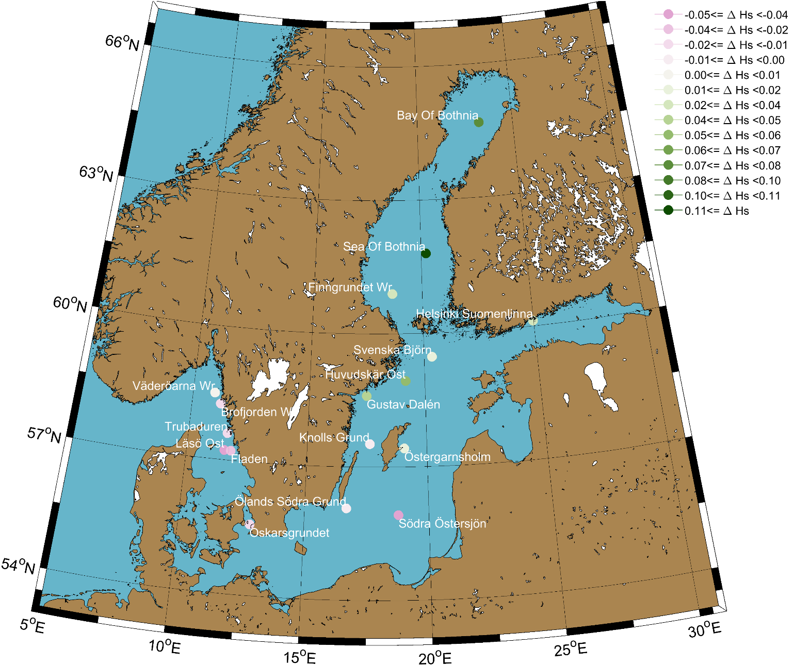
Figure A10: Spatial distribution of projected changes in the 95th percentile of significant wave height (ΔHs) (in m) between the future period (2070–2099) and the reference period (1980–2009), based on the ensemble mean of four CMIP6 models under the SSP2-4.5 scenario. Negative values (in pink) indicate a decrease in the 95th percentile of Hs in the future period compared with the reference period, while positive values (in green) indicate an increase.

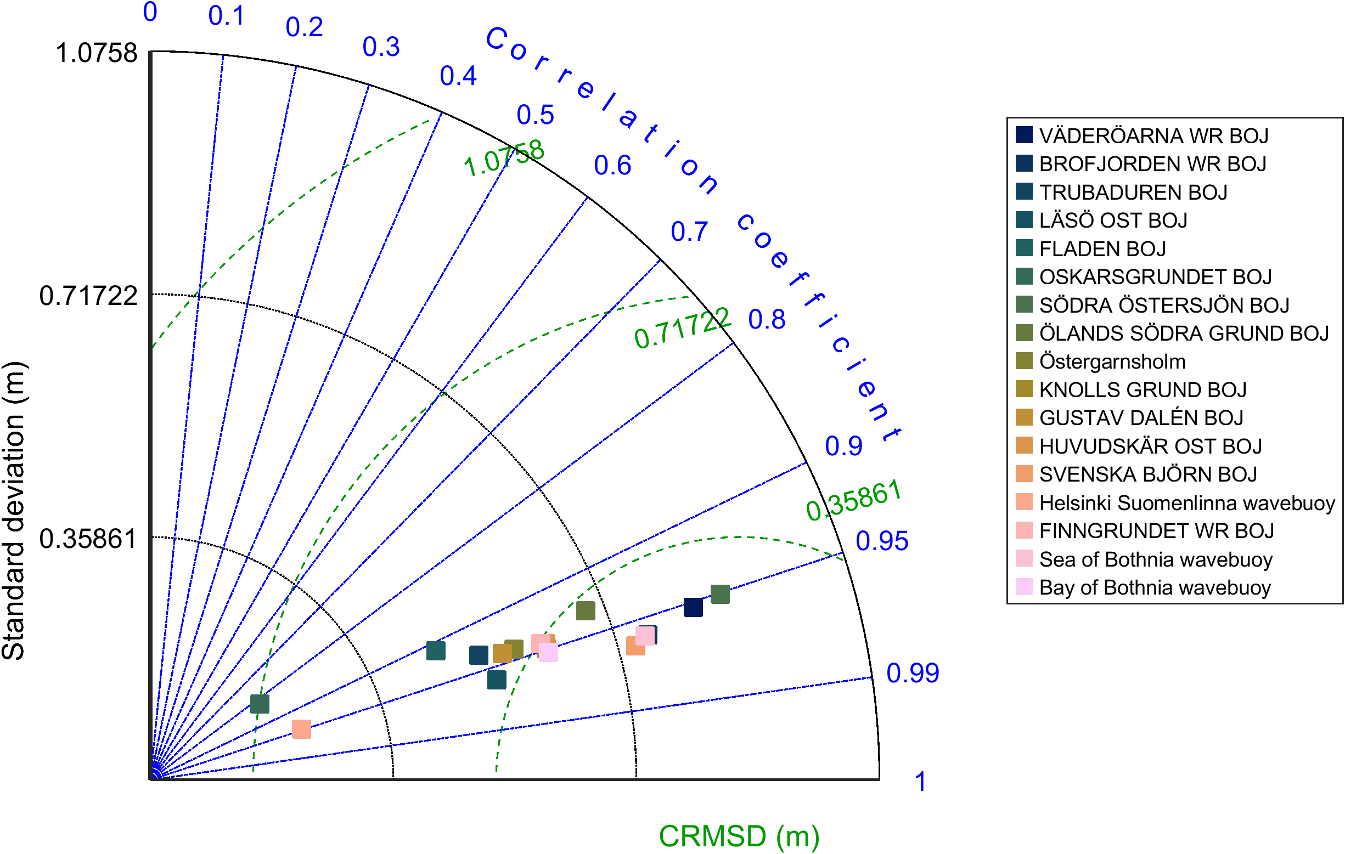
Figure A11: Taylor diagram of each model performance, based on co-occurring observations and predictions from ERA5 inputs, assessed over the testing period.

