Supplementary materials
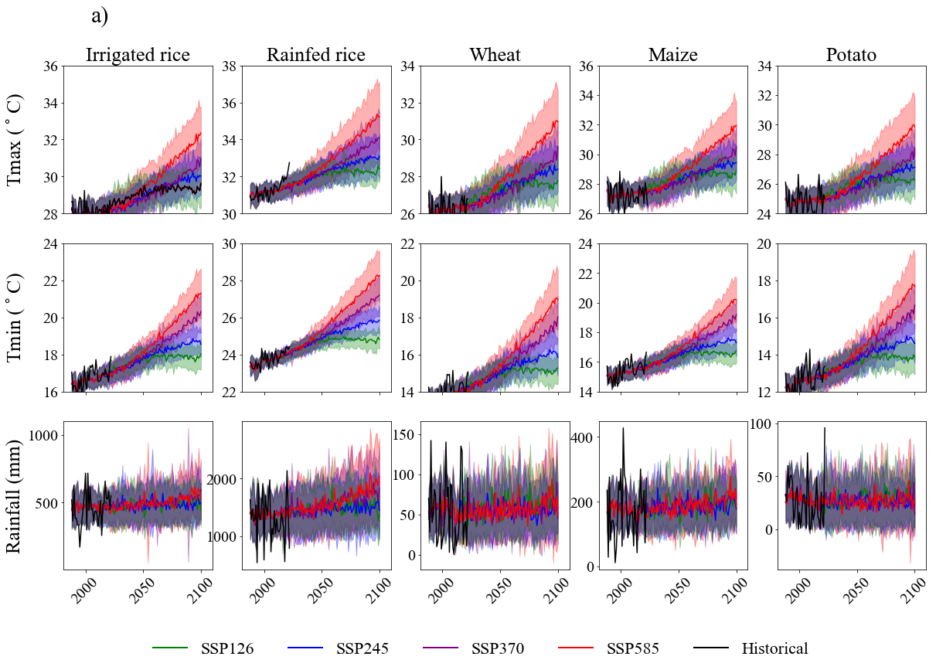
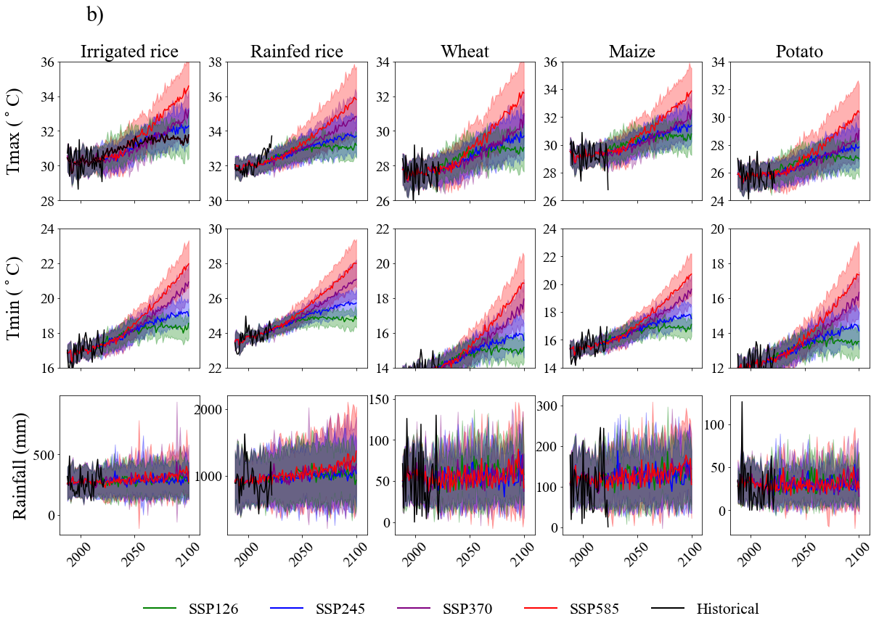
Figure S1. Projected seasonal T_{max} (maximum temperature), T_{min} (minimum temperature), and rainfall during the growing period of irrigated rice, rainfed rice, wheat, maize, and potatoes in a) Rangpur and b) Rajshahi under four climate change scenarios. The solid line indicates the mean of the models, and the shaded area represents the inter-model standard deviation.
A) Rangpur
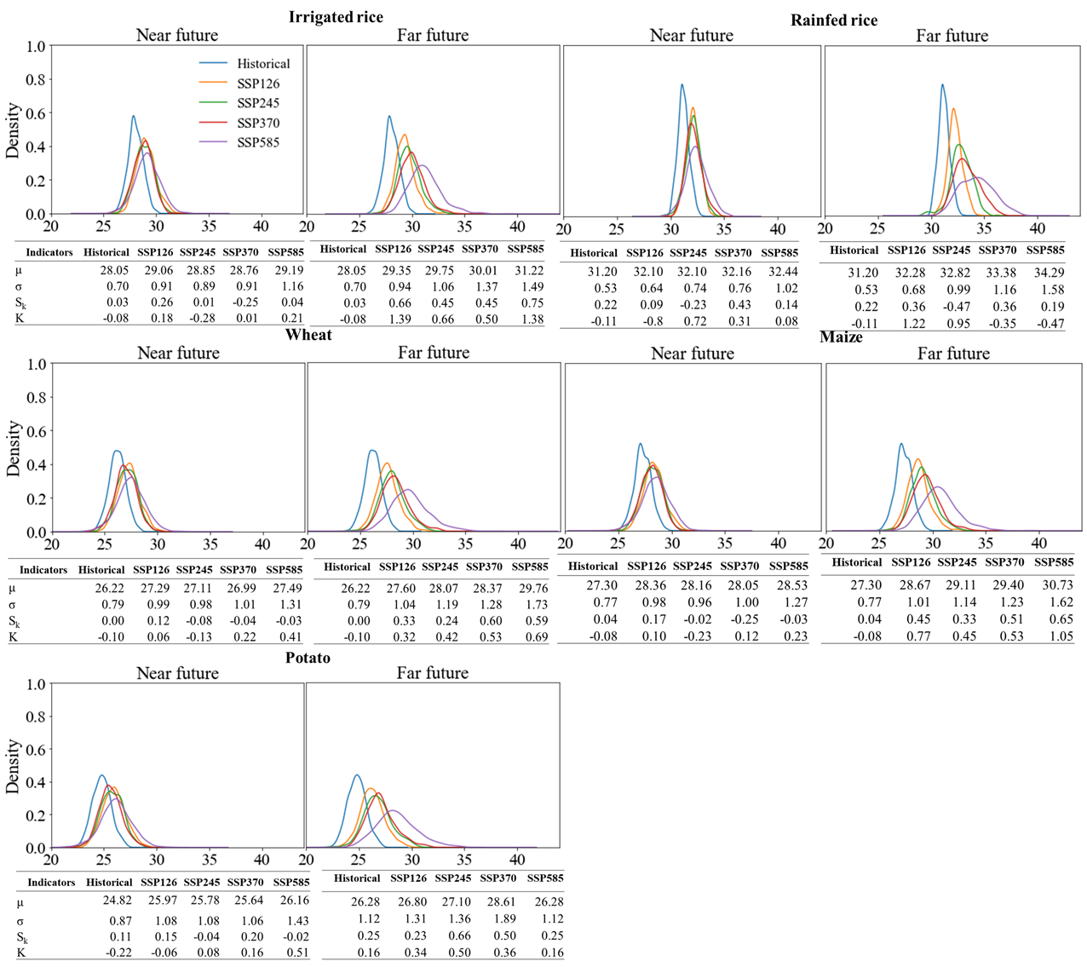
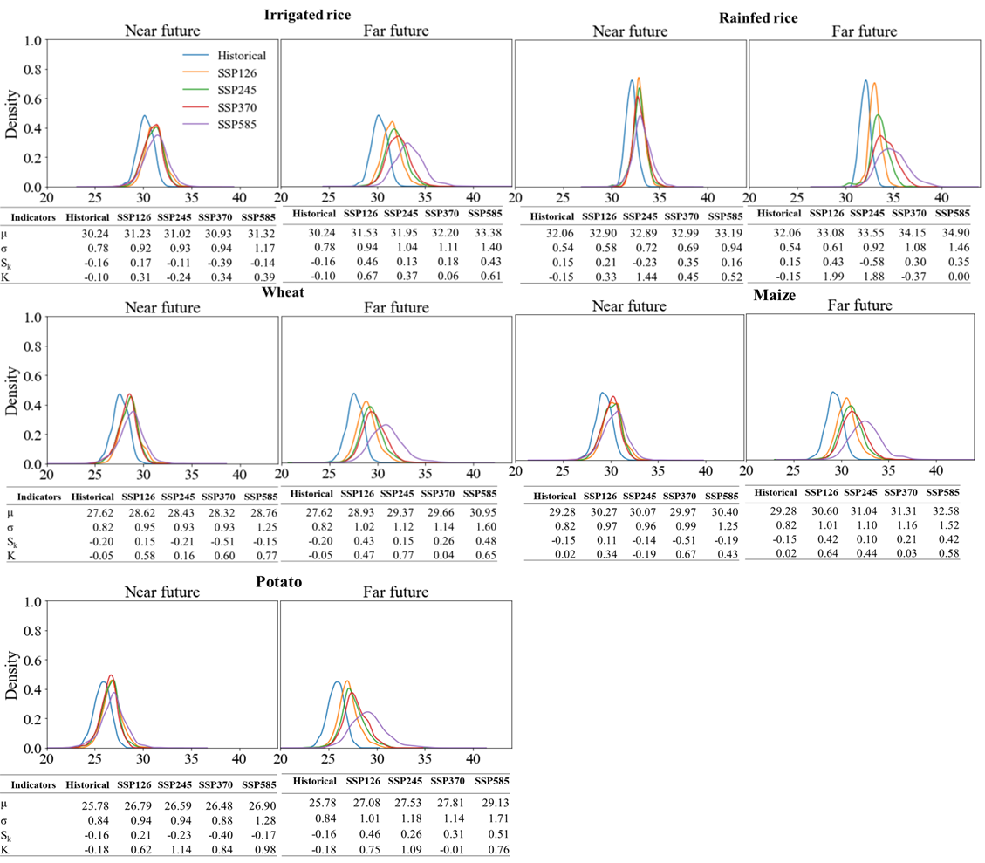
B) Rajshahi
Figure S2. Probability density functions of maximum temperature during the growing seasons for irrigated rice, rainfed rice, wheat, maize, and potatoes in A) Rangpur and B) Rajshahi comparing four climate change scenarios with historical for both near-future and far-future periods. In this figure, the symbols µ, σ, Sk, and K represent the mean, standard deviation, skewness, and kurtosis of the temperature distributions, respectively. The observations include 25 GCMs and 35 years for each warming scenario

- Rangpur
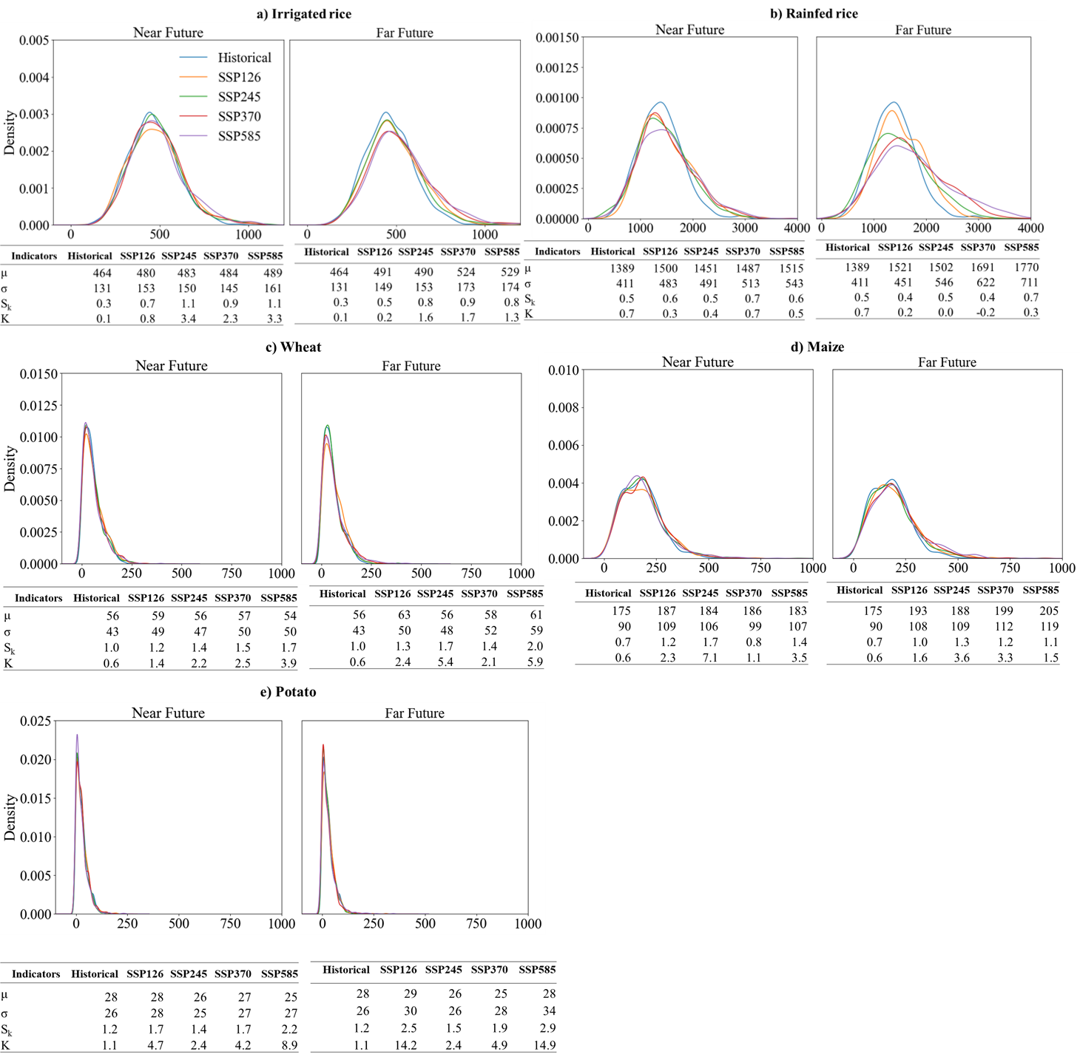

- Rajshahi
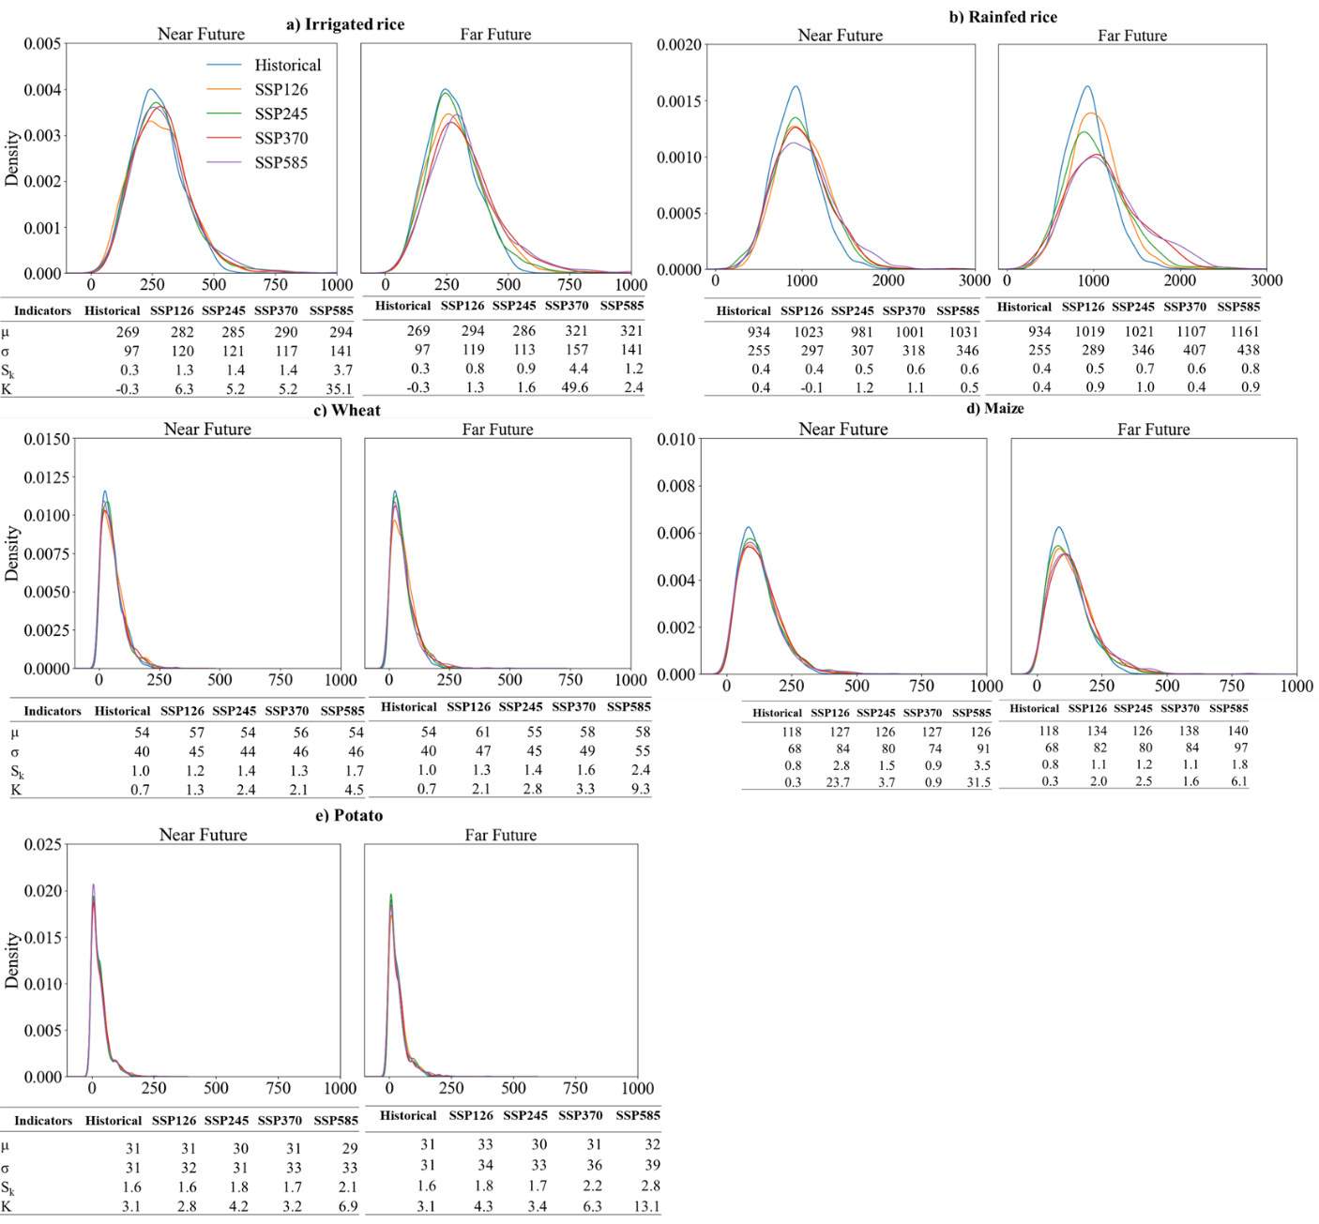
Figure S3. Probability density functions of Seasonal rainfall during the growing seasons for irrigated rice, rainfed rice, wheat, maize, and potatoes in A) Rangpur and B) Rajshahi comparing four climate change scenarios with historical for both near-future and far-future periods. In this figure, the symbols µ, σ, Sk, and K represent the mean, standard deviation, skewness, and kurtosis of the temperature distributions, respectively. The observations include 25 GCMs and 35 years for each warming scenario

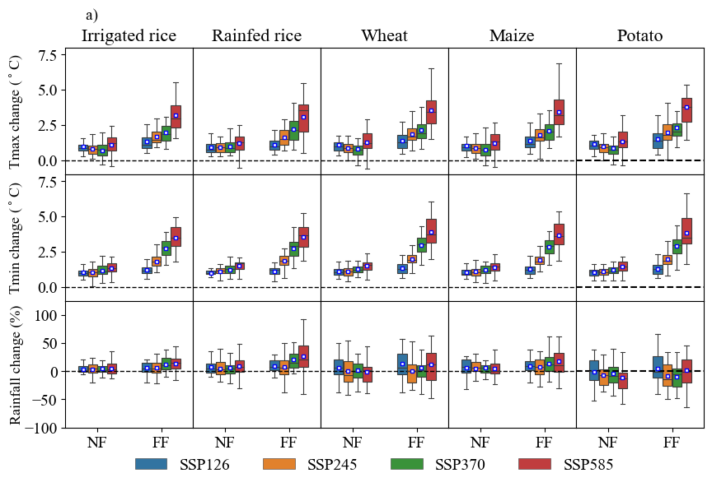
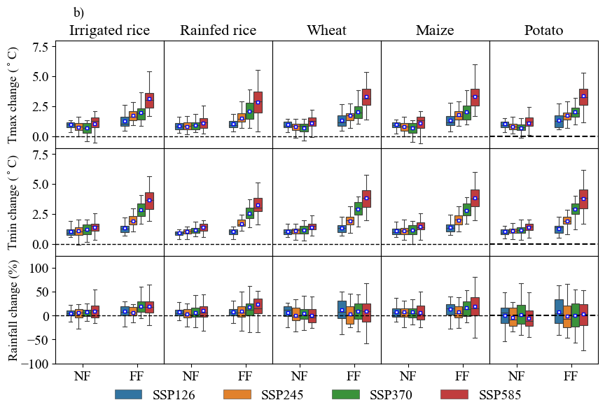
Figure S4. Relative changes in seasonal maximum temperature (Tmax), minimum temperature (Tmin), and rainfall during the growing seasons for irrigated rice, rainfed rice, wheat, maize, and potatoes in near future (NF: 2031–2065) and far future (FF: 2066–2100) periods, compared to the base period (1988–2022) under four climate change scenarios in a) Rangpur and b) Rajshahi, Bangladesh. The boxplots illustrate the variability among model projections.
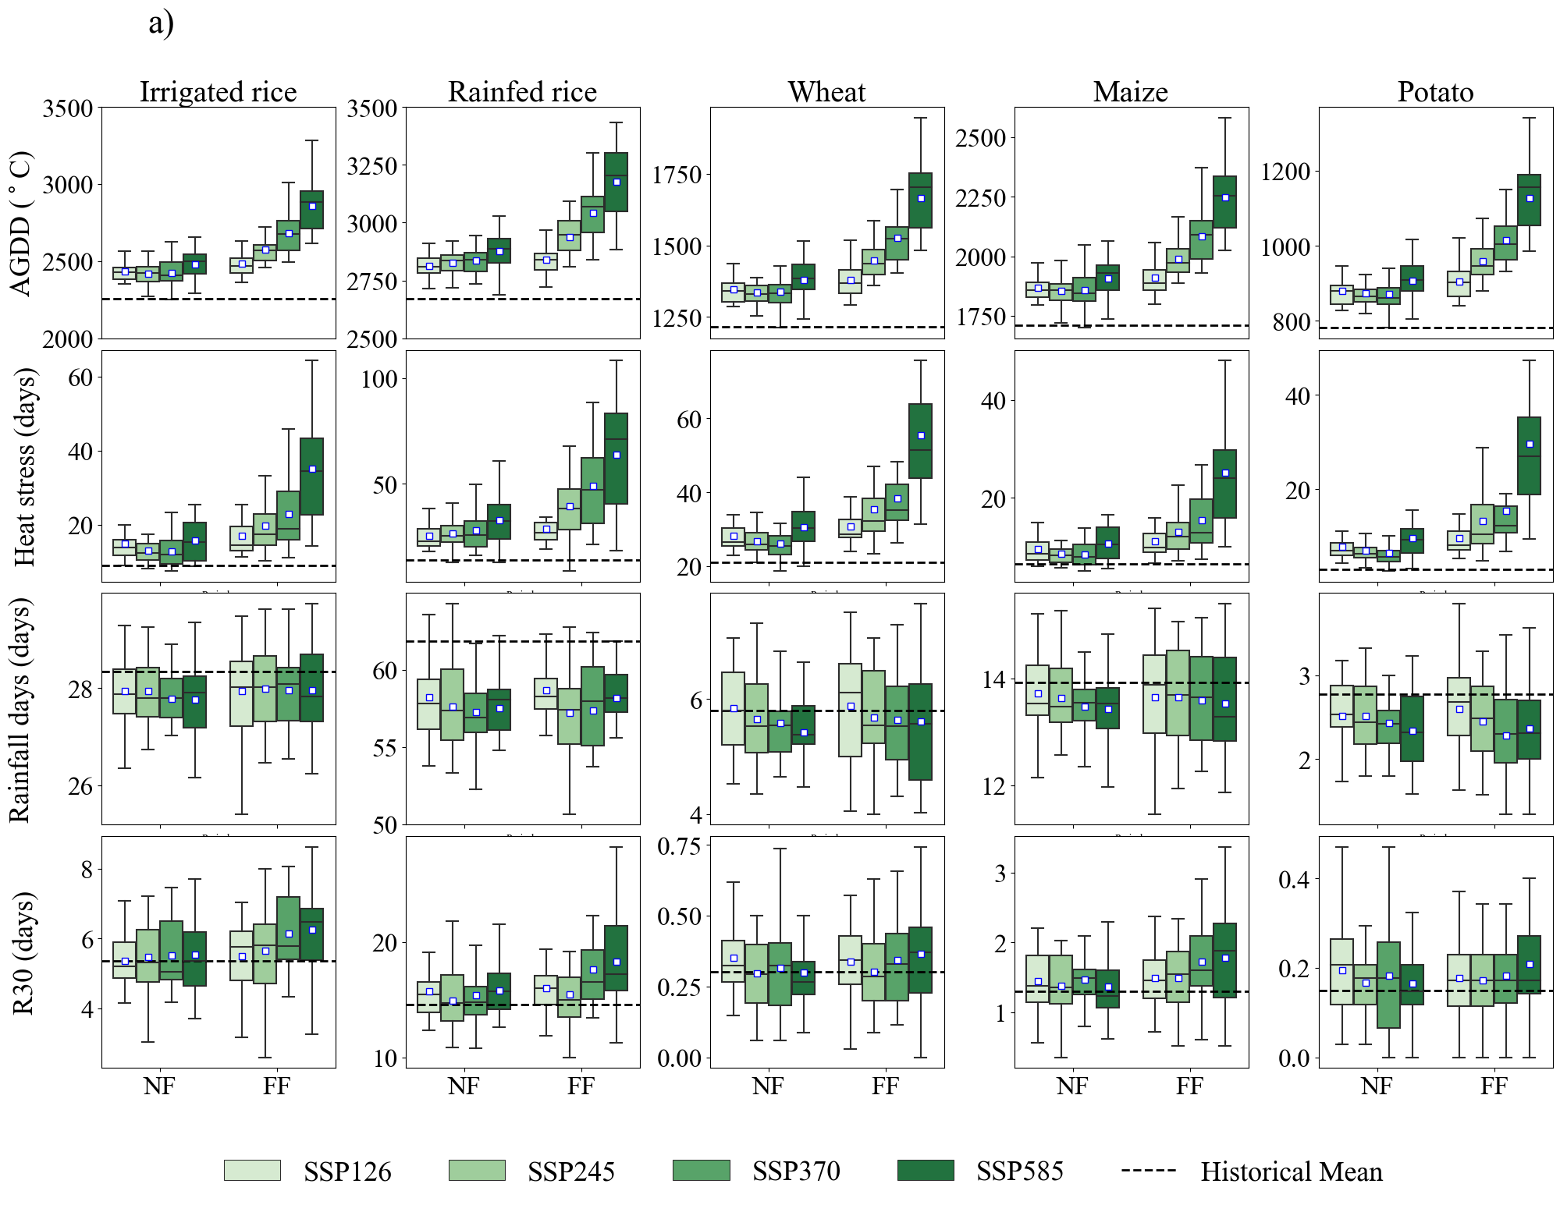
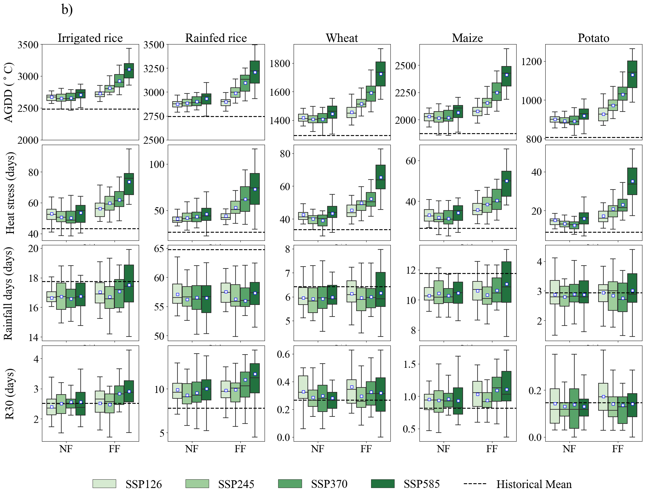
Figure S5. Box and Whisker plots illustrating the relative change of AGDD (accumulated growing degree days), total heat stress days, total rainy days, and R30 (heavy rainfall days) during the growing seasons for irrigated rice, rainfed rice, wheat, maize, and potatoes in near future (NF: 2031-2065), and far future (FF: 2066-2100) periods over the base period (1988-2022) in a) Rangpur and b) Rajshahi of Northwest Bangladesh.

