Supplementary Fig. 1 Change in area of land cover classes in Odisha, India displayed as a faceted line graph.

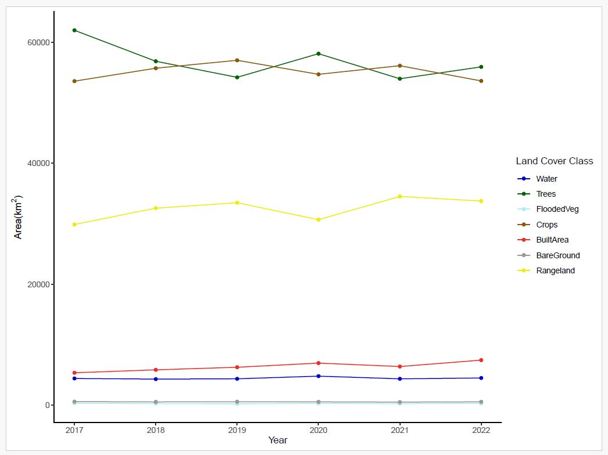
Supplementary Fig. 2 Change in area of land cover classes in Odisha, India displayed as a line graph.

