The bar scale on the right side of each subplot (a,b and c) explains which component (seasonality or trend) is dominant for a series. The significance of the component is higher with a smaller bar scale (Cleveland, 1990).

a)
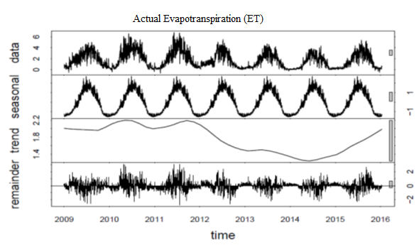
b)
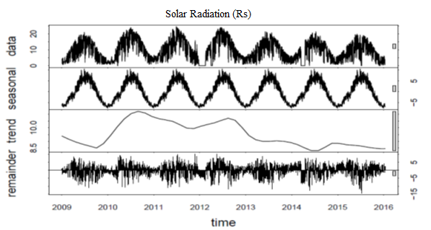

c)
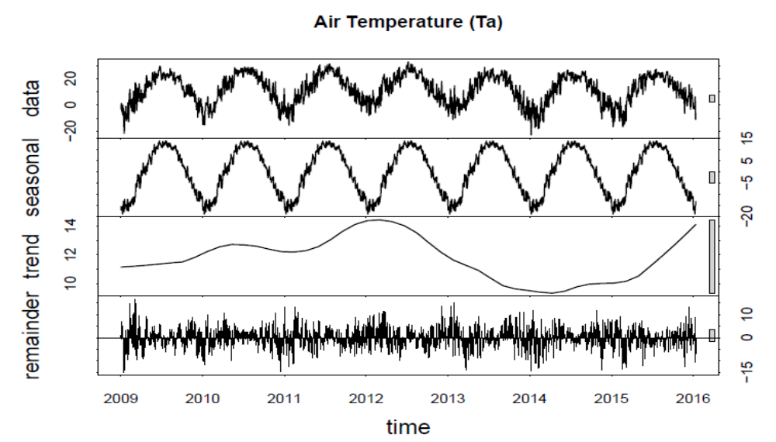
d)
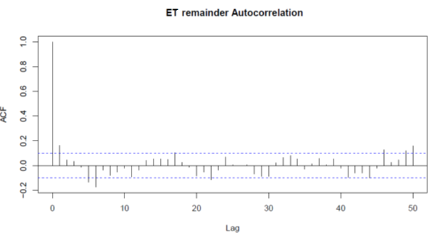

e)
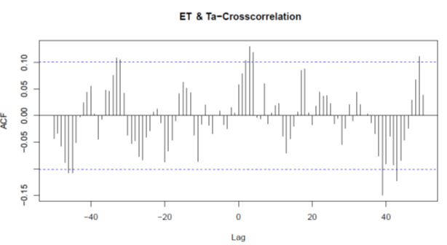
f)
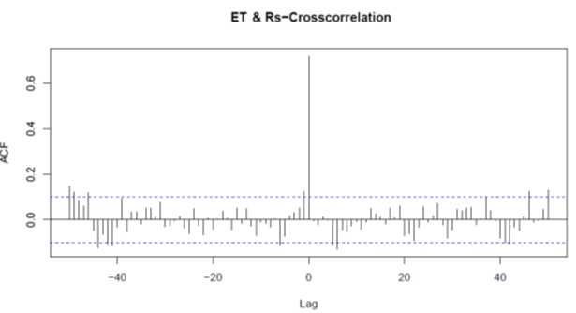
Figure S1. STL decomposition for ET (a), solar radiation, R_{s} (b), and air temperature, T_{a} (c) of M. × giganteus UIEF. From top to bottom, the original time series, seasonal component, trend component, and remainders are displayed. Further, the auto-correlation function of the ET-remainder (d), cross-correlation of R_{s} -remainder, and ET-remainder (e) and cross-correlation of T_{a}-remainder and ET-remainder (f) time series are shown. The blue dashed line indicates the confidence limit.
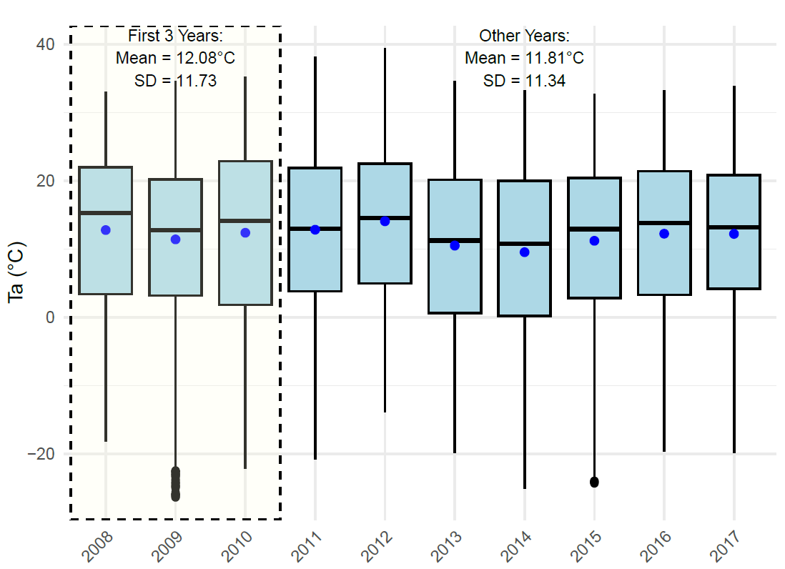
Figure S2. Box plot showing the annual variability in air temperature (Ta ​) from 2008 to 2017 in UIEF. The first three years (2008–2010) are highlighted with a dashed rectangle, indicating a mean ± standard deviation (12.08±11.73℃) that closely aligns with the remaining years (11.81±11.34℃). The medians, interquartile ranges, and overall patterns suggest that the first three years are representative of the entire study period. The black line within each box represents the median annual Ta ​, while the blue points indicate the mean annual Ta​.
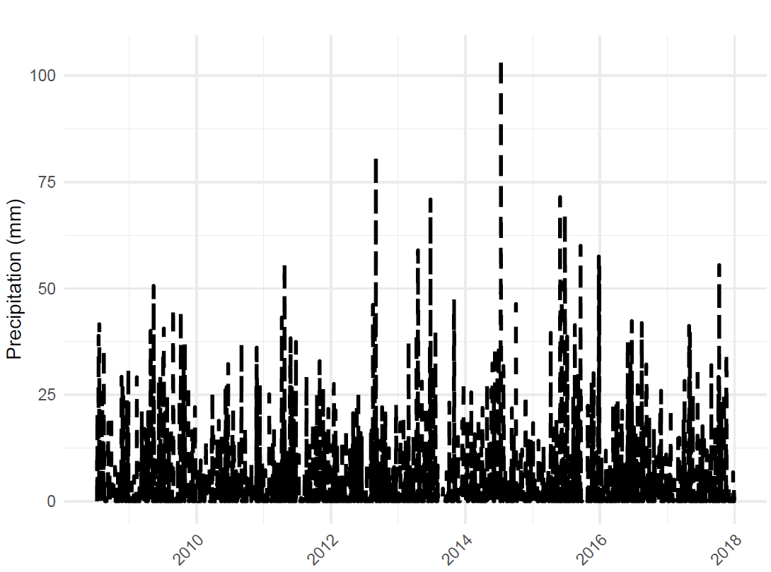
Figure S3. Daily mean precipitation (Precip) in mm for UIEF for the study period 2008-2017.

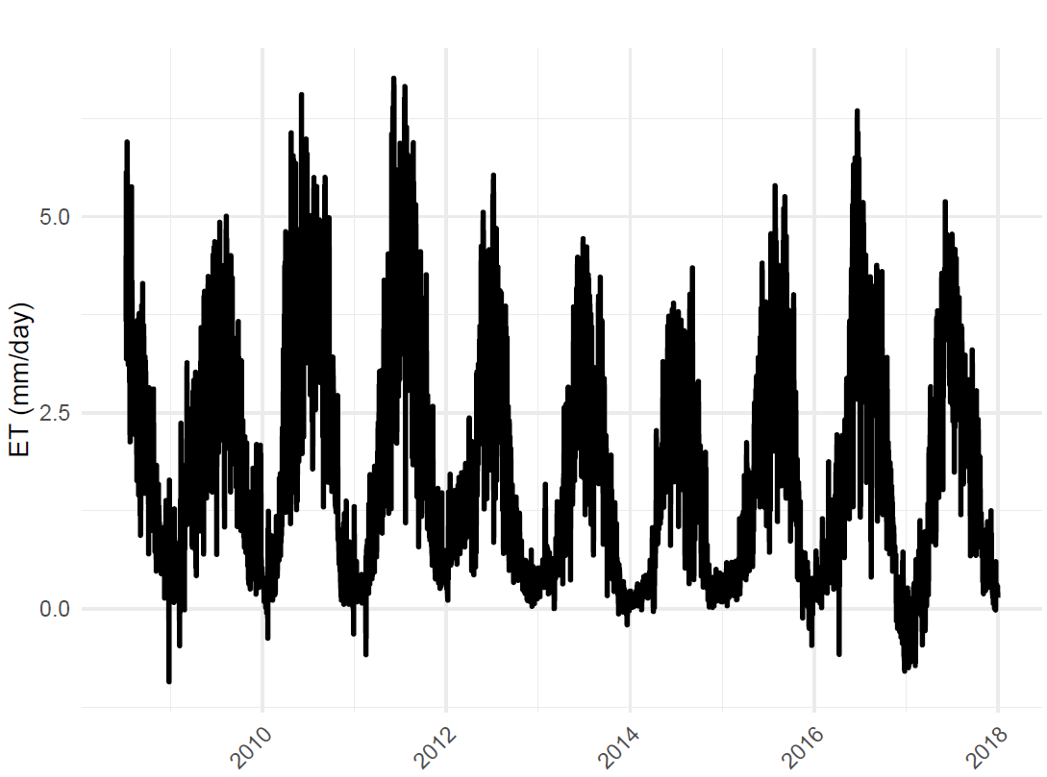
Figure S4. Daily evapotranspiration (ET, mm/day) for UIEF for the study period 2008-2017.

Table S1. Annual mean and cumulative precipitation (Precip, mm) from 2008 to 2017 in UIEF and 2019 in SABR.
Year | Mean Precip (mm) | Cumulative Precip (mm)
2008* | 3.46 | 609
2009 | 3.43 | 1252
2010 | 2.43 | 888
2011 | 2.95 | 1076
2012 | 2.46 | 902
2013 | 2.62 | 956
2014 | 3.20 | 1167
2015 | 3.58 | 1305
2016 | 2.84 | 1039
2017 | 2.49 | 910
2019-2020** (SABR) | 2.15 | 721
*2008 measurement is period between July to December. **2019-2020 measurement period is between June 2019 to April 2020.

