Supplementary materials
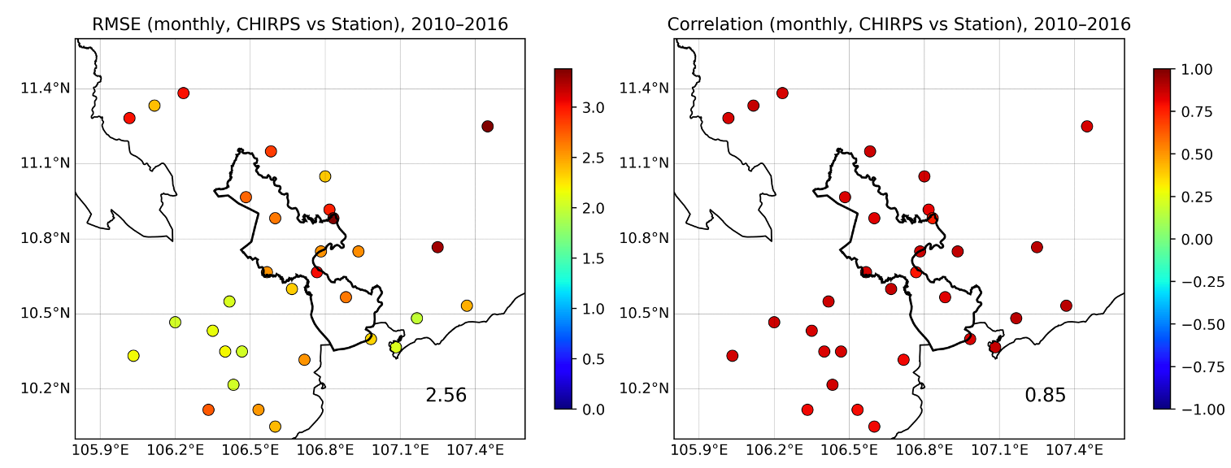
Supplementary Figure S1: Root Mean Square Error and Temporal Correlation of monthly CHIRPS rainfall compared with station observations during 2010–2016. The value shown at the lower right represents the mean RMSE across all stations.

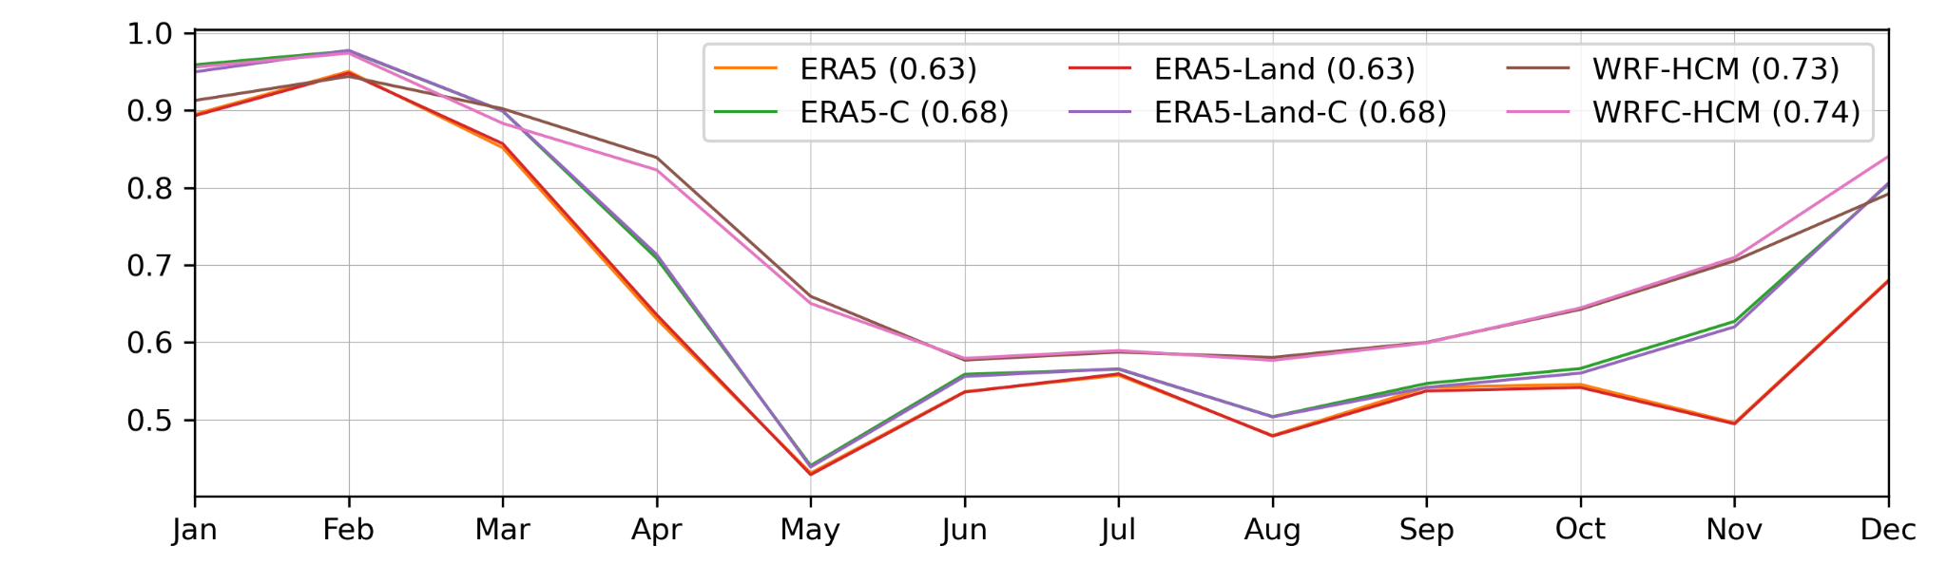
Supplementary Figure S2: Accuracy of different dataset, validated using station observations.

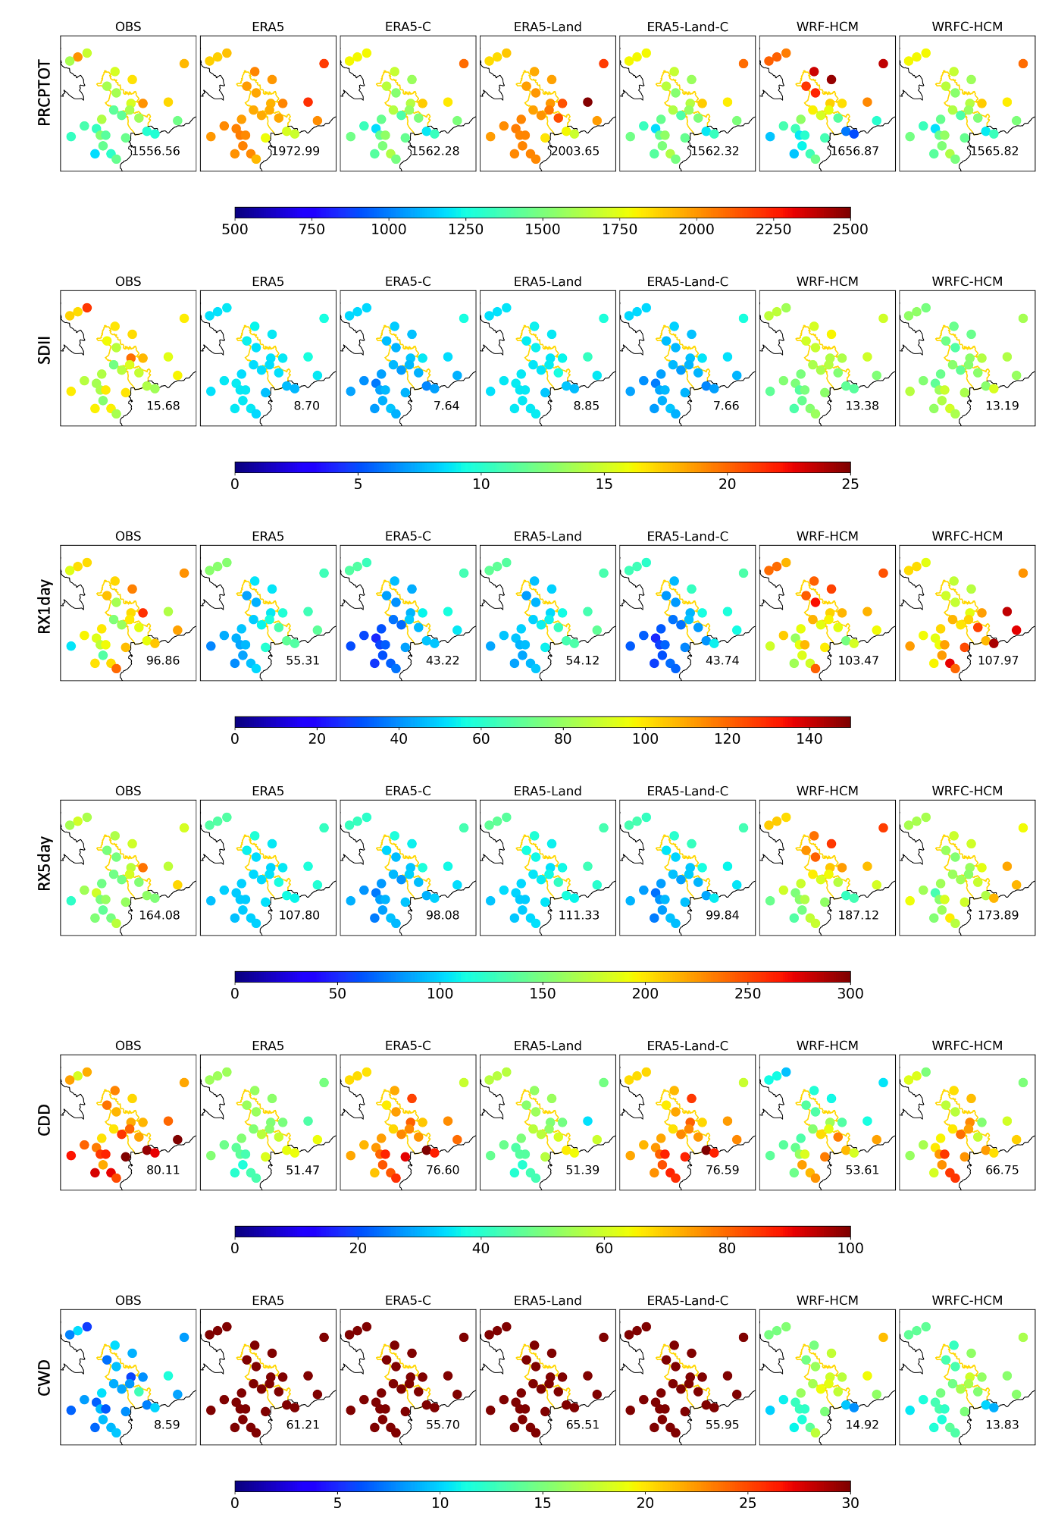
Supplementary Figure S3: Mean values of PRCPTOT, SDII, RX1day, RX5day, CDD, and CWD from different datasets during 2010–2016.

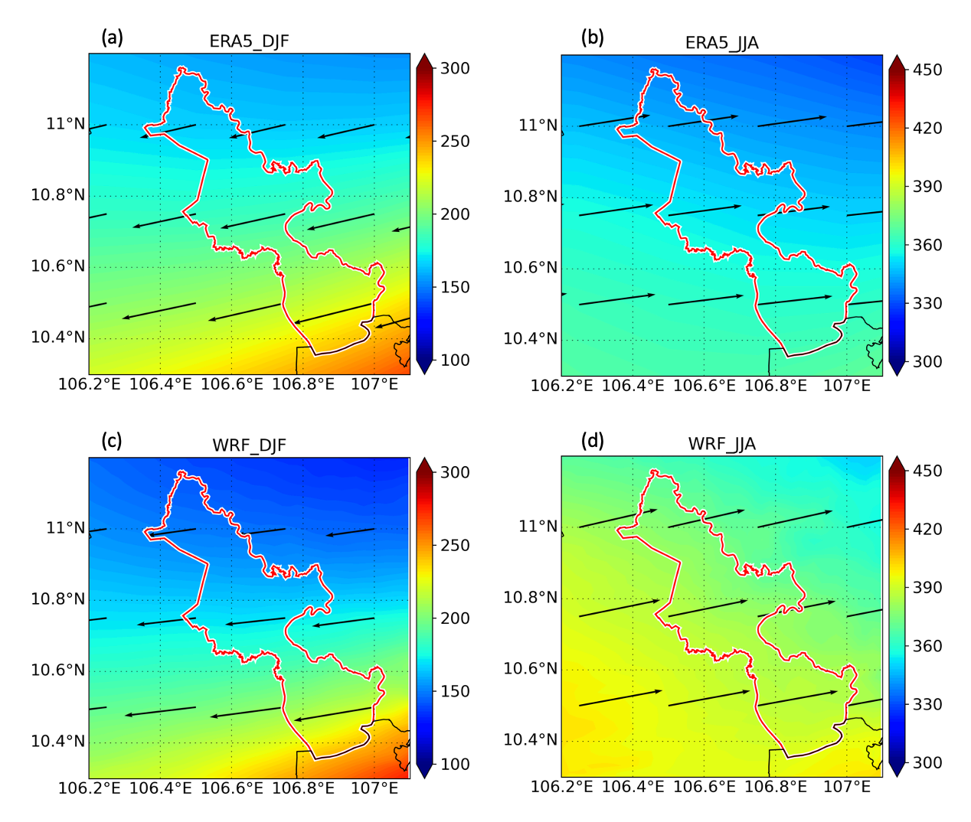
Supplementary Figure S4: Vertically integrated water vapor transport (IVT) (shaded colours, kgm⁻¹s⁻¹) and direction (vectors) in different seasons of ERA5 (a, b) and WRF (c, d), integrated from 1000 to 100 hPa. Units in kgm⁻¹s⁻¹. Please note the different color bars in different seasons.

