Supplementary (S) Material
Section 1: Sensitivity analysis of gap-filling methods
A sensitivity analysis of gap filling methods to the correlation and distance between the main and neighbouring stations base on the temperature data of the Fiche station (one of the main stations with the lowest percentage of missing data among other main stations). Two stations (Lemi and Gebre Guracha) were used to fill the assumed missing temperature data. Lemi was located within a 25km radius, and Gebre Guracha was located between 25km to 50km from the main station (Fiche) (see figure below).
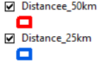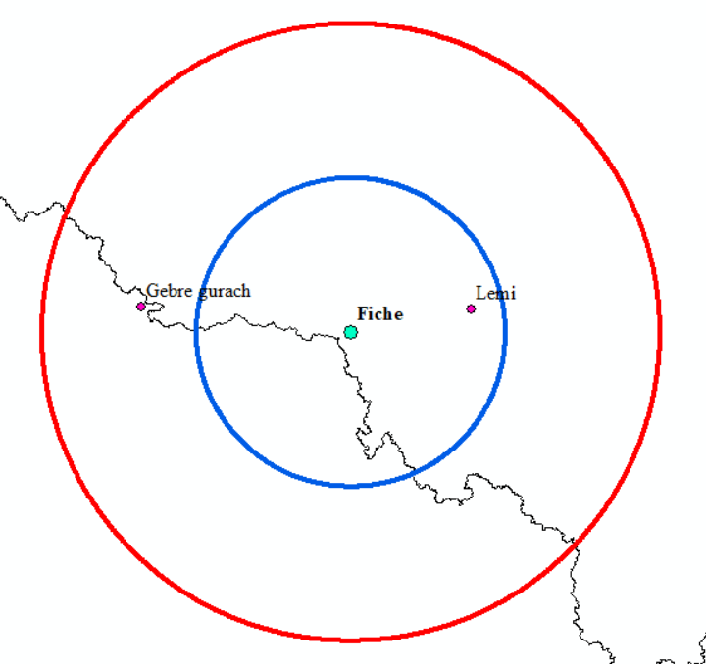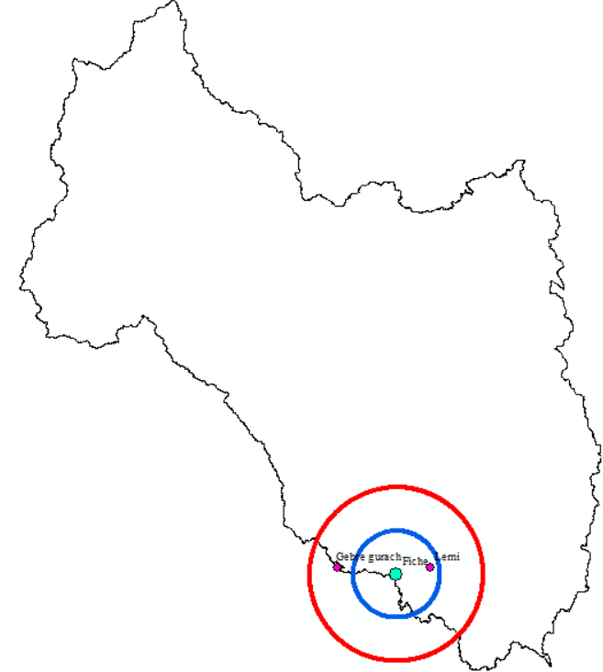
Figure: Distance between main and neighbouring stations
The correlation between Lemi to Fiche was 0.08 and 0.06 for maximum and minimum temperatures, respectively (see the table below, marked in the red rectangle). The correlation between other main stations to the corresponding neighbouring stations was above 0.2 (the minimum limit for the study).
Table. Spatial correlation between the target and the neighboring stations.
Target Station | Neighboring Stations and correlation to the main stations
Target Station | Maximum Temperature |  | Minimum Temperature
Adet | Merawi | Mota | Merawi | Mota
Adet | 0.52 | 0.73 | 0.44 | 0.66
Alem Ketema | Meragn | Eneware | Meragn | Eneware
Alem Ketema | 0.85 | 0.85 | 0.48 | 0.28
Amba Mariam | Wegel Tena | Dessie | Wegel Tena | Dessie
Amba Mariam | 0.82 | 0.26 | 0.68 | 0.55
Bahir Dar | BD Airport | Zege | BD Airport | Zege
Bahir Dar | 0.91 | 0.77 | 0.88 | 0.63
Dangila | Injibara | Wotet Abay | Injibara | Wotet Abay
Dangila | 0.90 | 0.82 | 0.49 | 0.79
Debre Berhan | Gudoberet | Mendida | Gudoberet | Mendida
Debre Berhan | 0.45 | 0.44 | 0.39 | 0.48
Debre Tabor | Amed Ber | Gassay | Amed Ber | Gassay
Debre Tabor | 0.46 | 0.20 | 0.43 | 0.59
Debere Work | Sh. Berenta | Yetmen | Sh.berenta | Yetmen
Debere Work | 0.66 | 0.50 | 0.29 | 0.27
Fiche | Lemi | G. Guracha | Lemi | G. Guracha
Fiche | 0.08 | 0.27 | 0.06 | 0.62
Gondar | Maksegnit | Ambagiorgis | Maksegnit | Ambagiorgis
Gondar | 0.40 | 0.49 | 0.22 | 0.25
Mehal Meda | Sarmider | Wereilu | Sarmider | Wereilu
Mehal Meda | 0.36 | 0.68 | 0.23 | 0.69
Mekane Selam | Wegidi | Rema | Wegidi | Rema
Mekane Selam | 0.86 | 0.78 | 0.47 | 0.44
Mota | Adet | Sekela | Adet | Sekela
Mota | 0.83 | 0.80 | 0.77 | 0.42
Nefas Mewucha | Debrezebit | Ageregenet | Debrezebit | Ageregenet
Nefas Mewucha | 0.83 | 0.67 | 0.59 | 0.22
 | Ambamariam | Sirinka | Ambamariam |  | Sirinka
Wegel Tena | 0.83 | 0.36 | 0.68 | 0.64
We estimated the assumed missing data using four gap-filling methods (NR, IDW, MIDW, and CC weighting), and then calculated the correlation between the observed (i.e., the assumed data as missing) and the estimated values using these methods. The result revealed sufficient correlation between the observed and estimated maximum and minimum temperatures across most stations and methods (see the results in the following table).
However, the correlation between the observed and estimated temperatures (both Tmin and Tmax) at the Fiche station was the lowest compared to other stations. Note that the correlation between Fiche (main station) and Lemi (one of the neighboring stations) was the lowest: 0.08 for Tmax and 0.06 for Tmin, as mentioned above. The lower correlation was obtained between the estimated temperature using the IDW and MIDW methods and the observed ones; this is because of the lowest correlation between the closest neighbouring stations (Lemi) to Fiche. Surprisingly, the correlation between the estimated Tmin using IDW and MIDW to the observed Tmin became negative. This may be because the correlation strength of Tmin is more dependent on the differences in horizontal distance (Yimer et al., 2021), and Lemi station was the closest to Fiche compared to the other surrounding station, Gebre Guracha.
Table. Correlation between estimated and observed data
Station |  |  | Tmax |  |  |  | Tmin
 | Ob/Si | NR |  | IDW | MID | CC |  | NR | IDW | MID | CC
Adet | Obser. | 0.96 |  | 0.95 | 0.94 | 0.96 |  | 0.92 | 0.92 | 0.90 | 0.92
Alem ketema | Obser | 0.97 |  | 0.97 | 0.97 | 0.97 |  | 0.65 | 0.65 | 0.65 | 0.65
Amba Mariam | Obser. | 0.64 |  | 0.73 | 0.93 | 0.89 |  | 0.83 | 0.83 | 0.84 | 0.83
Bahir Dar | Obser | 0.96 |  | 0.97 | 0.91 | 0.96 |  | 0.95 | 0.96 | 0.89 | 0.95
Dangila | Obser. | 0.96 |  | 0.93 | 0.91 | 0.96 |  | 0.94 | 0.94 | 0.92 | 0.94
Debre Berhan | Obser | 0.83 |  | 0.84 | 0.75 | 0.83 |  | 0.68 | 0.68 | 0.64 | 0.68
Debre Tabor | Obser. | 0.64 |  | 0.70 | 0.54 | 0.66 |  | 0.86 | 0.85 | 0.83 | 0.86
Debre Work | Obser | 0.90 |  | 0.91 | 0.88 | 0.91 |  | 0.64 | 0.64 | 0.64 | 0.64
Fiche | Obser. | 0.68 |  | 0.48 | 0.52 | 0.74 |  | 0.49 | -0.34 | -0.34 | 0.61
Gondar | Obser | 0.78 |  | 0.72 | 0.70 | 0.78 |  | 0.50 | 0.52 | 0.52 | 0.48
Mehal Meda | Obser. | 0.81 |  | 0.70 | 0.63 | 0.84 |  | 0.61 | 0.49 | 0.34 | 0.85
Mekane Selam | Obser | 0.94 |  | 0.95 | 0.94 | 0.95 |  | 0.76 | 0.84 | 0.81 | 0.83
Mota | Obser | 0.92 |  | 0.93 | 0.93 | 0.91 |  | 0.92 | 0.92 | 0.92 | 0.93
Nefas Mewucha | Obser. | 0.95 |  | 0.95 | 0.95 | 0.95 |  | 0.61 | 0.78 | 0.67 | 0.75
Wegel Tena | Obser | 0.79 |  | 0.76 | 0.96 | 0.88 |  | 0.87 | 0.90 | 0.83 | 0.90

Ob/Obser: Observed; Si: simulated
Hence, for those intended to fill in missing climate data, particularly Tmin, using IDW or MIDW, it is crucial to ensure a strong correlation between the main station and its neighbouring stations, especially the closest ones, for reliable gap filling. This is because the IDW and MIDW methods depend on horizontal distance, so the one closer to the main station receives a higher weight, and Tmin is more dependent on the difference in horizontal distance.
Section 2: procedures of Combined compromise solution (CoCoSo) methods
The five main steps of the CoCoSo method for ranking gap-filling techniques are presented below.
Step 1: Determine the initial decision-making matrix
The criteria used to evaluate method performance, including R², RMSE, r, and MSE for temperature, and an additional NSE for rainfall, were incorporated into the decision matrix. We had no reason to assign different weights to each criterion, so equal weights were assigned to each statistical metric.
Step 2: Normalize the criteria values
The compromise normalization equations (eq. 1 and 2) were applied to normalize the criteria values.
$r_{ij= \frac{x_{ij-{minx}_{ij}}}{{maxx}_{ij-{minx}_{ij}}} (1)}$ for benefit criteria
$r_{ij= \frac{{maxx}_{ij-x_{ij}}}{{maxx}_{ij-{minx}_{ij}}} (2)}$for cost criteria
For this study, the three criteria R², NSE, and r were considered benefit criteria because method performance increases when the metric values increase (close to 1). At the same time, the RMSE and MSE were considered as the cost criteria because the method's performance decreases when these values increase (far from 1).
Step 3: Sum ($S_{i}$) and power ($P_{i}$) the weighted comparability matrix
$S_{i}=\sum_{j=1}^{n}{\left(w_{j }r_{ij}\right)}$; $P_{i}=\sum_{j=1}^{n}{{\left(r_{ij}\right)}^{w_{j}} }$
Where: $w_{j }$: criteria weight value, which is 0.25 (0.20); $r_{ij}$: normalized criteria value obtained from step 2.
Step 4: Aggregate the appraisal score strategies
In this step, the relative weights of the alternatives were computed using the following method.
$$R_{ia}=\frac{P_{i}+S_{i}}{\sum_{i=1}^{m}{\left(P_{i}+S_{i}\right)}}$$
$$R_{ib}=\frac{S_{i}}{{\min{S}}_{i}}+\frac{P_{i}}{{\min{P}}_{i}}$$
$$R_{ib}=\frac{{a (S}_{i})+(1-a)(P_{i})}{(a{\max{S}}_{i}+\left(1-a\right)maxP_{i})}$$
0<=$a$ <=1 for this study 0.5 is given for $a$ value
Step 5: Final ranking (R)
The final ranking of the methods is then done based on the $R_{i}$ values obtained from equations using the following equation
$R=$(${R_{ia}R_{ib}R_{ic})}^{\frac{1}{3}}+\frac{1}{3}{(R}_{ia}{+R}_{ib}{+R}_{ic})$
Section 3: Mathematical Equations of Gap-Filling Methods and Statistical Metrics
The NR method, first developed by Paulhus and Kohler (1952) and further modified by Young (1992), depends on the mean values of the target and surrounding stations.
$Z_{i}=\frac{1 }{n}\sum_{i=1}^{n}{\frac{N_{s}}{N_{i}}} X_{i} 1$
Where${ Z}_{i}$: is the missed value $N_{s}$: is the average value of the target station, $N_{i}$: is the average value of surrounding stations, $X_{i}$: is the precipitation of surrounding stations, and n: is the number of stations considered.
The IDW method considers the horizontal distance and estimated by:
$Z_{i}=\sum_{i=1}^{n}{\left(\frac{\left(\frac{1}{d_{i}^{k}}\right)}{\sum_{i=1}^{n}{\left(\frac{1}{d_{i}^{k}}\right)}}\right)} X_{i} 2$
Where: $d_{i}$: distance from target to surrounding stations, $k$: distance fraction from 1 to 6 (Vieux. 2001). K=2 is commonly used (Teegavarapu and Chandramouli 2005); also used for this study.
The MIDW method is the improved version of the IDW method, which considers elevation and horizontal distance (Teegavarapu and Chandramouli 2005).
$Z_{i}=\sum_{i=1}^{n}{\left(\frac{\left(\frac{1}{{h_{i}^{α}d}_{i}^{k}}\right)}{\sum_{i=1}^{n}{\left(\frac{1}{{h_{i}^{α}.d}_{i}^{k}}\right)}}\right)} X_{i} 3$
$\left|hi\right|$: elevation difference between target and surrounding stations, $α$: power variable from 1 to 3 is suggested. Most researchers, for instance (Woldesenbet et al. 2017; Barrios et al. 2018; Balcha et al. 2021) used 2 for k, so to give equal deterministic power for elevation and distance, we used 2 for both $α$ and $k$.
The CC weighting method, also developed by Teegavarapu and Chandramouli (2005), considers the correlation coefficient ($r_{i}$) between the target and surrounding stations.
$Z_{i}=\sum_{i=1}^{n}{\left(\frac{\left(r_{i}\right)}{\sum_{i=1}^{n}{\left(r_{i}\right)}}\right)} X_{i} 4$
Pearson's correlation method ${(r}_{xy})$in XLSTAT software.
$$r_{xy}=\frac{\sum{(X_{i}-X̅)\sum{(Y_{i}-ȳ)}}}{\sqrt{{\sum{{(X}_{i}}-X̅)}^{2}}\sqrt{{\sum{{(Y}_{i}}-ȳ)}^{2}}} 5$$
$X_{i }(Y_{i})$: Variable 1(2) (station 1(2) in our case); $X̅$ ($ȳ$) means of station 1 (2), respectively.

$R^{2}=1-\frac{\sum{{\left(Y-Ȳ \right)}^{2}}}{\sum{{\left(X-\overline{X}\right)}^{2}}} 6$ $RMSE=\sqrt{\frac{1}{n}\sum_{i=1}^{n}{{\left(Y-X\right)}^{2}}} 7 r=\frac{Cov(X,Y)}{σXσY} 8$
$MSE=\frac{1}{n}\sum_{i=1}^{n}{{\left(Y-X\right)}^{2}} 9 N_{SE}=1-\frac{\sum{{\left(X-Y\right)}^{2}}}{\sum{{\left(X-\overline{X}\right)}^{2}}} 10$
Where X(Y): observed (estimated): $\overline{X} (Ȳ)$: observed (estimated) mean, $Cov$: covariance, and $σ$:standard deviation.
Shapiro-Wilk $\left(W\right)$and Anderson-Darling (AD), two comparatively robust normality test methods (Razali and Wah 2011).
$$W=\frac{{\left(\sum_{i}^{n}{α_{i} x_{(i)}}\right)}^{2}}{{\left(\sum_{i}^{n}{α_{i}- X̅}\right)}^{2}} 11$$
Where W: Shapiro-Wilk: ordered sample values$α_{i}$: constant generated from the means, variance, and covariance of the order statistics of a sample distribution from the normal distribution, and$X̅$: mean value of the distribution.
$$AD=-n-\frac{1}{n}\sum_{i=1}^{n}{\left(2i-1\right)}\left\lceil \ln{F{(X}_{i})}+ln⁡(1-F{(X}_{n-i+1}){)}\right\rceil 12$$
Where AD: Anderson-Darling, n: sample size, F(x): cumulative distribution function for the specific distribution, and i: the i^{th} sample when the data is sorted in ascending order.

Table S1: Statistical results of the gap-filling methods
stations | Maximum temperature | Minimum Temperature | Rainfall
Adet | Method CC R2 RMSE MSE Rank  NR 0.98 0.96 1.39 1.94 2  IDW 0.97 0.94 1.19 1.41 1  MIDW 0.95 0.91 1.20 1.45 4  CC 0.98 0.97 1.41 1.99 3 | Method CC R2 RMSE MSE Rank  NR 0.88 0.78 1.23 1.51 1  IDW 0.88 0.77 1.50 2.26 2  MIDW 0.87 0.75 1.72 2.95 4  CC 0.88 0.77 2.07 4.30 3 | Method CC R2 NSE RMSE Rank  NR 0.96 0.93 0.88 28.80 1  IDW 0.96 0.92 0.76 41.07 2  MIDW 0.96 0.92 0.35 68.37 4  CC 0.96 0.93 0.76 41.28 2
Alem ketema | NR 0.99 0.98 0.39 0.15 1  IDW 0.99 0.98 4.15 17.22 4  MIDW 0.99 0.98 4.01 16.07 2  CC 0.99 0.98 4.13 17.06 3 | NR 0.93 0.86 1.61 2.58 3  IDW 0.93 0.87 3.44 11.83 4  MIDW 0.97 0.93 3.11 9.67 1  CC 0.97 0.94 3.14 9.86 1 | NR 1.00 0.99 0.98 15.09 4  IDW 1.00 0.99 0.99 13.90 2  MIDW 1.00 0.99 0.99 13.37 1  CC 1.00 0.99 0.99 13.91 2
Amba Mariam | NR 0.77 0.59 2.01 4.02 4  IDW 0.65 0.42 1.15 1.31 3  MIDW 0.99 0.98 0.21 0.04 1  CC 0.90 0.82 0.92 0.85 2 | NR 0.92 0.85 0.89 0.79 4  IDW 0.92 0.84 0.86 0.75 2  MIDW 0.92 0.85 0.90 0.81 3  CC 0.92 0.85 0.88 0.77 1 | NR 0.99 0.98 0.94 24.84 3  IDW 0.99 0.98 0.88 35.56 1  MIDW 0.99 0.98 0.82 43.93 4  CC 0.99 0.98 0.88 35.17 2
Bahir Dar | NR 0.97 0.95 0.59 0.35 1  IDW 0.98 0.96 1.14 1.30 2  MIDW 0.95 0.90 1.29 1.67 4  CC 0.98 0.95 1.16 1.36 3 | NR 0.97 0.94 1.18 1.38 1  IDW 0.98 0.95 1.92 3.70 3  MIDW 0.92 0.85 1.40 1.97 4  CC 0.98 0.95 1.59 2.53 2 | NR 0.97 0.93 0.93 36.18 3  IDW 0.97 0.93 0.93 34.81 2  MIDW 0.97 0.94 0.82 56.29 4  CC 0.97 0.94 0.92 36.31 1
Dangila | NR 0.99 0.98 0.69 0.47 1  IDW 0.97 0.94 2.97 8.81 2  MIDW 0.96 0.92 2.96 8.75 4  CC 0.99 0.98 3.02 9.13 3 | NR 0.99 0.98 1.00 1.00 1  IDW 0.98 0.95 2.19 4.78 3  MIDW 0.96 0.92 2.44 5.96 4  CC 0.99 0.98 1.95 3.80 2 | NR 0.99 0.97 0.97 26.16 1  IDW 0.97 0.95 0.94 37.62 3  MIDW 0.97 0.94 0.93 39.32 4  CC 0.99 0.98 0.93 39.34 2
Debre Berhan | NR 0.95 0.91 0.39 0.15 2  IDW 0.96 0.92 1.08 1.17 3  MIDW 0.90 0.81 2.01 4.06 4  CC 0.97 0.94 0.73 0.53 1 | NR 0.91 0.83 1.99 3.95 1  IDW 0.93 0.86 2.21 4.90 3  MIDW 0.86 0.75 2.12 4.52 4  CC 0.92 0.85 2.18 4.77 2 | NR 0.96 0.91 0.91 29.78 1  IDW 0.96 0.92 0.78 47.20 2  MIDW 0.83 0.70 0.62 62.14 4  CC 0.96 0.93 0.63 61.04 3
Debre Tabor | NR 1.00 0.99 0.38 0.15 1  IDW 0.99 0.99 3.36 11.27 4  MIDW 0.99 0.98 0.46 0.21 3  CC 0.99 0.99 2.39 5.71 2 | NR 0.95 0.91 1.54 2.37 2  IDW 0.91 0.83 0.94 0.89 4  MIDW 0.97 0.94 2.38 5.67 3  CC 0.95 0.91 0.82 0.68 1 | NR 0.99 0.98 0.97 29.83 1  IDW 0.98 0.97 0.97 30.73 2  MIDW 0.98 0.96 0.95 36.74 4  CC 0.99 0.97 0.96 32.69 3
Debre Work | NR 0.95 0.90 0.62 0.38 1  IDW 0.96 0.92 0.89 0.80 2  MIDW 0.94 0.88 0.78 0.61 3  CC 0.93 0.87 0.83 0.69 4 | NR 0.84 0.71 0.66 0.44 1  IDW 0.84 0.71 1.20 1.43 3  MIDW 0.84 0.71 0.62 0.38 2  CC 0.84 0.71 1.20 1.43 3 | NR 0.92 0.85 0.84 37.13 2  IDW 0.95 0.90 0.76 45.31 3  MIDW 0.95 0.90 0.82 39.08 1  CC 0.93 0.87 0.72 48.57 4
Fiche | NR 0.95 0.89 0.49 0.24 2  IDW 0.87 0.75 0.04 0.00 3  MIDW 0.95 0.89 0.53 0.29 4  CC 0.94 0.89 0.47 0.22 1 | NR 0.87 0.76 0.49 0.24 1  IDW 0.62 0.39 0.38 0.15 3  MIDW 0.62 0.39 0.38 0.15 4  CC 0.86 0.74 0.17 0.03 1 | NR 0.96 0.92 0.87 33.75 1  IDW 0.96 0.92 0.87 33.75 1  MIDW 0.95 0.90 0.81 40.95 4  CC 0.96 0.92 0.87 33.75 1
Gondar | NR 0.93 0.86 0.98 0.96 3  IDW 0.97 0.95 0.90 0.82 1  MIDW 0.98 0.96 1.82 3.33 2  CC 0.94 0.88 3.65 13.29 4 | NR 0.90 0.82 0.83 0.68 3  IDW 0.92 0.85 1.56 2.42 2  MIDW 0.93 0.86 0.58 0.34 1  CC 0.89 0.79 4.27 18.25 4 | NR 0.98 0.96 0.95 23.06 2  IDW 0.98 0.97 0.86 33.52 4  MIDW 0.98 0.96 0.93 23.51 2  CC 0.98 0.96 0.93 23.30 1
Mehal Meda | NR 0.89 0.80 0.56 0.32 1  IDW 0.85 0.72 2.26 5.12 3  MIDW 0.82 0.67 2.13 4.52 4  CC 0.90 0.82 2.61 6.81 2 | NR 0.81 0.65 0.86 0.74 1  IDW 0.96 0.92 1.84 3.38 1  MIDW 0.58 0.34 3.32 10.99 4  CC 0.72 0.52 2.48 6.16 3 | NR 0.99 0.98 0.97 14.32 1  IDW 0.99 0.98 0.84 34.17 3  MIDW 0.98 0.96 0.68 47.48 4  CC 0.99 0.98 0.90 25.98 2
Mekane Selam | NR 0.94 0.88 0.89 0.80 3  IDW 0.97 0.94 3.27 10.66 2  MIDW 0.97 0.94 2.91 8.47 1  CC 0.94 0.88 4.19 17.53 4 | NR 0.83 0.68 0.59 0.35 4  IDW 0.92 0.84 0.48 0.23 1  MIDW 0.89 0.80 0.63 0.40 3  CC 0.90 0.80 0.63 0.39 2 | NR 0.94 0.88 0.64 49.81 2  IDW 0.95 0.91 0.70 45.72 2  MIDW 0.94 0.88 0.59 53.19 4  CC 0.96 0.92 0.70 45.53 1
Mota | NR 0.94 0.89 0.78 0.61 1  IDW 0.95 0.91 3.46 11.95 3  MIDW 0.96 0.92 3.19 10.19 2  CC 0.92 0.84 3.83 14.70 4 | NR 0.98 0.96 0.40 0.16 1  IDW 0.98 0.96 0.51 0.26 2  MIDW 0.98 0.97 0.93 0.87 3  CC 0.97 0.95 0.69 0.48 4 | NR 0.94 0.87 0.87 33.97 1  IDW 0.94 0.88 0.35 77.03 2  MIDW 0.93 0.86 0.35 77.56 3  CC 0.93 0.87 0.24 83.61 4
Nefas Mewucha | NR 0.99 0.97 0.25 0.06 1  IDW 0.99 0.98 2.89 8.37 2  MIDW 0.99 0.97 3.09 9.56 4  CC 0.99 0.97 2.99 8.95 3 | NR 0.78 0.61 1.09 1.18 4  IDW 0.94 0.88 0.67 0.44 1  MIDW 0.84 0.70 0.89 0.79 3  CC 0.91 0.83 0.61 0.37 2 | NR 0.99 0.99 0.97 50.09 1  IDW 0.99 0.99 0.74 18.15 1  MIDW 0.99 0.98 0.61 61.38 4  CC 0.99 0.98 0.63 59.76 3
Wogel Tena | NR 0.79 0.63 0.93 0.87 3  IDW 0.76 0.58 3.36 11.31 4  MIDW 1.00 0.99 0.13 0.02 1  CC 0.89 0.80 1.99 3.98 2 | NR 0.90 0.82 1.03 1.05 1  IDW 0.93 0.87 3.14 9.84 2  MIDW 0.94 0.88 3.16 10.01 3  CC 0.86 0.75 1.18 1.39 4 | NR 0.96 0.93 0.93 24.04 1  IDW 0.97 0.94 0.78 41.54 2  MIDW 0.97 0.94 0.77 42.40 4  CC 0.95 0.91 0.89 28.79 3

Figure S1. Rainfall data consistency check
Table S2. Rainfall homogeneity test result
Ad01 |  | Pettitt |  | SNHT test | Buishand |  |  | von Neumann |  | Ak02 |  | Pettitt |  | SNHT test | Buishand | von Neumann
Jan |  | 0.873 |  | 0.029 | 0.577 |  |  | 0.222 |  |  |  | 0.316 |  | 0.139 | 0.030* | 0.119
Feb |  | 0.600 |  | 0.242 | 0.244 |  |  | 0.933 |  |  |  | 0.140 |  | 0.050 | 0.071 | 0.154
Mar |  | 0.209 |  | 0.627 | 0.422 |  |  | 0.460 |  |  |  | 0.269 |  | 0.699 | 0.969 | 0.826
Apr |  | 0.877 |  | 0.954 | 0.912 |  |  | 0.859 |  |  |  | 0.231 |  | 0.044* | 0.075 | 0.653
May |  | 0.540 |  | 0.405 | 0.306 |  |  | 0.089 |  |  |  | 0.489 |  | 0.278 | 0.193 | 0.686
Jun |  | 0.072 |  | 0.807 | 0.920 |  |  | 0.836 |  |  |  | 0.714 |  | 0.485 | 0.336 | 0.233
Jul |  | 0.941 |  | 0.868 | 0.673 |  |  | 0.860 |  |  |  | 0.600 |  | 0.925 | 0.779 | 0.993
Aug |  | 0.926 |  | 0.707 | 0.490 |  |  | 0.803 |  |  |  | 0.938 |  | 0.858 | 0.812 | 0.656
Sep |  | 0.815 |  | 0.793 | 0.487 |  |  | 0.027* |  |  |  | 0.193 |  | 0.010* | 0.001* | 0.303
Oct |  | 0.325 |  | 0.967 | 0.941 |  |  | 0.173 |  |  |  | 0.972 |  | 0.186 | 0.056 | 0.300
Nov |  | 0.178 |  | 0.172 | 0.160 |  |  | 0.051 |  |  |  | 0.822 |  | 0.834 | 0.719 | 0.849
Dec |  | 0.677 |  | 0.561 | 0.571 |  |  | 0.633 |  |  |  | 0.480 |  | 0.293 | 0.300 | 0.216
Annual Rf |  | 0.402 |  | 0.637 | 0.383 |  |  | 0.331 |  |  |  | 0.644 |  | 0.104 | 0.044* | 0.687
Am03 |  |  |  |  |  |  | Bd4
Jan |  | 0.182 |  | 0.069 |  | 0.301 |  |  | 0.472 |  |  |  | 0.654 | 0.058 | 0.678 |  | 0.270
Feb |  | 0.152 |  | 0.049* |  | 0.154 |  |  | 0.210 |  |  |  | 0.344 | 0.225 | 0.130 |  | 0.084
Mar |  | 0.691 |  | 0.603 |  | 0.309 |  |  | 0.747 |  |  |  | 0.244 | 0.881 | 0.713 |  | 0.870
Apr |  | 0.734 |  | 0.550 |  | 0.368 |  |  | 0.547 |  |  |  | 0.912 | 0.657 | 0.684 |  | 0.384
May |  | 0.213 |  | 0.048 |  | 0.276 |  |  | 0.309 |  |  |  | 0.409 | 0.632 | 0.460 |  | 0.309
Jun |  | 0.708 |  | 0.055 |  | 0.832 |  |  | 0.610 |  |  |  | 0.720 | 0.814 | 0.741 |  | 0.194
Jul |  | 0.767 |  | 0.309 |  | 0.277 |  |  | 0.320 |  |  |  | 0.128 | 0.003* | 0.071 |  | 0.008*
Aug |  | 0.302 |  | 0.235 |  | 0.075 |  |  | 0.385 |  |  |  | 0.391 | 0.690 | 0.678 |  | 0.178
Sep |  | 0.839 |  | 0.131 |  | 0.293 |  |  | 0.103 |  |  |  | 0.910 | 0.102 | 0.188 |  | 0.014
Oct |  | 0.455 |  | 0.598 |  | 0.353 |  |  | 0.957 |  |  |  | 0.394 | 0.941 | 0.736 |  | 0.029*
Nov |  | 0.376 |  | 0.924 |  | 0.797 |  |  | 0.222 |  |  |  | 0.584 | 0.096 | 0.062 |  | 0.083
Dec |  | 0.027* |  | 0.240 |  | 0.094 |  |  | 0.042* |  |  |  | 0.722 | 0.226 | 0.131 |  | 0.744
Annual Rf |  | 0.225 |  | 0.001* |  | 0.053 |  |  | 0.094 |  |  |  | 0.142 | 0.001* | 0.039* |  | 0.007*
Dan05 |  |  |  |  | Db6
Jan | 0.850 | 0.283 | 0.834 | 0.292 |  | 0.012 | 0.127 | 0.027 | 0.060
Feb | 0.698 | 0.844 | 0.968 | 0.915 |  | 0.019 | 0.001 | 0.002 | 0.022
Mar | 0.034 | 0.100 | 0.009 | 0.041 |  | 0.880 | 0.078 | 0.500 | 0.379
Apr | 0.194 | 0.550 | 0.475 | 0.958 |  | 0.767 | 0.478 | 0.400 | 0.939
May | 0.481 | 0.394 | 0.228 | 0.160 |  | 0.178 | 0.254 | 0.137 | 0.513
Jun | 0.764 | 0.569 | 0.661 | 0.161 |  | 0.363 | 0.589 | 0.413 | 0.530
Jul | 0.447 | 0.420 | 0.173 | 0.408 |  | 0.178 | 0.230 | 0.294 | 0.717
Aug | 0.769 | 0.708 | 0.451 | 0.284 |  | 0.398 | 0.495 | 0.280 | 0.550
Sep | 0.201 | 0.109 | 0.089 | 0.798 |  | 0.921 | 0.058 | 0.169 | 0.214
Oct | 0.605 | 0.420 | 0.392 | 0.090 |  | 0.853 | 0.918 | 0.731 | 0.426
Nov | 0.852 | 0.238 | 0.131 | 0.764 |  | 0.028 | 0.533 | 0.521 | 0.824
Dec | 0.663 | 0.771 | 0.640 | 0.918 |  | 0.950 | 0.851 | 0.864 | 0.926
Annual Rf | 0.267 | 0.207 | 0.090 | 0.293 |  | 0.017 | 0.022 | 0.012 | 0.203
Dt07 |  |  |  |  |  |  |  |  |  |  |  |  |  |  |  |  |  |  |  | Dw08
Jan |  | 0.983 |  |  |  |  |  | 0.907 |  | 0.819 |  |  |  |  |  | 0.163 |  |  |  |  |  |  | 0.672 |  |  |  | 0.937 |  |  |  |  | 0.796 |  |  |  | 0.559
Feb |  | 0.724 |  |  |  |  |  | 0.319 |  | 0.313 |  |  |  |  |  | 0.365 |  |  |  |  |  |  | 0.097 |  |  |  | 0.235 |  |  |  |  | 0.146 |  |  |  | 0.631
Mar |  | 0.401 |  |  |  |  |  | 0.391 |  | 0.350 |  |  |  |  |  | 0.736 |  |  |  |  |  |  | 0.101 |  |  |  | 0.811 |  |  |  |  | 0.930 |  |  |  | 0.391
Apr |  | 0.434 |  |  |  |  |  | 0.633 |  | 0.822 |  |  |  |  |  | 0.556 |  |  |  |  |  |  | 0.898 |  |  |  | 0.345 |  |  |  |  | 0.831 |  |  |  | 0.820
May |  | 0.798 |  |  |  |  |  | 0.474 |  | 0.288 |  |  |  |  |  | 0.300 |  |  |  |  |  |  | 0.104 |  |  |  | 0.078 |  |  |  |  | 0.035 |  |  |  | 0.297
Jun |  | 0.493 |  |  |  |  |  | 0.056 |  | 0.983 |  |  |  |  |  | 0.442 |  |  |  |  |  |  | 0.366 |  |  |  | 0.222 |  |  |  |  | 0.322 |  |  |  | 0.502
Jul |  | 0.250 |  |  |  |  |  | 0.917 |  | 0.950 |  |  |  |  |  | 0.964 |  |  |  |  |  |  | 0.070 |  |  |  | 0.703 |  |  |  |  | 0.502 |  |  |  | 0.387
Aug |  | 0.783 |  |  |  |  |  | 0.777 |  | 0.481 |  |  |  |  |  | 0.398 |  |  |  |  |  |  | 0.145 |  |  |  | 0.105 |  |  |  |  | 0.076 |  |  |  | 0.811
Sep |  | 0.938 |  |  |  |  |  | 0.338 |  | 0.520 |  |  |  |  |  | 0.931 |  |  |  |  |  |  | 0.881 |  |  |  | 0.534 |  |  |  |  | 0.263 |  |  |  | 0.890
Oct |  | 0.373 |  |  |  |  |  | 0.307 |  | 0.118 |  |  |  |  |  | 0.237 |  |  |  |  |  |  | 0.159 |  |  |  | 0.196 |  |  |  |  | 0.144 |  |  |  | 0.004
Nov |  | 0.122 |  |  |  |  |  | 0.073 |  | 0.029 |  |  |  |  |  | 0.122 |  |  |  |  |  |  | 0.188 |  |  |  | 0.353 |  |  |  |  | 0.227 |  |  |  | 0.365
Dec |  | 0.699 |  |  |  |  |  | 0.424 |  | 0.299 |  |  |  |  |  | 0.915 |  |  |  |  |  |  | 0.949 |  |  |  | 0.228 |  |  |  |  | 0.292 |  |  |  | 0.958
Annual Rf |  | 0.894 |  |  |  |  |  | 0.595 |  | 0.649 |  |  |  |  |  | 0.306 |  |  |  |  |  |  | 0.058 |  |  |  | 0.094 |  |  |  |  | 0.057 |  |  |  | 0.136
Fe09 |  |  |  |  |  |  |  |  |  |  |  |  |  |  |  |  |  |  |  |  | Go10
Jan | 0.168 |  |  |  |  | 0.221 |  |  |  |  |  | 0.081 |  |  |  |  | 0.066 |  |  |  |  |  |  |  | 0.266 |  |  | 0.135 |  |  |  |  | 0.693 |  |  |  | 0.399
Feb | 0.007 |  |  |  |  | <0.0001 |  |  |  |  |  | 0.000 |  |  |  |  | 0.014 |  |  |  |  |  |  |  | 0.793 |  |  | 0.560 |  |  |  |  | 0.607 |  |  |  | 0.583
Mar | 0.276 |  |  |  |  | 0.173 |  |  |  |  |  | 0.265 |  |  |  |  | 0.736 |  |  |  |  |  |  |  | 0.113 |  |  | 0.916 |  |  |  |  | 0.918 |  |  |  | 0.690
Apr | 0.845 |  |  |  |  | 0.357 |  |  |  |  |  | 0.560 |  |  |  |  | 0.191 |  |  |  |  |  |  |  | 0.714 |  |  | 0.064 |  |  |  |  | 0.363 |  |  |  | 0.339
May | 0.373 |  |  |  |  | 0.131 |  |  |  |  |  | 0.255 |  |  |  |  | 0.058 |  |  |  |  |  |  |  | 0.439 |  |  | 0.434 |  |  |  |  | 0.312 |  |  |  | 0.274
Jun | 0.203 |  |  |  |  | 0.057 |  |  |  |  |  | 0.084 |  |  |  |  | 0.355 |  |  |  |  |  |  |  | 0.450 |  |  | 0.068 |  |  |  |  | 0.192 |  |  |  | 0.025
Jul | 0.080 |  |  |  |  | 0.027 |  |  |  |  |  | 0.040 |  |  |  |  | 0.288 |  |  |  |  |  |  |  | 0.982 |  |  | 0.600 |  |  |  |  | 0.343 |  |  |  | 0.279
Aug | 0.730 |  |  |  |  | 0.941 |  |  |  |  |  | 0.740 |  |  |  |  | 0.311 |  |  |  |  |  |  |  | 0.104 |  |  | 0.094 |  |  |  |  | 0.037 |  |  |  | 0.283
Sep | 0.311 |  |  |  |  | 0.325 |  |  |  |  |  | 0.843 |  |  |  |  | 0.945 |  |  |  |  |  |  |  | 0.182 |  |  | 0.142 |  |  |  |  | 0.053 |  |  |  | 0.035
Oct | 0.544 |  |  |  |  | 0.859 |  |  |  |  |  | 0.646 |  |  |  |  | 0.238 |  |  |  |  |  |  |  | 0.708 |  |  | 0.629 |  |  |  |  | 0.371 |  |  |  | 0.015
Nov | 0.640 |  |  |  |  | 0.320 |  |  |  |  |  | 0.116 |  |  |  |  | 0.565 |  |  |  |  |  |  |  | 0.108 |  |  | 0.095 |  |  |  |  | 0.046 |  |  |  | 0.327
Dec | 0.640 |  |  |  |  | 0.746 |  |  |  |  |  | 0.747 |  |  |  |  | 0.581 |  |  |  |  |  |  |  | 0.068 |  |  | 0.899 |  |  |  |  | 0.663 |  |  |  | 0.935
Annual Rf | 0.277 |  |  |  |  | 0.584 |  |  |  |  |  | 0.447 |  |  |  |  | 0.678 |  |  |  |  |  |  |  | 0.016 |  |  | <0.0001 |  |  |  |  | 0.003 |  |  |  | 0.001
Mm11 |  |  |  |  |  |  |  |  |  |  |  |  |  |  |  |  |  |  |  |  |  | Ms12
Jan | 0.550 |  |  | 0.303 |  |  |  |  |  |  |  |  | 0.117 |  |  |  |  | 0.027 |  |  |  |  |  |  |  | 0.463 |  |  |  |  | 0.836 |  |  | 0.710 |  |  |  | 0.382
Feb | 0.089 |  |  | <0.0001 |  |  |  |  |  |  |  |  | 0.006 |  |  |  |  | 0.007 |  |  |  |  |  |  |  | 0.264 |  |  |  |  | 0.114 |  |  | 0.225 |  |  |  | 0.364
Mar | 0.747 |  |  | 0.755 |  |  |  |  |  |  |  |  | 0.466 |  |  |  |  | 0.868 |  |  |  |  |  |  |  | 0.991 |  |  |  |  | 0.633 |  |  | 0.457 |  |  |  | 0.872
Apr | 0.017 |  |  | 0.977 |  |  |  |  |  |  |  |  | 0.963 |  |  |  |  | 0.983 |  |  |  |  |  |  |  | 0.999 |  |  |  |  | 0.323 |  |  | 0.641 |  |  |  | 0.499
May | 0.947 |  |  | 0.738 |  |  |  |  |  |  |  |  | 0.916 |  |  |  |  | 0.970 |  |  |  |  |  |  |  | 0.161 |  |  |  |  | 0.028 |  |  | 0.025 |  |  |  | 0.172
Jun | 0.149 |  |  | 0.027 |  |  |  |  |  |  |  |  | 0.283 |  |  |  |  | 0.235 |  |  |  |  |  |  |  | 0.654 |  |  |  |  | 0.561 |  |  | 0.296 |  |  |  | 0.169
Jul | 0.424 |  |  | 0.038 |  |  |  |  |  |  |  |  | 0.223 |  |  |  |  | 0.255 |  |  |  |  |  |  |  | 0.901 |  |  |  |  | 0.540 |  |  | 0.607 |  |  |  | 0.415
Aug | 0.618 |  |  | 0.813 |  |  |  |  |  |  |  |  | 0.496 |  |  |  |  | 0.925 |  |  |  |  |  |  |  | 0.007 |  |  |  |  | 0.110 |  |  | 0.010 |  |  |  | 0.274
Sep | 0.881 |  |  | 0.357 |  |  |  |  |  |  |  |  | 0.208 |  |  |  |  | 0.516 |  |  |  |  |  |  |  | 0.985 |  |  |  |  | 0.755 |  |  | 0.840 |  |  |  | 0.582
Oct | 0.502 |  |  | 0.582 |  |  |  |  |  |  |  |  | 0.358 |  |  |  |  | 0.345 |  |  |  |  |  |  |  | 0.906 |  |  |  |  | 0.927 |  |  | 0.762 |  |  |  | 0.281
Nov | 0.791 |  |  | 0.750 |  |  |  |  |  |  |  |  | 0.752 |  |  |  |  | 0.202 |  |  |  |  |  |  |  | 0.997 |  |  |  |  | 0.867 |  |  | 0.793 |  |  |  | 0.636
Dec | 0.591 |  |  | 0.698 |  |  |  |  |  |  |  |  | 0.486 |  |  |  |  | 0.720 |  |  |  |  |  |  |  | 0.388 |  |  |  |  | 0.536 |  |  | 0.931 |  |  |  | 0.814
Annual | 0.428 |  |  | 0.332 |  |  |  |  |  |  |  |  | 0.270 |  |  |  |  | 0.843 |  |  |  |  |  |  |  | 0.075 |  |  |  |  | 0.022 |  |  | 0.062 |  |  |  | 0.119
Mo13 |  |  |  |  |  |  |  |  |  |  |  |  |  |  |  |  |  |  |  |  |  |  |  | Nm14
Jan | 0.966 |  |  |  |  |  | 0.313 |  | 0.246 |  |  |  |  | 0.163 |  |  |  |  |  |  |  |  |  | 0.338 |  |  |  |  | 0.951 |  |  |  | 0.904 |  |  |  | 0.908
Feb | 0.086 |  |  |  |  |  | 0.084 |  | 0.142 |  |  |  |  | 0.244 |  |  |  |  |  |  |  |  |  | 0.532 |  |  |  |  | 0.268 |  |  |  | 0.447 |  |  |  | 0.318
Mar | 0.791 |  |  |  |  |  | 0.641 |  | 0.563 |  |  |  |  | 0.731 |  |  |  |  |  |  |  |  |  | 0.650 |  |  |  |  | 0.486 |  |  |  | 0.436 |  |  |  | 0.535
Apr | 0.021 |  |  |  |  |  | 0.743 |  | 0.982 |  |  |  |  | 0.958 |  |  |  |  |  |  |  |  |  | 0.622 |  |  |  |  | 0.296 |  |  |  | 0.285 |  |  |  | 0.142
May | 0.050 |  |  |  |  |  | 0.020 |  | 0.021 |  |  |  |  | 0.013 |  |  |  |  |  |  |  |  |  | 0.334 |  |  |  |  | 0.311 |  |  |  | 0.167 |  |  |  | 0.072
Jun | 0.528 |  |  |  |  |  | 0.417 |  | 0.294 |  |  |  |  | 0.414 |  |  |  |  |  |  |  |  |  | 0.066 |  |  |  |  | 0.129 |  |  |  | 0.582 |  |  |  | 0.692
Jul | 0.815 |  |  |  |  |  | 0.348 |  | 0.340 |  |  |  |  | 0.937 |  |  |  |  |  |  |  |  |  | 0.024 |  |  |  |  | 0.469 |  |  |  | 0.934 |  |  |  | 0.910
Aug | 0.095 |  |  |  |  |  | 0.042 |  | 0.017 |  |  |  |  | 0.609 |  |  |  |  |  |  |  |  |  | 0.276 |  |  |  |  | 0.431 |  |  |  | 0.652 |  |  |  | 0.574
Sep | 0.912 |  |  |  |  |  | 0.107 |  | 0.441 |  |  |  |  | 0.781 |  |  |  |  |  |  |  |  |  | 0.284 |  |  |  |  | 0.574 |  |  |  | 0.341 |  |  |  | 0.504
Oct | 0.750 |  |  |  |  |  | 0.560 |  | 0.395 |  |  |  |  | 0.045 |  |  |  |  |  |  |  |  |  | 0.678 |  |  |  |  | 0.567 |  |  |  | 0.294 |  |  |  | 0.443
Nov | 0.134 |  |  |  |  |  | 0.159 |  | 0.064 |  |  |  |  | 0.331 |  |  |  |  |  |  |  |  |  | 0.089 |  |  |  |  | 0.263 |  |  |  | 0.133 |  |  |  | 0.299
Dec | 0.461 |  |  |  |  |  | 0.962 |  | 0.960 |  |  |  |  | 0.953 |  |  |  |  |  |  |  |  |  | 0.836 |  |  |  |  | 0.629 |  |  |  | 0.648 |  |  |  | 0.561
Mean Annual | 0.007 |  |  |  |  |  | 0.004 |  | 0.009 |  |  |  |  | 0.120 |  |  |  |  |  |  |  |  |  | 0.757 |  |  |  |  | 0.351 |  |  |  | 0.686 |  |  |  | 0.201
 |  |  |  |  | Wt15
Jan |  |  | 0.124 |  | 0.778 |  |  |  |  |  | 0.544 |  |  |  | 0.790 |  |  |  | Aug |  |  |  |  |  | 0.709 |  |  |  |  | 0.116 |  |  |  |  | 0.430 |  |  |  | 0.633
Feb |  |  | 0.010 |  | 0.018 |  |  |  |  |  | 0.016 |  |  |  | 0.081 |  |  |  | Sep |  |  |  |  |  | 0.022 |  |  |  |  | 0.026 |  |  |  |  | 0.007 |  |  |  | 0.044
Mar |  |  | 0.187 |  | 0.997 |  |  |  |  |  | 0.986 |  |  |  | 0.855 |  |  |  | Oct |  |  |  |  |  | 0.734 |  |  |  |  | 0.342 |  |  |  |  | 0.210 |  |  |  | 0.096
Apr |  |  | 0.900 |  | 0.311 |  |  |  |  |  | 0.377 |  |  |  | 0.564 |  |  |  | Nov |  |  |  |  |  | 0.743 |  |  |  |  | 0.727 |  |  |  |  | 0.819 |  |  |  | 0.768
May |  |  | 0.351 |  | 0.005 |  |  |  |  |  | 0.426 |  |  |  | 0.147 |  |  |  | Dec |  |  |  |  |  | 0.111 |  |  |  |  | 0.750 |  |  |  |  | 0.481 |  |  |  | 0.477
Jun |  |  | 0.006 |  | 0.007 |  |  |  |  |  | 0.829 |  |  |  | 0.375 |  |  |  | Annual Rf |  |  |  |  |  | 0.619 |  |  |  |  | 0.014 |  |  |  |  | 0.426 |  |  |  | 0.297
Jul |  |  | 0.719 |  | 0.324 |  |  |  |  |  | 0.274 |  |  |  | 0.206
Note: * fails the date homogeneity test
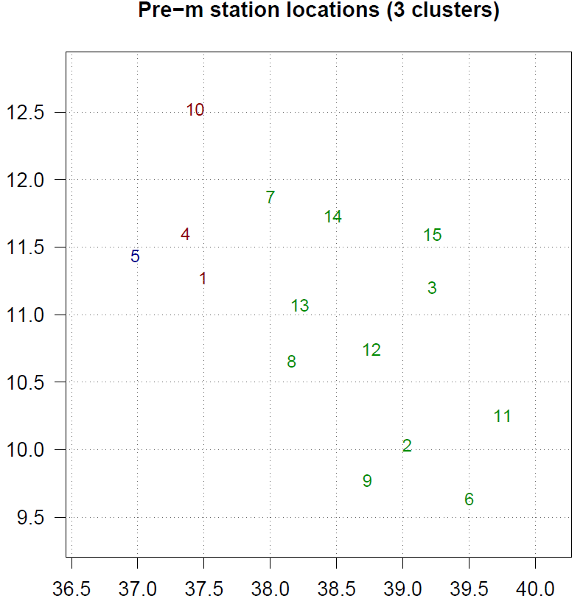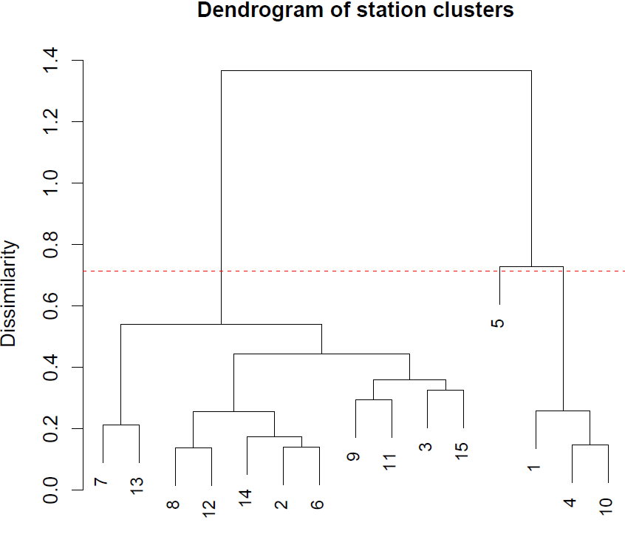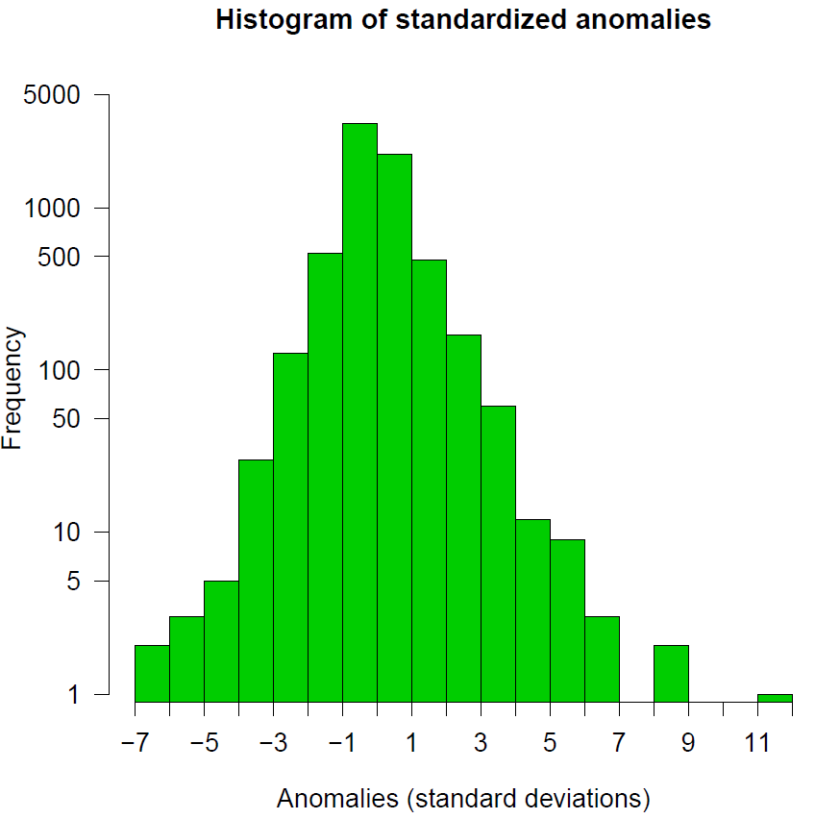
Figure S2: station clustering and standardized anomalies for rainfall
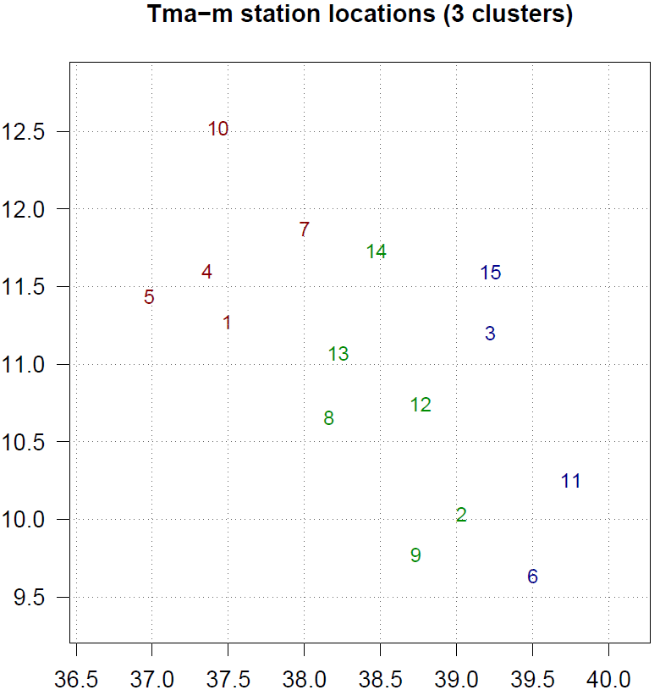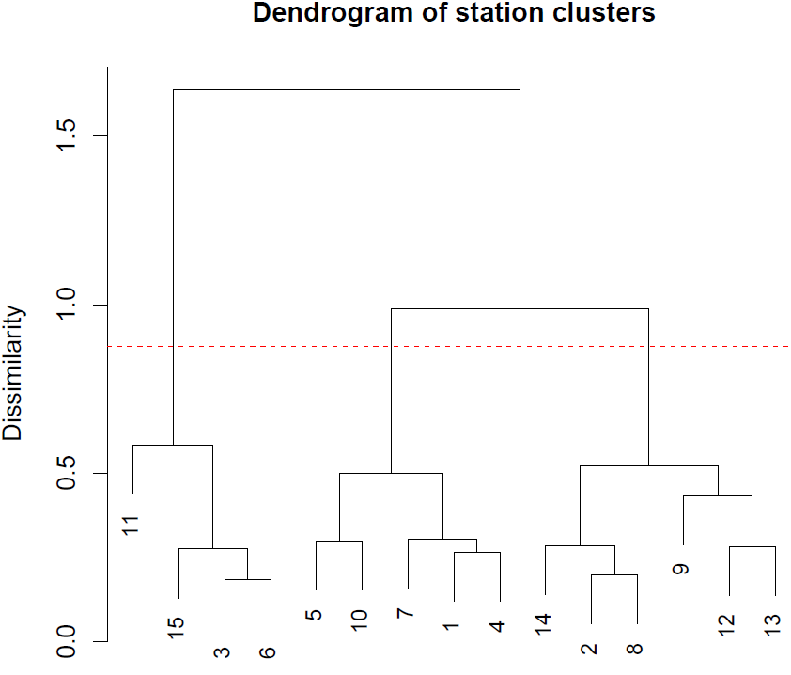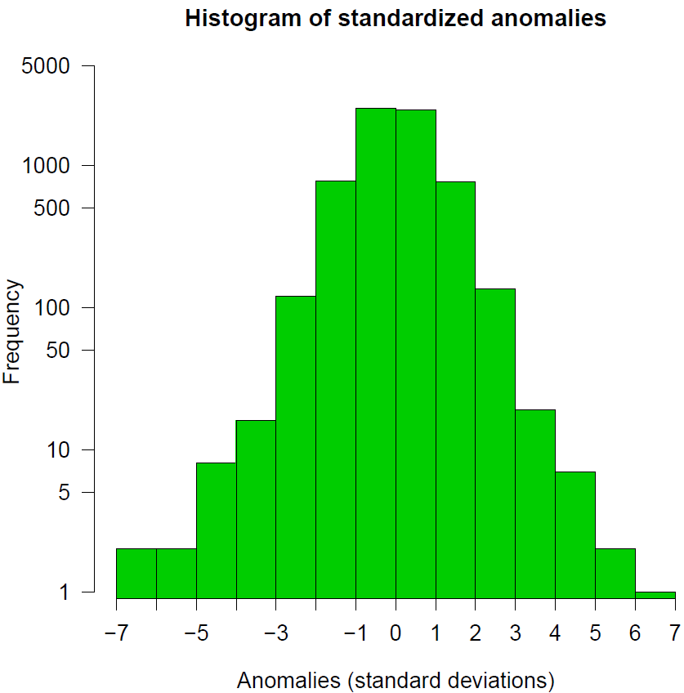
Figure S3: station clustering and standardized anomalies for Tmax
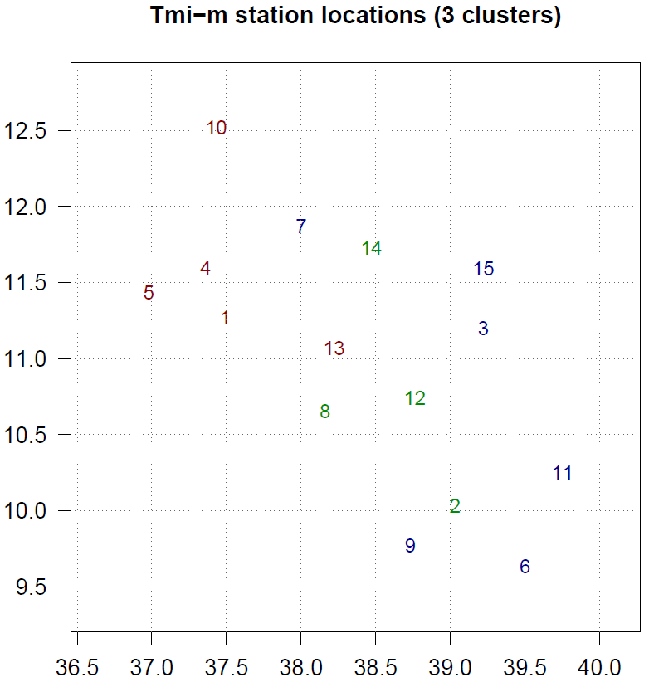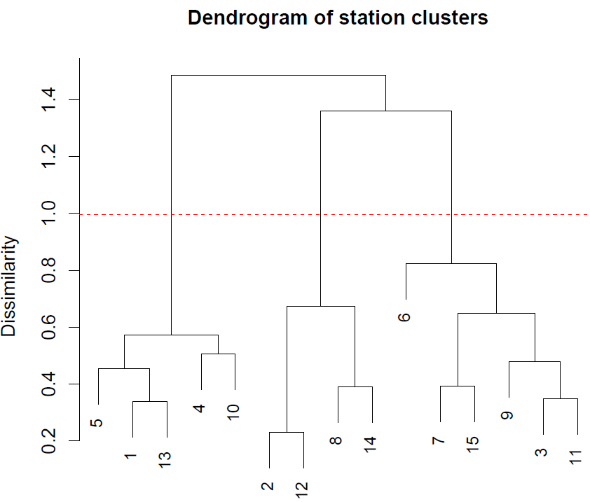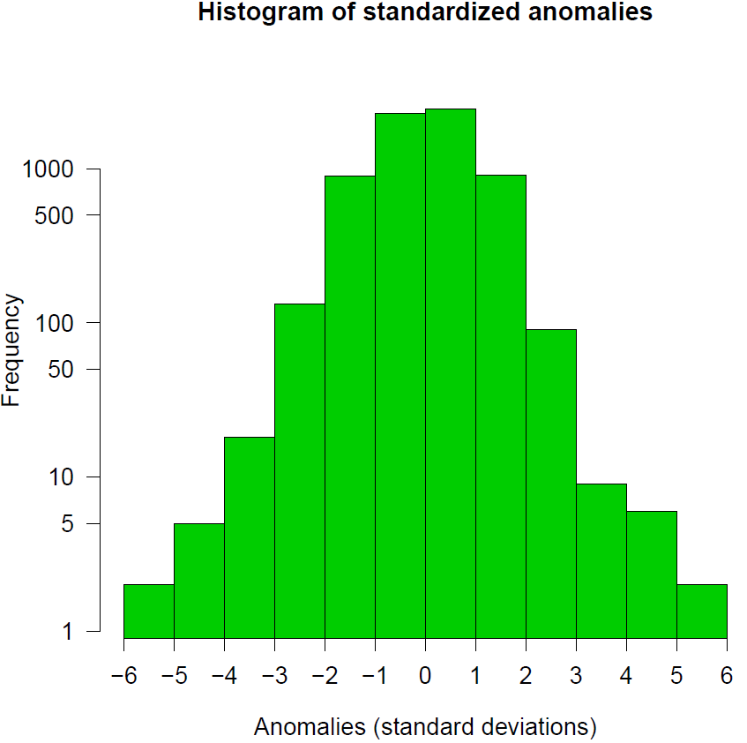
Figure S4: station clustering and standardized anomalies for Tmin
Table S3. Trend analysis results before and after homogenization
Station | Data Status | Rainfall |  | Tmax |  | Tmin
 |  | P-Value | Kendall's tau | P-Value | Kendall's tau | P-Value | Kendall's tau
Ad01 | Non-homogeneous | 0.197 | -0.008 | 0.000 | 0.083 | 0.000 | 0.215
 | Homogeneous | 0.195 | -0.008 | 0.000 | 0.082 | 0.000 | 0.081
Ak02 | Non-homogeneous | 0.428 | 0.005 | 0.000 | 0.119 | 0.000 | -0.149
 | Homogeneous | 0.561 | 0.004 | 0.000 | 0.119 | 0.000 | 0.076
Am03 | Non-homogeneous | 0.000 | -0.054 | 0.000 | 0.208 | 0.000 | -0.222
 | Homogeneous | 0.000 | -0.055 | 0.000 | 0.095 | 0.000 | 0.049
Bd04 | Non-homogeneous | 0.213 | 0.008 | 0.000 | 0.108 | 0.000 | -0.033
 | Homogeneous | 0.213 | 0.008 | 0.000 | 0.082 | 0.000 | 0.116
Da05 | Non-homogeneous | 0.000 | -0.025 | 0.000 | 0.057 | 0.000 | 0.148
 | Homogeneous | 0.000 | -0.025 | 0.000 | 0.056 | 0.000 | 0.091
Db06 | Non-homogeneous | 0.423 | 0.005 | 0.000 | 0.102 | 0.052 | -0.011
 | Homogeneous | 0.448 | 0.005 | 0.000 | 0.103 | 0.000 | 0.116
Dt07 | Non-homogeneous | 0.000 | -0.026 | 0.000 | 0.15 | 0.200 | -0.007
 | Homogeneous | 0.000 | -0.026 | 0.000 | 0.102 | 0.000 | 0.100
Dw08 | Non-homogeneous | 0.000 | 0.036 | 0.000 | -0.077 | 0.000 | 0.197
 | Homogeneous | 0.000 | 0.035 | 0.000 | 0.057 | 0.000 | 0.094
Fe09 | Non-homogeneous | 0.000 | 0.039 | 0.000 | 0.062 | 0.000 | 0.06
 | Homogeneous | 0.000 | 0.036 | 0.000 | 0.099 | 0.000 | 0.102
Go10 | Non-homogeneous | 0.186 | 0.008 | 0.000 | 0.132 | 0.000 | 0.141
 | Homogeneous | 0.191 | 0.008 | 0.000 | 0.082 | 0.000 | 0.108
Mm11 | Non-homogeneous | 0.019 | -0.015 | 0.000 | 0.159 | 0.000 | 0.035
 | Homogeneous | 0.02 | -0.015 | 0.000 | 0.094 | 0.000 | 0.128
Ms12 | Non-homogeneous | 0.058 | -0.012 | 0.007 | 0.015 | 0.000 | 0.326
 | Homogeneous | 0.036 | -0.013 | 0.000 | 0.066 | 0.000 | 0.087
Mo13 | Non-homogeneous | 0.008 | 0.017 | 0.000 | 0.078 | 0.000 | 0.091
 | Homogeneous | 0.014 | 0.015 | 0.000 | 0.077 | 0.000 | 0.101
Nm14 | Non-homogeneous | 0.000 | -0.024 | 0.000 | 0.065 | 0.000 | 0.154
 | Homogeneous | 0.000 | -0.025 | 0.000 | 0.09 | 0.000 | 0.081
Wt15 | Non-homogeneous | 0.000 | -0.064 | 0.000 | 0.046 | 0.000 | 0.134
 | Homogeneous | 0.000 | -0.063 | 0.000 | 0.096 | 0.000 | 0.073
Mean | Non-homogeneous | 0.677 | -0.002 | 0.000 | 0.099 | 0.000 | 0.109
 | Homogeneous | 0.628 | -0.003 | 0.000 | 0.097 | 0.000 | 0.129
If P≤0.005: shows a significant trend, If P>0.005 shows an insignificant trend; negative Kendall's tau is a decreasing trend, and positive is an increasing trend

Figure S5.RMSE between reanalysis vs homogenised and reanalysis vs raw Tmin and Tmax

Figure S6. Correlation between satellite and raw rainfall

Figure S7. Correlation between homogenised and satellite rainfall

Figure S8. Correlation between homogenised and raw rainfall
Table S4: Normality test of Tmax before homogenization (left) and after homogenization (right)
Stations | Shapiro-Wilk |  | Anderson-Darling |  | Variable\Test | Shapiro-Wilk |  |  | Anderson-Darling
Adet |  | 0.139 |  | 0.311 | Adet |  |  | 0.139 |  |  | 0.123
Alem Ketama | 0.567 |  | 0.761 |  | Alem Ketama |  | 0.530 |  |  | 0.561
Amba Mariam* | 0.002 |  | 0.002 |  | Amba Mariam |  | 0.775 |  |  | 0.769
Bahir Dar | 0.540 |  | 0.433 |  | Bahir Dar |  | 0.655 |  |  | 0.729
Dangila | 0.620 |  | 0.631 |  | Dangila |  | 0.560 |  |  | 0.578
Debre Berhan | 0.172 |  | 0.085 |  | Debre Berhan |  | 0.251 |  |  | 0.116
Debre Tabor | 0.739 |  | 0.593 |  | Debre Tabor |  | 0.599 |  |  | 0.434
Debre Work | 0.462 |  | 0.444 |  | Debre Work |  | 0.351 |  |  | 0.289
Fiche* | 0.002 |  | 0.012 |  | Fiche |  | 0.099 |  |  | 0.084
Gondar | 0.036 |  | 0.168 |  | Gondar |  | 0.540 |  |  | 0.565
Mehal Meda | 0.314 |  | 0.145 |  | Mehal Meda |  | 0.872 |  |  | 0.707
Mekane Selam | 0.025 |  | 0.074 |  | Mekane Selam |  | 0.548 |  |  | 0.439
Mota | 0.275 |  | 0.214 |  | Mota |  | 0.250 |  |  | 0.157
Nefas Mewucha* | 0.000 |  | 0.007 |  | Nefas Mewucha |  | 0.423 |  |  | 0.314
Wegel Tena | 0.205 |  | 0.084 |  | Wegel Tena |  | 0.111 |  |  | 0.033
Average | 0.120 |  | 0.107 |  | Average | 0.272 |  |  | 0.202
* Stations with data normality problems (p<0.02)
Table S4: Normality test of Tmin before homogenization (left) and after the homogenization (right)
Stations | Shapiro-Wilk | Anderson-Darling | Stations | Shapiro Wilk |  | Anderson-Darling
Adet | 0.41 | 0.235 | Adet |  | 0.059 |  | 0.016
Alem Ketama* | <0.0001 | <0.0001 | Alem Ketama |  | 0.058 |  | 0.098
Amba Mariam* | 0.007 | 0.007 | Amba Mariam |  | 0.844 |  | 0.858
Bahir Dar | 0.135 | 0.350 | Bahir Dar |  | 0.918 |  | 0.868
Dangila* | 0.004 | 0.000 | Dangila |  | 0.045 |  | 0.016
Debre Berhan | 0.268 | 0.436 | Debre Berhan |  | 0.847 |  | 0.618
Debre Tabor | 0.050 | 0.050 | Debre Tabor |  | 0.067 |  | 0.081
Debre Work* | <0.0001 | <0.0001 | Debre Work |  | 0.025 |  | 0.030
Fiche | 0.651 | 0.754 | Fiche |  | 0.373 |  | 0.418
Gondar * | <0.0001 | 0.000 | Gondar * |  | 0.001 |  | 0.001
Mehal Meda | 0.813 | 0.825 | Mehal Meda |  | 0.69 |  | 0.72
Mekane Selam* | <0.0001 | <0.0001 | Mekane Selam* |  | 0.005 |  | 0.004
Mota* | <0.0001 | 0.000 | Mota |  | 0.022 |  | 0.050
Nefas Mewucha* | 0.000 | 0.001 | Nefas Mewucha |  | 0.133 |  | 0.491
Wegel Tena* | 0.007 | 0.009 | Wegel Tena |  | 0.021 |  | 0.030
Average* | 0.005 | 0.004 | Average | 0.034 |  | 0.058
* Stations with data normality problems (p<0.02)

