Supplementary Figure S1 – Administrative Districts of Caraguatatuba
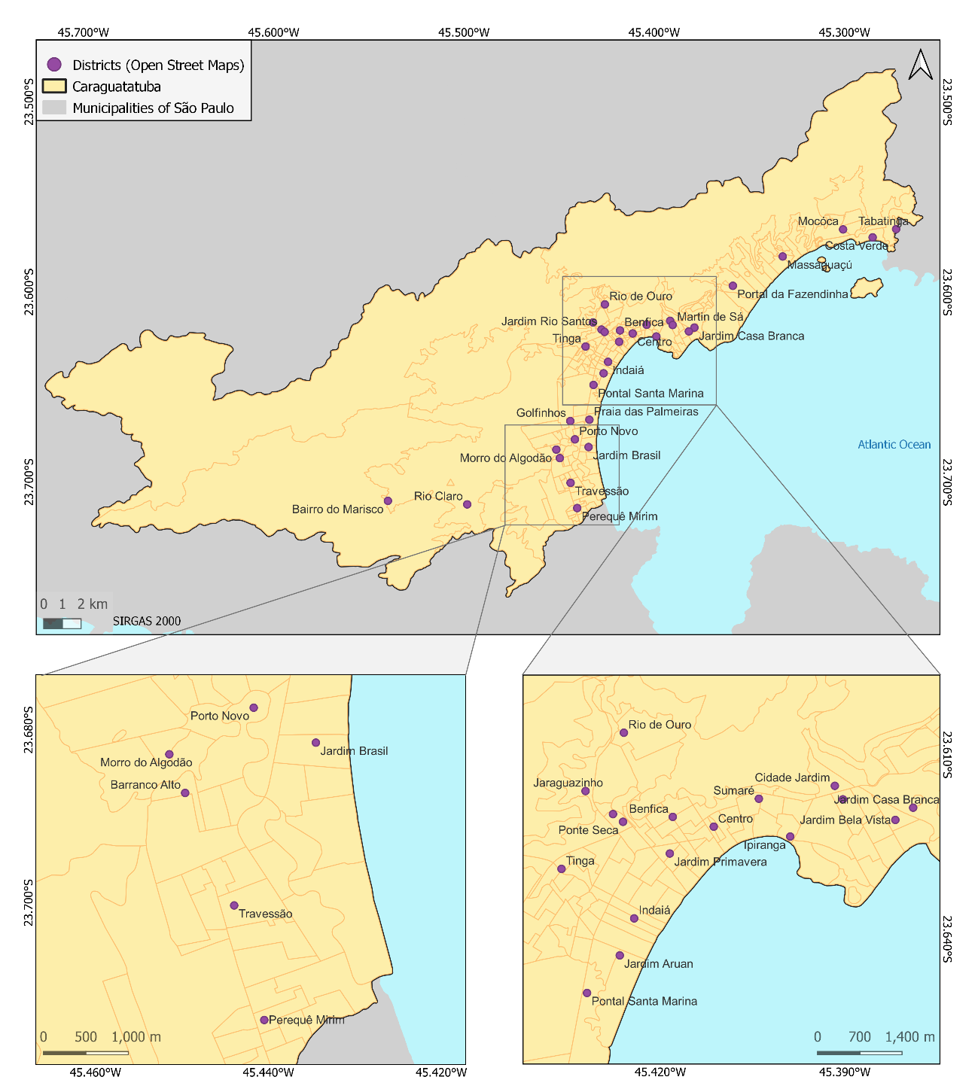
Figure S1. Administrative district boundaries of Caraguatatuba. District divisions support zonal statistics and interpretation of climate index variability across urban, coastal, and forested zones. Source: Base map © OpenStreetMap contributors; boundaries and layout generated by the authors using QGIS 3.22.5.

