Theoretical and Applied Climatology
Escalating Hydroclimatic Extremes and Water-Balance Shifts Under Climate Change: Evidence from a Dryland Ecotone in Northeastern Brazil
Leonardo dos Santos Segantin^{a*}, Marcelo Loureiro Garciaª
ª São Paulo State University, Institute of Geosciences and Exact Sciences, Av. 24 A - Bela Vista 13506-900, Rio Claro, São Paulo, Brazil
*Correspondence to: leonardo.segantin@unesp.br

1 Model performance assessment
The Coefficient of determination (R²) describes the proportion of the variance in the measured data that is explained by the model, i.e., the ability of the independent variables to predict the dependent variables, ranging from 0 to 1 (Eq. 1). It has the disadvantage of being highly sensitive to outliers, resulting in a bias toward extreme events. Additionally, R² is insensitive to proportional and additive differences between observed and simulated data (Legates and McCabe 1999).
R² = ${[\frac{\sum_{i=1}^{n}{(Oi-\overline{O})(Pi-\overline{P}})}{\sqrt{\sum_{i=1}^{n}{{\left(Oi-\overline{O}\right)}^{2}}} \sqrt{\sum_{i=1}^{n}{{\left(Pi-\overline{P}\right)}^{2}}}} ]}^{2}$ (1)
where n is the total number of observations, Oi is the i-th observed value, $\overline{O}$ is the average of the observed values, Pi is the i-th simulated value and $\overline{P}$ is the average of the simulated values.
The Nash-Sutcliffe efficiency (NSE) determines the relative magnitude of the residual variance of the model in relation to the variance of the measured data, indicating how well the relationship between the simulated and observed data fits a 1:1 line (Nash and Sutcliffe 1970) (Eq. 2). Its value ranges from −∞ to 1, with values close to 1 indicating good model performance. Negative values indicate that the mean of the observed data is a better predictor than the simulated values, thus reflecting unacceptable performance (Moriasi et al. 2007). Because squared errors are used in its formulation, NSE is highly sensitive to extreme events, tending to overestimate model performance during peak flows and underestimate it under low-flow conditions (Krause et al. 2005).
NSE = 1 - $\frac{\sum_{i=1}^{n}{{(Oi-Pi)}^{2}}}{\sum_{i=1}^{n}{{(Oi-\overline{O})}^{2}}}$ (2)
The Percent Bias (PBIAS) (Eq. 3) measures the tendency of the simulated data to be higher or lower than measured data, with 0 being its ideal value. It is also a metric for underestimation (positive values) or overestimation (negative values) of the model. Its limitations include the inability to be used for assessing single events to identify the timing and magnitude of peak flows. Additionally, if the model overpredicts and underpredicts results in similar proportions, the PBIAS value may appear satisfactory even though the overall simulation is poor (Moriasi et al. 2007).
PBIAS = $\frac{\sum_{i=1}^{n}{Oi-Pi}}{\sum_{i=1}^{n}{Oi}}$ * 100 (3)
The Kling-Gupta efficiency (KGE) (Eq. 4) is based on the decomposition of the NSE into its three components, i.e., correlation (Eq. 5), relative variability (Eq. 6) and conditional and unconditional bias (Eq. 7). Its value ranges from −∞ to 1, with values close to 1 indicating good model performance . As well as being a measure of the model's accuracy, it is also capable of reproducing the shape and timing of the measured data (Gupta et al. 2009).
KGE = 1 - $\sqrt{{(r-1)}^{2}+{(α-1)}^{2}+{(β-1)}^{2}}$ (4)
$r$ = $\sqrt{R^{2}}$ (5)
α = $\frac{αs}{αo}$ (6)
β = $\frac{µs}{µo}$ (7)
where r is the correlation coefficient between simulated and measured data, α_{s} and α_{o} are the standard deviation of the simulated and measured data, respectively, and µ_{s} and µ_{o} are the averages of the simulated and measured data, respectively.
The Root Mean Standard Deviation Ratio (RSR) (Eq. 8) is defined as the ratio between the Root Mean Square Error (RMSE) and the standard deviation of the observed data, yielding an index that incorporates both an error metric and a normalization factor, with an optimal value of 0 (Moriasi et al. 2007).
RSR = $\frac{\sqrt{\sum_{i=1}^{n}{{(Oi-Pi)}^{2}}}}{\sqrt{\sum_{i=1}^{n}{{(Oi-\overline{O})}^{2}}}}$ (8)

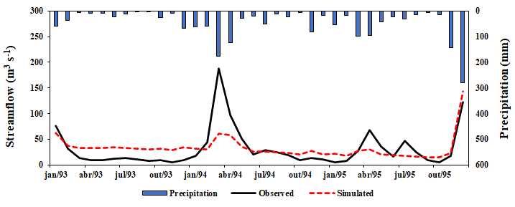
Fig. S1 Observed and simulated monthly streamflow between 1993-1995

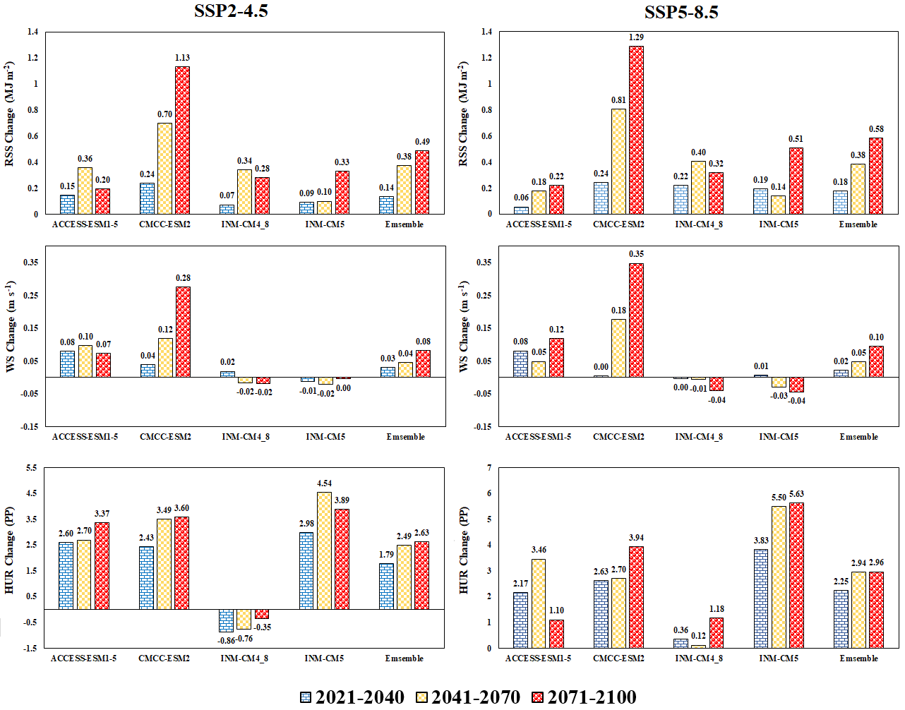
Fig. S2 Average changes in net solar radiation (RSS), wind speed (WS), and relative humidity (HUR) for the UPRB under SSP2-4.5 and SSP5-8.5 scenarios relative to baseline period. HUR changes are presented in percentage points (PP)
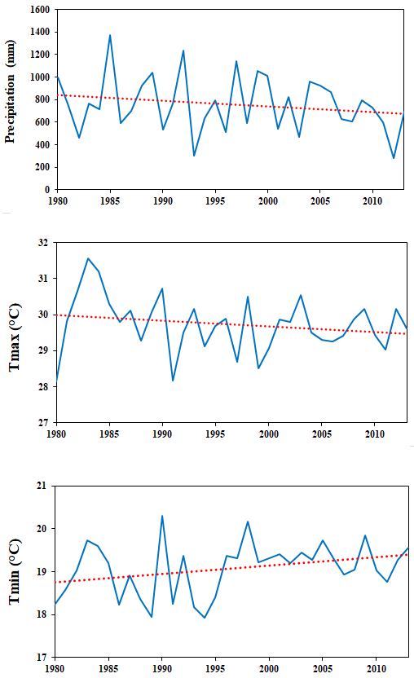
Fig S3 Annual variation and trend line for baseline average precipitation, minimum and maximum temperatures

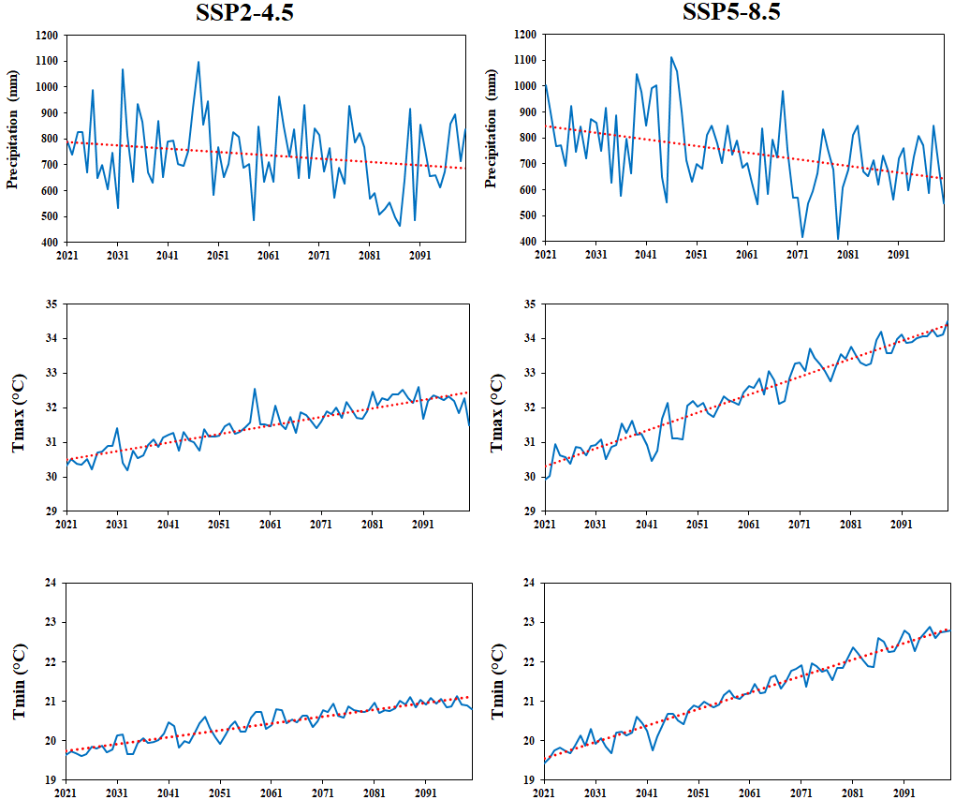
Fig S4 Projected changes and trend lines in annual average minimum and maximum temperatures and precipitation for the multi-model ensemble projections, considering the entire analyzed period (2021–2100)

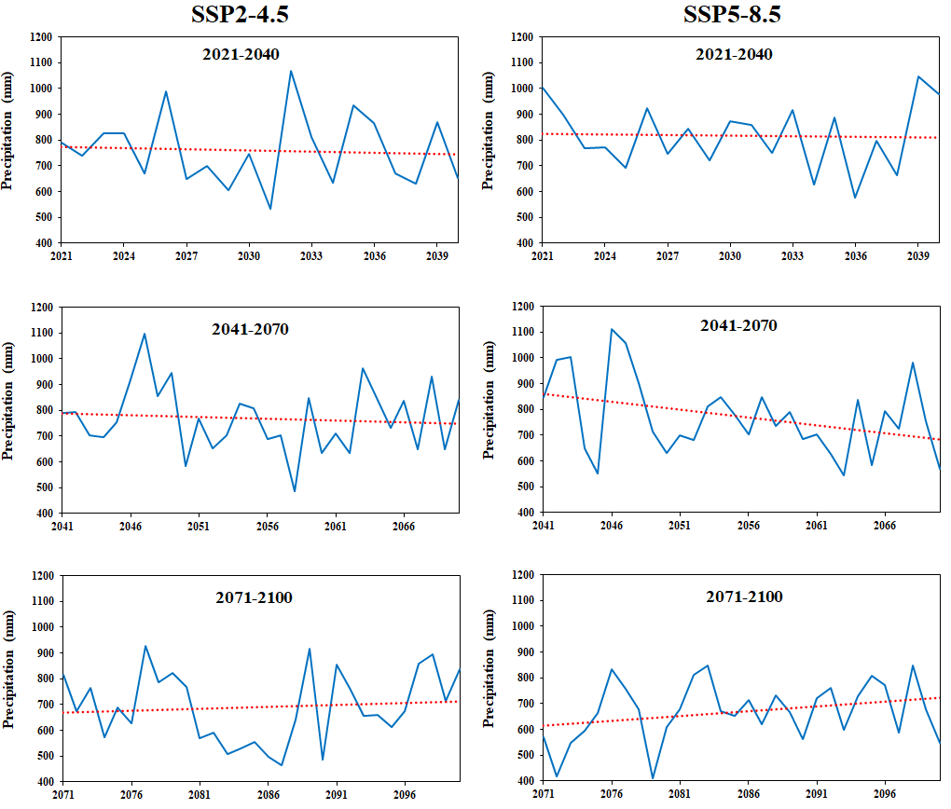
Fig S5 Projected changes and trend lines in annual precipitation under SSP2-4.5 and SSP5-8.5 for the immediate (2021-2040), intermediate (2041-2070) and distant (2071-2100) future time slices for the multi-model ensemble projections
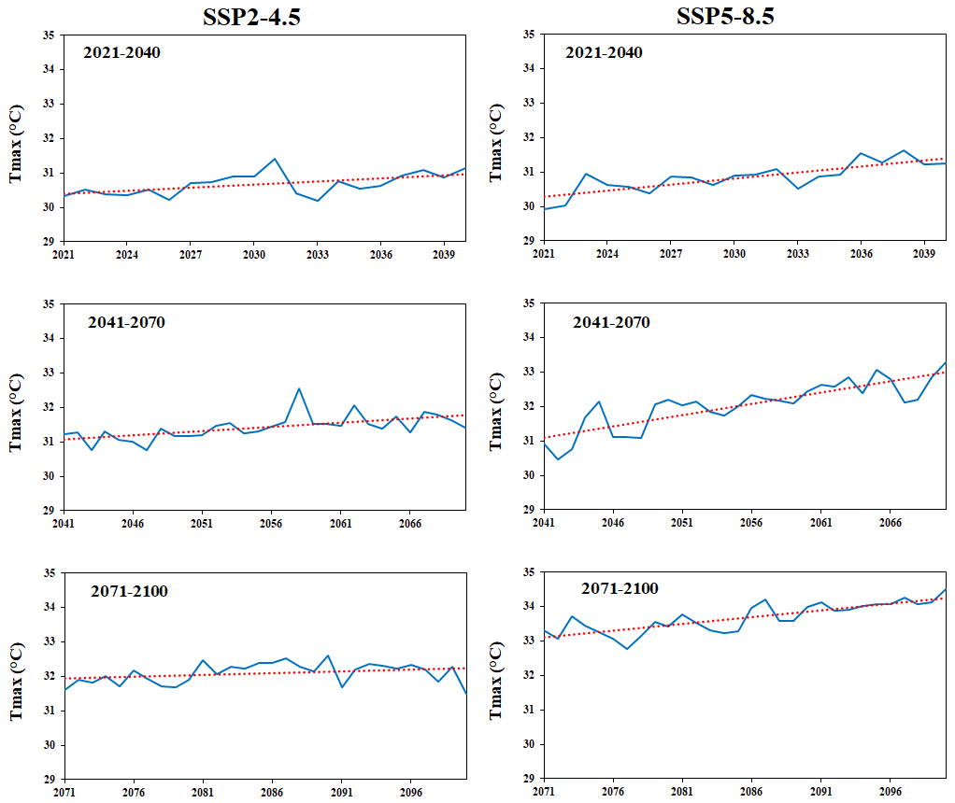
Fig S6 Projected changes and trend lines in annual average maximum temperature under SSP2-4.5 and SSP5-8.5 for the immediate (2021-2040), intermediate (2041-2070) and distant (2071-2100) future time slices for the multi-model ensemble projections

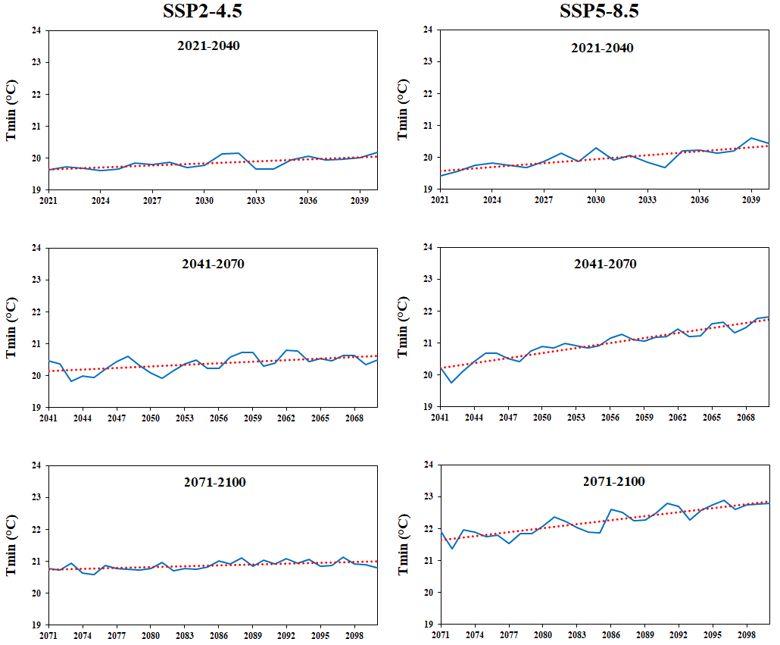
Fig S7 Projected changes and trend lines in annual average minimum temperature under SSP2-4.5 and SSP5-8.5 for the immediate (2021-2040), intermediate (2041-2070) and distant (2071-2100) future time slices for the multi-model ensemble projections
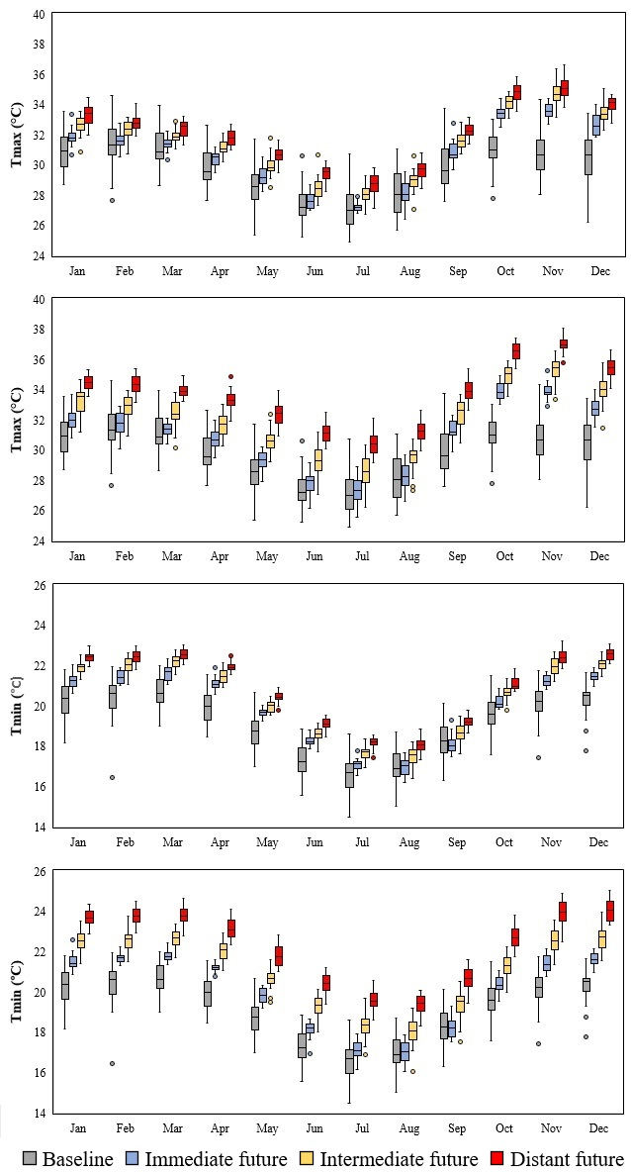
Fig S8 Distribution of monthly maximum and minimum temperature projections under SSP2-4.5 and SSP5-8.5 scenarios for the multi-model ensemble

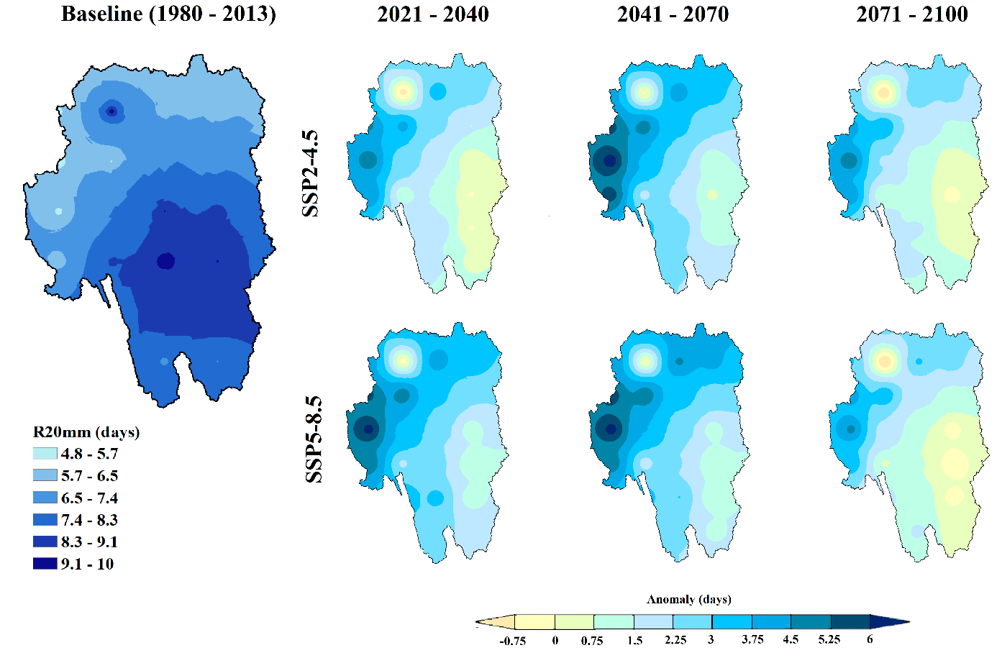
Fig. S9 Spatial distribution of R20mm index in the baseline period and projected anomaly changes (days) in future scenarios for the multi-model ensemble under SSP2-4.5 and SSP5-8.5

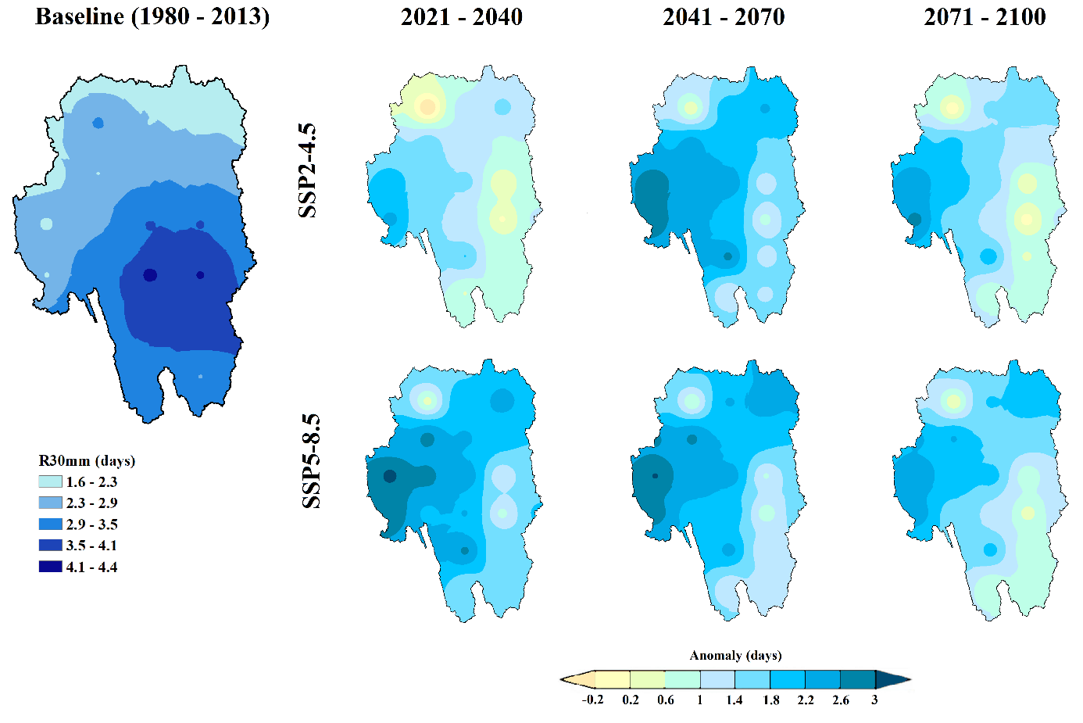
Fig. S10 Spatial distribution of R30mm index in the baseline period and projected anomaly changes (days) in future scenarios for the multi-model ensemble under SSP2-4.5 and SSP5-8.5

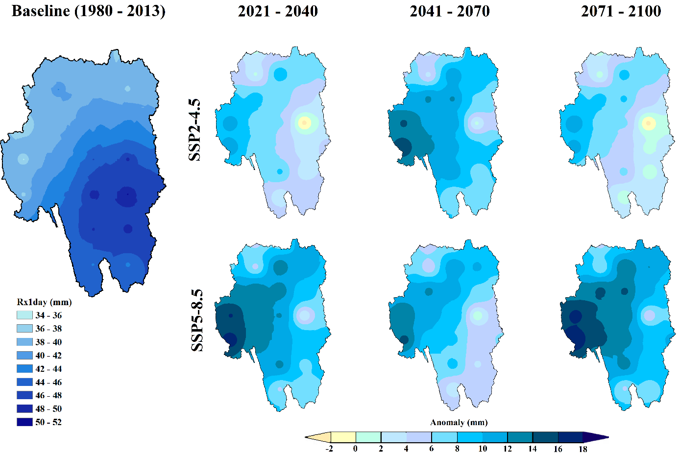
Fig. S11 Spatial distribution of RX1day index in the baseline period and projected anomaly changes (mm) in future scenarios for the multi-model ensemble under SSP2-4.5 and SSP5-8.5

Table S1 Adjusted vegetation parameters
Parameter | Description | Adjusted (Default)
Parameter | Description | FRSD | RNGB | RNGE | PAST
LAI_MIN | Minimum LAI during dormant period (m² m⁻²) | 4.5(0.75)^{d} | 0.7(0.05)^{b} | 0.7(0.05)^{b} | 0.75(2)ª
LAI_POT | Maximum potential leaf area index (m² m⁻²) | 6.3(5)^{c} | 2.7(2)^{c} | 2.65(2.5)^{c} | 3(4)^{d}
BM_E | Biomass-energy ratio ((kg ha⁻¹)/(MJ m⁻²)) | 20(15)^{b} | 20(34)^{b} | 20(34)^{b} | -
FRAC_HU1 | Fraction of the plant growing season or the total potential heat units corresponding to the 1st point on optimal leaf area development curve | 0.07(0.05)^{b} | 0.07(0.05)^{b} | 0.07(0.05)^{b} | -
FRAC_HU2 | Fraction of the plant growing season or the total potential heat units corresponding to the 2nd point on optimal leaf area development curve | 0.5(0.4)^{b} | 0.4(0.25)^{b} | 0.4(0.25)^{b} | -
LAI_MAX1 | Fraction of the maximum leaf area index corresponding to the 1st point on optimal leaf area development curve | 0.15(0.05)^{b} | 0.15(0.1)^{b} | 0.15(0.1)^{b} | -
LAI_MAX2 | Fraction of the maximum leaf area index corresponding to the 1st point on optimal leaf area development curve | - | 0.95(0.7)^{b} | 0.95(0.7)^{b} | -
STCON_MAX | Maximum stomatal conductance at high solar radiation and low vapor pressure deficit (m s⁻¹) | 0.005(0.002)^{d} | 0.0035(0.005)^{d} | 0.0035(0.005)^{d} | 0.003(0.005)^{d}
CAN_HT_MAX | Maximum canopy height (m) | 30(6)^{d} | - | - | -
RT_DP_MAX | Maximum rooting depth (m) | 6(3.5)^{d} | - | - | 1.5(2)^{d}
TMP_BASE | Minimum temperature for plant growth (°C) | - | 10(12)^{b} | 10(12)^{b} | -
EXT_COEF | Light extinction coefficient | 0.59(0.65)^{c} | 0.45(0.33)^{c} | 0.40(0.33)^{c} | -
ªHernandes et al. (2018); ^{b}Strauch and Volk (2013); ^{c}Abitew et al. (2023); ^{d}Silva (2013)

Table S2 SWAT+ performance evaluation criteria
Statistic | Performance rating
Statistic | Very good | Good | Satisfactory | Unsatisfactory
ªR² | R² > 0.85 | 0.75 < R² ≤ 0.85 | 0.60 < R² ≤ 0.75 | R² ≤ 0.60
ªNSE | NSE > 0.80 | 0.70 < NSE ≤ 0.80 | 0.50 < NSE ≤ 0.70 | NSE ≤ 0.50
ªPBIAS | PBIAS < ±5 | ±5 ≤ PBIAS < ±10 | ±10 ≤ PBIAS < ± 15 | PBIAS ≥ 15
^{c}KGE | KGE > 0.80 | 0.70 < KGE ≤ 0.80 | 0.50 < KGE ≤ 0.70 | KGE ≤ 0.50
^{b}RSR | 0 ≤ RSR ≤ 0.5 | 0.5 < RSR ≤ 0.6 | 0.6 < RSR ≤ 0.7 | RSR > 0.7
ªMoriasi et al. (2015); ^{b}Moriasi et al. (2007); ^{c}Adopted as same as NSE
Table S3 Selected GCMs (r1i1p1f1) for climate change assessment
Model | Region | Resolution | Reference
ACESS-ESM1-5 | Australia | 1.87° × 1.25° | Ziehn et al. 2020
CMCC-ESM2 | Europe | 0.9° × 1.25° | Cherchi et al. 2019
INM-CM4-8 | Russia | 1.5° × 2.0° | Volodin et al. 2018
INM-CM5 | Russia | 1.5° × 2.0° | Volodin et al. 2017

Table S4 Sensitivity rank and calibrated parameters for UPRB
Rank | Parameter | Description | Min. | Max. | Fitted
1 | r_SOL_AWC | Avaliable water capacity (mm mm⁻¹) | -60 | 60 | 51.74
2 | r_CN2 | Condition II curve number | -40 | 40 | 30.62
3 | v_PET_CO | Linear adjustment factor for PET equations | 0.8 | 1.2 | 1.15
4 | r_SOL_BD | Moist bulk density (g cm⁻³) | -60 | 60 | 50.96
5 | v_CANMX | Maximum canopy storage (mm H₂O) | 0 | 100 | 3.00
6 | r_SOL_Z | Depth from soil surface to bottom of layer (mm) | -60 | 60 | 34.00
7 | r_SOL_K | Soil hydraulic conductivity (mm h⁻¹) | -95 | 95 | -91.00
8 | v_LAT_TTIME | Lateral flow travel time (d) | 0.5 | 180 | 1.26
9 | v_ESCO | Soil evaporation compensation factor | 0.01 | 1 | 0.98
10 | v_LAT_LEN | Slope length for lateral subsurface flow (m) | 1 | 150 | 71.16
11 | v_LATQ_CO | Lateral flow coefficient | 0 | 1 | 1.00
12 | v_SURLAG | Surface runoff lag coefficient | 0.05 | 24 | 0.96
13 | v_ALPHA_BF | Baseflow alpha factor (d⁻¹) | 0 | 1 | 0.58
14 | v_EPCO | Plant uptake compensation factor | 0.01 | 1 | 0.70
15 | v_DEEP_SEEP | Fraction of percolating water that moves from the bottom of the soil profile into the deep aquifer | 0.001 | 0.4 | 0.29
16 | v_REVAP_CO | Groundwater "revap" coefficient | 0.02 | 0.2 | 0.03
17 | v_REVAP_MIN | Threshold depth of water in the shallow aquifer for “revap” or percolation to the deep aquifer to occur (mm) | 0 | 50 | 31.38
18 | v_FLO_MIN | Minimum aquifer storage to allow return flow (m) | 0 | 50 | 32.69
19 | r_SLOPE_LEN | Average slope length for erosion (m) | -40 | 40 | 8.75
20 | r_OV_N | Manning’s N value for overland flow | -40 | 40 | -21.45
21 | v_CHK | Effective hydraulic conductivity in main channel alluvium (mm h⁻¹) | 0.00001 | 500 | 130.60
Prefixes “v” and “r” correspond to “replace” and “percent” changes, respectively

Table S5 Statistical trends for Precipitation (mm yr⁻¹), Tmax (°C yr⁻¹), and Tmin (°C yr⁻¹) for the baseline period and future GCM multi-model ensemble projections at annual time scale. Bold values indicate statistically significant trends at 95% confidence level. Upper and lower bounds represent the 95% Confidence Interval for the Sen’s slope estimator
Scenario | Time slice | z-stat | p-value | Sen's slope | Upper bound | Lower bound
Precipitation (mm)
Baseline | 1980-2013 | -1.0081 | 0.3134 | -4.9232 | 4.1529 | -15.3646
SSP2-4.5 | 2021-2040 | -0.3569 | 0.7212 | -2.5793 | 9.9229 | -13.9454
SSP2-4.5 | 2041-2070 | -0.3568 | 0.7212 | -0.7995 | 4.1903 | -6.6209
SSP2-4.5 | 2071-2100 | 0.3211 | 0.7481 | 1.6152 | 7.6142 | -6.3055
SSP2-4.5 | 2021-2100 | -1.6909 | 0.0908 | -1.1762 | 0.1821 | -2.6826
SSP5-8.5 | 2021-2040 | -0.2271 | 0.8203 | -2.1534 | 10.6200 | -14.5633
SSP5-8.5 | 2041-2070 | -1.7127 | 0.0868 | -6.4830 | 0.8212 | -13.9799
SSP5-8.5 | 2071-2100 | 1.4986 | 0.1340 | 4.4492 | 9.1823 | -1.3263
SSP5-8.5 | 2021-2100 | -3.5605 | 0.0004 | -2.4036 | -1.1278 | -3.7229
Tmax (°C)
Baseline | 1980-2013 | -1.2453 | 0.2130 | -0.0182 | 0.0086 | -0.0460
SSP2-4.5 | 2021-2040 | 2.7578 | 0.0058 | 0.0342 | 0.0616 | 0.0097
SSP2-4.5 | 2041-2070 | 3.9250 | 8.67E-05 | 0.0223 | 0.0334 | 0.0124
SSP2-4.5 | 2071-2100 | 1.8198 | 0.0688 | 0.0143 | 0.0268 | -0.0020
SSP2-4.5 | 2021-2100 | 9.5848 | 9.26E-22 | 0.0254 | 0.0280 | 0.0229
SSP5-8.5 | 2021-2040 | 3.6013 | 0.0003 | 0.0587 | 0.0827 | 0.0338
SSP5-8.5 | 2041-2070 | 5.1382 | 2.77E-07 | 0.0660 | 0.0869 | 0.0458
SSP5-8.5 | 2071-2100 | 4.8528 | 1.22E-06 | 0.0399 | 0.0519 | 0.0280
SSP5-8.5 | 2021-2100 | 10.9891 | 4.31E-28 | 0.0513 | 0.0547 | 0.0483
Tmin (°C)
Baseline | 1980-2013 | 1.4824 | 0.1382 | 0.0164 | 0.0394 | -0.0061
SSP2-4.5 | 2021-2040 | 3.0173 | 0.0026 | 0.0227 | 0.0320 | 0.0105
SSP2-4.5 | 2041-2070 | 2.9973 | 0.0027 | 0.0182 | 0.0277 | 0.0068
SSP2-4.5 | 2071-2100 | 2.9616 | 0.0031 | 0.0083 | 0.0142 | 0.0038
SSP2-4.5 | 2021-2100 | 9.9089 | 3.81E-23 | 0.0177 | 0.0193 | 0.0159
SSP5-8.5 | 2021-2040 | 3.8609 | 0.0001 | 0.0434 | 0.0576 | 0.0264
SSP5-8.5 | 2041-2070 | 6.6012 | 4.08E-11 | 0.0490 | 0.0568 | 0.0422
SSP5-8.5 | 2071-2100 | 5.2096 | 1.89E-07 | 0.0416 | 0.0500 | 0.0306
SSP5-8.5 | 2021-2100 | 11.6123 | 3.57E-31 | 0.0418 | 0.0436 | 0.0400

Table S6 Statistical trends for Precipitation (mm yr⁻¹) at seasonal time scale for the baseline period and future GCM multi-model ensemble projections for the period 2021-2100. Bold values indicate statistically significant trends at 95% confidence level. Upper and lower bounds represent the 95% Confidence Interval for the Sen’s slope estimator
Scenario | Time slice | z-stat | p-value | Sen's slope | Upper bound | Lower bound
DJF
Baseline | 1980-2013 | -0.6523 | 0.5142 | -2.2494 | 4.0638 | -7.5913
SSP2-4.5 | 2021-2100 | 0.0000 | 1.0000 | 9.58E-05 | 0.7069 | -0.8938
SSP5-8.5 | 2021-2100 | -1.5995 | 0.1097 | -0.5239 | 0.1318 | -1.3968
MAM
Baseline | 1980-2013 | -0.2075 | 0.8356 | -0.9478 | 3.2133 | -5.5844
SSP2-4.5 | 2021-2100 | -2.0482 | 0.0405 | -0.7361 | -0.0223 | -1.5311
SSP5-8.5 | 2021-2100 | -3.1783 | 0.0015 | -1.4480 | -0.5694 | -2.3080
JJA
Baseline | 1980-2013 | 0.0593 | 0.9527 | 0.0509 | 0.8488 | -1.0210
SSP2-4.5 | 2021-2100 | -1.9901 | 0.0466 | -0.0760 | -0.0015 | -0.1529
SSP5-8.5 | 2021-2100 | -3.3694 | 0.0008 | -0.1220 | -0.0547 | -0.1894
SON
Baseline | 1980-2013 | -0.3558 | 0.7220 | -0.3279 | 2.3475 | -2.3918
SSP2-4.5 | 2021-2100 | -2.9955 | 0.0027 | -0.4695 | -0.1665 | -0.7724
SSP5-8.5 | 2021-2100 | -2.0067 | 0.0448 | -0.2851 | -0.0066 | -0.6040

Table S7 Descriptive statistics of seasonal precipitation for the baseline period and GCM multi-model ensemble projections over 2021–2100. *SD = Standard Deviation
Scenario | Time slice | Mean | Median | Mín | Max | SD | 25 percentile | 75 percentile
DJF
Baseline | 1980-2013 | 307.8 | 254.2 | 72.7 | 825.3 | 181.3 | 175.4 | 389.96
SSP2-4.5 | 2021-2100 | 358.6 | 366.4 | 199.5 | 568.2 | 82.1 | 298.0 | 401.1
SSP5-8.5 | 2021-2100 | 375.9 | 375.1 | 218.2 | 557.6 | 78.1 | 328.4 | 409.8
MAM
Baseline | 1980-2013 | 214.4 | 199.5 | 28.0 | 634.3 | 129.9 | 122.2 | 271.3
SSP2-4.5 | 2021-2100 | 271.0 | 275.3 | 144.4 | 482.3 | 75.8 | 211.1 | 320.8
SSP5-8.5 | 2021-2100 | 267.0 | 258.4 | 80.0 | 509.4 | 92.2 | 206.1 | 333.0
JJA
Baseline | 1980-2013 | 78.9 | 75.9 | 39.8 | 143.4 | 24.3 | 59.3 | 94.1
SSP2-4.5 | 2021-2100 | 33.7 | 33.4 | 20.5 | 53.5 | 7.9 | 26.5 | 39.5
SSP5-8.5 | 2021-2100 | 33.5 | 32.6 | 16.1 | 61.6 | 8.3 | 28.1 | 37.9
SON
Baseline | 1980-2013 | 163.4 | 147.7 | 65.3 | 349.0 | 71.6 | 103.0 | 229.9
SSP2-4.5 | 2021-2100 | 73.7 | 66.9 | 12.3 | 157.0 | 30.0 | 51.2 | 100.2
SSP5-8.5 | 2021-2100 | 67.9 | 64.1 | 17.1 | 167.3 | 34.5 | 42.9 | 86.3

References
Abitew TA, Arnold G, Jeong J, Jones A, Srinivasan, R (2023) Innovative approach to prognostic plant growth modeling in SWAT+ for forest and perennial vegetation in tropical and Sub-Tropical climates. J Hydrol X 20:100156. https://doi.org/10.1016/j.hydroa.2023.100156
Cherchi A, Fogli PG, Lovato T, Peano D, Iovino D, Gualdi S, Masina S, Scoccimarro E, Materia S, Belluci A, Navarra A (2019) Global Mean Climate and Main Patterns of Variability in the CMCC-CM2 Coupled Model. J Adv Model Earth Syst 11(1):185-209. https://doi.org/10.1029/2018MS001369
Gupta HV, Kling H, Yilmaz KK, Martinez GF (2009) Decomposition of the mean squared error and NSE performance criteria: Implications for improving hydrological modelling. J Hydrol 377(1-2):80.91. https://doi.org/10.1016/j.jhydrol.2009.08.003
Hernandes TAD, Scarpare FV, Seabra JEA (2018) Assessment of the recent land use change dynamics related to sugarcane expansion and the associated effects on water resources availability. J Clean Prod 197(1):1328-1341. https://doi.org/10.1016/j.jclepro.2018.06.297
Krause P, Boyle DP, Bäse F (2005) Comparison of different efficiency criteria for hydrological model assessment. Adv Geosci 5:89-97. https://doi.org/10.5194/adgeo-5-89-2005
Legates DR, McCabe GJ (1999) Evaluating the use of "goodness-of-fit" measures in hydrologic and hydroclimatic model validation. Water Resour Res 35(1):233-241. https://doi.org/10.1029/1998WR900018
Moriasi DN, Arnold JG, Van Liew MW, Bingner RL, Harmel RD, Veith TL (2007) Model Evaluation Guidelines for Systematic Quantification of Accuracy in Watershed Simulations. Trans ASABE 50(3):885-900. http://dx.doi.org/10.13031/2013.23153
Moriasi DN, Gitau MW, Pai N, Daggupati D (2015) Hydrologic and Water Quality Models: Performance Measures and Evaluation Criteria. Trans ASABE 58(6):1763-1785. http://doi.org/10.13031/trans.58.10715
Nash JE, Sutcliffe JV (1970). River Flow Forecasting through Conceptual Models Part I—A Discussion of Principles. J Hydrol 10(3):282-290. http://dx.doi.org/10.1016/0022-1694(70)90255-6
Silva JM (2013) O serviço ambiental hidrológico das áreas de proteção permanente: um estudo de caso com modelagem numérica em pequena e mesoescala na bacia do Rio Piracicaba. [Doctoral dissertation, University of São Paulo]. https://www.teses.usp.br/teses/disponiveis/14/14133/tde-11052014-114604/en.php
Strauch M, Volk M (2013) SWAT plant growth modification for improved modeling of perennial vegetation in the tropics. Ecol Model 269:98-112. https://doi.org/10.1016/j.ecolmodel.2013.08.013
Volodin EM, Mortikov EV, Kostrykin SV, Galin VY, Lykossov VN, Gritsun AS, Diansky NA, Gusev AV, Iakovlev NG (2017) Simulation of the present-day climate with the climate model INMCM5. Clim Dyn 49:3715-3734. https://doi.org/10.1007/s00382-017-3539-7
Volodin EM, Mortikov EV, Kostrykin SV, Galin VY, Lykossov VN, Gritsun AS, Diansky NA, Gusev AV, Iakovlev NG, Shestakova AA, Emelina SV (2018) Simulation of the modern climate using the INM-CM48 climate model. Russ J Numer Anal Math Model 33(6):367-374. https://doi.org/10.1515/rnam-2018-0032
Ziehn T, Chamberlain MA, Law RM, Lenton A, Bodman RW, Dix M, Stevens L, Wang YP, Srbinovsky J (2020) The Australian Earth System Model: ACCESS-ESM1.5. South Hemisph Earth Syst Sci 70(1):193-214. https://doi.org/10.1071/ES19035

