Supplementary material for:
Influence of atmospheric circulation on temperature extremes in mountainous regions of Central Europe during 1961–2022
David Tichopád^{1*}, Jan Řehoř^{1,2}, Lukáš Dolák^{1,2}, Kamil Láska¹, Pavel Zahradníček^{2,3}, Petr Štěpánek^{2,3}
¹ Department of Geography, Masaryk University, Brno, Czech Republic; rehor.j@mail.muni.cz (J.Ř.); dolak@sci.muni.cz (LD); laska@sci.muni.cz (KL)
² Global Change Research Institute, Czech Academy of Sciences, Brno, Czech Republic; zahradnicek.p@czechglobe.cz (PZ)
³ Czech Hydrometeorological Institute, Brno, Czech Republic
* Correspondence: david.tichopad@mail.muni.cz

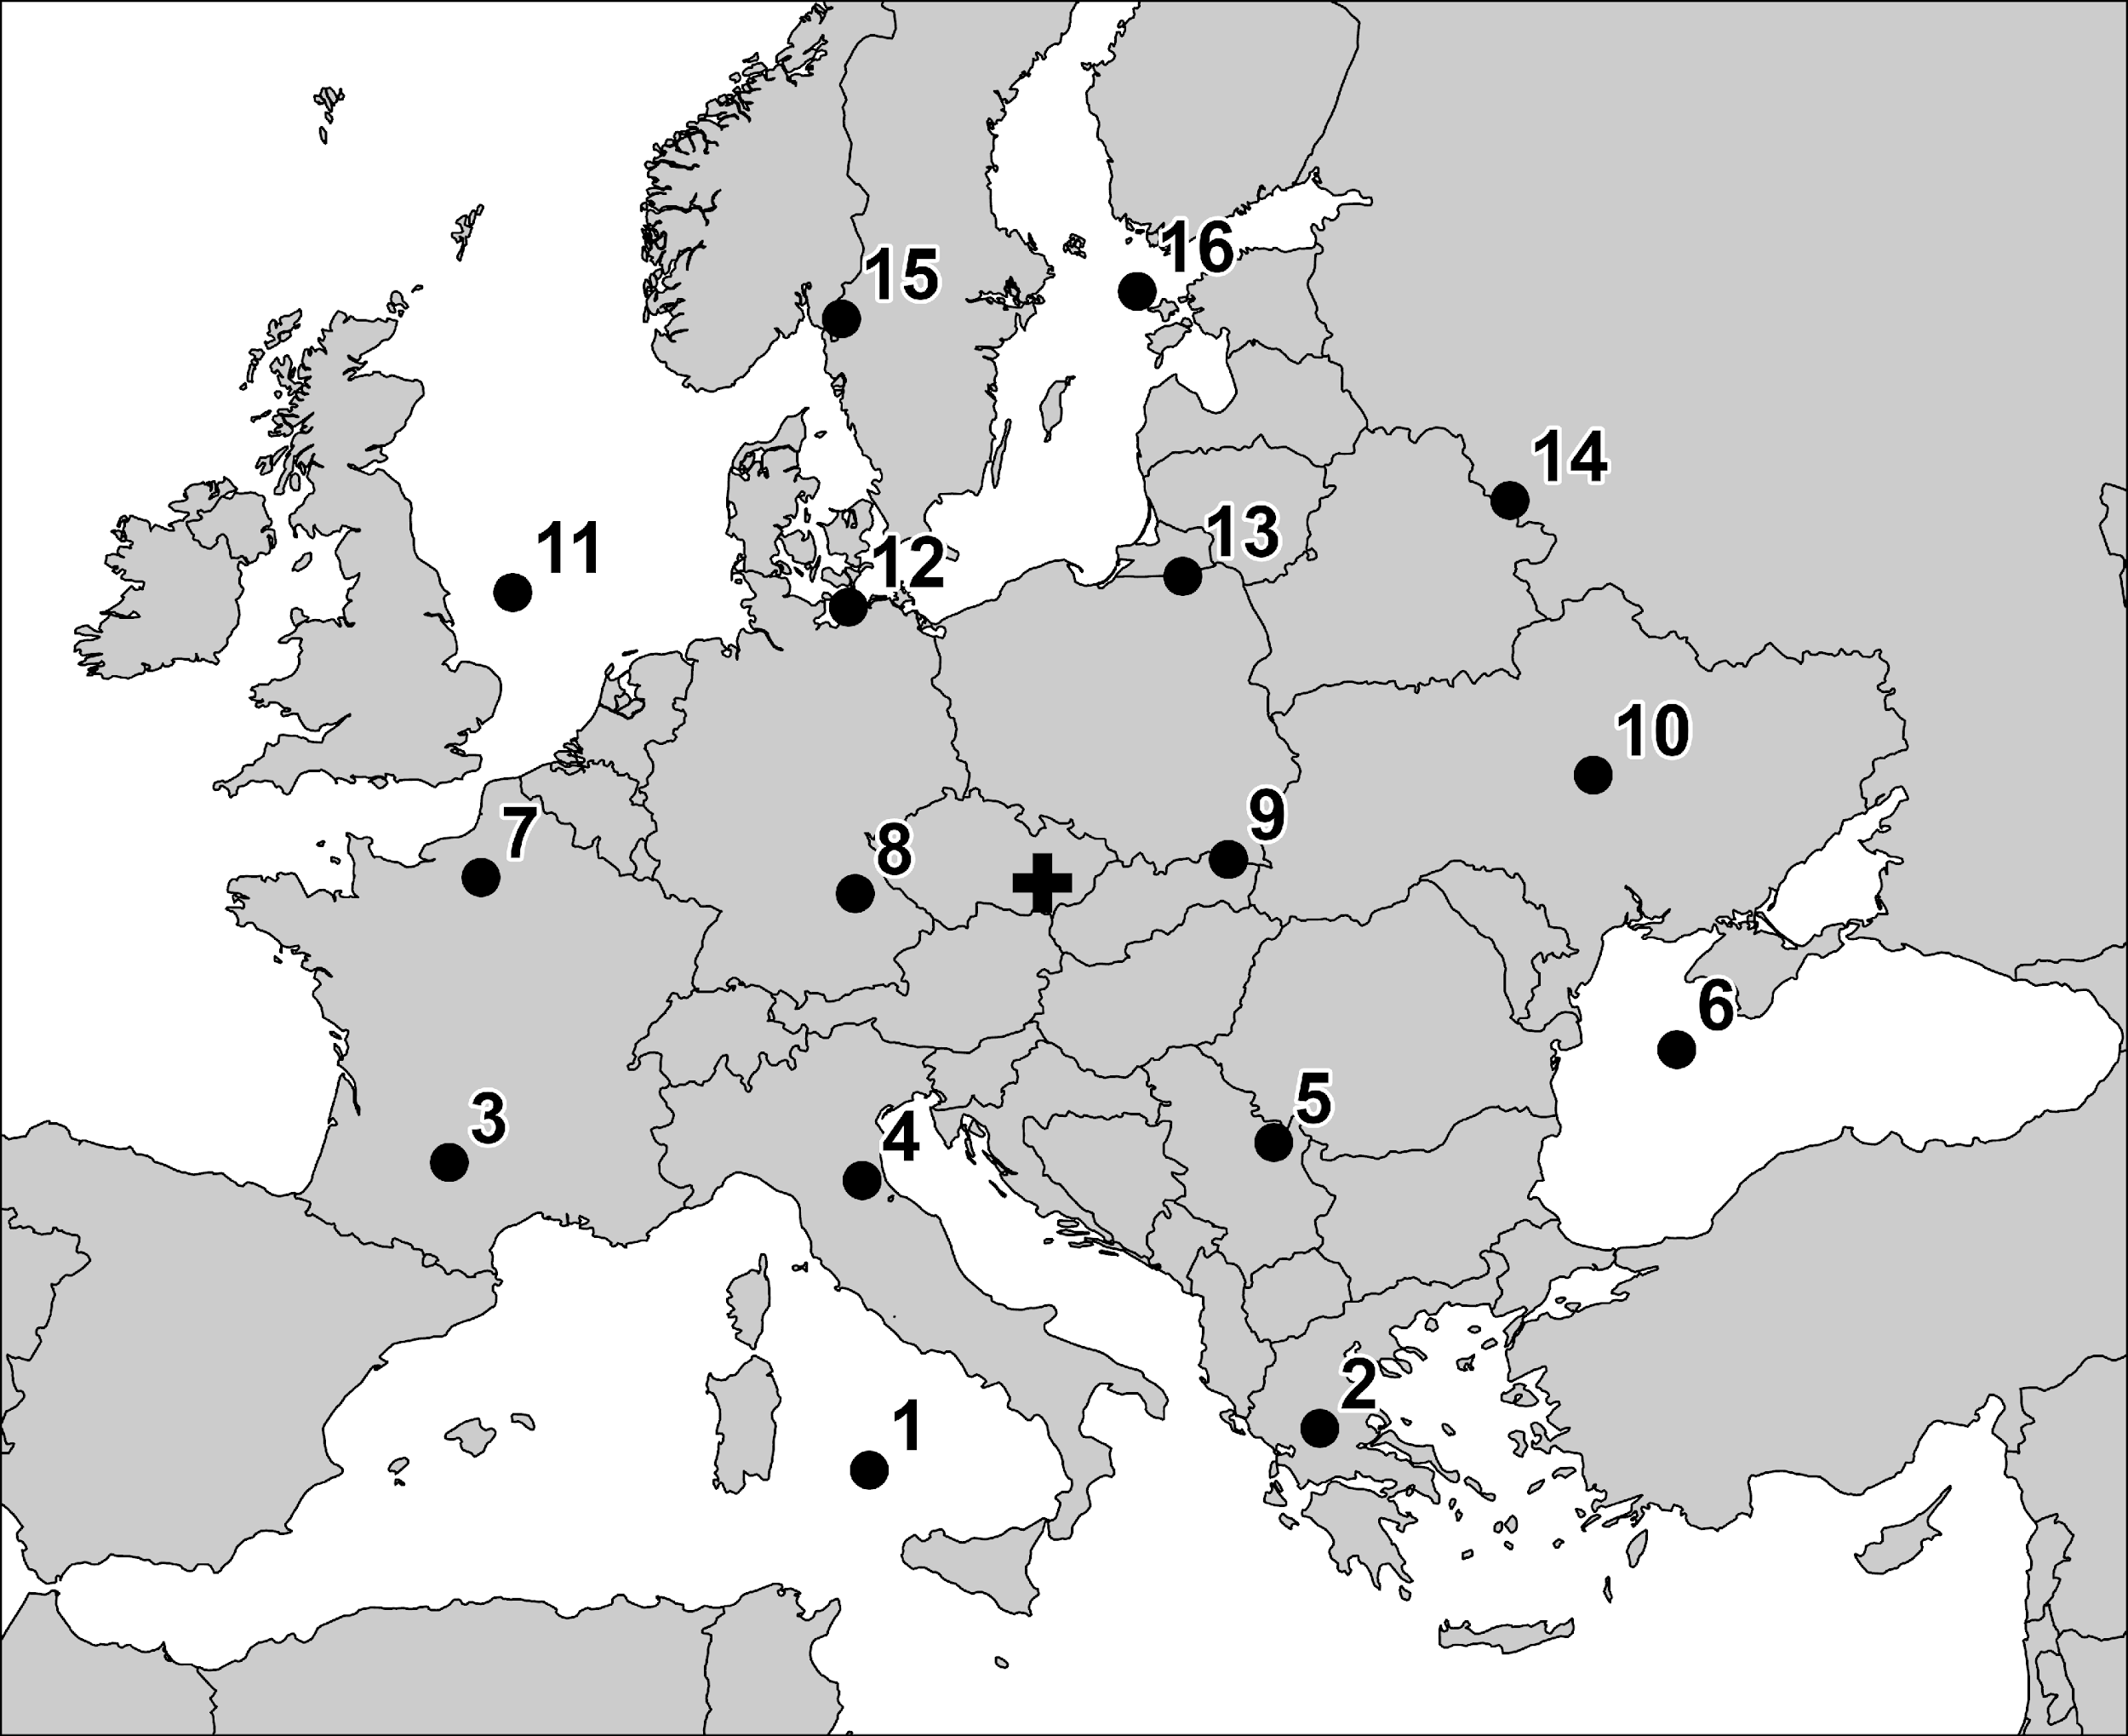
Figure S1 Position of the 16 grid points for the calculation of circulation types. The centroid of the area shows a cross.

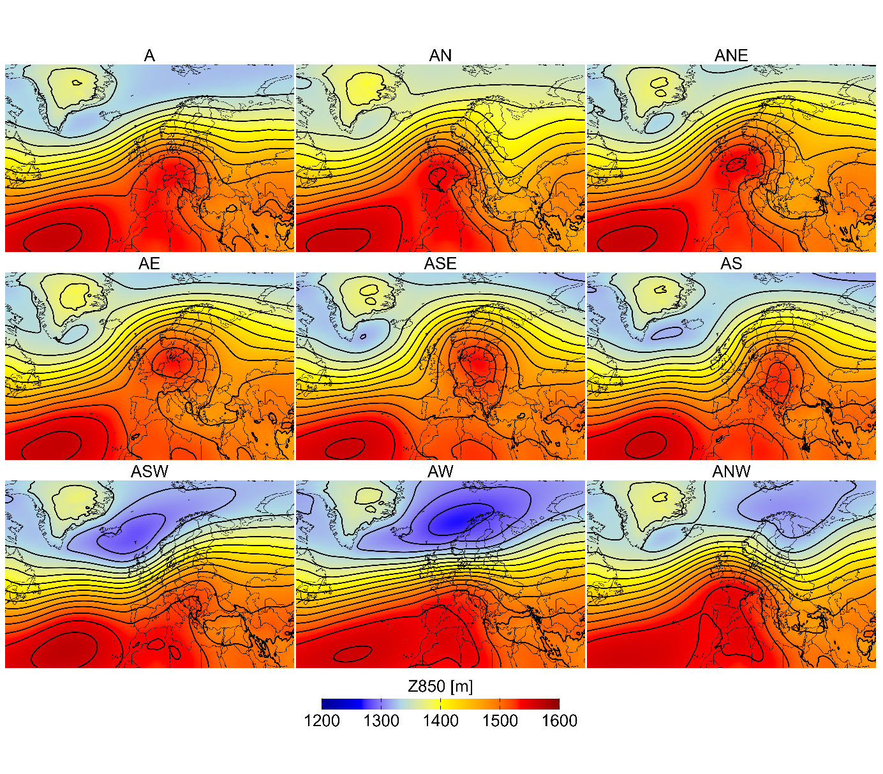
Figure S2 Composite geopotential height at 850 hPa for anticyclonic circulation types derived from the Jenkinson–Collison classification. The maps illustrate the typical synoptic-scale pressure field over Europe associated with each circulation type based on ERA5 data for the period 1961–2022. Black contours indicate geopotential height.
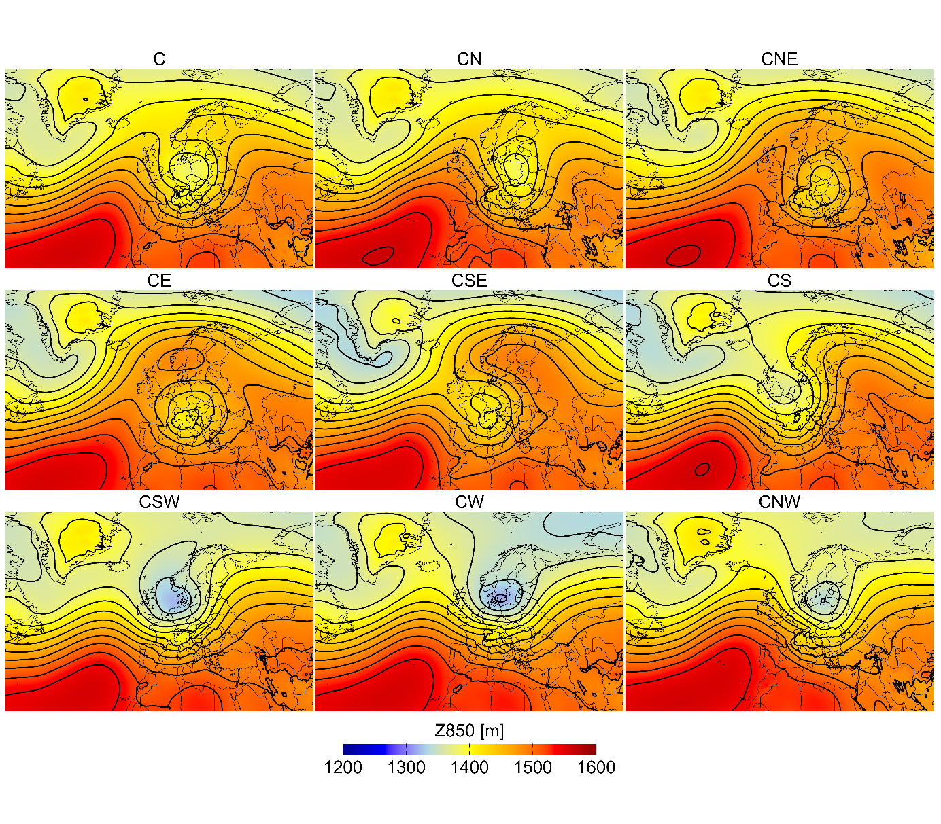
Figure S3 The same as in Figure S1, but for cyclonic circulation types

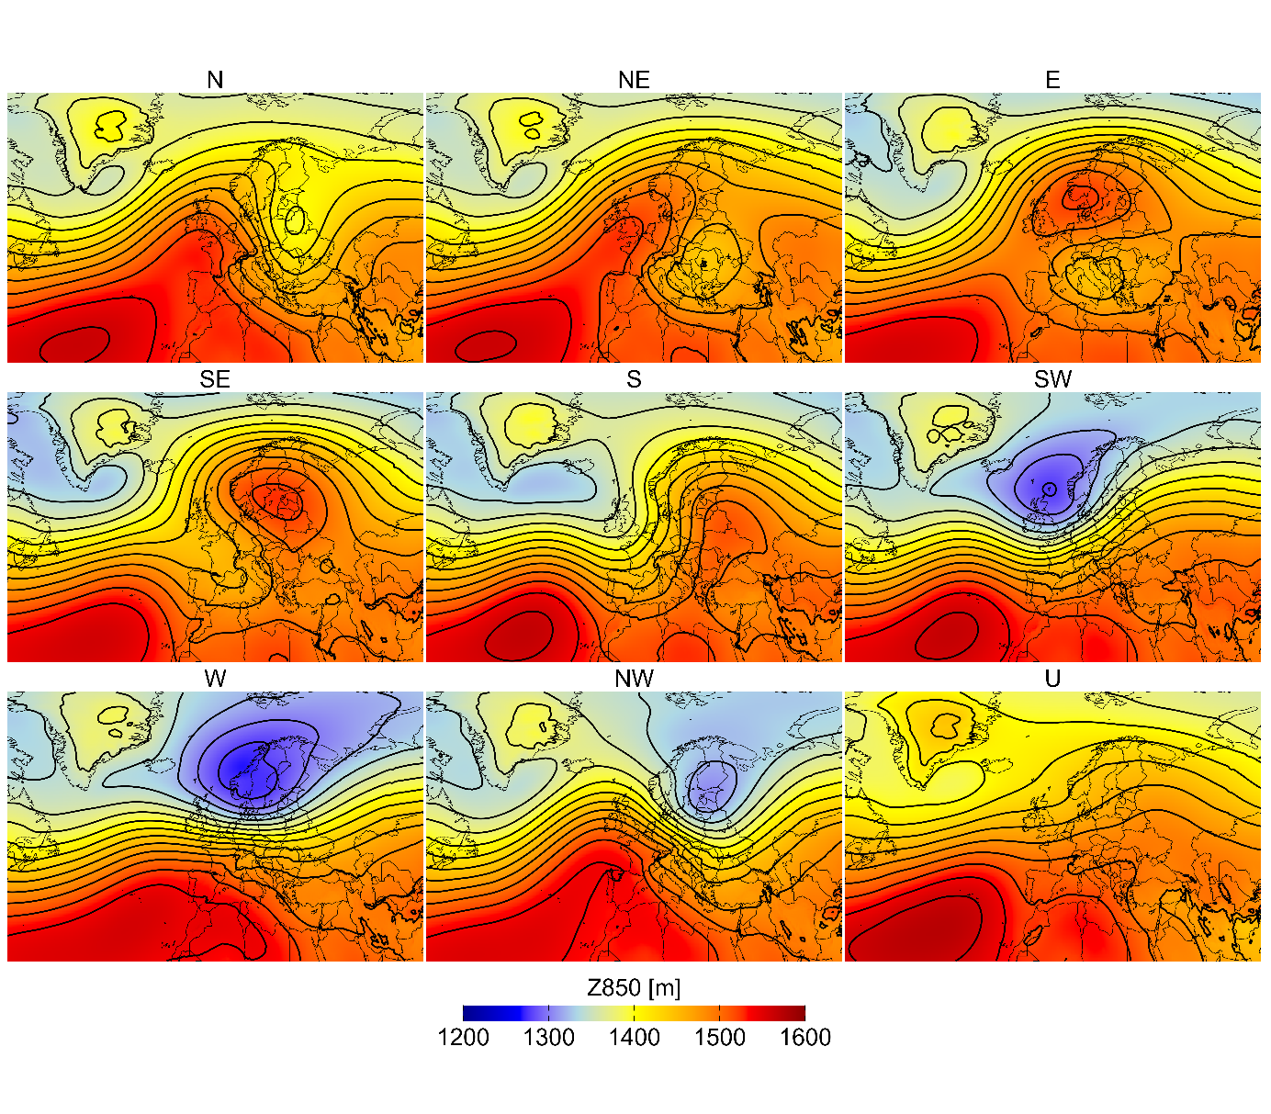
Figure S4 The same as in Figure S1, but for directional and undefined circulation types

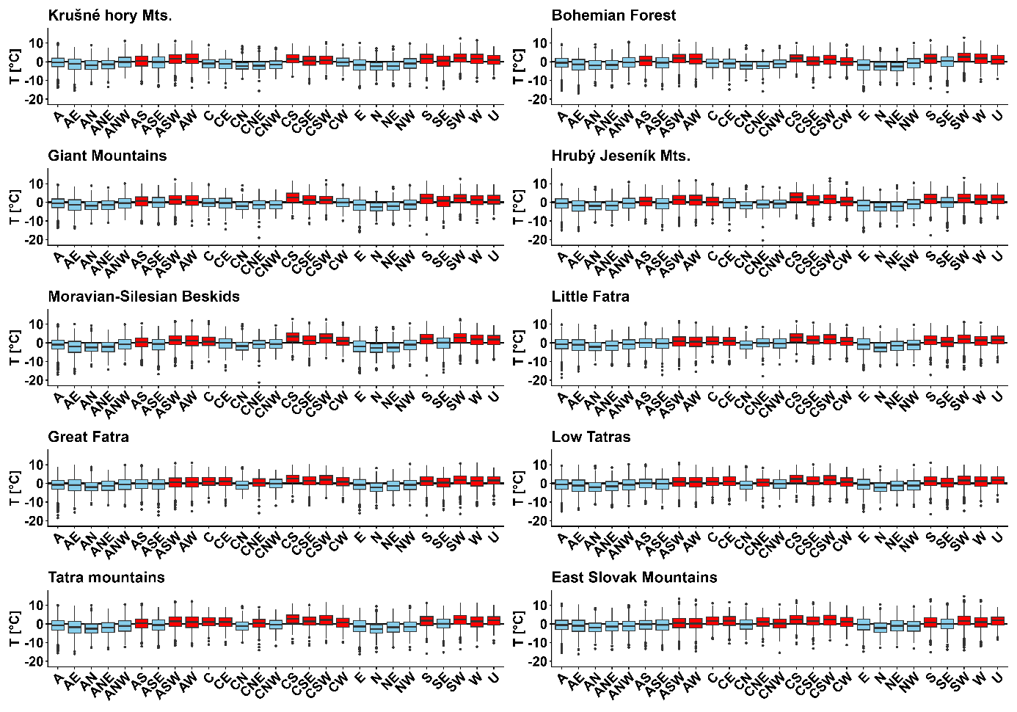
Figure S5 Boxplots of TAVG anomalies for individual circulation types over the 1961–2022 period, shown separately for each analysed mountain range. The boxplots depict the median, interquartile range, and the distribution of temperature extremes associated with the different circulation regimes. The box indicates the interquartile range (IQR) (Q1–Q3), the horizontal line marks the median, whiskers represent values within 1.5×IQR, and dots denote outliers. Red indicates boxplots with a median above the mean (positive anomalies), while blue indicates medians below the mean (negative anomalies).

Table S1 Results of the Shapiro–Wilk test for the annual mean temperature series
Mountain range | W | p-value
Krušné hory Mts. | 0.9807 | 0.4047
Bohemian Forest | 0.9854 | 0.6424
Giant Mountains | 0.9892 | 0.8442
Hrubý Jeseník Mts. | 0.9838 | 0.5533
Moravian-Silesian Beskids | 0.9874 | 0.7514
Little Fatra | 0.9777 | 0.2901
Great Fatra | 0.9851 | 0.6218
Low Tatras | 0.9786 | 0.3186
Tatra Mountains | 0.9790 | 0.3352
East Slovak Mountains | 0.9716 | 0.1402

Table S2 Annual and seasonal trends in the frequency of occurrence of individual circulation types (%/10 years). Statistically significant trends (p < 0.05) are shown in bold. The column ALL represents the aggregated trend across all circulation types within the respective group (i.e., anticyclonic, cyclonic, or directional types).
Season | Anticyclonic circulation types
 | A | AE | AN | ANE | ANW | AS | ASE | ASW | AW | ALL
ANN | 0.29 | 0.20 | 0.09 | 0.17 | -0.15 | 0.00 | 0.09 | 0.30 | 0.23 | 0.94
DJF | 0.00 | 0.00 | 0.00 | 0.00 | 0.22 | -0.38 | -0.24 | 0.37 | 1.08 | 1.49
MAM | 0.58 | 0.00 | 0.19 | 0.00 | 0.00 | 0.00 | 0.00 | 0.00 | 0.00 | 0.59
JJA | 0.77 | 0.30 | 0.00 | 0.33 | 0.00 | 0.00 | 0.00 | 0.22 | 0.00 | 0.93
SON | -0.32 | 0.00 | 0.00 | 0.00 | -0.49 | 0.00 | 0.40 | 0.55 | 0.00 | -0.11
 | Cyclonic circulation types
 | C | CE | CN | CNE | CNW | CS | CSE | CSW | CW | ALL
ANN | 0.00 | -0.08 | 0.00 | -0.13 | 0.00 | -0.09 | -0.20 | 0.00 | -0.11 | -0.71
DJF | 0.00 | 0.00 | 0.00 | 0.00 | 0.00 | 0.00 | 0.00 | 0.00 | 0.00 | -0.38
MAM | 0.00 | 0.00 | 0.00 | 0.00 | 0.00 | -0.22 | -0.39 | 0.00 | 0.00 | -2.10
JJA | 0.00 | 0.00 | 0.00 | 0.00 | 0.00 | 0.00 | 0.00 | 0.00 | 0.00 | -0.96
SON | 0.00 | 0.00 | 0.00 | 0.00 | 0.00 | 0.00 | 0.00 | 0.00 | 0.00 | 0.24
 | Directional circulation types |  |  |  |  |  |  |  |  | U
 | E | N | NE | NW | S | SE | SW | W | ALL | U
ANN | 0.00 | 0.00 | 0.10 | -0.15 | -0.06 | -0.03 | 0.00 | 0.00 | -0.06 | 0.00
DJF | 0.00 | 0.00 | 0.00 | 0.00 | -0.48 | 0.00 | 0.00 | 0.00 | -0.81 | 0.00
MAM | 0.10 | 0.00 | 0.13 | 0.12 | 0.00 | 0.00 | 0.00 | 0.00 | 0.49 | 0.00
JJA | 0.00 | 0.00 | 0.00 | -0.38 | 0.00 | 0.00 | 0.00 | 0.00 | -0.44 | 0.00
SON | 0.00 | 0.00 | 0.00 | 0.00 | 0.18 | 0.29 | -0.23 | 0.00 | -0.23 | 0.00

