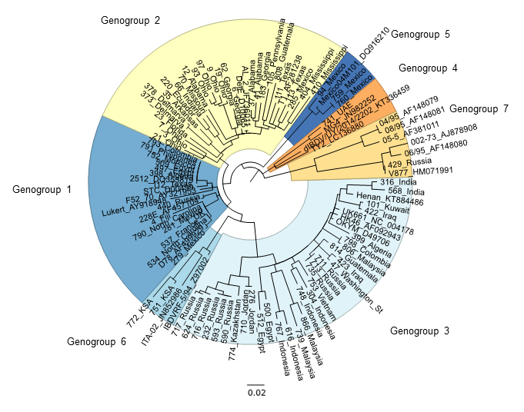
Online Resource 1 Phylogenetic analysis of the DNA sequences of hvVP2 of IBDV by Maximum Likelihood method based on the Kimura 2-parameter model [23]. The tree with the highest log likelihood (-4377.30) is shown. The tree is drawn to scale, with branch lengths measured in the number of substitutions per site. The analysis involved 105 nucleotide sequences. All positions containing gaps and missing data were eliminated. There were a total of 366 positions in the final dataset.
Genogroup
210 220 230 240 250 260 270 280
1 STC_D00499 AADDYQFSSQ YQPGGVTITL FSANIDAITS LSVGGELVFQ TSVQGLVLGA TIYFIGFDGT TVITRAVAAD NGLTAGTDNL

2 DelE_AF133904 ...N...... ..T....... .......... .........K ....S..... ..CL...... A........N ......I...
3 UK661_NC_004178 .......... ..A....... .......... ..I....... ......I... ...L...... A......... ..........
4 MG4_JN982252 .......... ..S....... .......... .......... ....S..... ...L...... ..T..T...N T........P
4 741_UAE .......... ..S....... .......... .......... ....S..... ...L...... ..T..T...N T........P
5 Mexico_DQ916210 ---N...... ..T....... .......... .......... .N..N..... ...L...... K.......SN ..........
5 759_Mexico ...N...... ..T....... .......... .......... .N..N..... ...L...... K.......SN ..........
6 ITA-02_JN852986 ---------. H.Q....... .......... .......... ...ES.K.D. S..L.....S ........S. ..........
6 IBDVRF_Z97002 .......... ..Q....... .......... .......... ....S.I... ...L.....S ........S. ..........
6 772_KSA .......... ..Q....... .......... .......... ...ES.K... ...L.....S ........S. ..........
6 751_KSA .......... ..Q....... .......... .......... ...ES.K... ...L.....S ........S. ..........
7 V877_HM071991 .......... .......... .......... .......... ........N. .V.LV..... ..T......G ..........
7 429_Russia .......... .......... .......... .......... ........N. .V.LV..... ..T......G ..........
P_{BC} P_{DE} P_{FG}

290 300 310 320 330 340 350 360
1 STC_D00499 MPFNLVIPTN EITQPITSIK LEVVTSKSGG QAGDQMSWSA SGSLAVTIHG GNYPGALRPV TLVAYERVAT GSVVTVAGVS

2 DelE_AF133904 .......... .......... ..I.....D. ...E...... .......... .......... .......... ..........
3 UK661_NC_004178 ....I....S .......... ..I....... .......... .......... .......... .......... ..........
4 MG4_JN982252 I.....F... .......... ..I....... V......... .......... .......... .........K ..........
4 741_UAE I.....F... .......... ..I....... V......... .......... .......... .........K ..........
5 Mexico_DQ916210 .......... .......... ..I....KD. .PE....... .......... .......... .........K ..........
5 759_Mexico .......... .......... ..I....KD. .PE....... .......... .......... .........K ..........
6 ITA-02_JN852986 .........S .......... ..I....... .V........ .......... .......... .........K ..........
6 IBDVRF_Z97002 .........S .......... ..I....... .......... .......... .......... .....----- ----------
6 772_KSA .........S .......... ..I....... .V........ .......... .......... .........K ..........
6 751_KSA .........S .......... ..I....... .......... .......... .......... .........K ..........
7 V877_HM071991 .........S .....V.... ..I....... ........L. ..N....... .......... .......... .---------
7 429_Russia .........S .....V.... ..I....... ........L. ..N....... .......... .......... .......... P_{HI}

Online Resource 2 Alignment of the hvVP2 amino acid sequences of representatives of each of the seven IBDV genogroups. Loops P_{BC}, P_{DE}, P_{FG}, and P_{HI} of the projection domain are marked with blue boxed regions.

210 220 230 240 250 260 270 280

UK661_vvIBDV AADDYQFSSQ YQAGGVTITL FSANIDAITS LSIGGELVFQ TSVQGLILGA TIYLIGFDGT AVITRAVAAD NGLTAGTDNL

500_Egypt .......... F......... .......... .......... ....S..... .......... .......... ..........
739_Malaysia ...N...... .......... .......... .......... ....D..... .......... .......... ..........
866_Malaysia ...N...... ..T....... .......... .......... ....D..... .......... .......... ..........
616_Indonesia ...N...... ..S....... .......... .......... .......... ....V..... .......... .R........
767_Indonesia ...N...... ..S....... .......... .......... .......... .......... .......... .R........
711_Russia (3-1) .......... .......... .......... .......... .......... .......... ..T......N ..........
624_Russia (3-2) ..N..K.... ..T....... .......... .......... ....D..... .......... .........N ..........
437_Russia (3-3) ..NG...... .......... .......... .......... ....D..... .......... .........N ..........
774_Kazakhstan ..N....... ..T....... .......... .......... ....D..... .......... .........N ..........
P_{BC} P_{DE} P_{FG}

290 300 310 320 330 340 350 360
UK661_vvIBDV MPFNIVIPTS EITQPITSIK LEIVTSKSGG QAGDQMSWSA SGSLAVTIHG GNYPGALRPV TLVAYERVAT GSVVTVAGVS

500_Egypt .......... .......... .......... .......... .......... .......... .......... ..........
739_Malaysia .......... Q....V.... .....T.R.. .E.N...... .......... .......... .......... ..........
866_Malaysia .......... Q....V.... .....T.R.. .E.N...... .......... .......... .........K ..........
616_Indonesia .........N A....V.... .......... .E........ .......... .......... .......... ..........
767_Indonesia .........N A....V.... .......... .E........ .......... .......... .......... ..........
711_Russia (3-1) .......... .......... .......... .......... .......... .......... .......... ..........
624_Russia (3-2) .......... .......... .......... ........K. ..N....... .......... .......... ..........
437_Russia (3-3) .......... .......... .......... ........K. ..N....... .......... .......... ..........
774_Kazakhstan .......... .......... .......... .......... ..N....... .......... .......... ..........
P_{HI}

Online Resource 3 Alignment of the hvVP2 amino acid sequences of representative Genogroup 3 samples. Loops P_{BC}, P_{DE}, P_{FG}, and P_{HI} of the projection domain are marked with blue boxed regions.

Site | Location | Residues
213 |  | D N G
222 | P_{BC} | P T A Q S  L has also been found at this site [55]
249 | P_{DE} | Q H K R
253 | P_{DE} | E H N Q
254 | P_{DE} | D G N S
256 |  | I V K A
270 |  | A T K
300 |  | E A D Q
317 | P_{HI} | S K R
318 | P_{HI} | D G N S
321 | P_{HI} | A E D V P T
323 | P_{HI} | D E N Q
328 |  | S K L
330 |  | S N R K

Online Resource 4 Amino acid residues located at various sites in the hvVP2 region

