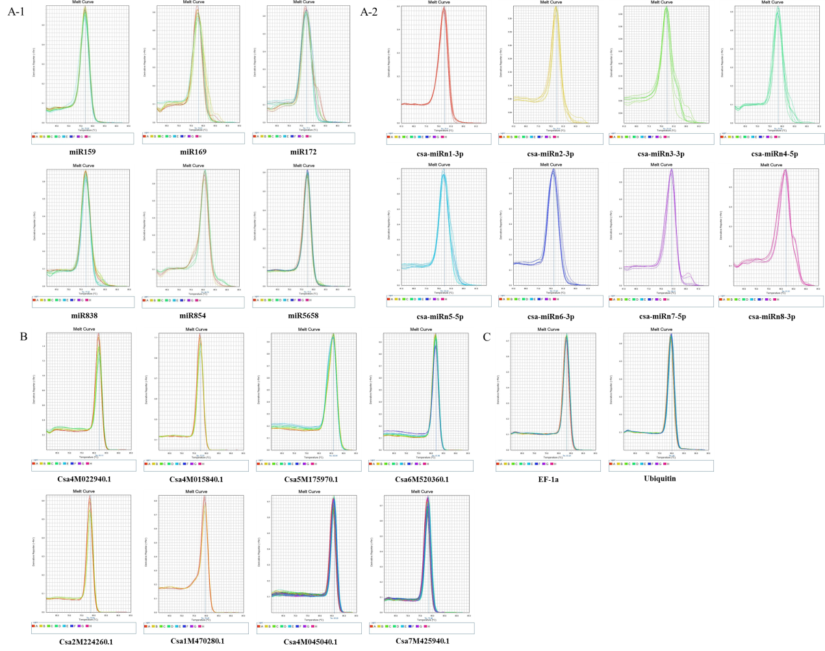
Supplementary material 5 Fig. S1 Melting curves of miRNAs (A-1, known miRNAs; A-2, novel miRNAs), target genes (B) and reference genes (C).

