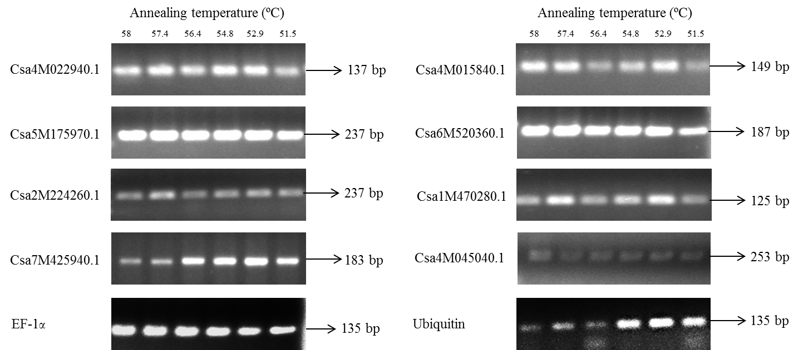
Supplementary material 6 Fig. S2 Agarose gel electrophoresis of PCR products of eight target genes and two reference genes with gradient annealing temperatures (from 58ºC to 52ºC) by RT-PCR.

