SUPPLEMENTARY MATERIAL

SUPPLEMENTARY FIGURE LEGENDS

Supplementary Figure S1. Microarray showing the distribution along the SARS-CoV-2 genome and in viral genes of nucleotide changes observed in comparison with the genome of the Wuhan-Hu-1 isolate for the Pangolin B.1.640.1 and B.1.640.2 (IHU variant) lineages.
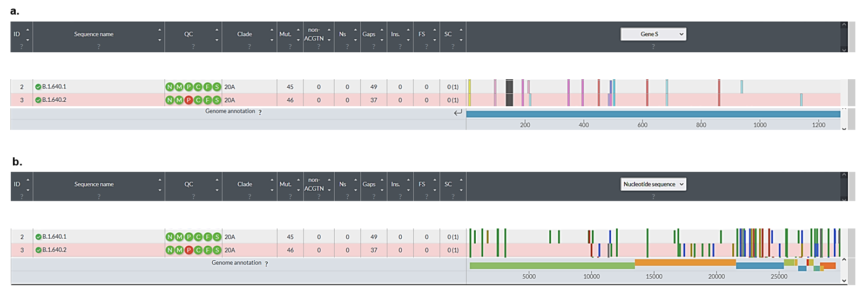
Genomes were analyzed using the Nextstrain web-tool (https://clades.nextstrain.org/) [1,2]. Representation is adapted from Nextclade sequence analysis web application output (https://clades.nextstrain.org/).

Supplementary Figure S2. Phylogeny reconstruction based on genomes of Pangolin lineages B.1.640.1 and B.1.640.2.
Phylogenetic analysis was performed using the nextstrain/ncov tool (https://github.com/nextstrain/ncov) then visualized with Auspice (https://docs.nextstrain.org/projects/auspice/en/stable/). The genome of the original Wuhan-Hu-1 SARS-CoV-2 isolate (GenBank accession no. NC_045512.2) was added as outgroup, in addition to SARS-CoV-2 genomes of Pangolin lineage B.1.640.2 (available from the GISAID sequence database as of 31/12/2021) and to some SARS-CoV-2 genomes of Pangolin lineage B.1.640.1. X-axis shows time. This Figure is a screenshot of the nextclade web application (https://clades.nextstrain.org) [1, 2].

SUPPLEMENTARY TABLES

Supplementary Table S1. Comparison of nucleotide mutational patterns of the B.1.640.1 and B.1.640.2 lineages
B.1.640.1 | B.1.640.2 (IHU variant)
C241T | C241T
C601T | -
C1191T | C1191T
A1620G | -
C2416T | C2416T
C2455T | C2455T
C3037T | C3037T
G6622T | -
G7328T | -
C9711T | -
G9756A | -
- | G9929A
C10029T | -
- | T10561C
- | Deletion 11288-11296
T11418C | -
- | C11514T
C11956T | C11956T
C14408T | C14408T
C16575T | -
C16869T | C16869T
- | C17004T
- | T17348C
- | A17916G
- | C18175T
- | C18804T
- | G19348T
- | T19680C
C20283T | -
- | A21258G
C21588T | C21588T
G21848C | G21848C
Deletion 21968-21994 | Deletion 21968-21994
G22132T | G22132T
T22191C | -
- | G22205C
A22600C | A22600C
A22743G | A22743G
T22907A | T22907A
- | G23012A
T23030C | -
T23031G | T23031C
A23063T | A23063T
A23403G | A23403G
C23604A | C23604A
C24138A | C24138A
G24368C | -
- | G24977C
C25487T | C25487T
G25563T | G25563T
A26492T | -
T26767C | T26767G
C27513T | C27513T
C27807T | C27807T
- | T27833C
C27972T | C27972T
- | T28002C
Deletion 28271 | Deletion 28271
T28297C | C28312T
G28337T | G28337T
C28887T | C28887T
T29377C | T29377C
G29405C | -
Deletion 29738-29758 | -
G29779T | G29779T

Genomes were analyzed using the Nextstrain web-tool (https://clades.nextstrain.org/) [1,2].
Spike region is indicated by a grey background.

Supplementary Table S2. Comparison of amino acid mutational patterns of the B.1.640.1 and B.1.640.2 lineages
B.1.640.1 | B.1.640.2 (IHU variant)
M:I82T | M:I82S
N:D22Y | N:D22Y
N:T205I | N:T205I
N:E378Q | -
ORF1a:P309L | ORF1a:P309L
ORF1a:E452G | -
ORF1a:L2119F | -
ORF1a:A2355S | -
ORF1a:S3149F | -
ORF1a:R3164H | -
- | ORF1a:D3222N
ORF1a:T3255I | -
- | Deletions ORF1a:S3675-, ORF1a:G3676-, ORF1a:F3677-
ORF1a:V3718A | -
- | ORF1a:T3750I
ORF1b:P314L | ORF1b:P314L
- | ORF1b:V1294A
- | ORF1b:P1570S
- | ORF1b:V1961F
ORF3a:T32I | ORF3a:T32I
ORF3a:Q57H | ORF3a:Q57H
ORF8:Q27* | ORF8:Q27*
ORF9b:I5T | -
ORF9b:Q18H | -
- | ORF8:C37R
- | ORF9b:P10L
- | ORF9b:Q18H
S:P9L | S:P9L
S:E96Q | S:E96Q
Deletions S:C136-, S:N137-, S:D138-, S:P139-, S:F140-, S:L141-, S:G142-, S:V143-, S:Y144- | Deletions S:C136-, S:N137-, S:D138-, S:P139-, S:F140-, S:L141-, S:G142-, S:V143-, S:Y144-
S:R190S | S:R190S
S:I210T | -
- | S:D215H
S:R346S | S:R346S
S:N394S | S:N394S
S:Y449N | S:Y449N
- | S:E484K
S:F490R | S:F490S
S:N501Y | S:N501Y
S:D614G | S:D614G
S:P681H | S:P681H
S:T859N | S:T859N
S:D936H | -
- | S:D1139H

Genomes were analyzed using the Nextstrain web-tool (https://clades.nextstrain.org/) [1,2].
Spike region is indicated by a grey background.
REFERENCES
1. Hadfield J, Megill C, Bell SM, Huddleston J, Potter B, Callender C, Sagulenko P, Bedford T, Neher RA (2018). Nextstrain: real-time tracking of pathogen evolution. Bioinformatics 34: 4121-4123.
2. Aksamentov I, Roemer C, Hodcroft EB, Neher RA (2021). Nextclade: clade assignment, mutation calling and quality control for viral genomes. Zenodo https://doi.org/10.5281/zenodo.5607694.

