Supplemental data 1
Macro used for counting the cells in the images from the microscope in Fiji (ImageJ) software.

// Set the input and output directories
inputDir = "inputDir";
outputDir = "outputDir";

// Set the file extension of the images (e.g., "tif", "jpg", "png", etc.)
fileExtension = "czi";

// Get the list of image files in the input folder
list = getFileList(inputDir);

// Load necessary plugins (only required if not already installed)
run("Blobs (25K)");
run("Bio-Formats Macro Extensions");

// Loop through the list of files
for (i = 0; i < list.length; i++) {
if (endsWith(list[i], fileExtension)) {
// Open the image
open(inputDir + list[i]);

// Process the image
run("Convert to Mask");

// Adjust the threshold if necessary
setAutoThreshold("Default");

// Run the "Analyze Particles" function
run("Analyze Particles...", "size=0-Infinity show=Overlay summarize add");

// Save the results to a CSV file
saveAs("Results", outputDir + File.nameWithoutExtension + "_results.csv");

// Close the image
close();
}
}

// Notify when the processing is complete
print("Cell counting for all images in the folder is complete.");

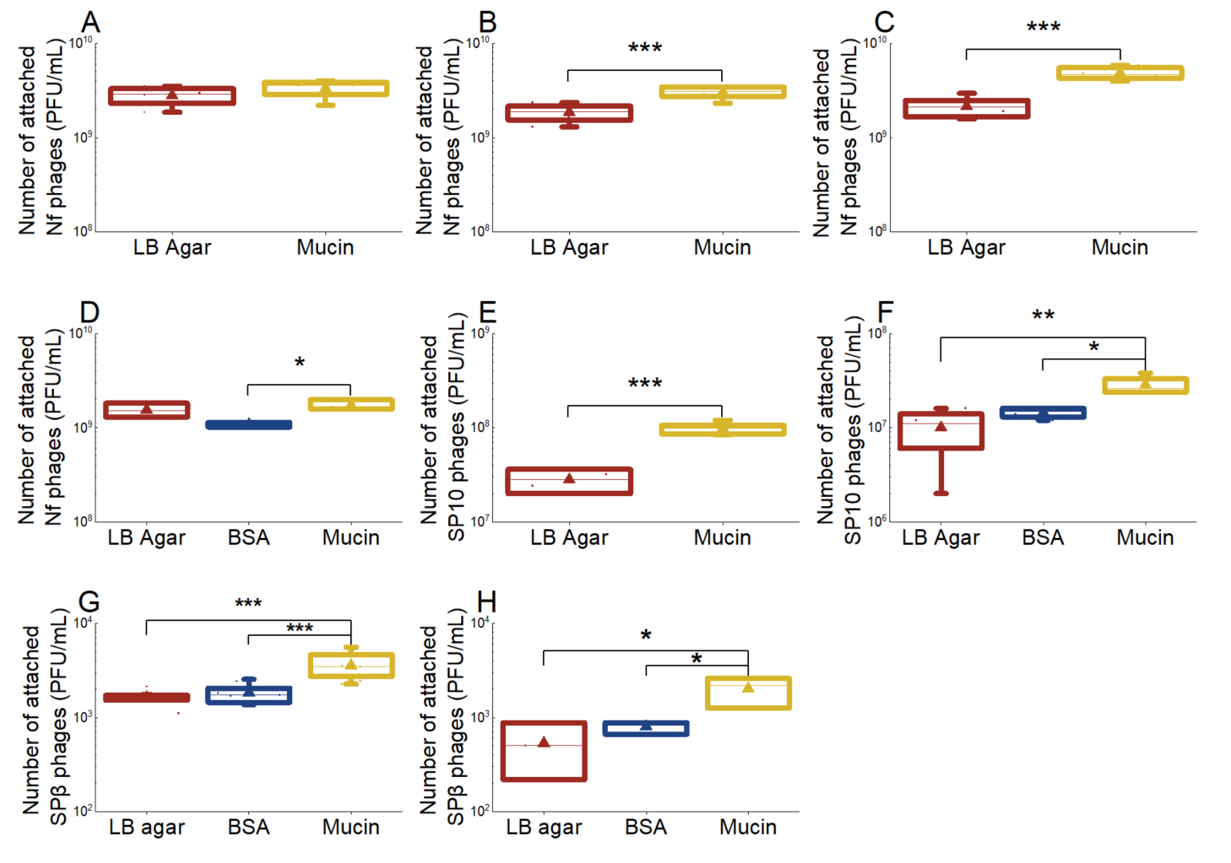
Supplemental figure 1: Data from all individual experiments of Bacillus phages attached to mucin prior to normalization. A, B, C and D represent PFU / mL of Nf phage attached, E and F represent PFU / mL of SP10 phage attached and G and H represent PFU / mL of SPβ phage attached. Each letter represents an independent run of the same type of experiment.

