Dynamics of antiretroviral restriction factor expression in sheep naturally infected with Small Ruminant Lentivirus (SRLV).

Supplementary Material
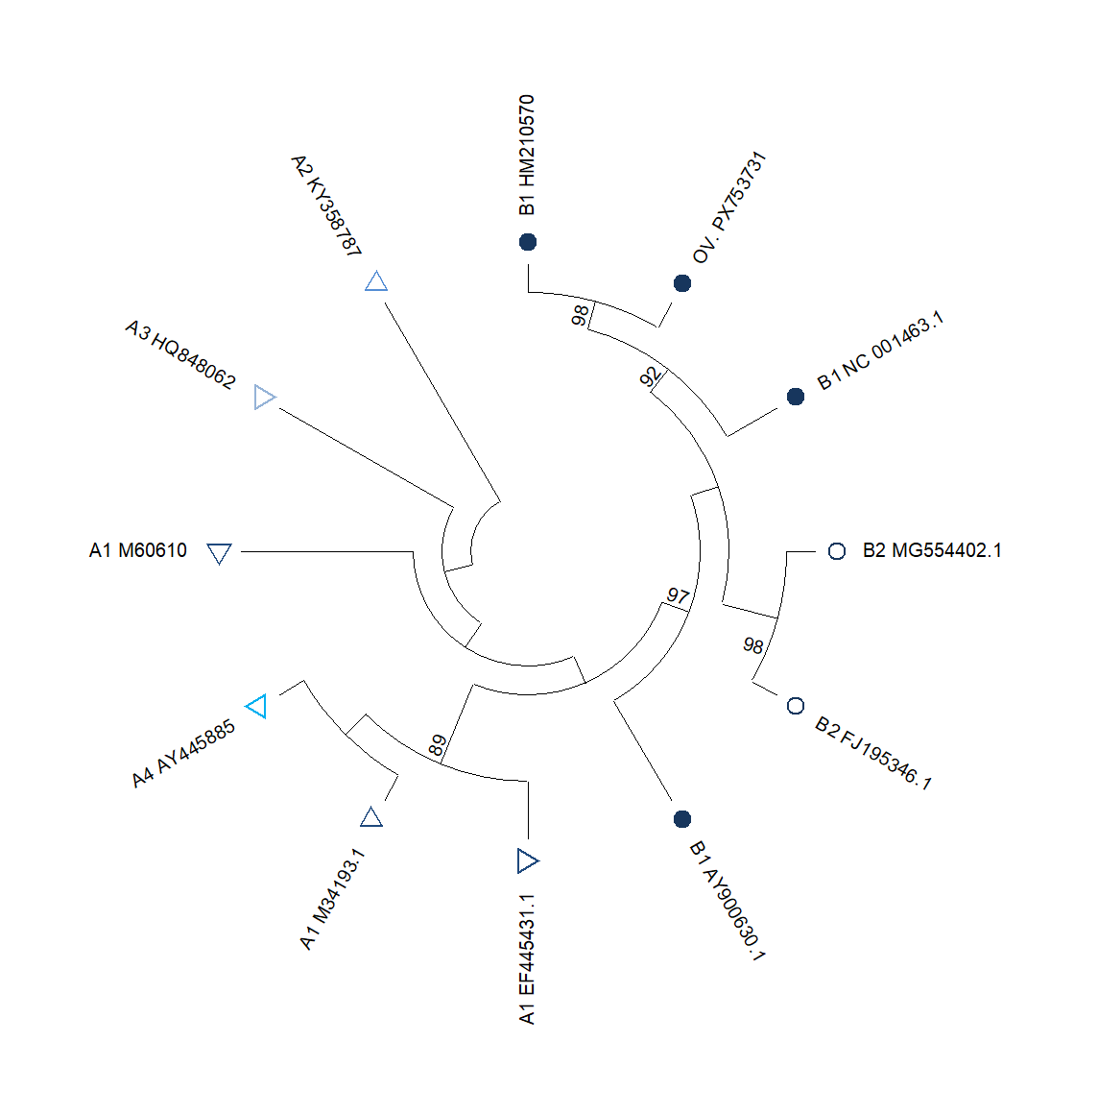
Figure S1. Phylogenetic analysis was performed using the Maximum Likelihood method under the General Time Reversible (GTR) model. The tree with the highest log likelihood (−5399.55) is shown. Branch support was assessed using 1000 bootstrap replicates. The analysis included Small Ruminant Lentivirus (SRLV) sequences belonging to genotypes A (EV1 EF445431.1; SA-OMVV M34193.1; Icelandic1514 M60610.1; USMARC KY358787.1; Isolate 697 HQ848062.1; SWI AY445885.1) (∇) and B (Isolate Clements NC_001463.1; Gansu AY900630.1; FESC-752 HM210570.1; SRLV001 MG554402.1; Ov496 FJ195346.1) (○). The sequence PX753731, obtained from one of the sheep included in the present study, clustered with reference sequences of SRLV genotype B. The final dataset consisted of 12 sequences and 359 nucleotide positions. Analyses were conducted in MEGA12 software.

Variable | Z1 | Z3 | BST2 | Serology | Viral load | Proviral load | Time
APOBEC3 Z1 | 1 | 0.229  (*** ) | 0.261  (*** ) | –0.122  (* ) | 0.140  (* ) | –0.094  (ns) | –0.259  (*** )
APOBEC3 Z3 |  | 1 | 0.329  (*** ) | 0.050  (ns) | 0.088  (ns) | 0.109  (ns) | 0.174  (** )
BST2 |  |  | 1 | 0.088  (ns) | –0.076 (ns) | 0.171  (** ) | 0.405  (*** )
Serology |  |  |  | 1 | 0.070  (ns) | 0.020  (ns) | 0.343  (*** )
Viral load |  |  |  |  | 1 | –0.158  (** ) | –0.029  (ns)
Proviral load |  |  |  |  |  | 1 | 0.249  (*** )
Time |  |  |  |  |  |  | 1
Table S1 Spearman’s rank correlation coefficients (ρ) between gene expression of APOBEC3 Z1 (Z1), Z3 (Z3), and BST2 (Tetherin), and infection parameters (viral load, proviral load, serology, and time). Significance levels: ns (non-significant, p ≥ 0.05), * (p < 0.05), ** (p < 0.01), *** (p < 0.001).

Response | Source | df | Sum of Squares | Mean Square | F | p-value
APOBEC3  Z1 | Time | 5 | 207.94 | 41.59 | 35.54 | < 0.001 ***
 | Error | 276 | 322.96 | 1.17
APOBEC3  Z3 | Time | 5 | 23753 | 4750.7 | 14.30 | < 0.001 ***
 | Error | 276 | 91689 | 332.2
BST2 | Time | 5 | 10318 | 2063.53 | 39.49 | < 0.001 ***
 | Error | 276 | 14422 | 52.26
Table S2 MANOVA results evaluating the effect of time on the expression of APOBEC3 Z1, Z3, and BST2. All genes showed significant temporal variation (p < 0.001).

A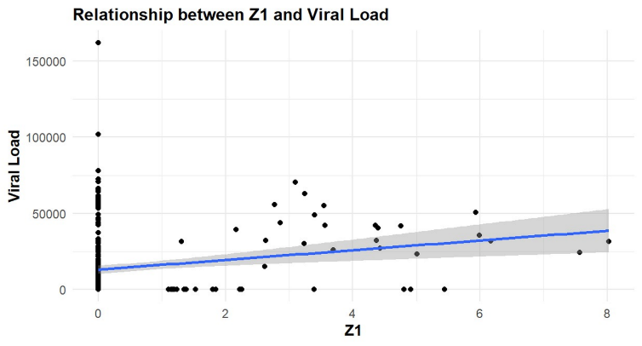 | B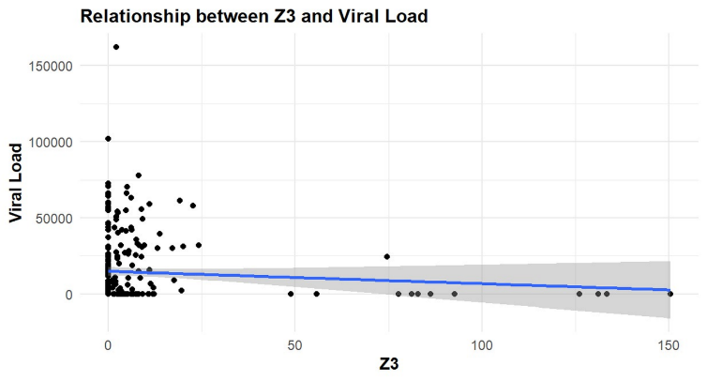
C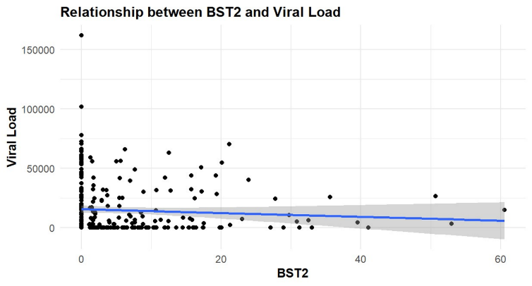
Figure S2. Linear regressions showing associations between gene expression and viral load. A) Z1 vs viral load; B) Z3 vs viral load C) BST2 vs viral RNA load. The blue line represents the regression trend, and the shaded area indicates the 95% confidence interval.

A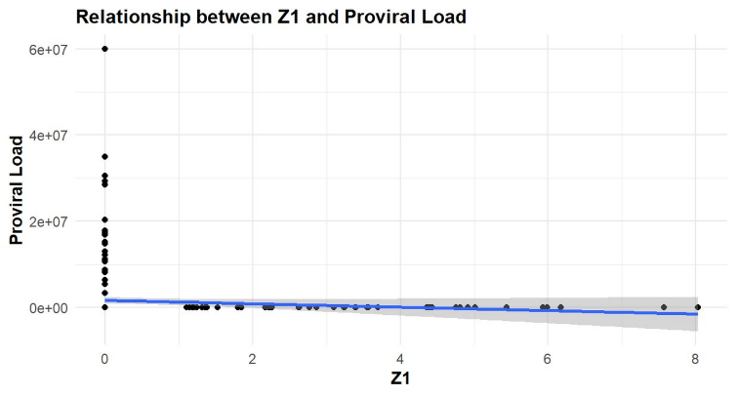 | B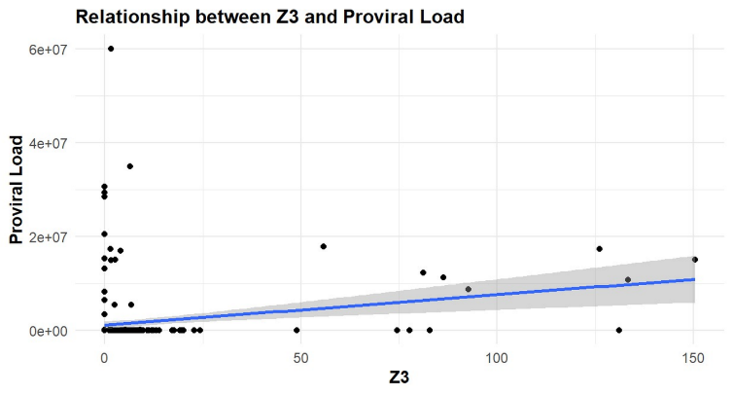
C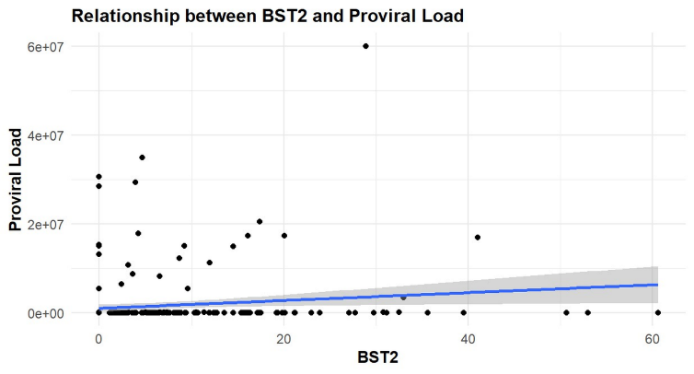

Figure S3. Linear regressions showing associations between gene expression and proviral load: A) Z1 vs proviral load; B) Z3 vs proviral load; C) S6: BST2 (Tetherin) vs proviral load. The blue line represents the regression trend and the shaded area denotes the 95% confidence interval.

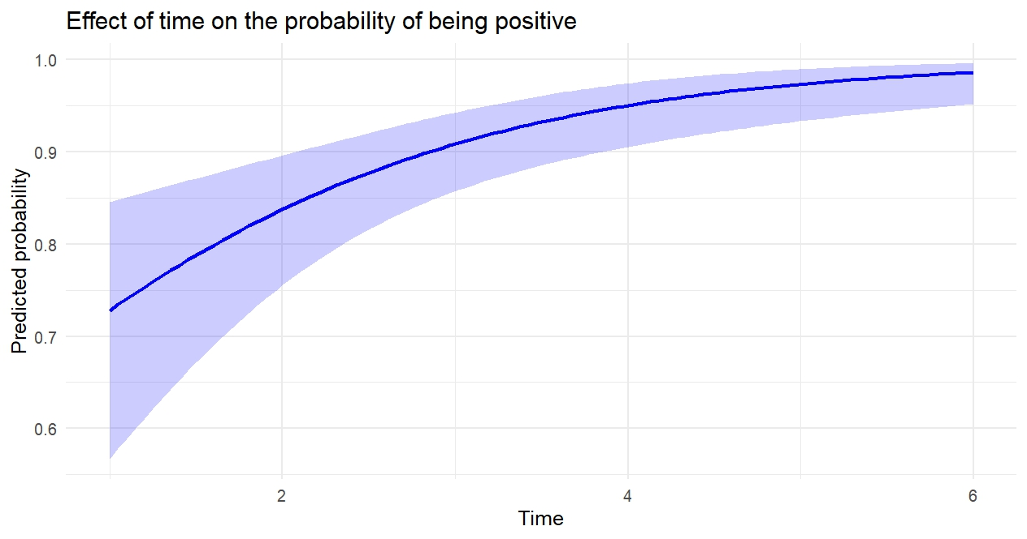

Figure S4. Logistic regression model showing the predicted probability of seropositivity over time. Shaded area represents the 95% confidence interval.

Total animals | Animals with  ≥1 sampling point with RNA+/  Proviral DNA-/Ab- results | Percent of cohort | Seroconverted animals | Not seroconverted animals | Subsequent proviral DNA+ detection | Animals remaining provirus-negative
47 | 7 | 14.9 | 5 | 2 | 6 | 1

Table S3. Sub-analysis of animals with viral RNA+/proviral DNA−/serology− at the same sampling point and subsequent developing of seroconversion or proviral DNA detection.

Variable | β (Estimate) | Standard error | z-value | p-value | Significant*
Intercept | 0.345 | 0.430 | 0.801 | 0.423 | ❌
APOBEC3 Z1 | –0.145 | 0.137 | –1.055 | 0.291 | ❌
APOBEC3 Z3 | 0.001 | 0.025 | 0.055 | 0.956 | ❌
BST2 | 0.008 | 0.033 | 0.231 | 0.818 | ❌
Time | 0.656 | 0.175 | 3.745 | 0.00018 | ✔️
Table S4. Logistic regression model for SRLV seropositivity. Only time was a statistically significant predictor (p < 0.001). Variables showing a statistically significant association are marked with ✔️ (p < 0.05)

