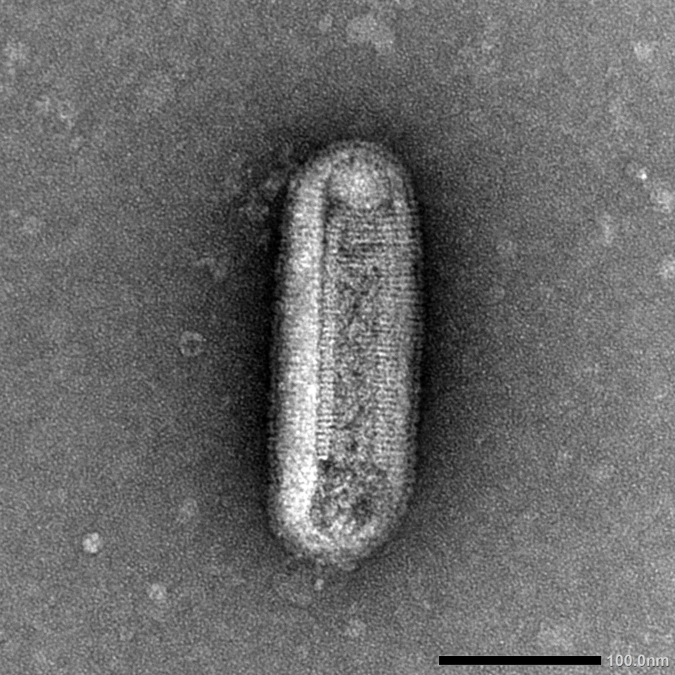
Supp Fig S2 Bacilliform-shaped particle characteristic of rhabdoviruses observed by transmission electron microscopy in Nicotiana benthamiana infected with Buckwheat alphacytorhabdovirus (sample GG-L2).

