Supporting Information
“Synthesis, structure and antioxidant activity of methoxy and hydroxy substituted 2-aminochalcones”

Chiara Sulpizioª, Alexander Roller^{b}, Gerald Giester^{c}, Annette Rompelª
ª Universität Wien, Fakultät für Chemie, Institut für Biophysikalische Chemie, Althanstraße 14, 1090 Wien, Austria
^{b} Universität Wien, Fakultät für Chemie, Zentrum für Röntgenstrukturanalyse, Währinger Straße 42, 1090 Wien, Austria
^{c} Universität Wien, Fakultät für Geowissenschaften, Geographie und Astronomie, Institut für Mineralogie und Kristallographie, Althanstraße 14, 1090 Wien, Austria

X-ray structures

The structures were solved by direct methods and refined by full-matrix least-squares techniques. Non-hydrogen atoms were refined with anisotropic displacement parameters. Hydrogen atoms were inserted in calculated positions and refined with a riding model respectively as rotating systems. Experimental data can be found in Table 1. Molecular Structures in “Ortep View” are presented in Figures S1 and 2.

Sample | Machine | Source | Temp. | Detector Distance | Time/ Frame | #Frames | Frame width | CCDC
 |  |  | [K] | [mm] | [s] |  | [°]
5 | Bruker,  Kappa  ApexII | Mo | 200 (2) | 40 | 70 | 515 | 2 | 1406883
6 | Bruker D8 | Mo | 100 (2) | 35 | 60 | 776 | 0.5 | 1406882
Table S1. Experimental parameters and CCDC-Codes.
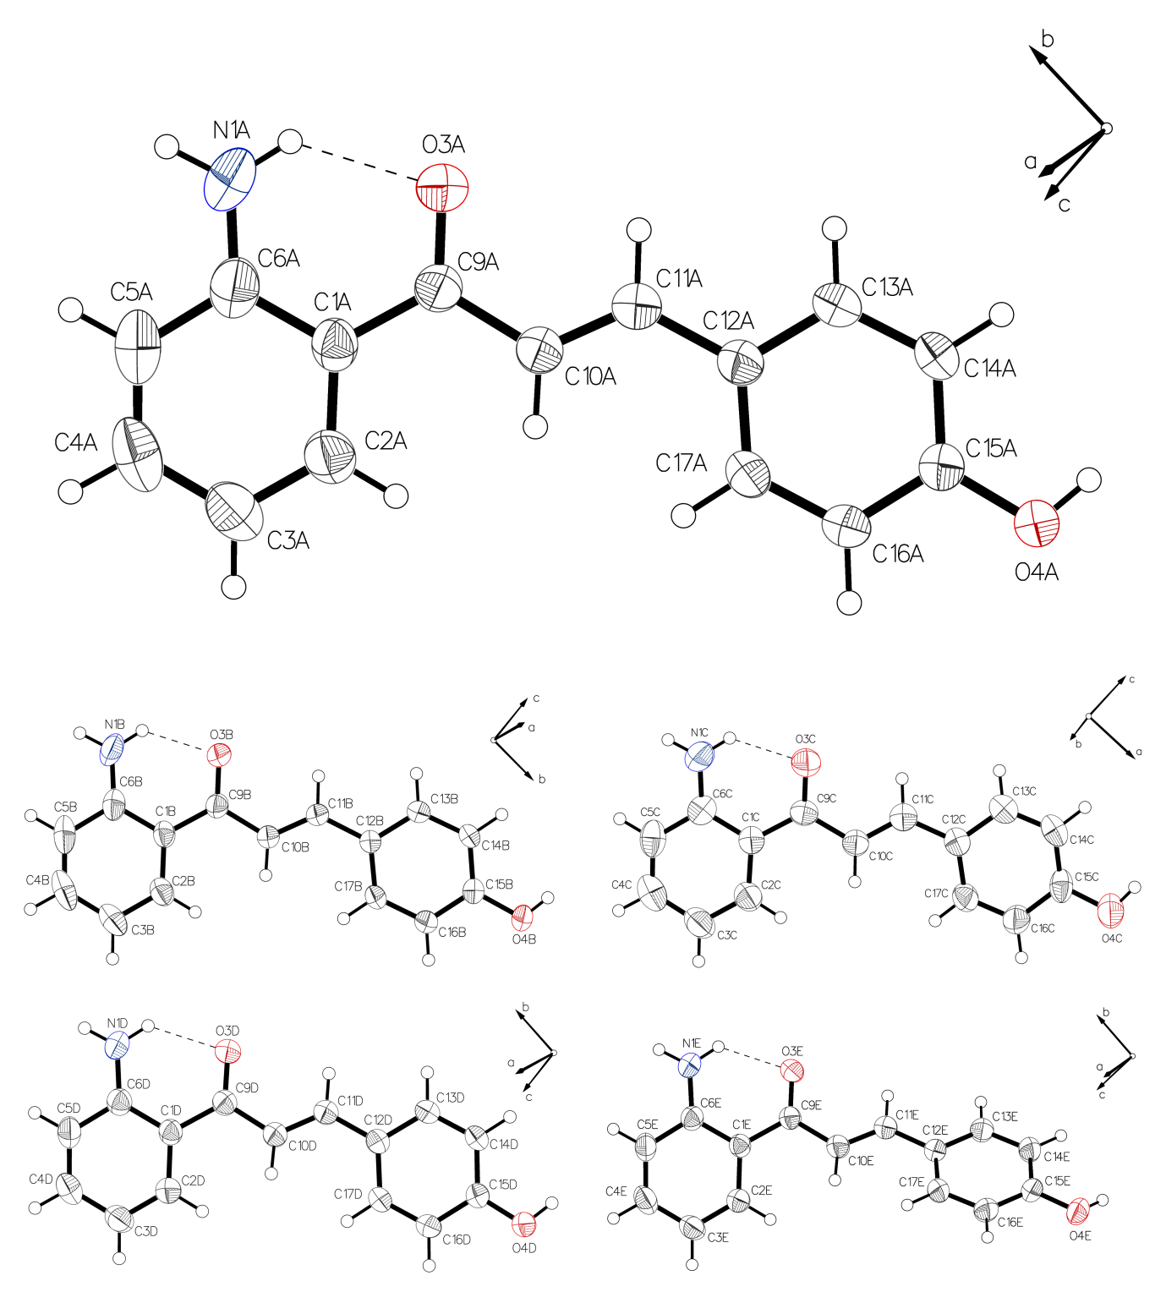
Figure S1. Crystal structure of 5, drawn with 50% displacement ellipsoids. The asymmetric unit is built up by five independent molecules. All of them form one intramolecular hydrogen bond in the range from 2.620 to 2.665 Å for the donor - acceptor distance. The corresponding angle range in the riding hydrogen model is 128.4 to 130.3°. All O4 positions are the basis for intermolecular hydrogen bonds. This is not the case for the positions of N1. The torsion range for N1-C6-C1-C12 is -15.731 to 17.503° and is responsible for the main difference in the 5 molecules from the Asymmetric Unit.

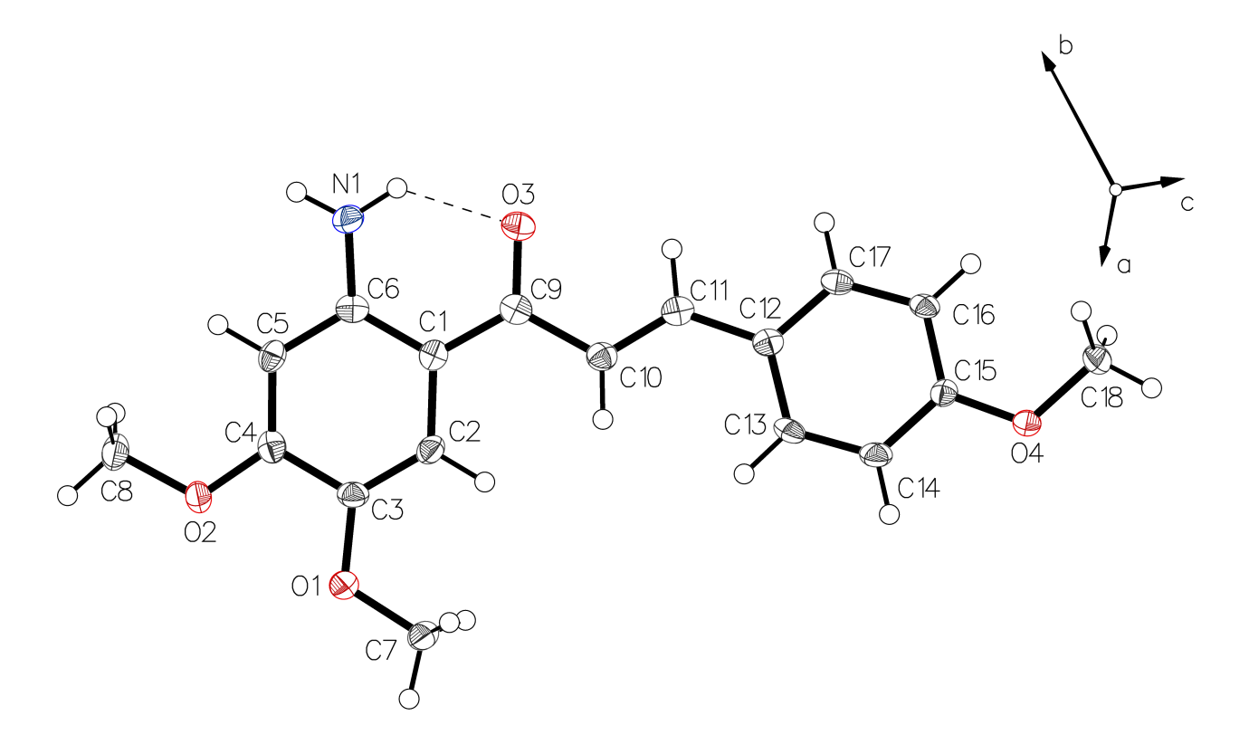
Figure S2. Asymmetric Unit of 6, drawn with 50% displacement ellipsoids. N1 and O3 form one intramolecular hydrogen bond with a donor - acceptor distance 2.584 Å. The corresponding angle in the riding hydrogen model is 130.4. N1 is also responsible for one intermolecular hydrogen bond. The torsion for N1-C6-C1-C12 is -0.702° and is in the range of 6.

¹H NMR spectra

Figure S3. ¹H-NMR in acetone-d₆ of (E)-1-(2-aminophenyl)-3-(4-hydroxyphenyl)prop-2-en-1-one (5)

Figure S4. ¹H-NMR in acetone-d₆ of E)-1-(2-aminophenyl)-3-(3,4-dihydroxyphenyl)prop-2-en-1-one (5a)

Figure S5. ¹H-NMR in MeOD-d₄ of (E)-1-(2-amino-4-methoxyphenyl)-3-(3,4-dimethoxyphenyl)prop-2-en-1-one (6)

Scheme 1

