Supporting information

Benzil / Trietylamine: A photo-reducing System for Cu²⁺

M. Schmallegger & G. Gescheidt

Institute of Physical and Theoretical Chemistry,Graz University of Technology, Stremayrgasse 9, 8010 Graz, Austria.

E-Mail: g.gescheidt-demner@tugraz.at

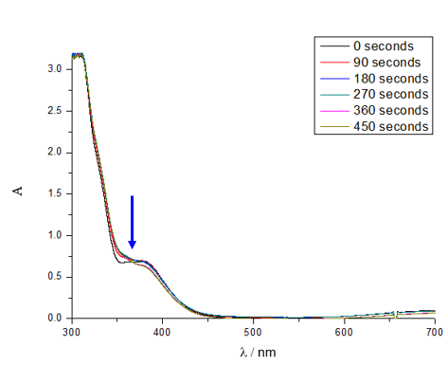
Figure 1. UV-VIS spectrum obtained upon photolysis of 1 in CH₃CN; the arrow represents the irradiation wavelength (365 nm)

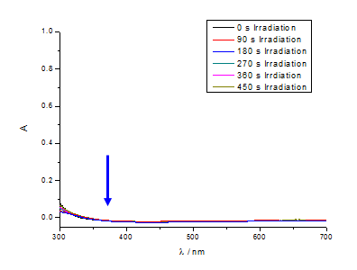
Figure 2. UV-VIS spectrum obtained upon photolysis of CuSO₄ in CH₃CN; the arrow represents the irradiation wavelength (365 nm)

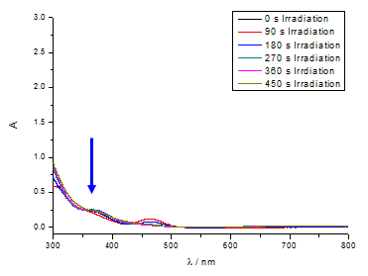
Figure 3. UV-VIS spectrum obtained upon photolysis of CuCl₂ in CH₃CN; the arrow represents the irradiation wavelength (365 nm)

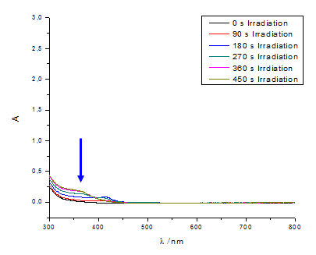
Figure 4. UV-VIS spectrum obtained upon photolysis of CuSO₄ and 2 in CH₃CN; the arrow represents the irradiation wavelength (365 nm)

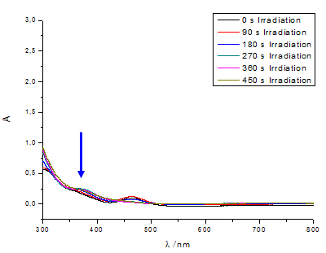
Figure 5. UV-VIS spectrum obtained upon photolysis of CuCl₂ and 2 in CH₃CN; the arrow represents the irradiation wavelength (365 nm)

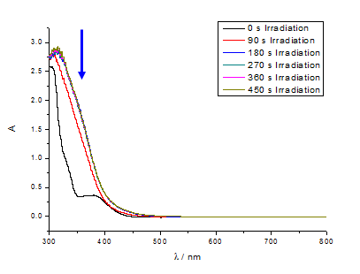
Figure 6. UV-VIS spectrum obtained upon photolysis of CuSO₄ and 1 in CH₃CN; the arrow represents the irradiation wavelength (365 nm)
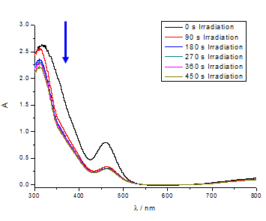
Figure 7. UV-VIS spectrum obtained upon photolysis of CuCl₂ and 1 in CH₃CN; the arrow represents the irradiation wavelength (365 nm)

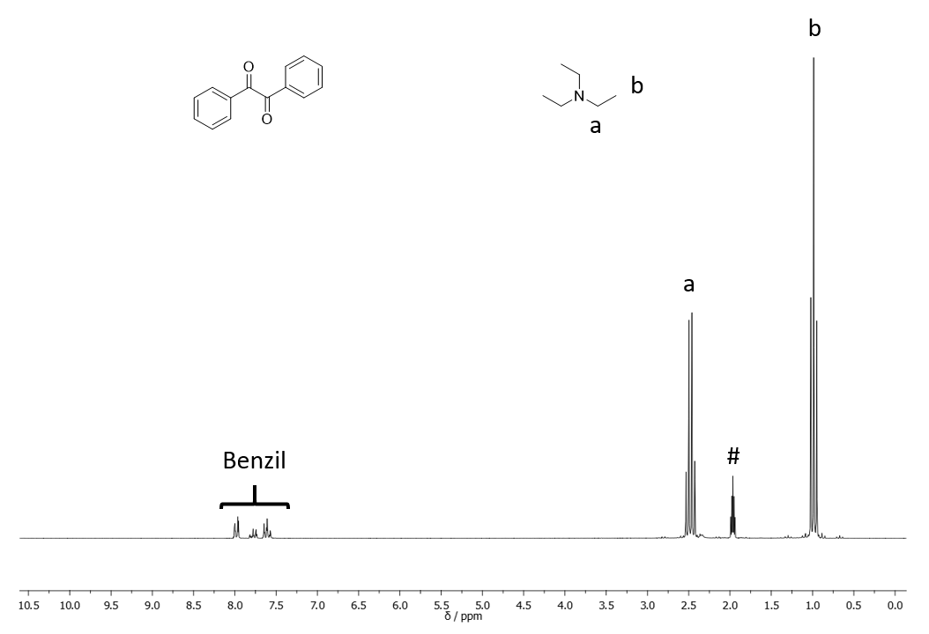
Figure 8. ¹H NMR of the benzil/TEA system before irradiation, the peak of the solvent is marked by an asterisk

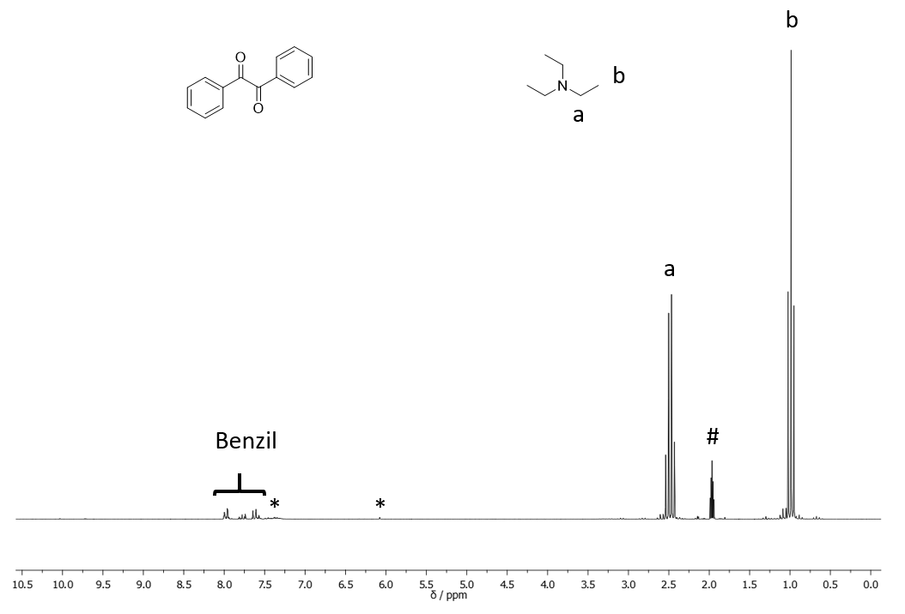
Figure 9. ¹H NMR of the benzil/TEA system after irradiation, the peak of the solvent is marked by an asterisk; new peaks observable after irradiation are marked by a (*)

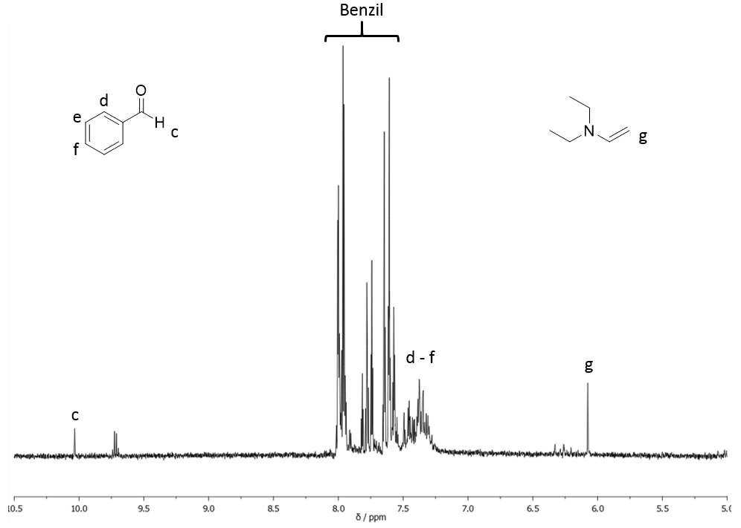
Figure 10. aromatic region of the ¹H NMR depicted in Figure 4; the formation of benzaldehyde stems from the cleavage of benzil, which is known to occur as a side reaction upon irradiation[1]; the signal at 9.7 ppm is assigned to acetaldehyde formed from the oxidation of triethylamine in the presence of oxygen[2, 3]

References
1. Park JW, Kim EK, Park KK (2002) Bull Korean Chem Soc 23:1229–1234.
2. Cullis CF, Waddingtion DJ (1958). Proc R Soc Lond A Math Phys Sci 244:110–123.
3. Taqui Khan MM, Mirza SA, Bajaj HC (1987). React Kinet Catal Lett 33:67–74.

