Supporting Information for

Synthesis and characterization of meso-substituted A₂B corroles with extended π−electronic structure

Sabrina Gonglach¹, Michael Haas¹, Stefan Müllegger², Wolfgang Schöfberger^{2,}
Institute of Organic Chemistry, Johannes Kepler University Linz (JKU), Altenberger Straße 69, 4040 Linz, Austria.
Institute of Semiconductor and Solid State Physics, Altenberger Straße 69, 4040 Linz, Austria.

Wolfgang Schöfberger
E-mail: wolfgang.schoefberger@jku.at

General Information

All chemicals were purchased from Alfa Aesar, Fluka, Merck or Sigma-Aldrich and used without further purification. Dipyrromethane was synthesized according to literature ^{[1]}. THF was distilled over sodium and benzophenone under an argon atmosphere and stored over molecular sieve (4 Å) until use. DCM was distilled over P₂O₅ under an argon atmosphere and stored over molecular sieve (4 Å) upon use. All solvents for the NMR were purchased from Euriso-Top. TLC was performed on Macherey-Nagel silica gel 60 (0.20 mm) with fluorescent indicator UV₂₅₄ on aluminium plates and on Merck aluminium oxide 60 (0.20 mm) with fluorescent indicator UV₂₅₄ on aluminium plates. For chromatography, silica-gel columns were prepared with silica-gel 60 (0.070 – 0.20 mesh) from Grace and aluminium oxide columns were prepared with aluminium oxide (activated, basic, Brockmann I) from Sigma-Aldrich. Proton (¹H-NMR) and Carbon (¹³C-NMR) spectra were recorded on a Bruker Ascend 700 MHz Advance III NMR spectrometer and on a Bruker Advance 300 MHz NMR spectrometer. Fluor (¹⁹F-NMR) spectra were recorded on a Bruker Advance 300 MHz NMR spectrometer at 282.4 MHz. The chemical shifts are given in parts per million (ppm) on the delta scale (δ) and are referred to the used deuterated solvent for ¹H-NMR and to TFA for ¹⁹F-NMR. Mass spectra were measured on a Finnigan LCQ DecaXPplus Ion trap mass spectrometer with ESI ion source and HRMS was performed on a 6510 quadrupole/time-of-flight (Q-TOF) instrument (Agilent). UV-Vis absorbtion spectra were collected on a Varian CARY 300 Bio spectrophotometer from 200 to 900 nm. Fluorescence spectra were measured on a CARY eclipse fluorescence spectrophotometer.

Characterization of 5, 15-pentafluorophenyl-10-trimethylsilylethynylcorrole
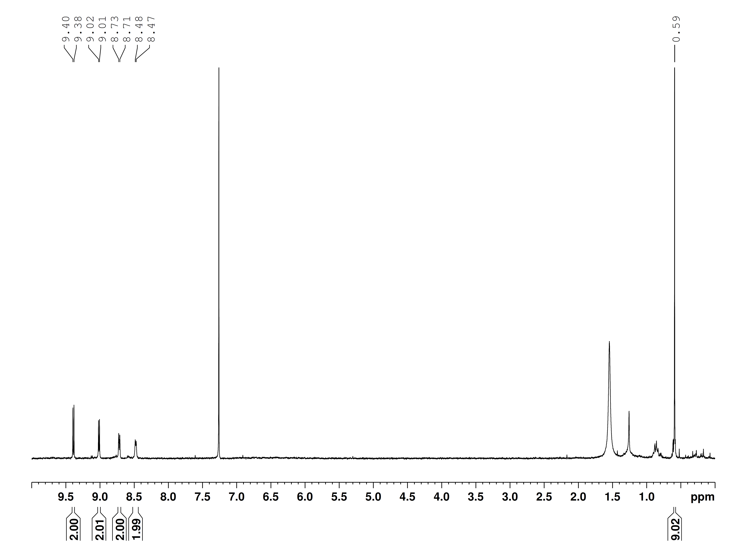
Fig.S1: ¹H-NMR spectrum of 5, 15-pentafluorophenyl-10-trimethylsilylethynyl-corrole 2.
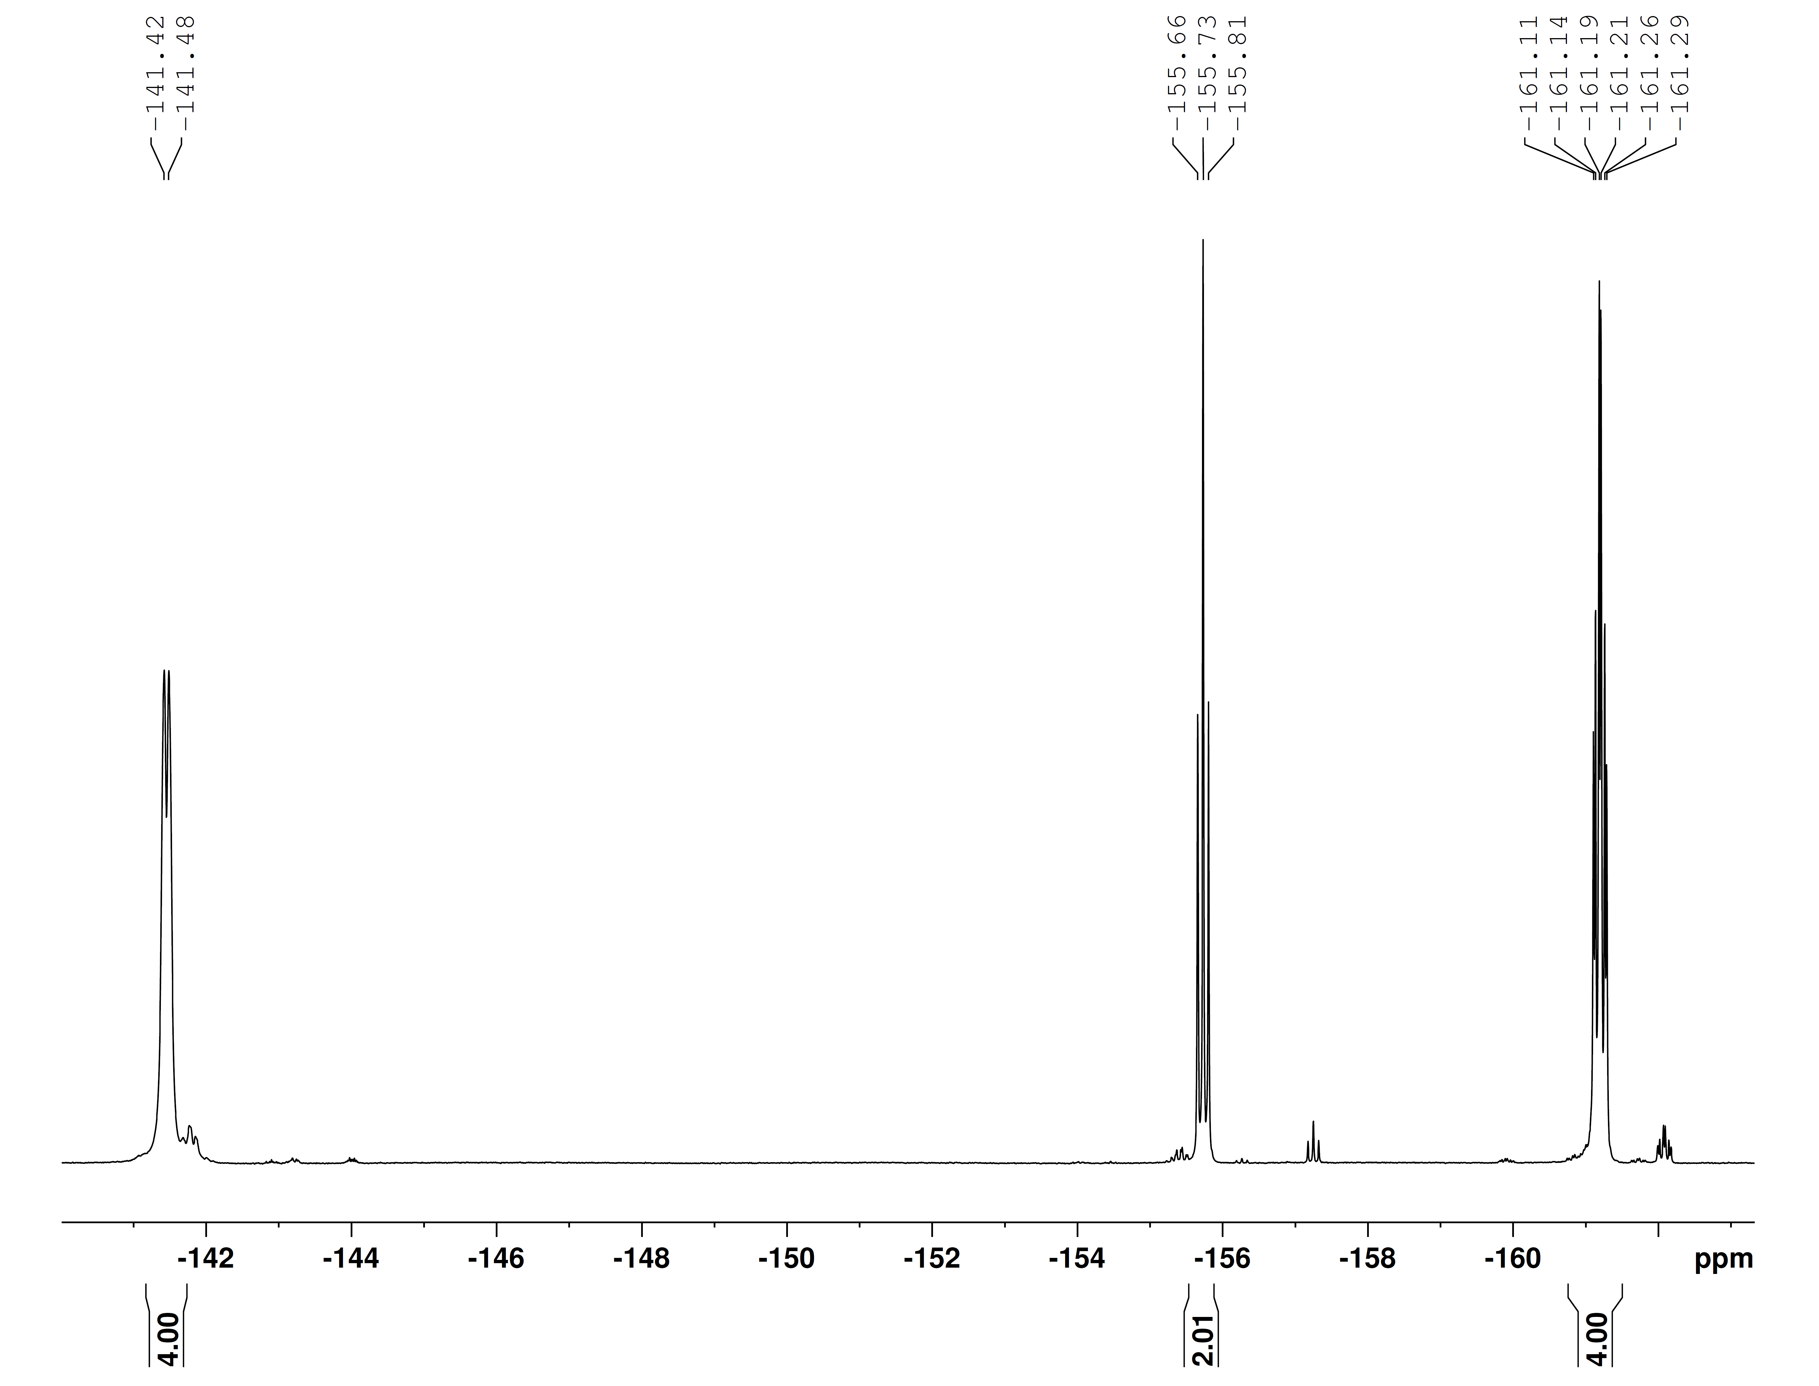
Fig. S2: ¹⁹F-NMR spectrum of 5, 15-pentafluorophenyl-10-trimethylsilylethynyl-corrole 2.
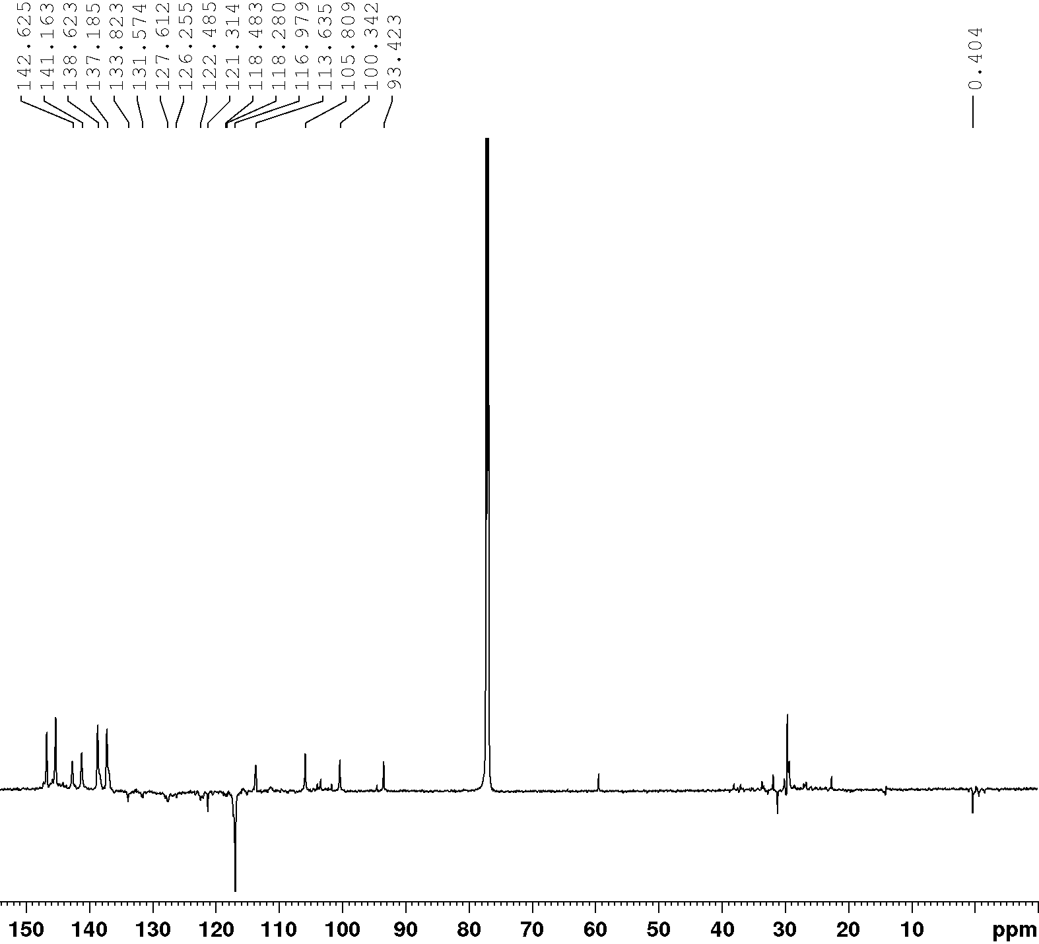
Fig. S3: ¹³C-NMR spectrum of 5, 15-pentafluorophenyl-10-trimethylsilylethynyl-corrole 2 (attached proton test - APT).
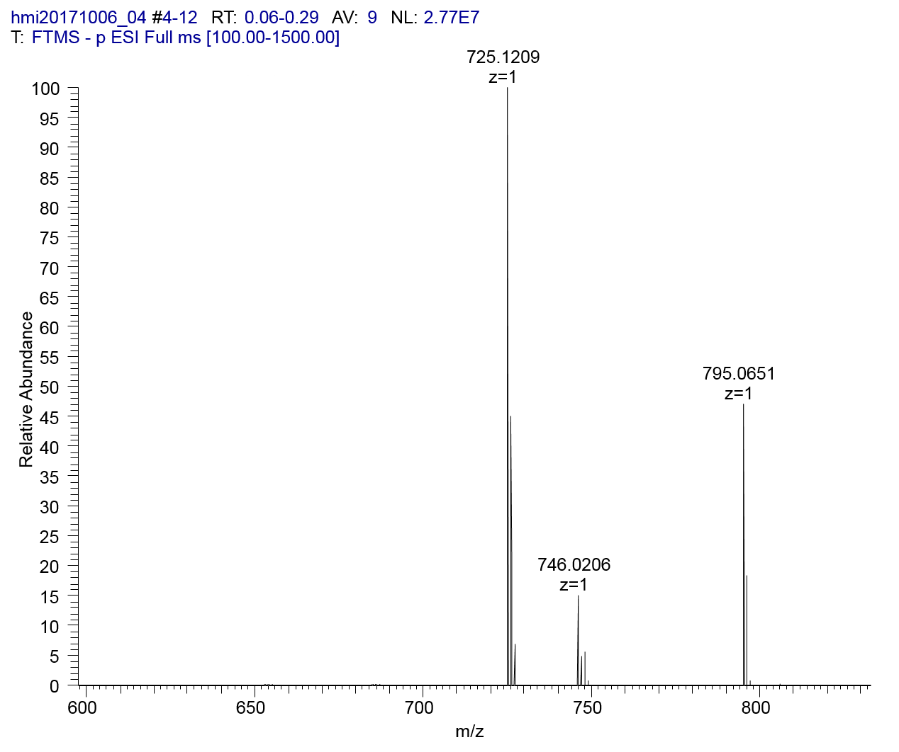
H₃TpFPC
Fig. S4: HRMS of 5, 15-pentafluorophenyl-10-trimethylsilylethynyl-corrole 2.

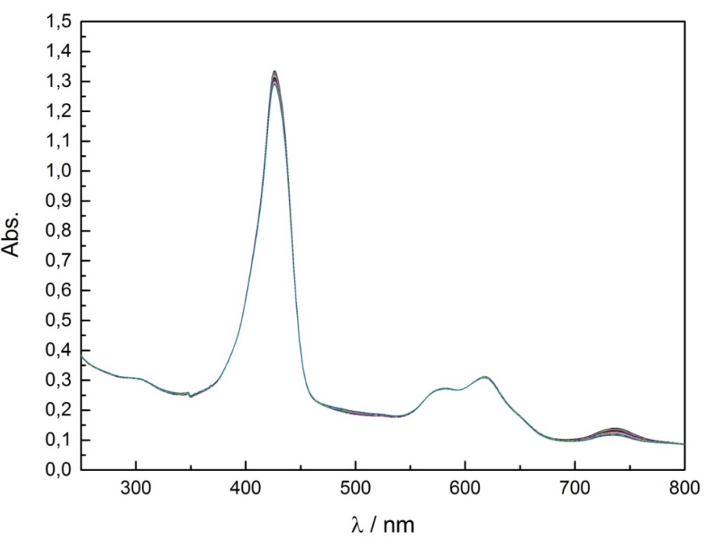
Fig. S5: UV-vis spectra of the stability test of 5, 15-pentafluorophenyl-10-trimethyl silylethynyl-corrole 2.

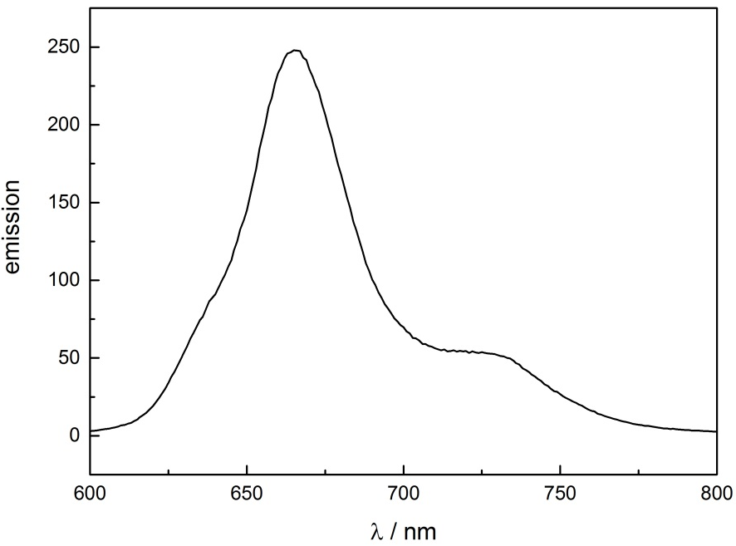
Fig. S6: Emission spectrum of 5, 15-pentafluorophenyl-10-trimethylsilylethynyl-corrole 2.

Characterization of 5, 15-pentafluorophenyl-10-ethynylcorrole

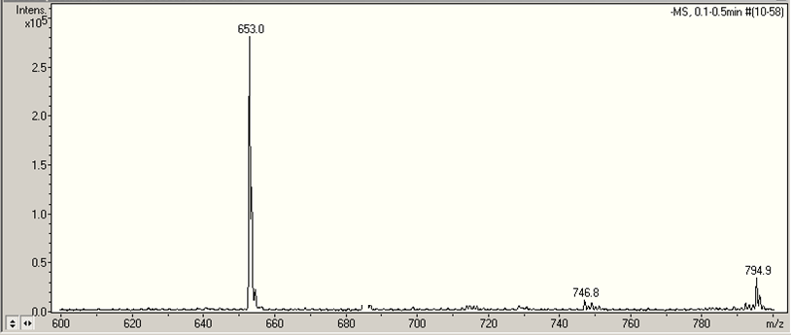
H₃TpFPC

Fig. S7: Mass spectrum of 5, 15-pentafluorophenyl-10-ethynylcorrole 3.

Characterization of 5,15-bispentafluorophenyl-10-(pyreneethynyl)corrole

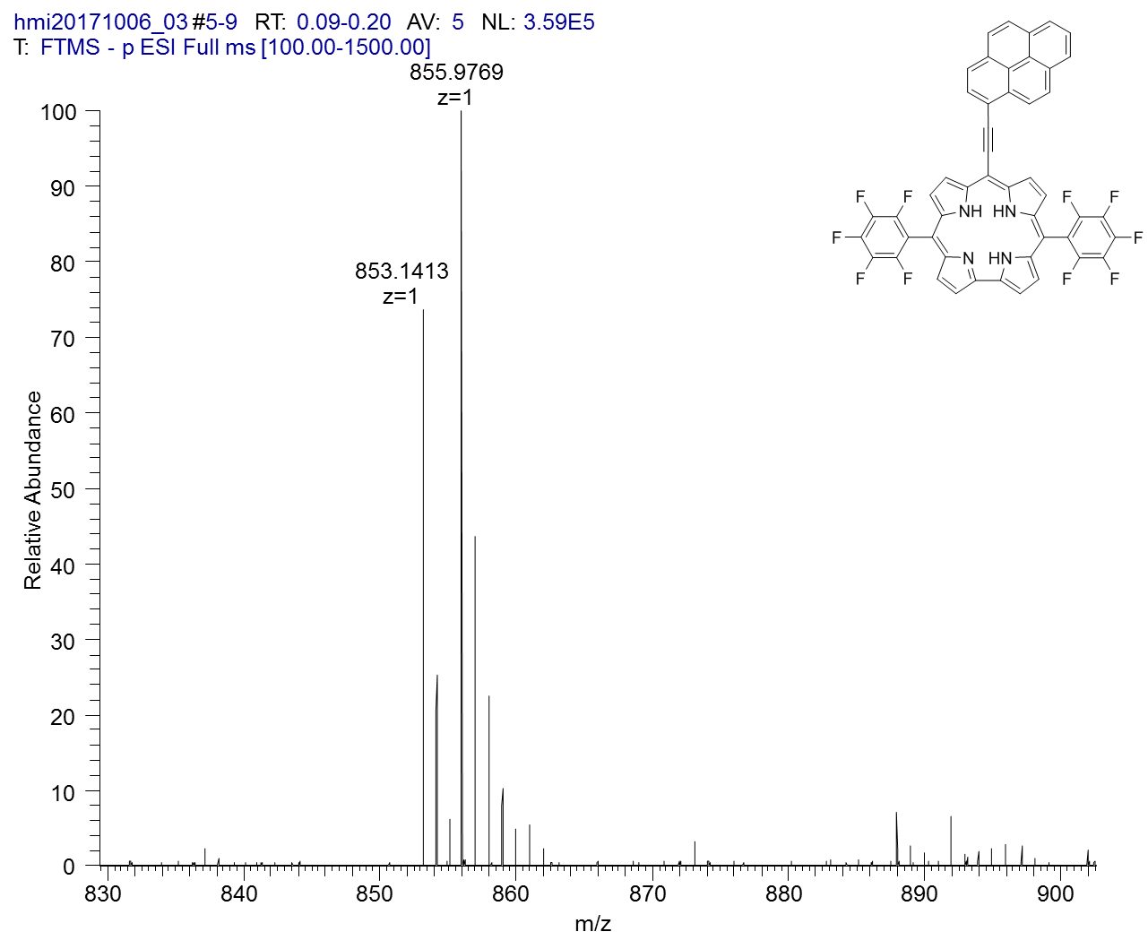
CuTpFPC
Fig S8: HRMS of 5,15-bispentafluorophenyl-10-(pyreneethynyl)corrole.

Characterization of copper 5,15-bispentafluorophenyl-10-(pyreneethynyl)corrole

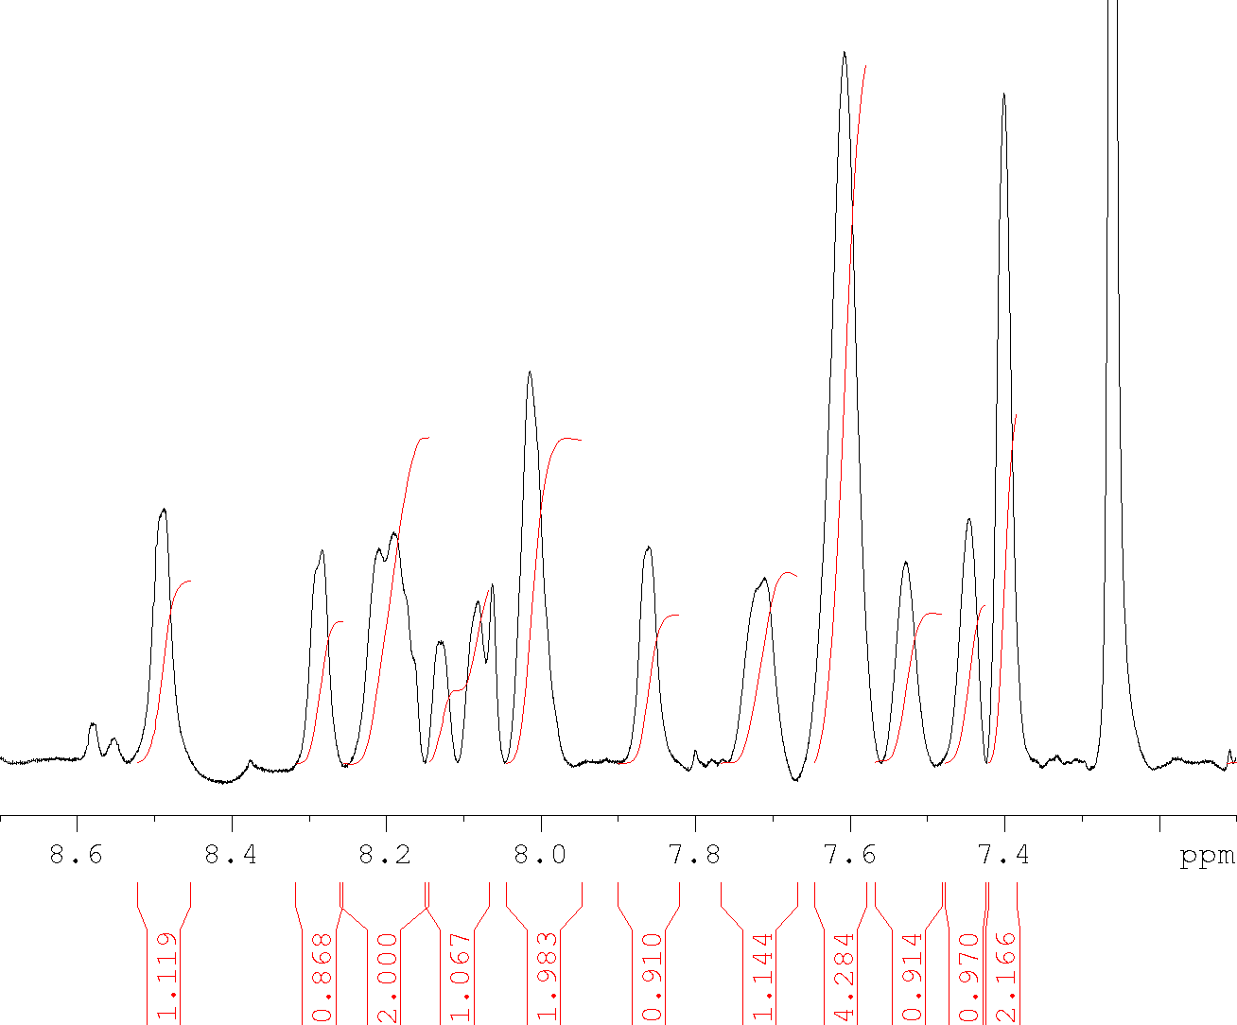

Fig. S9: ¹H-NMR spectrum of Copper 5,15-bispentafluorophenyl-10-(pyreneethynyl)corrole 4.
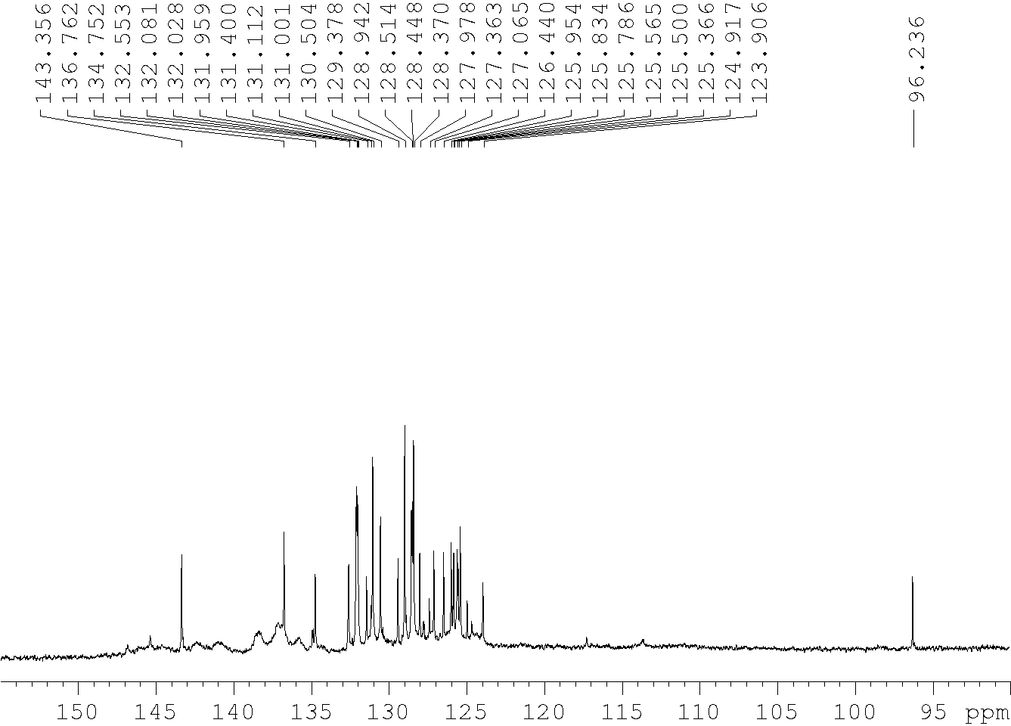

Fig. S10: ¹³C-NMR spectrum of Copper 5,15-bispentafluorophenyl-10-(pyreneethynyl)corrole.

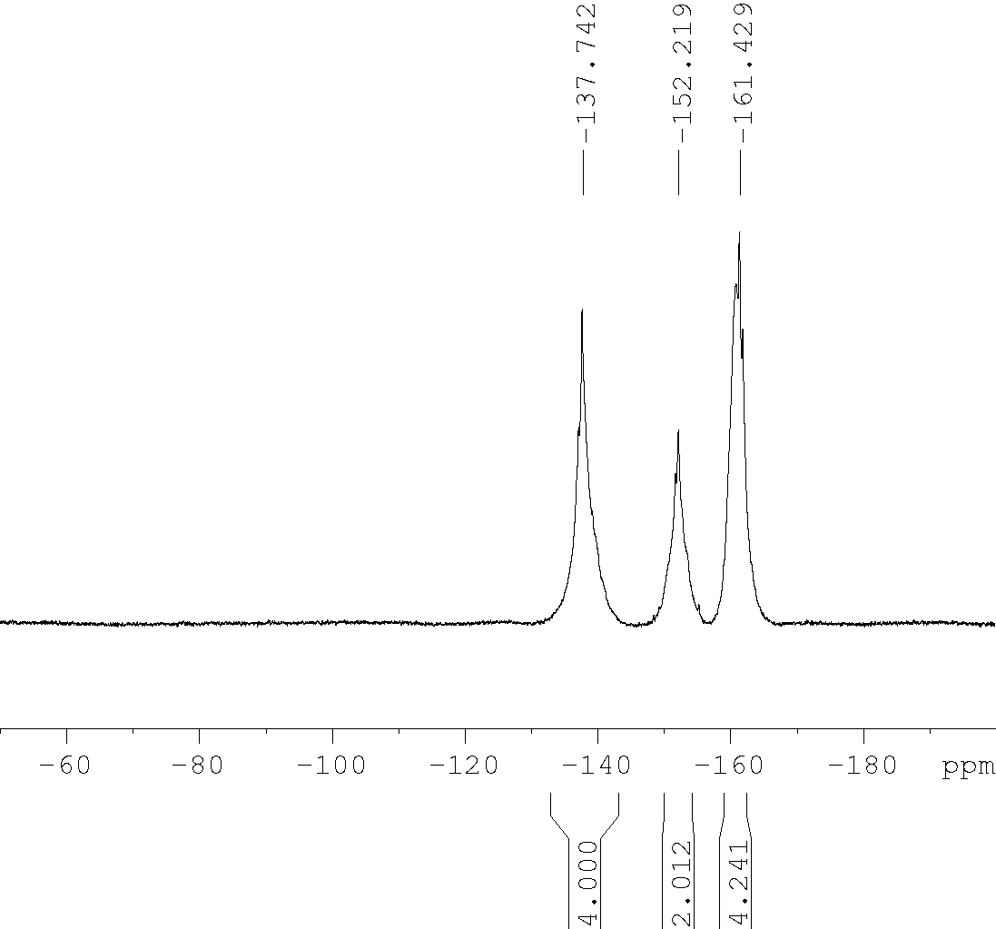
Fig. S11: ¹⁹F-NMR spectrum of Copper 5,15-bispentafluorophenyl-10-(pyreneethynyl)corrole.
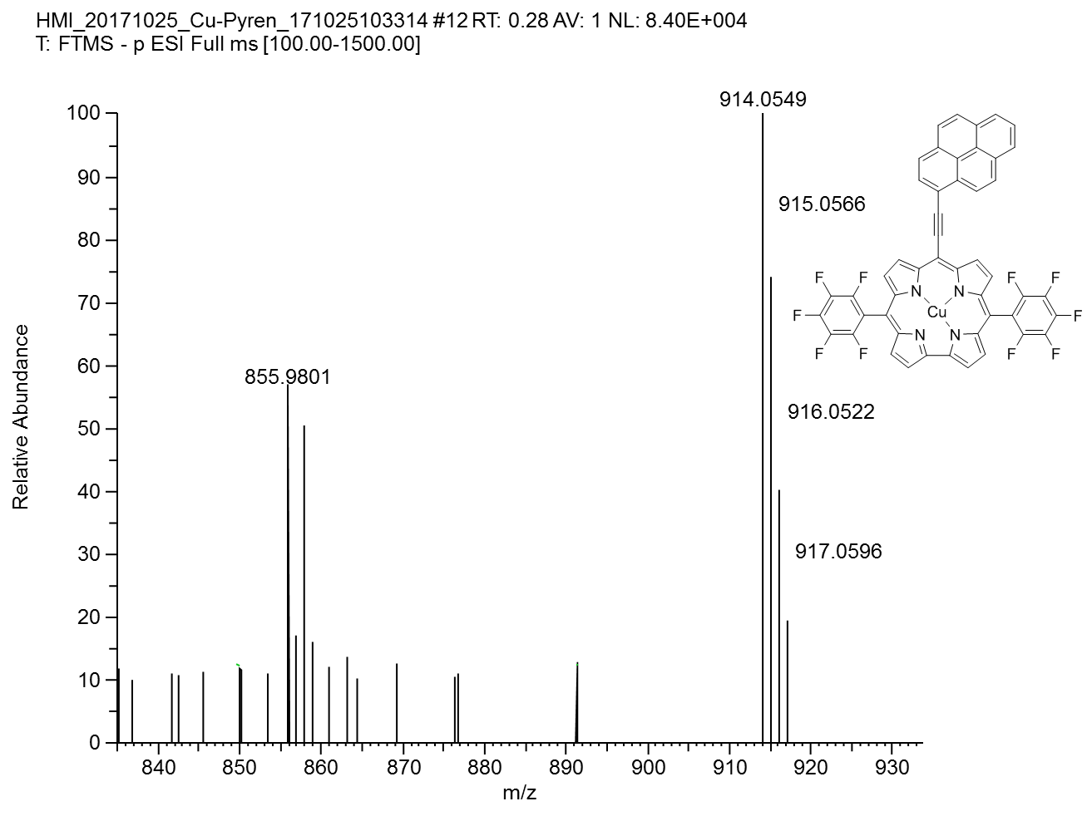
CuTpFPC
Fig S12: HRMS of Copper 5, 15-pentafluorophenyl-10-(pyreneethynyl)corrole (neutral M-peak detected).

[1] R. Orłowski, D. Gryko, D. T. Gryko, Chem. Rev. 2017, 117, 3102.
[2] M. König, F. Faschinger, L. M. Reith, W. Schöfberger, J. Porphyrins Phthalocyanines 2016, 20, 96.
[3] J. F. B. Barata, M. G. P. M. S. Neves, M. A. F. Faustino, A. C. Tomé, J. A. S. Cavaleiro, Chemical reviews 2017, 117, 3192.
[4] a) C. M. Lemon, P. J. Brothers, J. Porphyrins Phthalocyanines 2011, 15, 809; b) R. Paolesse, Synlett 2008, 2008, 2215.
[5] a) Z. Gross, N. Galili, Angew. Chem. Int. Ed. 1999, 111, 2536; b) R. Paolesse, S. Mini, F. Sagone, T. Boschi, L. Jaquinod, D. J. Nurco, K. M. Smith, Chem. Commun. 1999, 1307.
[6] a) I. Aviv-Harel, Z. Gross, Chem. Eur. J. 2009, 15, 8382; b) R. D. Teo, J. Y. Hwang, J. Termini, Z. Gross, H. B. Gray, Chem. Rev. 2017, 117, 2711; c) S. M. Borisov, A. Alemayehu, A. Ghosh, J. Mater. Chem. C 2016, 4, 5822; d) R. Paolesse, S. Nardis, D. Monti, M. Stefanelli, C. Di Natale, Chem. Rev. 2017, 117, 2517; e) C. M. Lemon, D. C. Powers, P. J. Brothers, D. G. Nocera, Inorg. Chem. 2017, 56, 10991.
[7] W. Schöfberger, F. Faschinger, S. Chattopadhyay, S. Bhakta, B. Mondal, J. A. A. W. Elemans, S. Müllegger, S. Tebi, R. Koch, F. Klappenberger et al., Angew. Chem. Int. Ed. 2016, 55, 2350.
[8] M. König, L. M. Reith, U. Monkowius, G. Knör, K. Bretterbauer, W. Schoefberger, Tetrahedron 2011, 67, 4243.
[9] a) M. Tiffner, S. Gonglach, M. Haas, W. Schöfberger, M. Waser, Chem. Asian. J. 2017, 12, 1048; b) W. Sinha, M. G. Sommer, N. Deibel, F. Ehret, B. Sarkar, S. Kar, Chem. Eur. J. 2014, 20, 15920; c) M. Stefanelli, M. Mastroianni, S. Nardis, S. Licoccia, F. R. Fronczek, K. M. Smith, W. Zhu, Z. Ou, K. M. Kadish, R. Paolesse, Inorg. Chem. 2007, 46, 10791; d) M. Schmidlehner, F. Faschinger, L. M. Reith, M. Ertl, W. Schoefberger, Appl. Organometal. Chem. 2013, 27, 395.
[10] D. T. Gryko, Eur. J. Org. Chem. 2002, 2002, 1735.
[11] K. Ueta, K. Naoda, S. Ooi, T. Tanaka, A. Osuka, Angew. Chem. Int. Ed. 2017, 56, 7223.
[12] H. L. Anderson, Tetrahedron Letters 1992, 33, 1101.
[13] T. Rohand, E. Dolusic, T. Ngo, W. Maes, W. Dehean, Arkivoc 2006, 2007, 307.
[14] B. Koszarna, D. T. Gryko, J. Org. Chem. 2006, 71, 3707.
[15] A. Nowak-Król, R. Plamont, G. Canard, J. A. Edzang, D. T. Gryko, T. S. Balaban, Chem. Eur. J. 2015, 21, 1488.
[16] G. R. Geier III, B. J. Littler, J. S. Lindsey, J. Chem. Soc., Perkin Trans. 2 2001, 701.
[17] B. J. Littler, Y. Ciringh, J. S. Lindsey, The Journal of organic chemistry 1999, 64, 2864.
[18] D. T. Gryko, K. Jadach, J. Org. Chem. 2001, 66, 4267.
[19] Kabeer Ahmed Shaikh, Vishal A. Patil, B.P. Bandgar, Orbital: Electron. J. Chem. 2012, 2012, 111.
[20] P. Yadav, M. Sankar, X. Ke, L. Cong, K. M. Kadish, Dalton Trans. 2017, 46, 10014.

